Created a data set

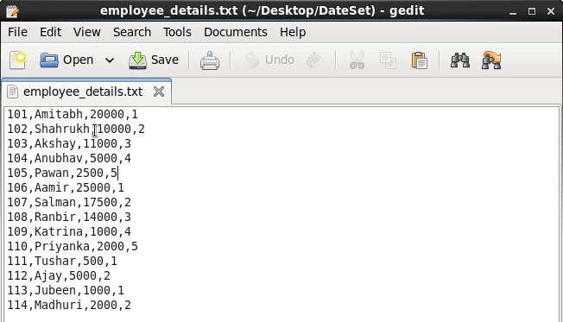

Now starts Pig in local mode

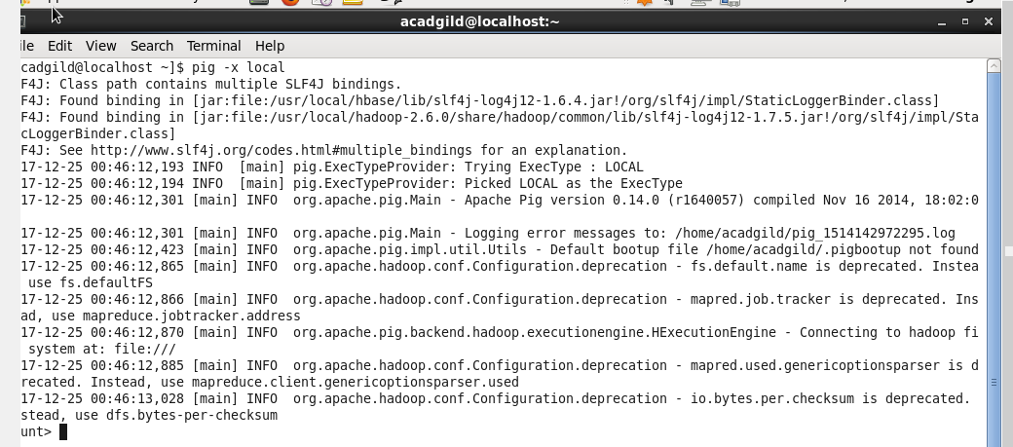

Load the data

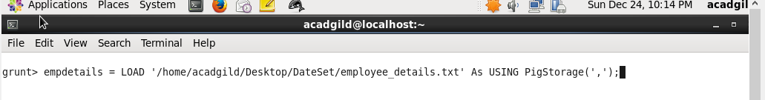



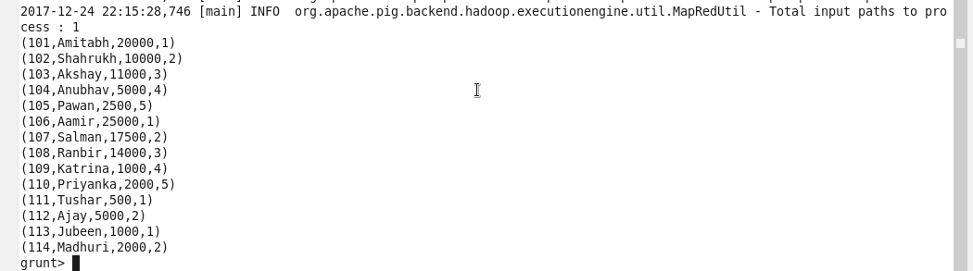

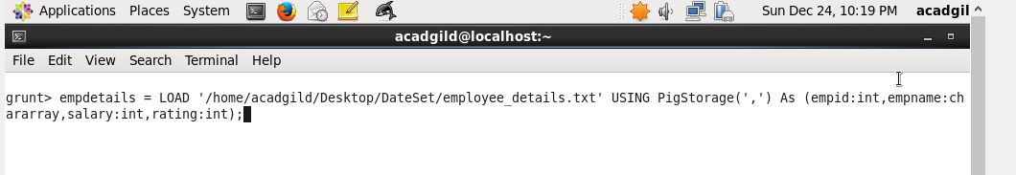

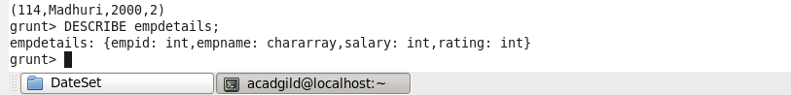

Concat

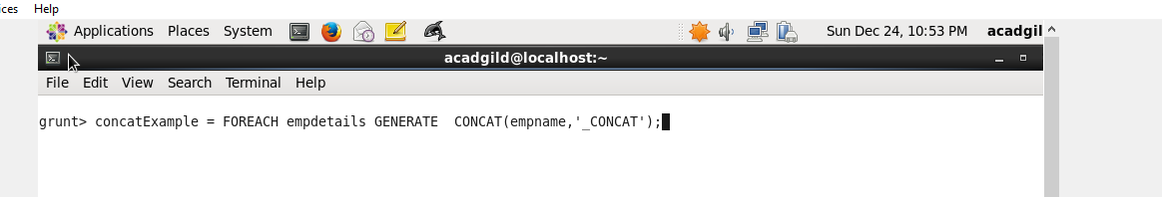

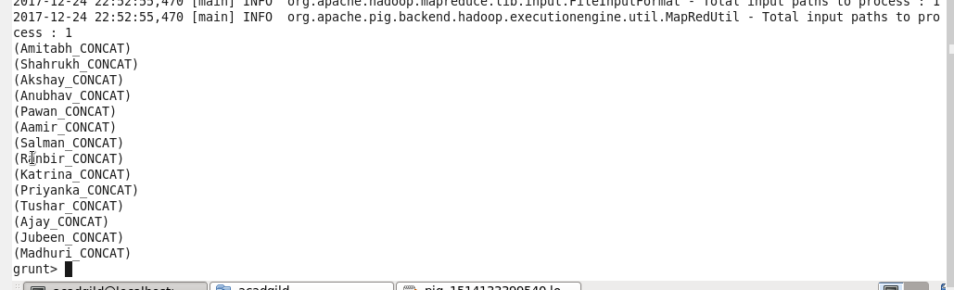

Tokenize

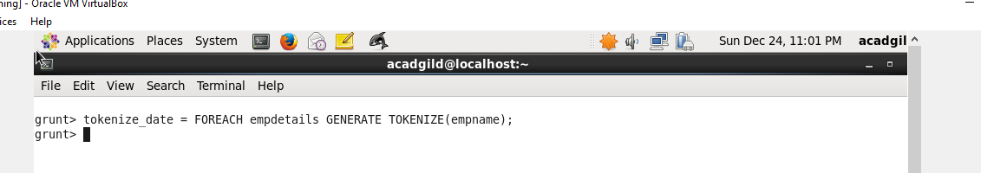



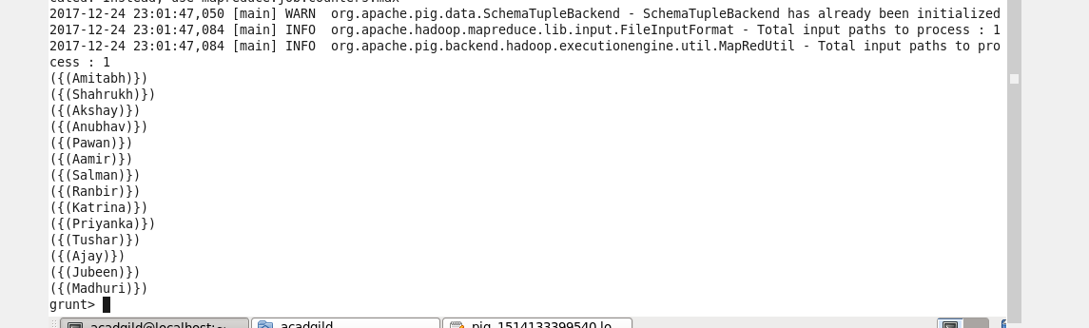

SUM:

Group by all



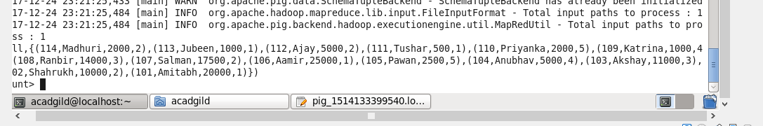

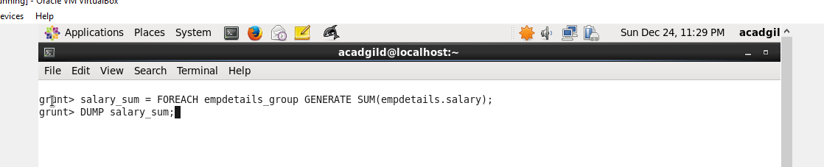

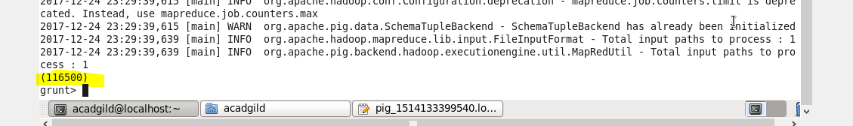

Min:

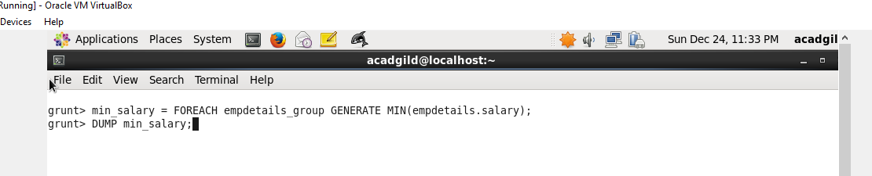

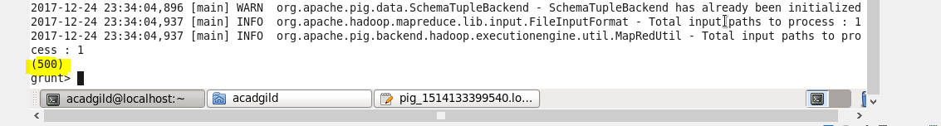

Max:

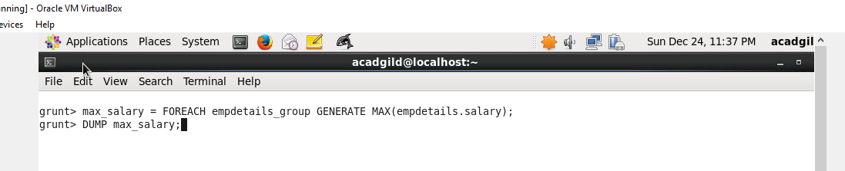

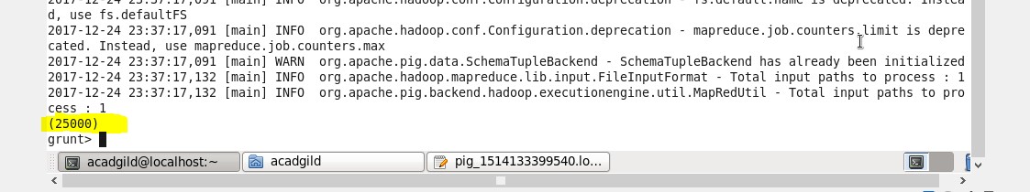

Limit:

All empdetails data :

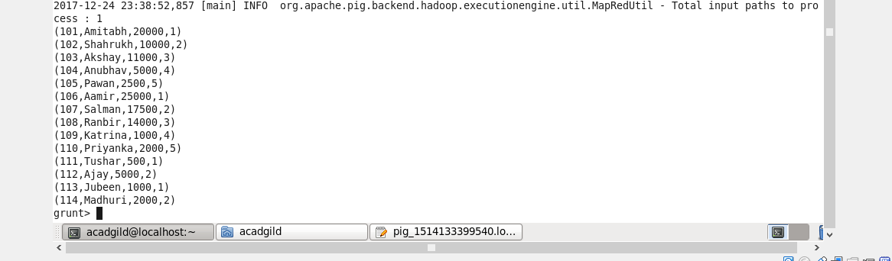

Now limit to 4

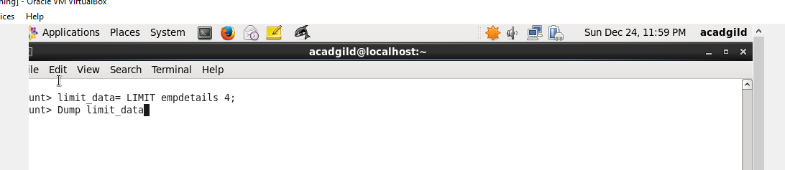

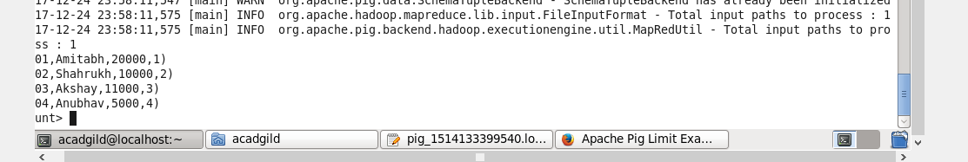

Store:

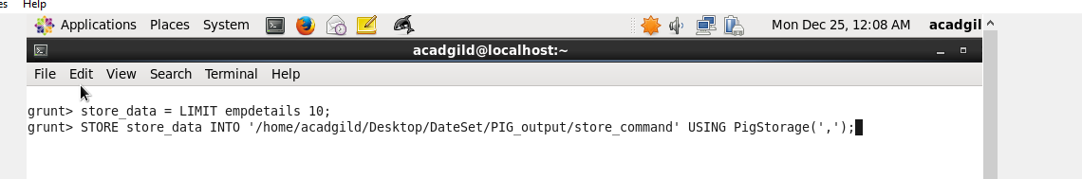

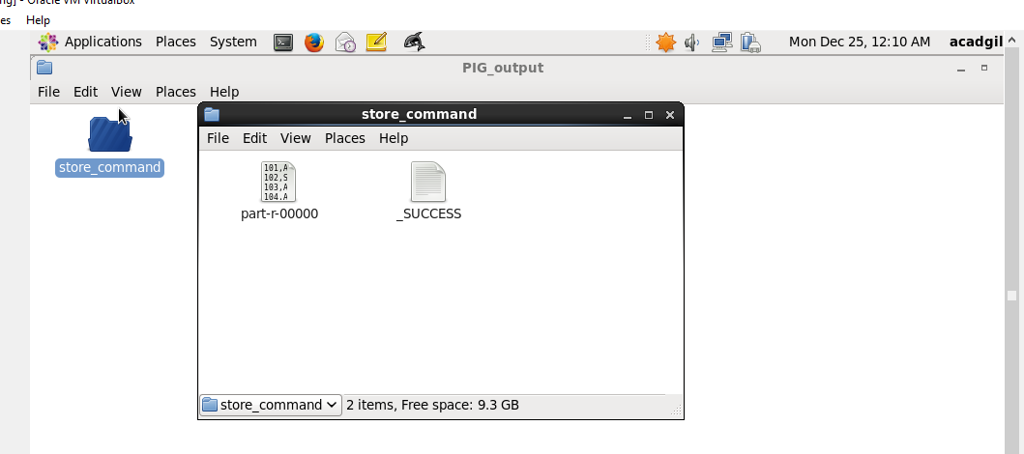

DISTINCT



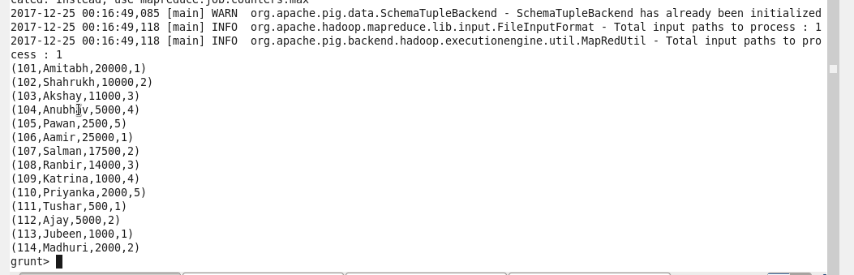

Flatten

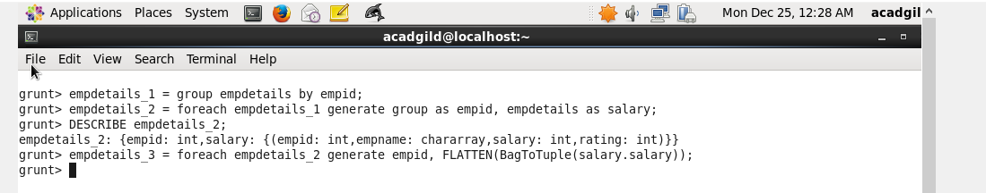

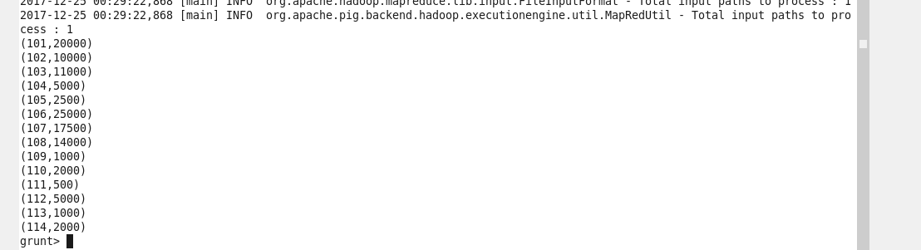

ISEmpty

Two releation

Empdetails & empBonus details



