# Output:

## Login page:

Register page:

Shop:

Admin page:  
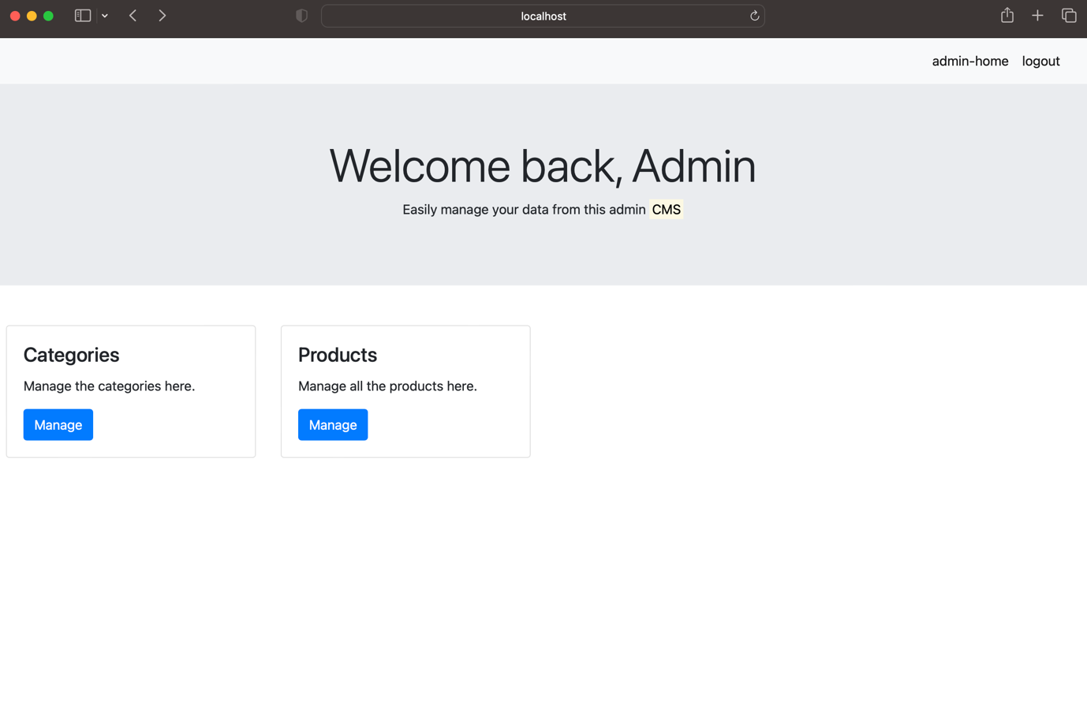

Admin categories page:  
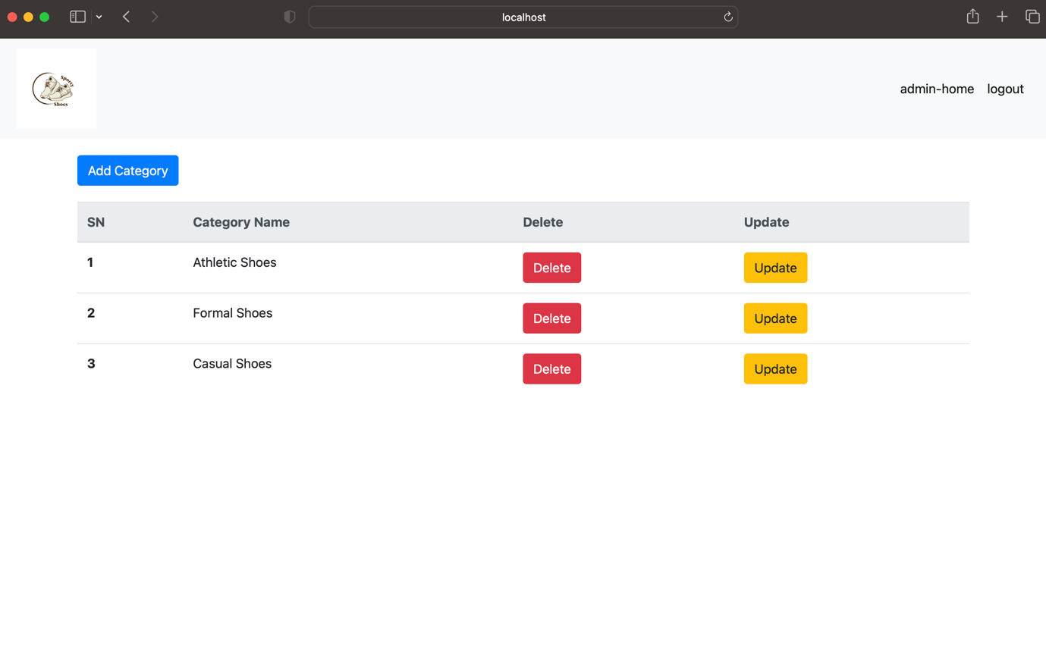

Admin product page:

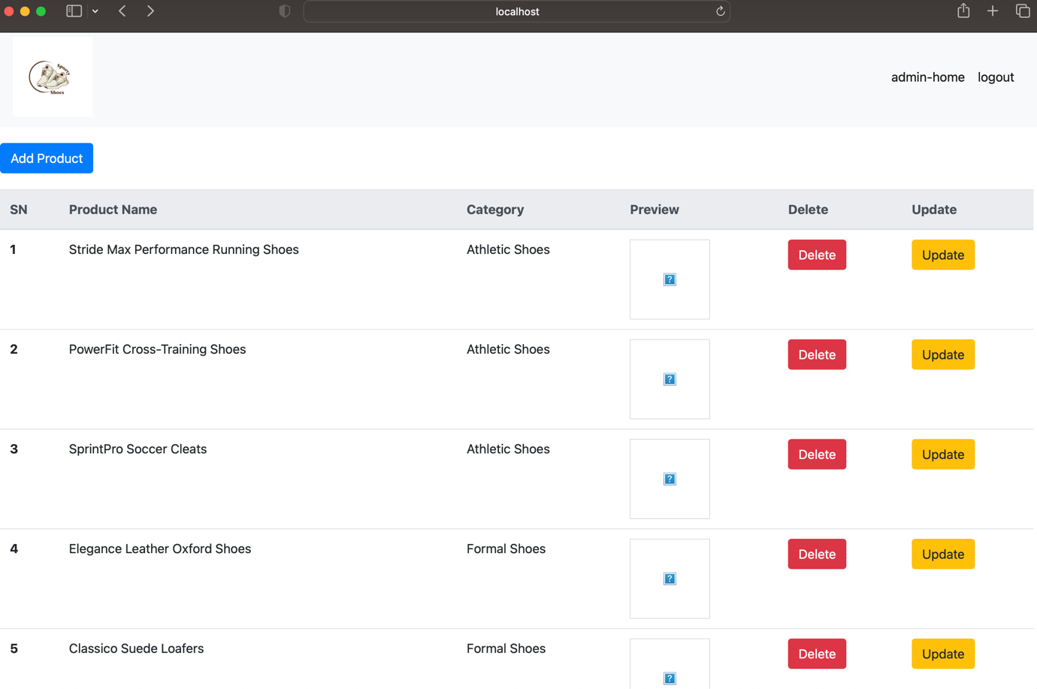

Admin add product page:

