# Project Evaluation: Predicting Electrical Energy Output of a Combined Cycle Power Plant

## 1. Modeling Approach

Type of Modeling Task: For predicting the electrical energy output of a Combined Cycle Power Plant, we need a **regression** approach since the target variable (PE) is continuous.

Features to Use:

* Temperature (T)
* Ambient Pressure (AP)
* Relative Humidity (RH)
* Exhaust Vacuum (V).

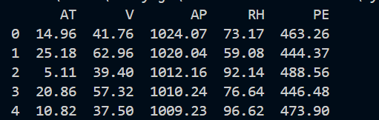

Possible Algorithms:

* Linear Regression
* Random Forest Regressor

Output Metrics:

* Mean Absolute Error (MAE)
* Mean Squared Error (MSE)
* R-squared (R²)

## 2. Model Building

For building the model, I used below strategy

* Data Split: Training and Testing sets (80/20 split)
* Validation Strategy: Cross-validation
* Models Compared: Linear Regression, Random Forest Regressor

## 3. Model Evaluation

Cross-validation result indicates as Random Forest Regressor is performing better compared to Linear Regression

Evaluation Metric:

To determine the performance of the model, I used MAE, MSE, R-squared output metrics. Metrics are calculated on training set and got the below results

## 4. Model Interpretation

The model explains 93% of the variance in the data (R-squared = 0.93).