Design to Cost
Part Cost Estimator

User Guide: install it, connect to the local server, and use it
With screenshots of every main page

Screenshots use the built-in EXAMPLE rates and a demo project (SCT26 Sensor cover). Numbers shown are for illustration only, not for negotiation.

1. What this software does
Design to Cost estimates the cost of a part, its tool or mould, and the whole product BOM, from a 3D STEP model, a drawing or a bill of materials. It runs on your own computer. Nothing is sent to the internet unless you click a fetch button on the Rates page.
- Estimate: upload a STEP file and get raw material, process and part cost in seconds.
- Projects: keep parts, variants, tool cost, CAPEX plan and BOM cost against the target.
- Rates: machine-hour, material and process rates, with Draft, Reviewed and Approved versions.
- Master data: all rates and formulas are editable tables, so you can replace the examples with your own.
- Traceability: click any number to see the formula, the inputs and the rate version behind it.
IMPORTANT: The rates delivered with the software are EXAMPLES. A red banner says 'Uses example rates - not for negotiation' until you replace them (section 7).

2. How it works (30-second version)
The software is a small web server running on your laptop. You start it in a terminal window; then you use it in your normal web browser at the address http://127.0.0.1:8000. 'Connecting to the local server' simply means opening that address.
Part | What it is | Where it lives
Backend | Python (FastAPI) web server. Does all calculations. | backend/ folder
Frontend | Web pages (HTML/CSS/JavaScript). No build step. | frontend/ folder
Project database | SQLite file (projects, parts, versions). PostgreSQL optional for teams. | created on first start
Rates and master data | costing_db.sqlite and master_data.xlsx | master_data/ folder
Uploaded files | STEP files, drawings, reports | storage/ folder

3. What you need
Item | Requirement
Computer | Windows 10/11, macOS or Linux; 8 GB RAM recommended
Python | Version 3.10 or newer, from python.org (tick 'Add Python to PATH' on Windows)
Browser | Chrome, Edge or Firefox (current version)
Internet | Needed once, to install the packages. Afterwards the tool works offline.
Optional | Tesseract (reads scanned BOM drawings); Git (only if you download with git)

4. Install, step by step

Step 1. Download the software
Open https://github.com/amitkumarshukla1210/Tool_part_cost_estimator in your browser. Click the green Code button, then Download ZIP. Unzip it, for example to C:\DesignToCost. (With Git installed you can instead run: git clone https://github.com/amitkumarshukla1210/Tool_part_cost_estimator.git)

Step 2. Open a terminal in that folder
Windows: open the folder in File Explorer, click the address bar, type cmd and press Enter. Mac/Linux: open Terminal and cd into the folder.

Step 3. Create a private Python environment (once)
Windows:
python -m venv .venv
.venv\Scripts\activate

Mac / Linux:
python3 -m venv .venv
source .venv/bin/activate

The prompt now starts with (.venv). That means the environment is active.

Step 4. Install the packages (once)
pip install -r requirements.txt

This downloads about 400 MB (CadQuery / OpenCascade is the large one) and takes 3 to 10 minutes. Wait for it to finish without errors.

Step 5. Start the local server
uvicorn backend.app.main:app --reload

You should see: 'Uvicorn running on http://127.0.0.1:8000'. Leave this window open. It is the server.

Step 6. Connect: open the software in the browser
Open your browser and go to:
http://127.0.0.1:8000

The home page below should appear. If it does, you are connected.
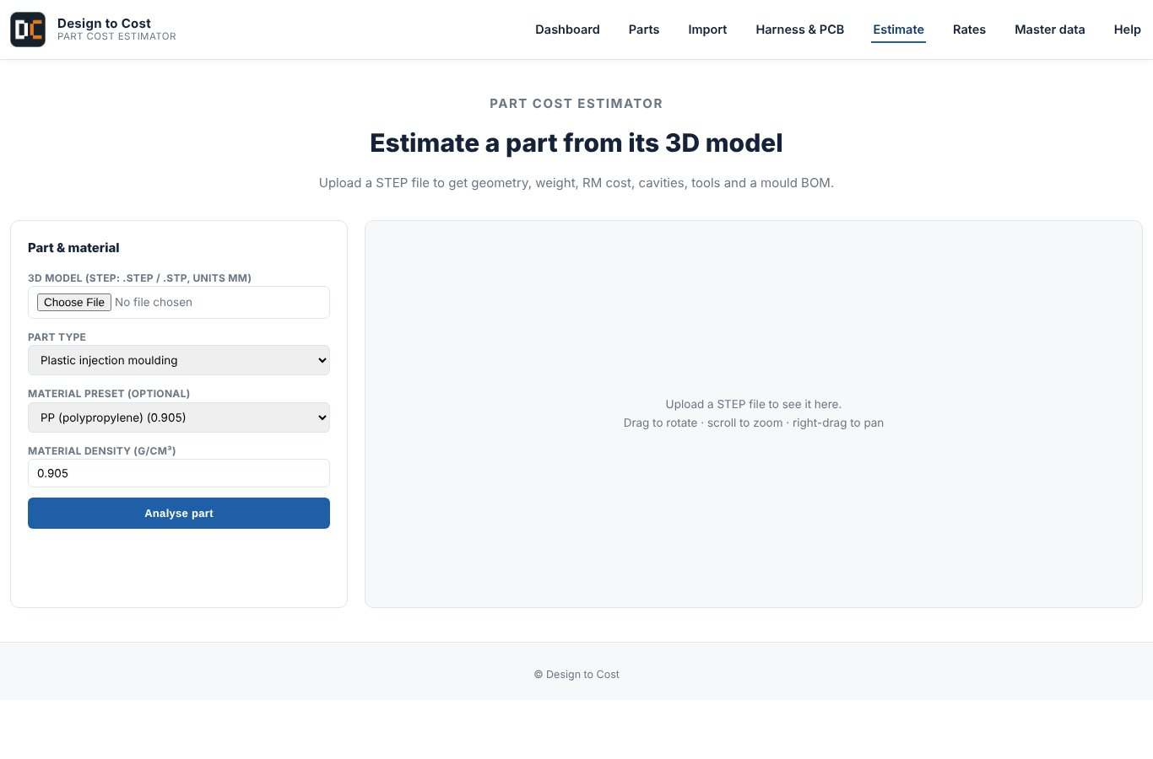
Figure 1. Home page, shown at http://127.0.0.1:8000

Stop, restart and daily use
Task | How
Stop the server | Click the terminal window and press Ctrl + C
Start again another day | Open a terminal in the folder, activate the environment (step 3, second line only), run the uvicorn command (step 5)
Use a different port | uvicorn backend.app.main:app --port 8080, then open http://127.0.0.1:8080
Let colleagues on your network use it | uvicorn backend.app.main:app --host 0.0.0.0, then they open http://<your-PC-IP>:8000. Use server mode (section 10) so they must log in.

Windows shortcut: save these three lines as start_dtc.bat in the software folder and double-click it each day.
@echo off
call .venv\Scripts\activate
start http://127.0.0.1:8000
uvicorn backend.app.main:app

5. If something goes wrong
Symptom | Fix
'python' is not recognised | Reinstall Python and tick 'Add Python to PATH'; open a new terminal. On Mac/Linux use python3.
pip install fails on cadquery | Use Python 3.10 to 3.12 (not the newest release). Upgrade pip: python -m pip install --upgrade pip, then retry.
'uvicorn' is not recognised | The environment is not active. Run the activate line (step 3) and try again.
Browser says 'can't connect' | The server window was closed or crashed. Start it again (step 5).
'address already in use' | Another program uses port 8000. Start with --port 8001 and open that address.
Page opens but looks old after an update | Hard refresh the browser: Ctrl + F5.
Scanned BOM says 'Tesseract is not installed' | Install Tesseract OCR, or upload an Excel/PDF BOM instead. Everything else works without it.

6. Guided tour with screenshots

6.1 Estimate: quick part cost from a STEP file
Click Estimate in the top menu. Choose a STEP file (samples are in the samples/ folder), pick the material, process and producing country, then Estimate.
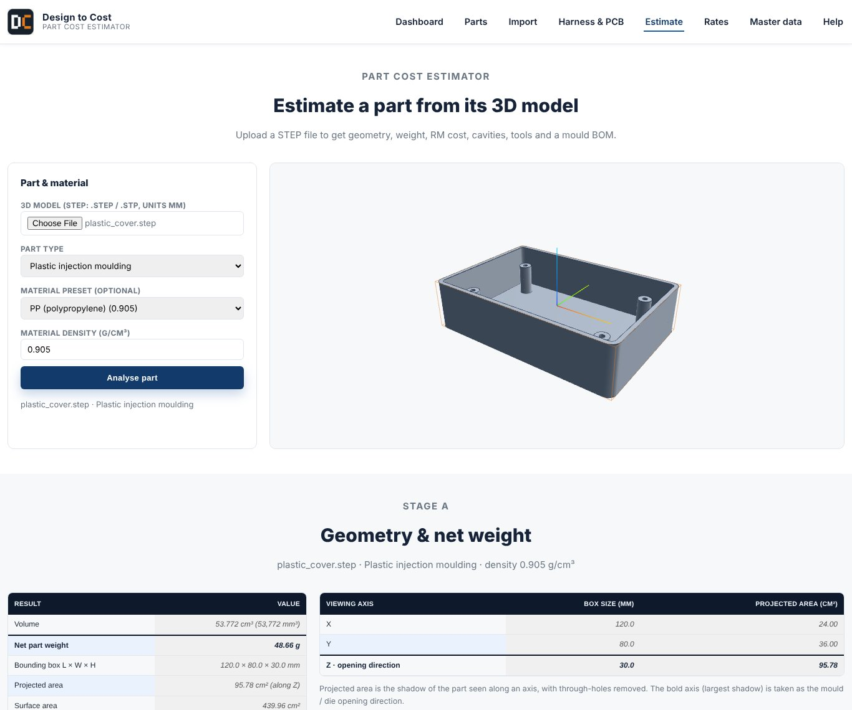
Figure 2. Estimate page: inputs and the cost result (top).
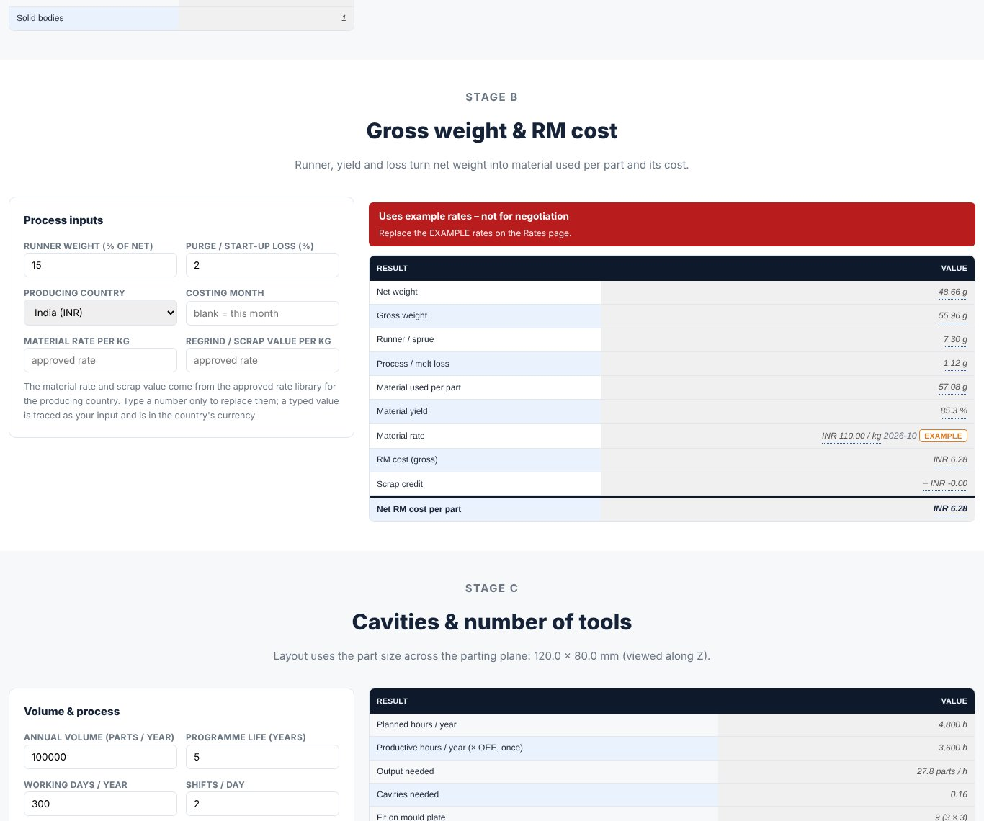
Figure 3. The result continues: cost breakdown, with every number clickable for its formula.
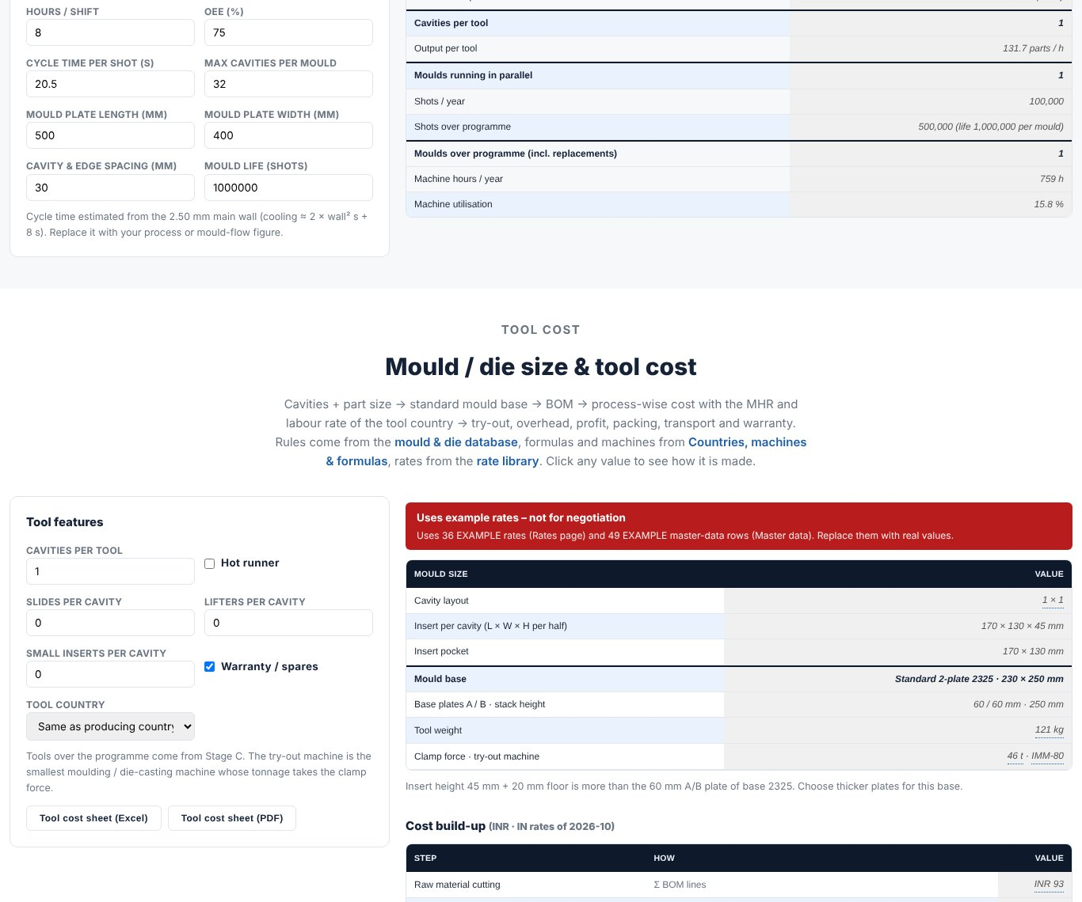
Figure 4. Result continued: process steps and rates used.
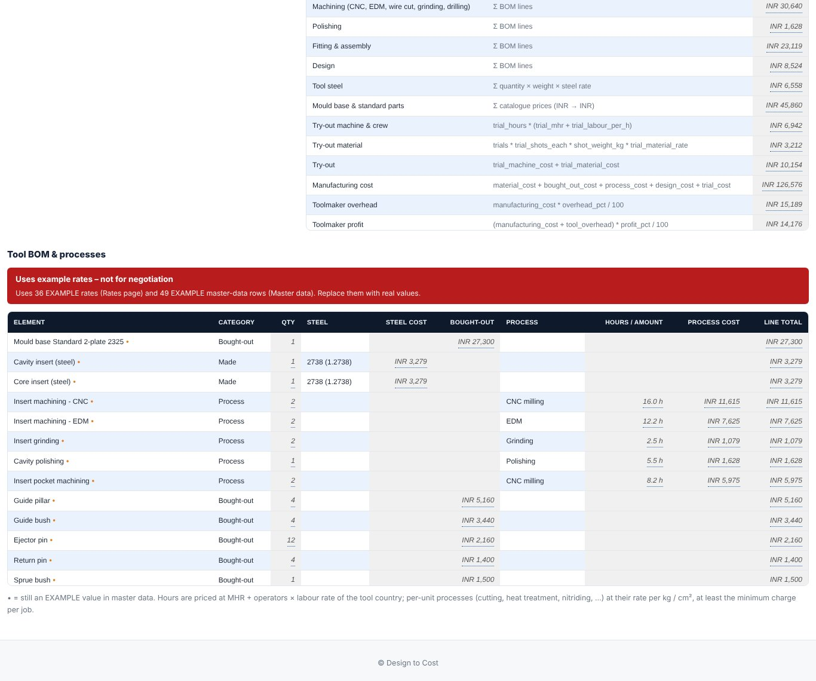
Figure 5. End of the result: totals and the traceability panel.

6.2 Dashboard: the project at a glance
The Dashboard shows BOM cost against target, CAPEX against budget, and the parts that still need attention.
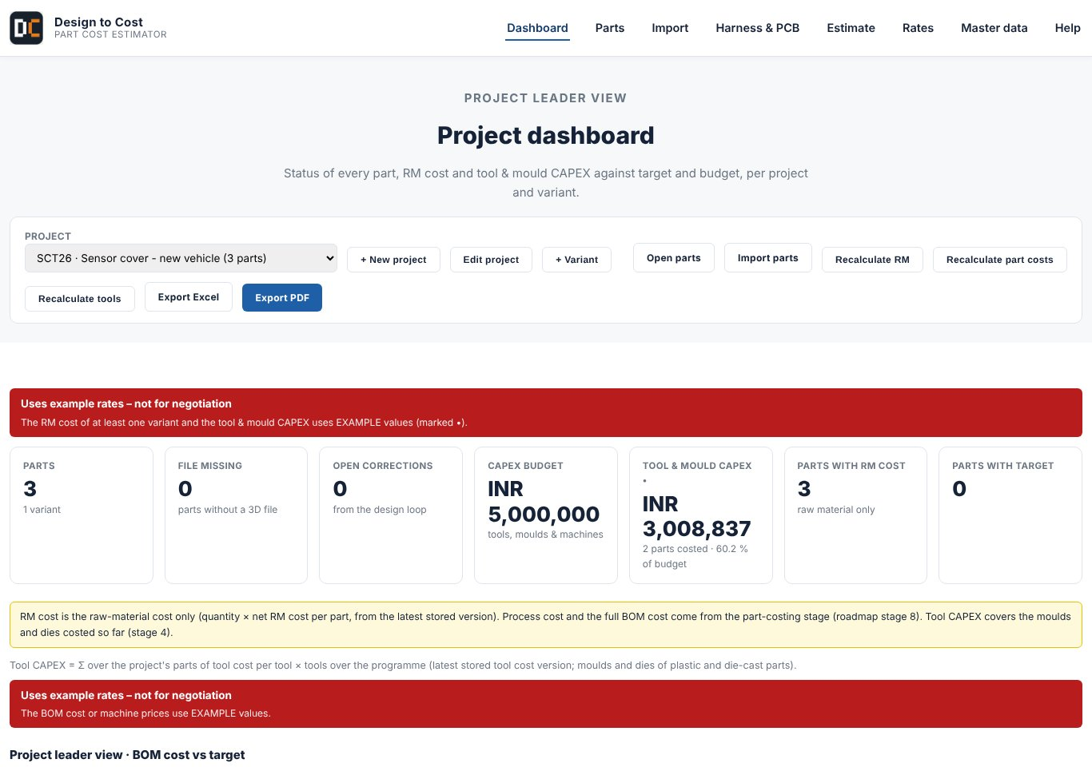
Figure 6. Dashboard: targets, BOM cost and status cards.
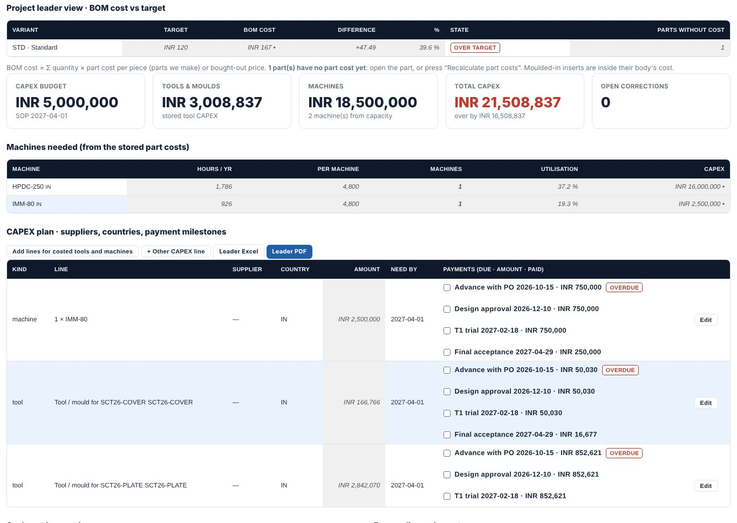
Figure 7. Dashboard: lower cards and the list of open items.

6.3 Import: bring in an assembly or BOM
Import reads an assembly STEP file, or a BOM from Excel, PDF or DXF. It shows a preview where you check every line before it is saved.
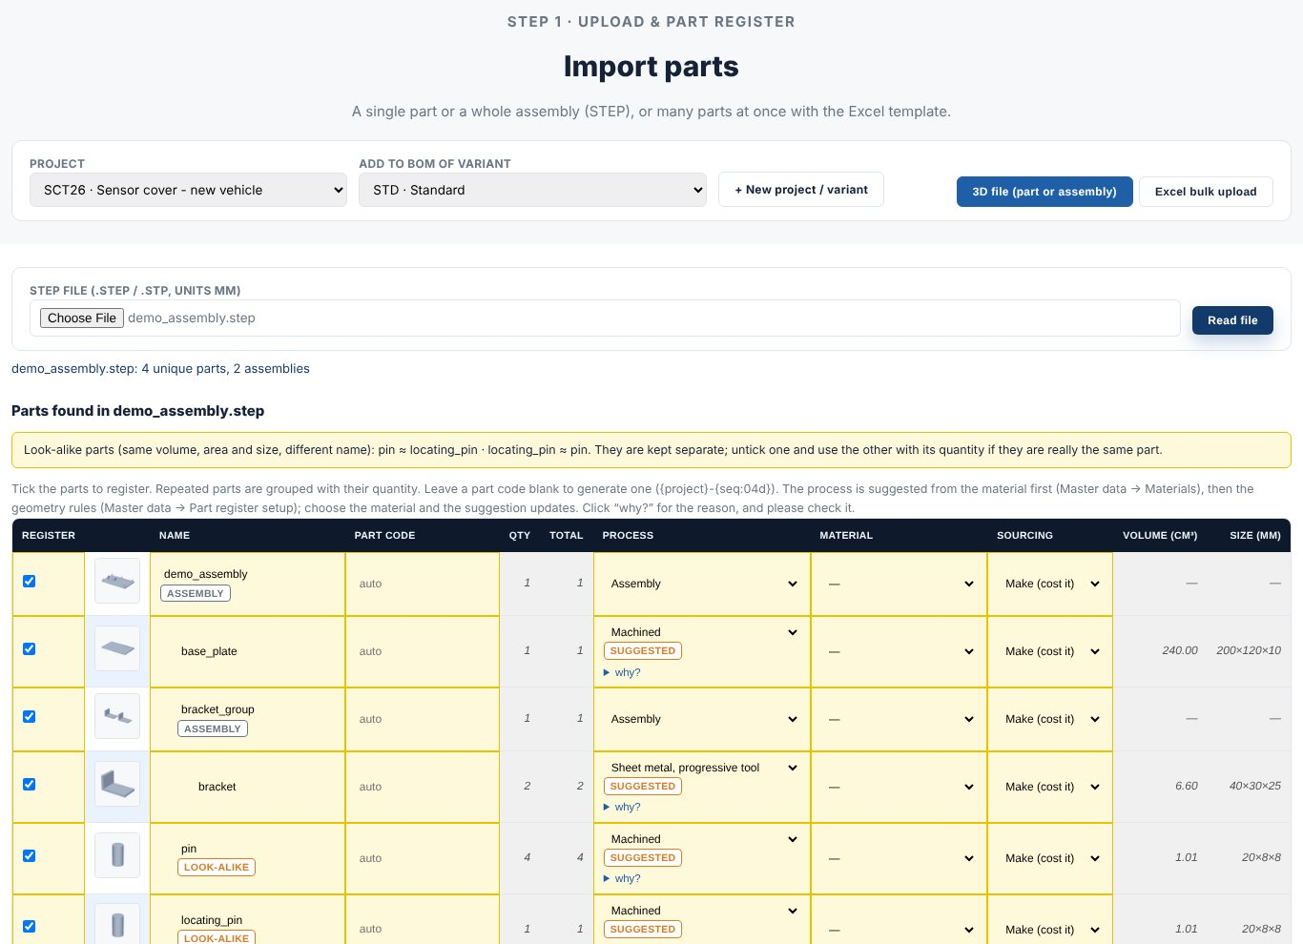
Figure 8. Import preview: check, correct, then save into the project.

6.4 Parts list and the part panel
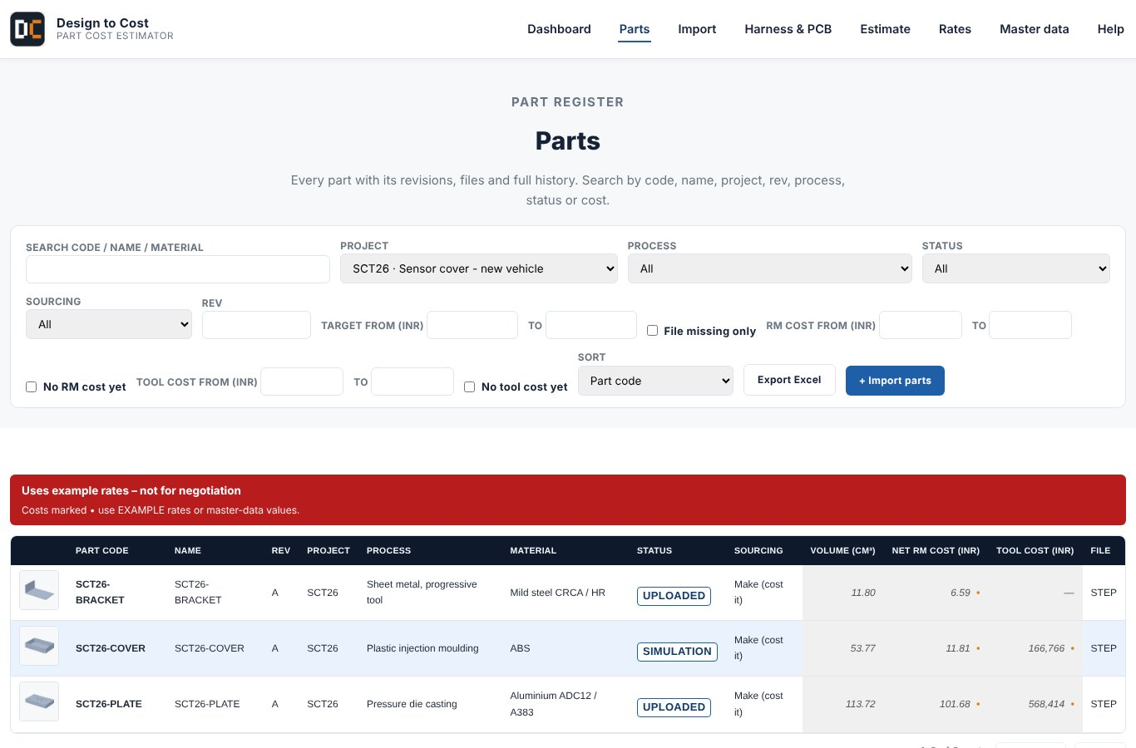
Figure 9. Parts: one row per part with material, process, tool and part cost.
Click a part to open its panel. The panel works from top to bottom. Each block uses the result of the one above.
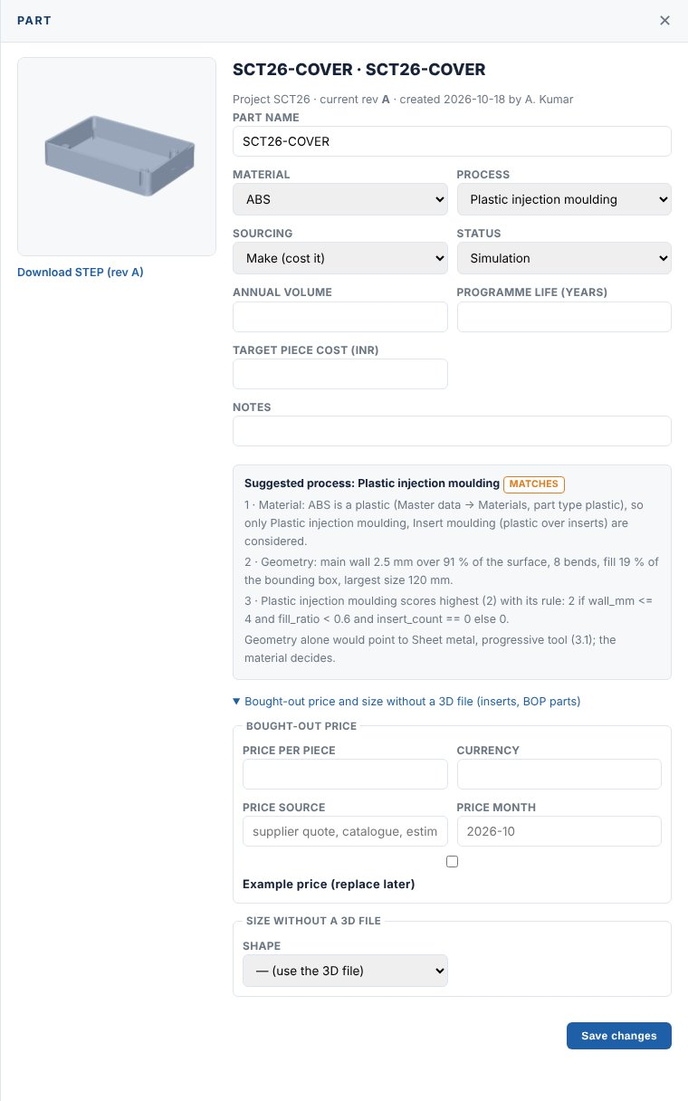 | Part details  - Code, name, material, process, country, volume.  - Upload or replace the STEP model.  - Every change creates a new numbered revision. Old versions are never changed.

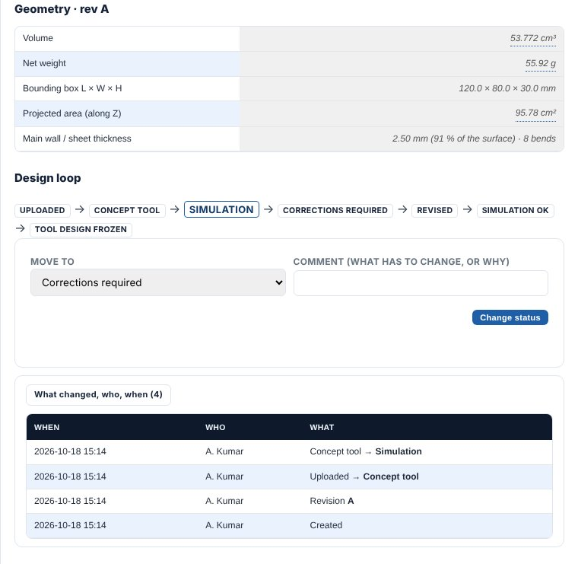 | Geometry and design loop  - Volume, weight, wall thickness, bounding box read from the STEP file.  - The design loop compares the part cost to the target and says what to change.

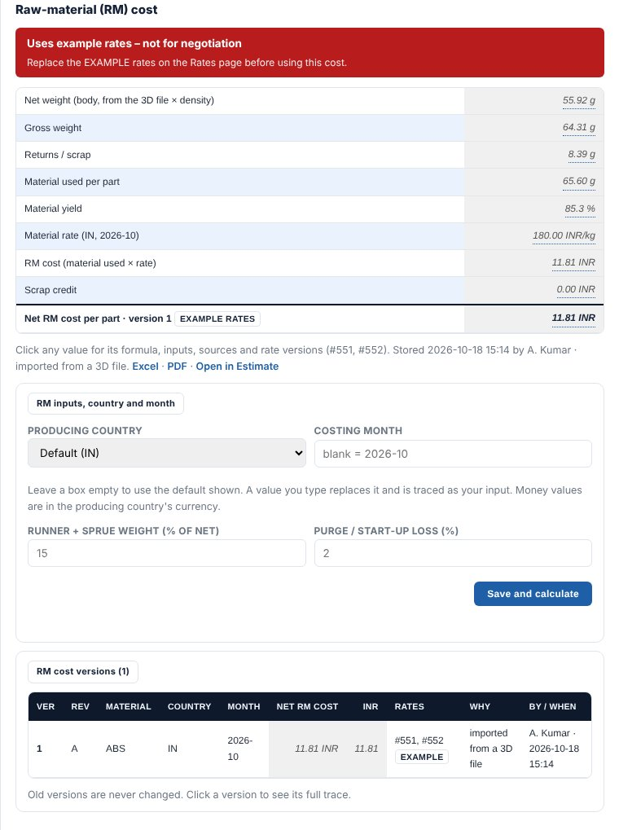 | Raw material cost  - Net weight + scrap/runner allowance, times the approved material rate.  - Click any number to see the formula.

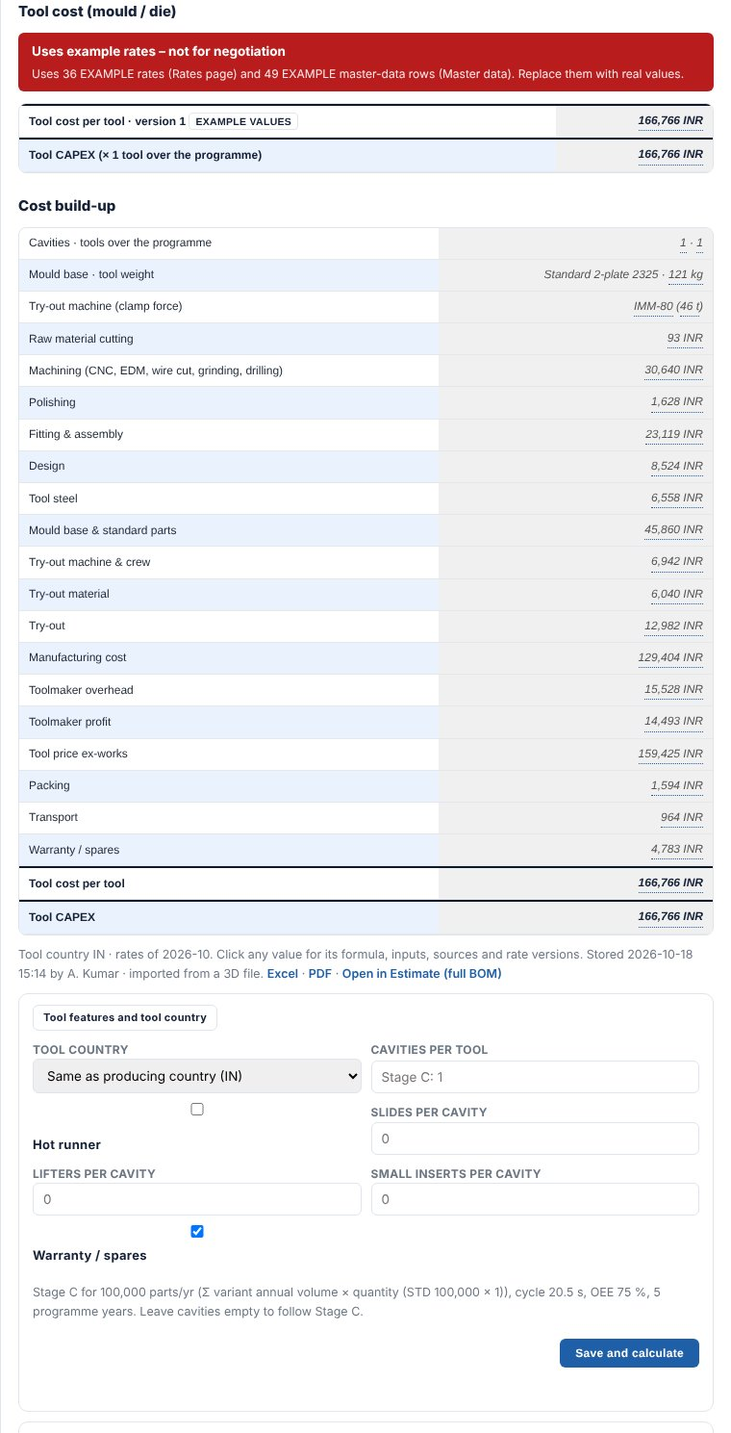 | Tool cost  - Choose the mould or die family (cavities, steel, size).  - Tool cost is built from steel, machining hours, standard parts and trials.  - Features such as slides and lifters add cost.

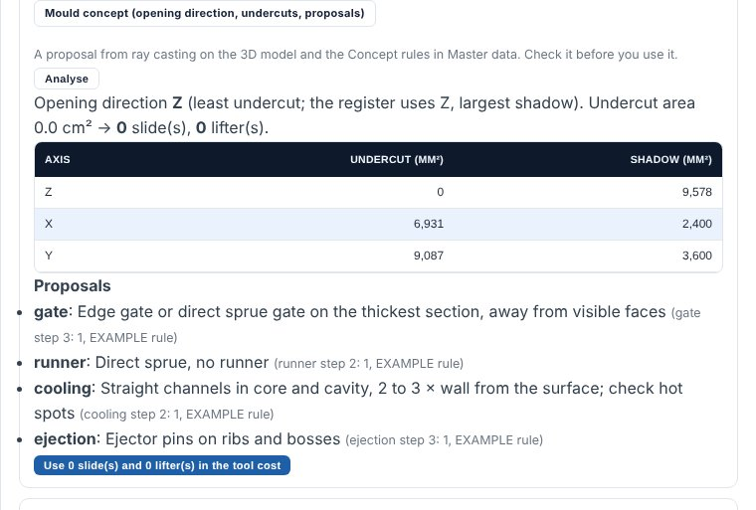 | Mould / die concept  - A first concept: cavity layout, parting line, slides, ejection and gate.  - A starting point to discuss with the toolmaker.

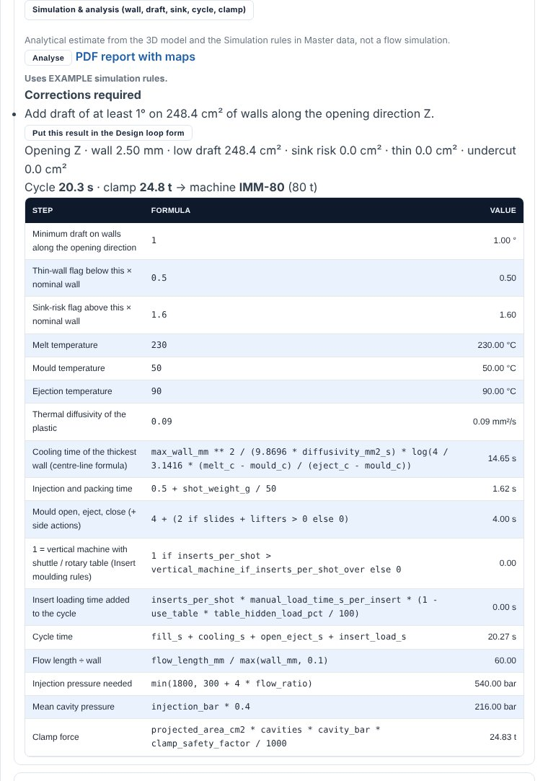 | Simulation check  - Fast check of draft angle, wall thickness, sink risk and cycle time.  - Corrections are listed with their area, so you know what to change in the design.

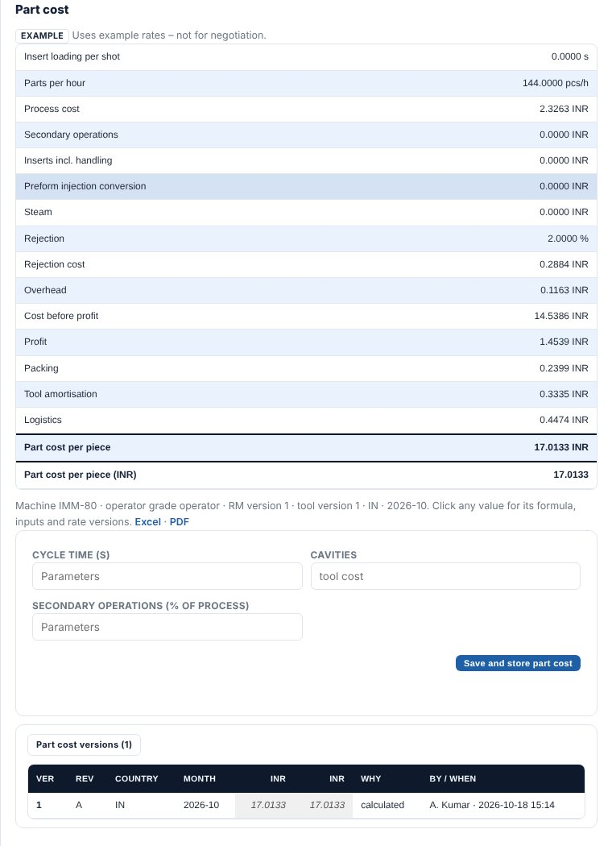 | Part cost  - Raw material + machine hour + labour + overheads + tool amortisation.  - Saved as a numbered cost version. Compare versions at any time.

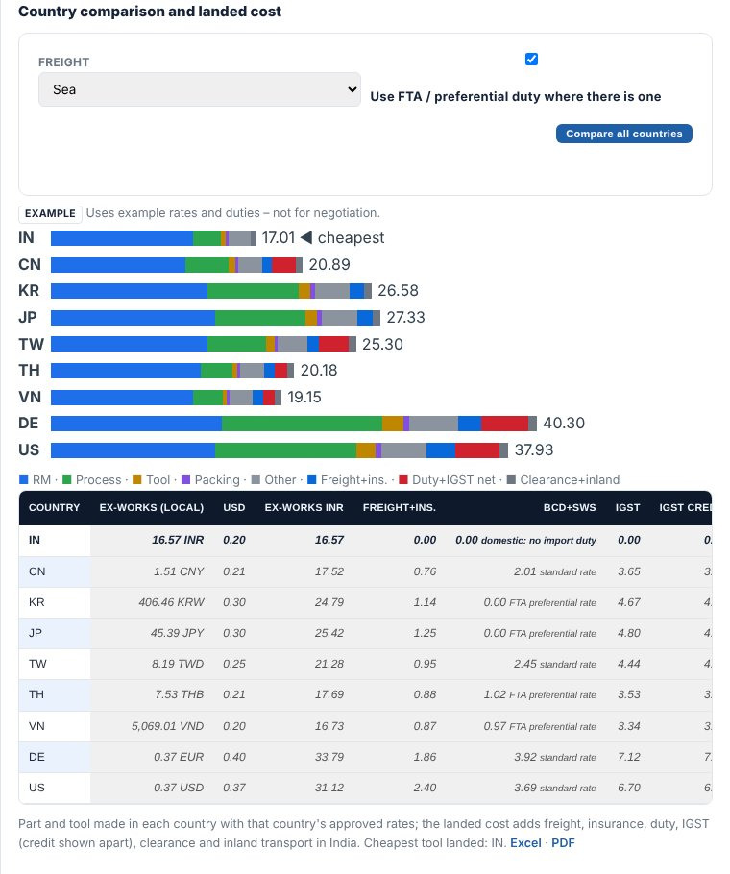 | Country comparison  - Same part, produced in different countries, using each country's approved rates.  - Landed cost can include freight and duty.

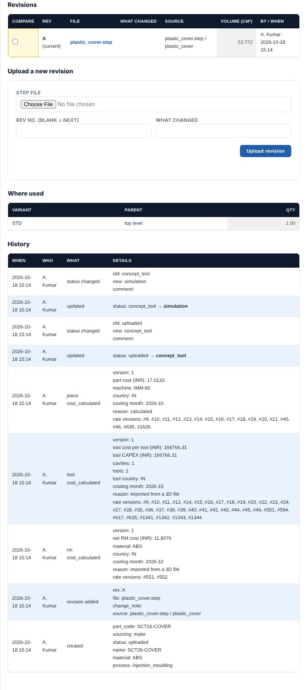 | Revisions and history  - Who changed what and when. Nothing is deleted.

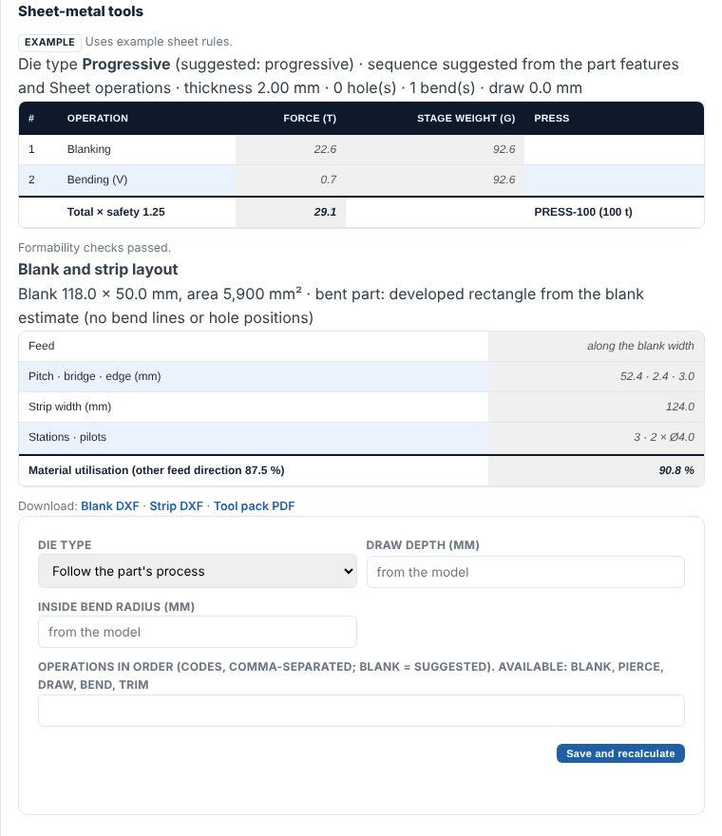 | Sheet-metal tools  - For brackets and stampings: progressive, compound or single-stage die layout and tool cost.

6.5 Rates: machine hour, library and approval
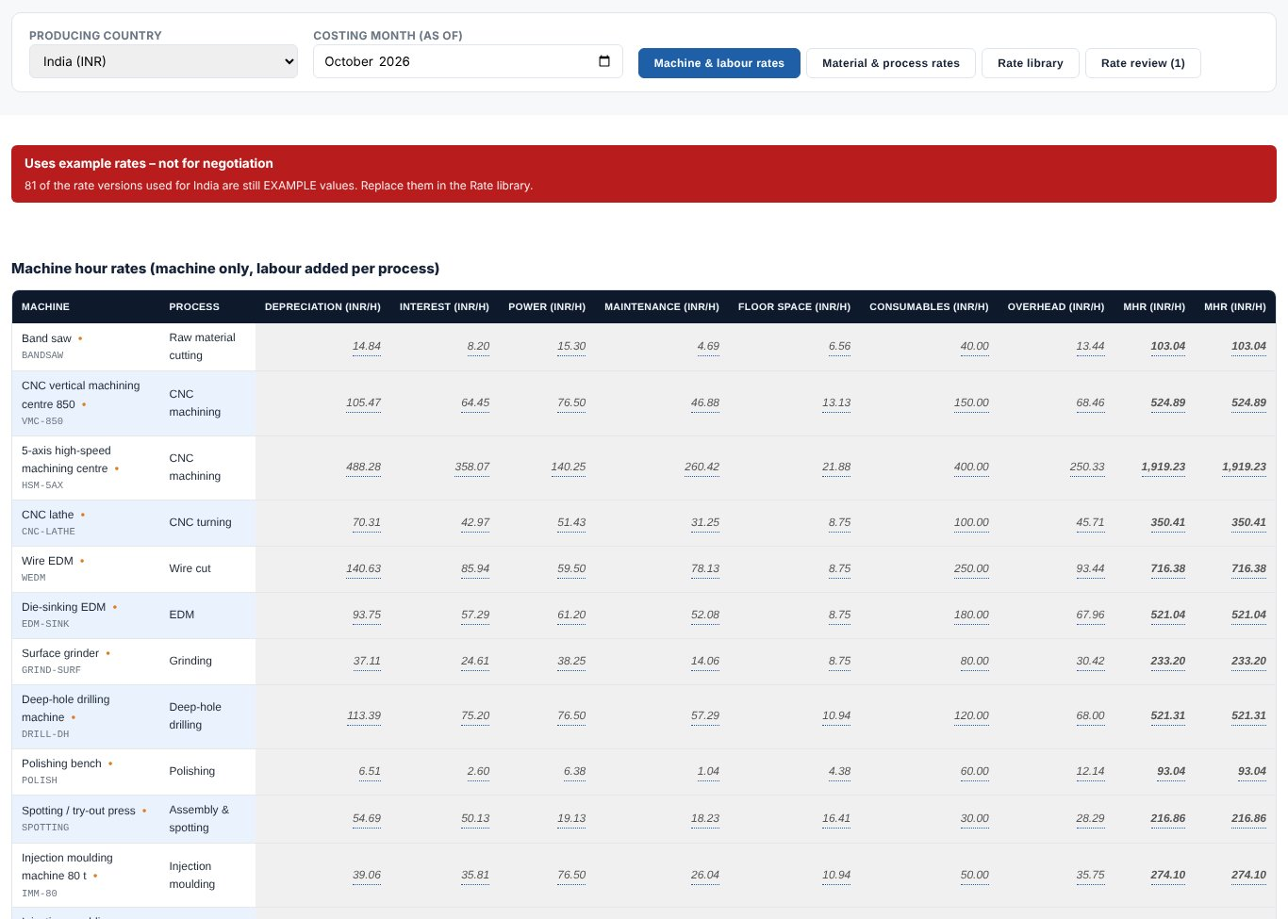
Figure 10. Machine and labour rates (MHR) for the producing country and costing month.
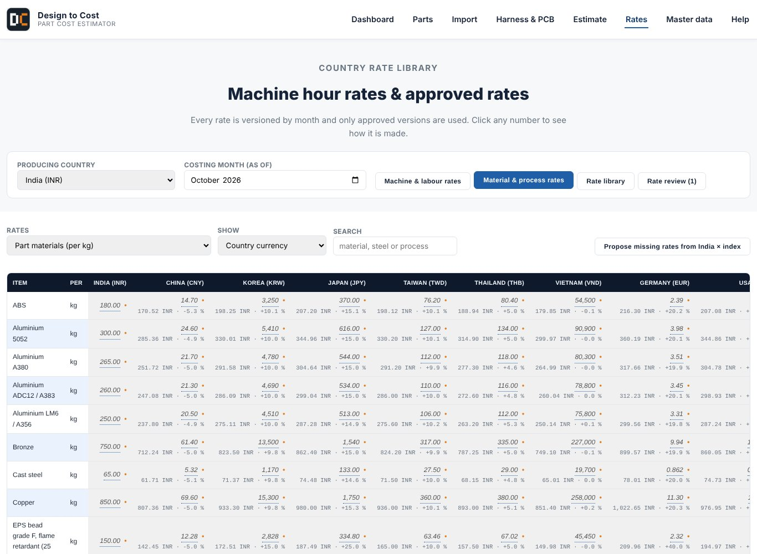
Figure 11. Material and process rates grid.
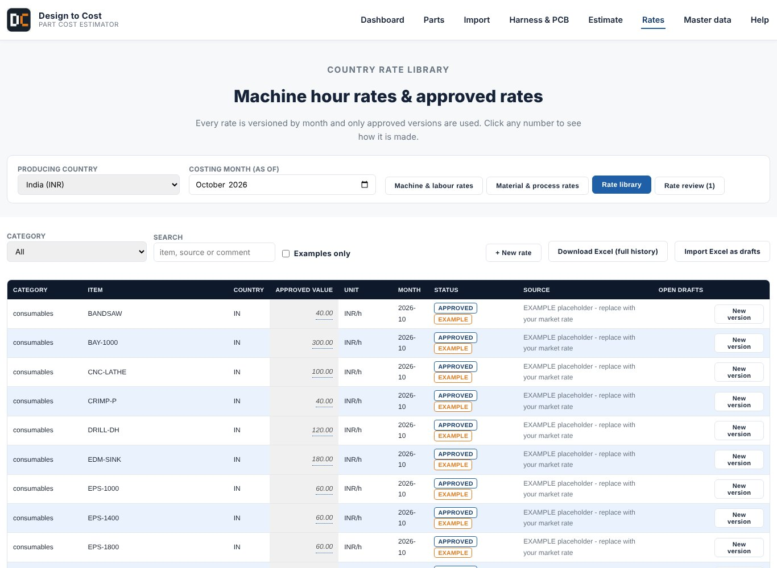
Figure 12. Rate library: every rate with status (Approved / Example), unit and month. Use New version to change a rate.
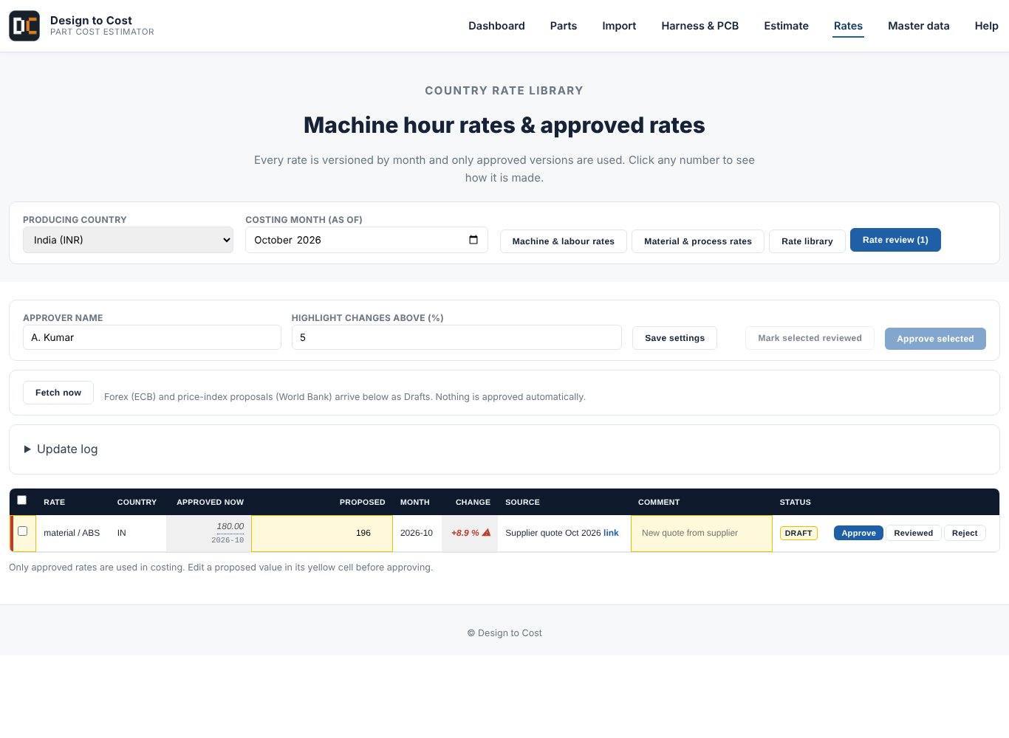
Figure 13. Rate review: new proposals arrive as Draft. A reviewer marks Reviewed, an approver clicks Approve. Only approved rates are used in costing.

6.6 Master data and replacing the example values
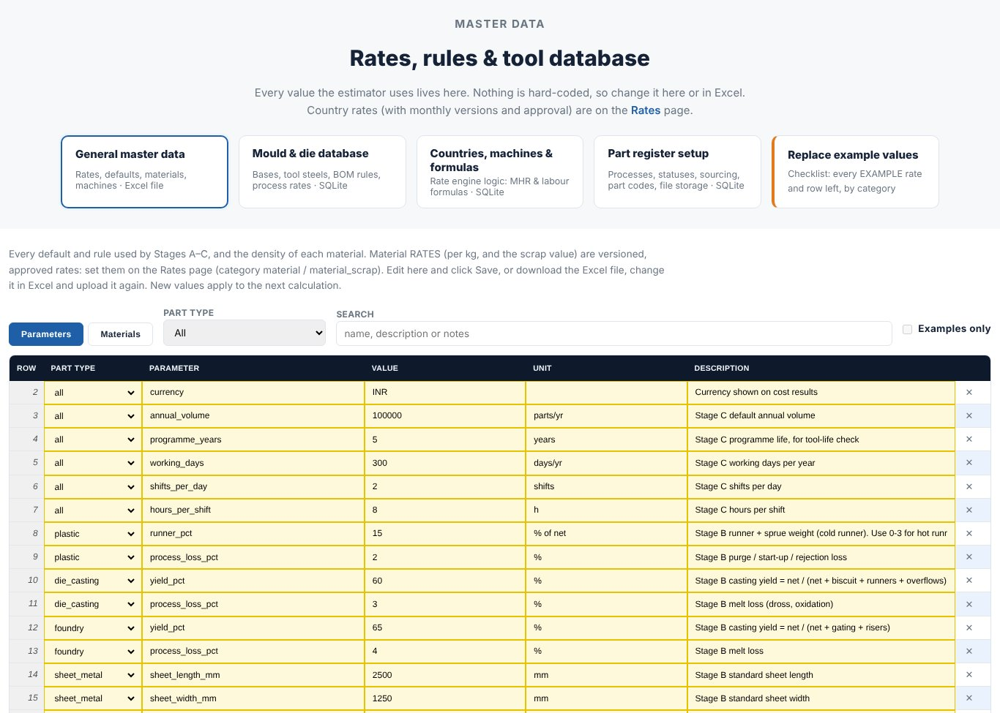
Figure 14. Master data: editable tables for rates, formulas and rules.
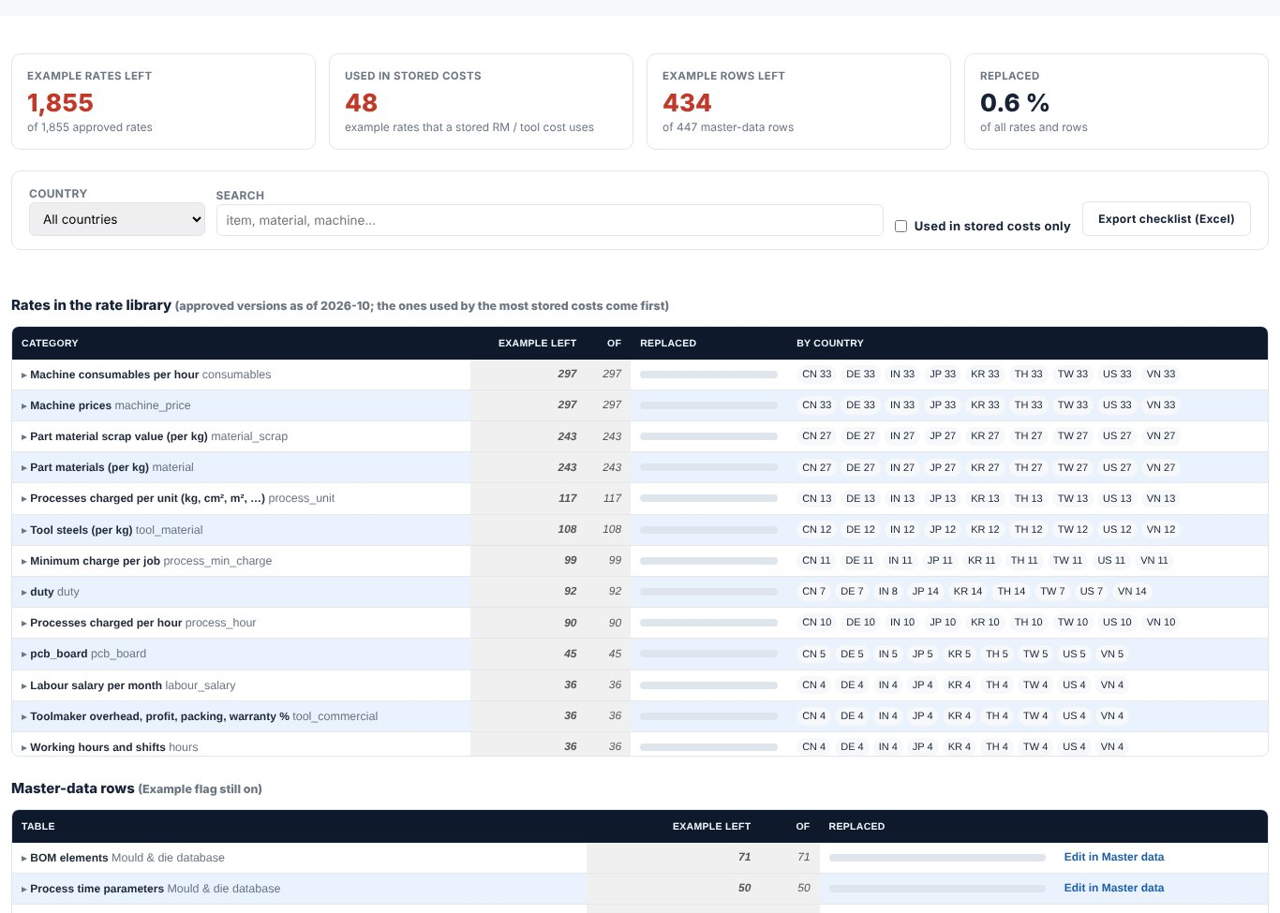
Figure 15. Replace example values: a checklist of every EXAMPLE value. Work down the list and enter your real rate; the red banner disappears when all are replaced.

6.7 Harness and PCB (electrical BOM)
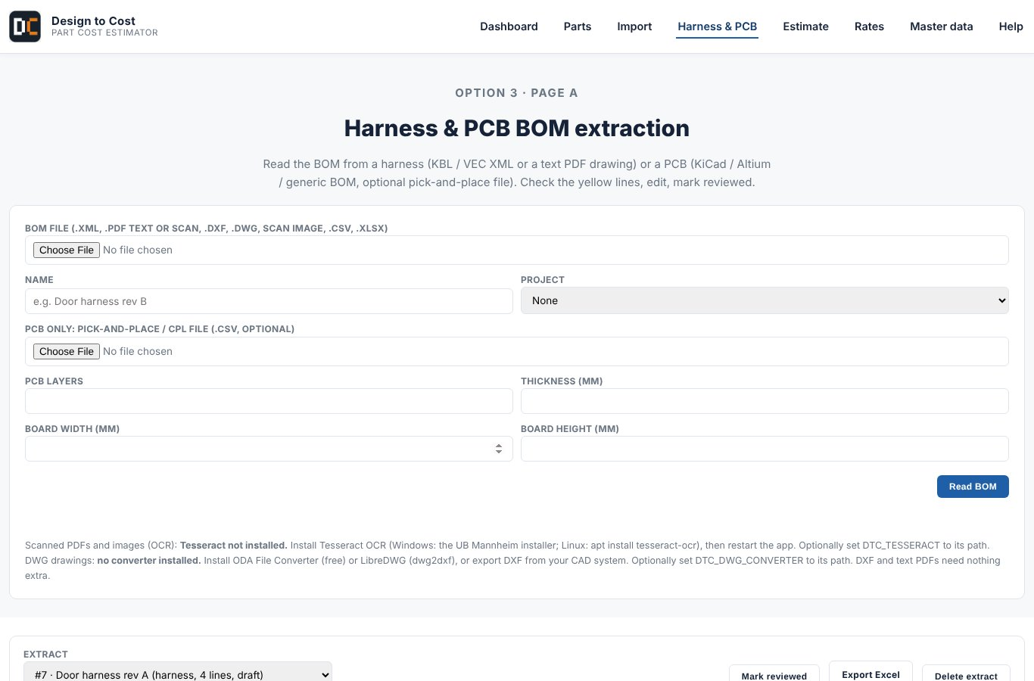
Figure 16. Harness & PCB page: upload a wiring harness (KBL/XML) or a BOM.
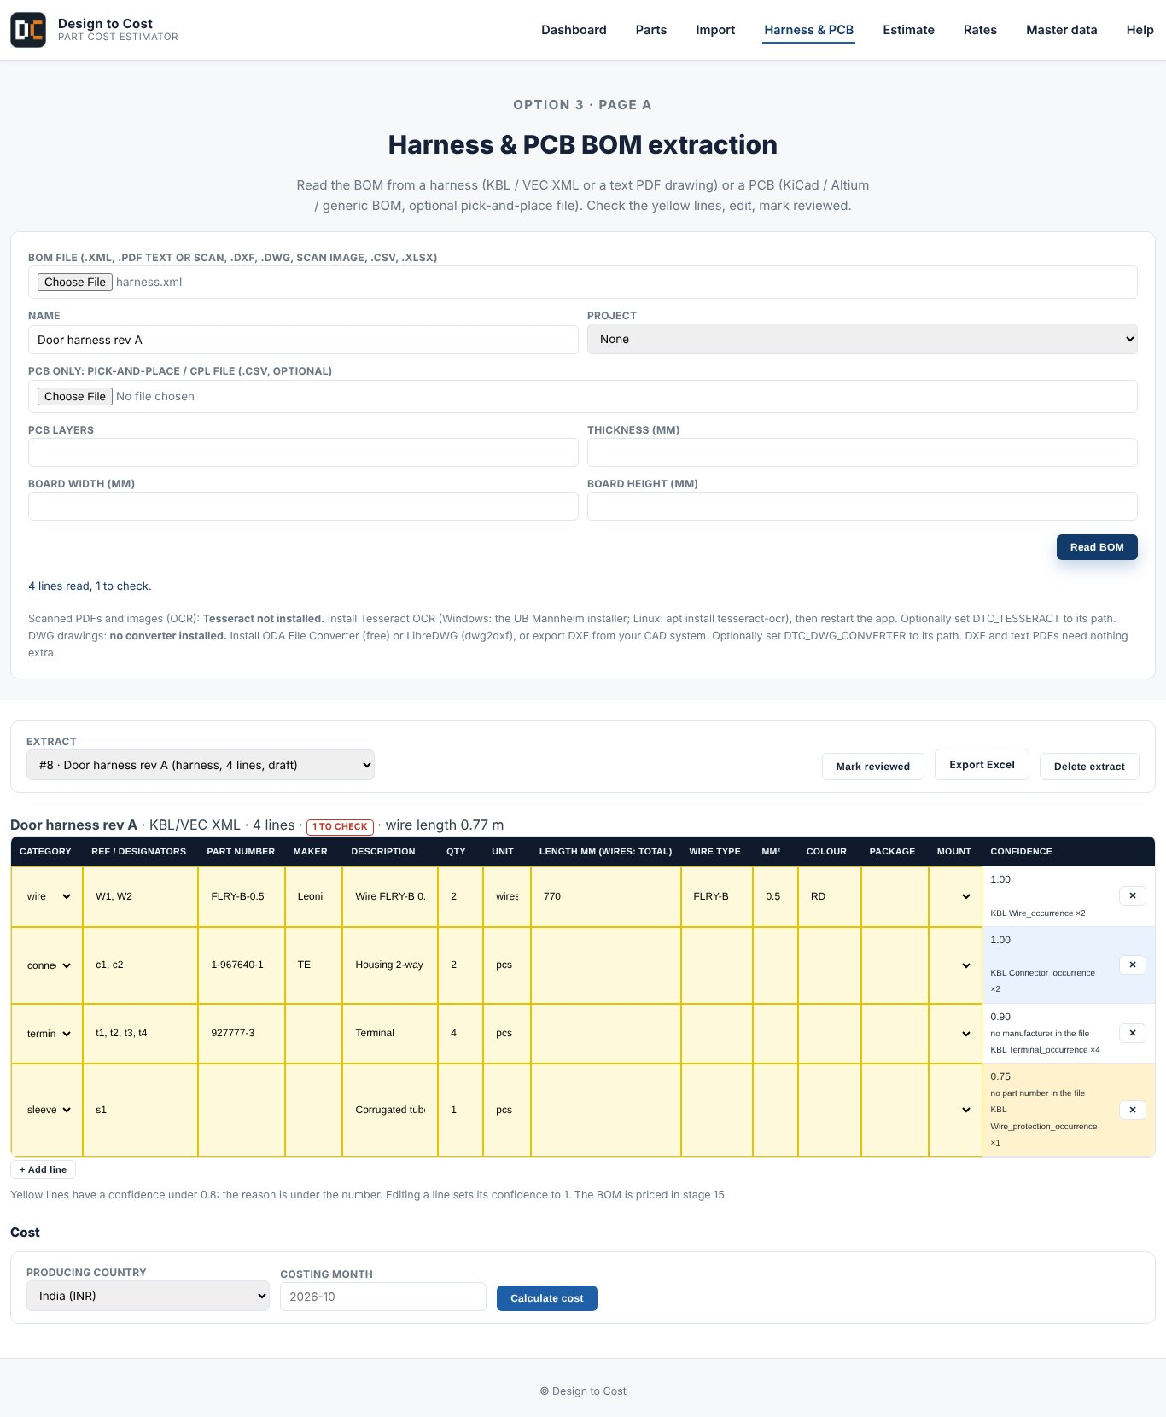
Figure 17. Review the lines read from the file: category, quantity, length and confidence.
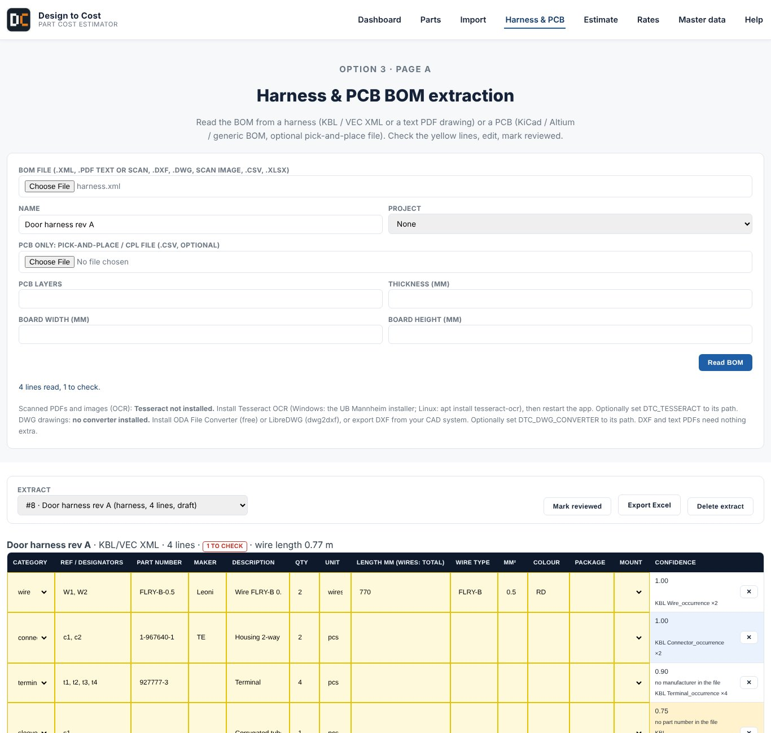
Figure 18. Cost of the harness or board, line by line.

6.8 Help
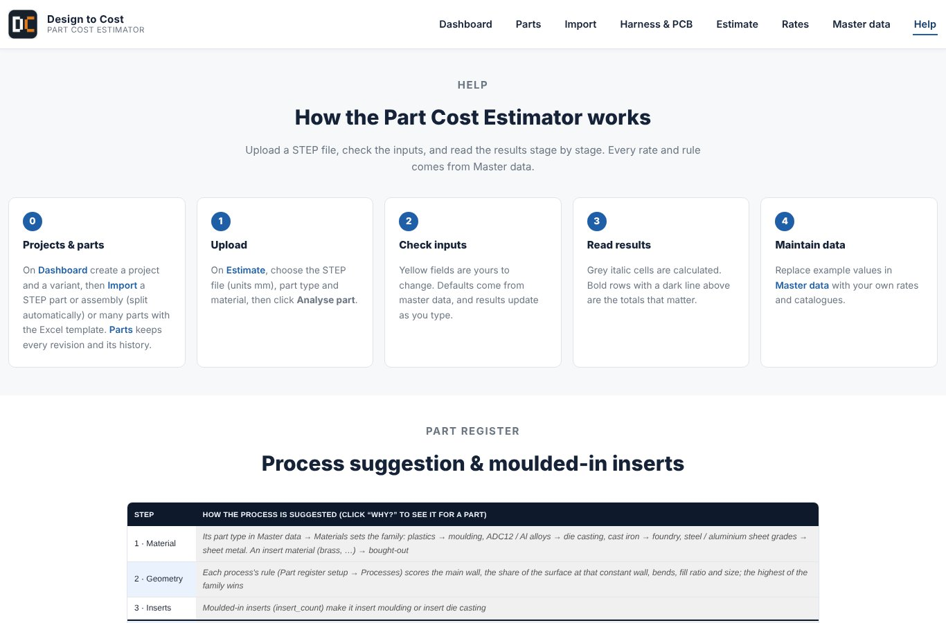
Figure 19. Built-in help page.
Other modules: EPS (expanded polystyrene) moulding with steam and thermocouple data, and PET stretch blow moulding (preform and bottle mould) are on the Estimate and part panels; select them as the process.

7. Replace the example values (do this first)
- Open Master data, then Replace example values (or go to http://127.0.0.1:8000/master-data/examples).
- Work through the list. For each item enter your real rate and source.
- Open Rates, Rate review. Approve the new rates (name of approver is stored).
- When the list is empty, the red 'example rates' banner is gone and costs can be shared.

8. Backup, update and corrections
Backup the whole working data (projects, rates, uploaded files) before any change:
python backup.py
python backup.py --restore latest
python backup.py --restore latest --only master_data

Update to the newest version of the software (your own rates and projects are kept):
python update.py
python update.py --keep-mine (keep your edited files on a conflict)
python update.py --take-new (take the new version on a conflict)

Corrections: re-download or update the code, restart the server. Cost versions already saved stay as they were; new calculations create a new version number.

9. Quick reference
I want to... | Go to
Get a quick part cost | Estimate
Create a project and parts | Import, then Parts
See cost vs target and CAPEX | Dashboard
Change a machine or material rate | Rates, Rate library, New version, then approve
See how a number is made | Click the number (traceability panel)
Cost a wiring harness or PCB | Harness & PCB
Save my work | python backup.py

Term | Meaning
MHR | Machine hour rate, cost of running a machine for one hour
BOM | Bill of materials
CAPEX | One-time investment, mainly tools and moulds
STEP | Neutral 3D CAD file format (.step / .stp)
EXAMPLE | Placeholder value that must be replaced with your own

10. Working in a team (server mode)
For more than one user, run the software on one PC or server in server mode. Users then log in with a name and password and have a role:
Role | May do
viewer | Look only
engineer | Create projects, parts, cost; propose rates as Draft
approver | Also approve rates
admin | Also manage users

set DTC_MODE=server
set DTC_ADMIN_PASSWORD=choose-a-long-password
uvicorn backend.app.main:app --host 0.0.0.0

(Mac/Linux: use export instead of set)
python -m backend.app.server_tools create-user alice --role engineer

Colleagues open http://<server-IP>:8000 and log in. For large teams use PostgreSQL by setting DATABASE_URL; see README.md.

11. Known limits
- Rates shipped with the tool are examples until you replace them.
- Sheet-metal parts get a tool cost but no full part cost yet (plastic and die-cast parts do).
- Scanned drawings need Tesseract installed; DWG files need a converter. DXF and Excel work directly.
- Simulation is a fast screening estimate, not a replacement for mould-flow software.
- Costs are estimates for planning and negotiation preparation. Confirm with supplier quotes.

