1. Add employee form>> (Upload Address Document) will be Upload Proof of Address
2. After Deleting the employees>>> still all leave showing in All Leaves Section. Please note, when we delete any employee, all data should be deleted.

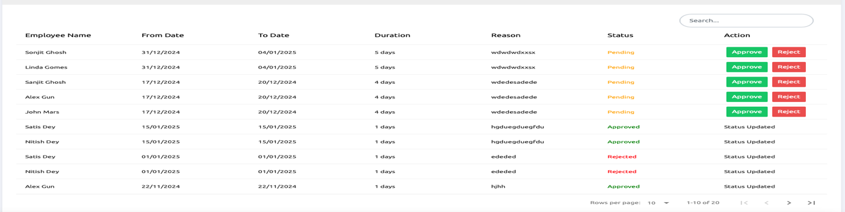

1. New employee created >>>still old leave data coming

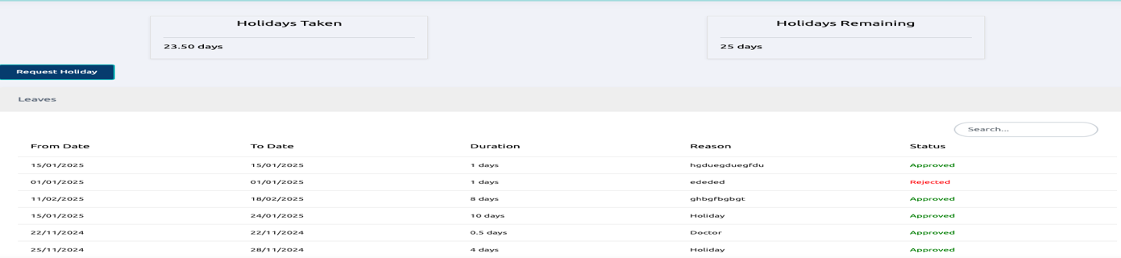

1. When admin send document to employee/ all employee>>> it is not coming to any employee
2. 6. Filter Attendance >>>>Select year>>> please add more advance year, delete 2020, 2021, 2022 (same as filtering in admin part)
3. Admin cannot send P60 to more than 1 employee.
4. Document and Payroll >>>> the view button>>> we cannot view the document
5. When employee add attendance the Logout time is not coming. (this one I think Ramesh you did not understand what I said. You need to talk to me)>>>>I CANNOT TEST THIS SECTION DUE TO THIS PROBLEM