**Internal Assessment**

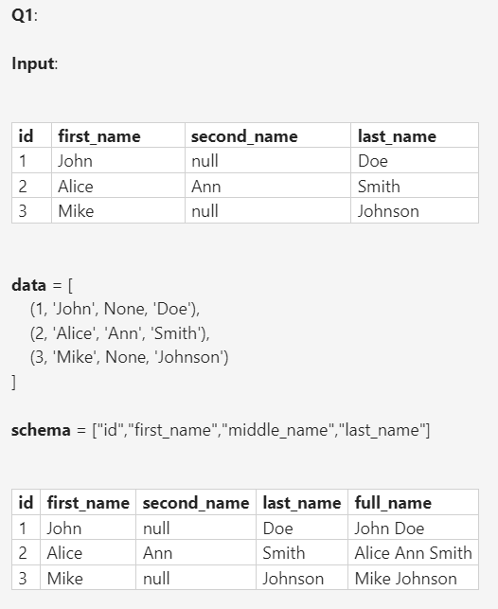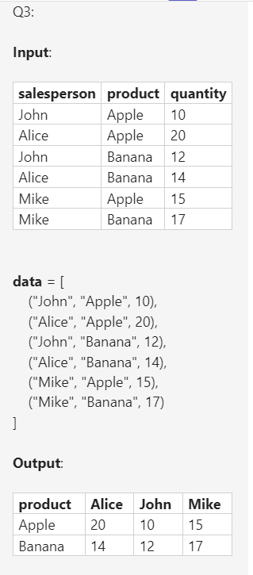

SQL Problem: [Consecutive Numbers - LeetCode](https://leetcode.com/problems/consecutive-numbers/description/)

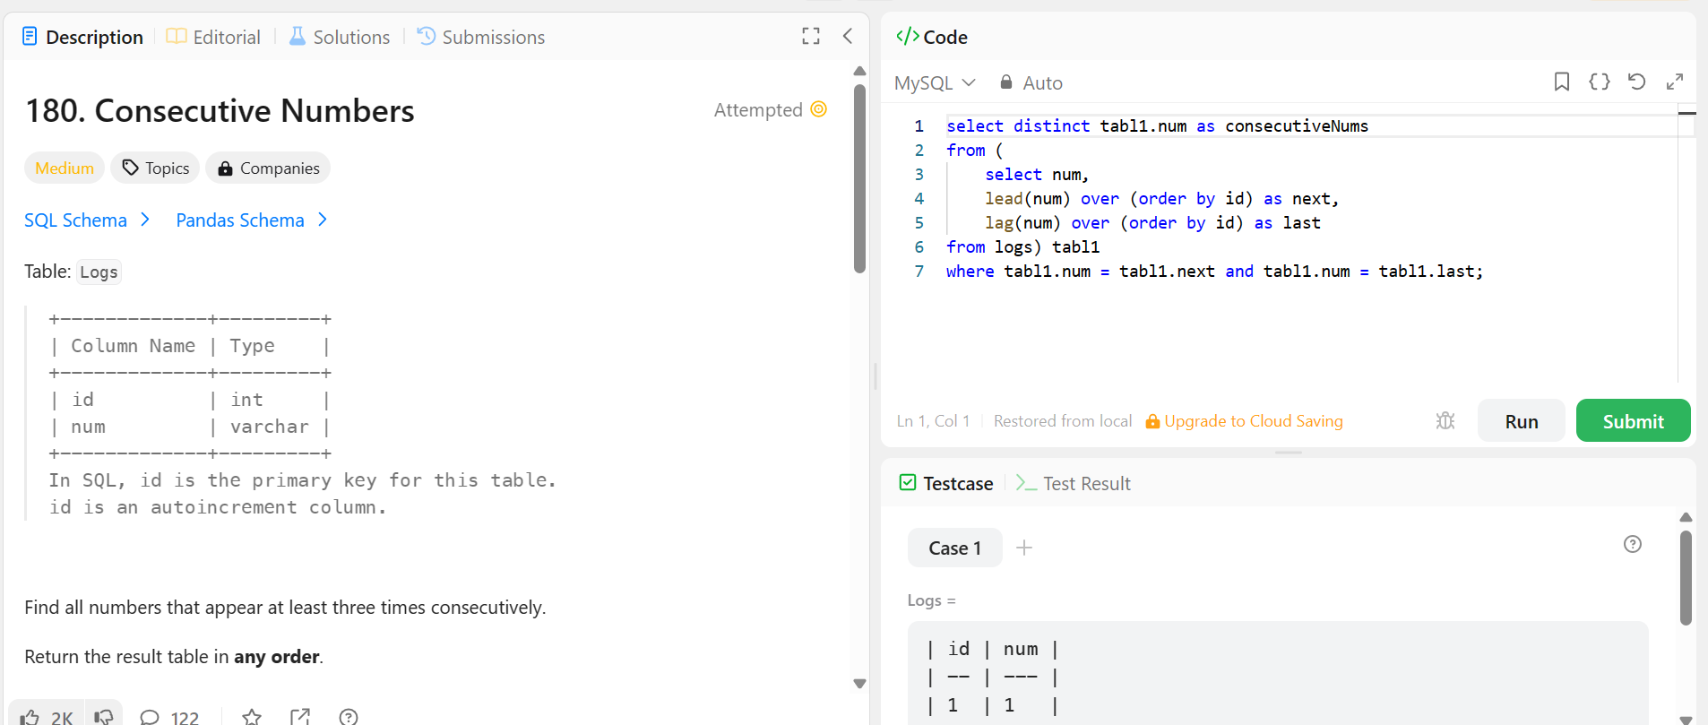

from pyspark.sql.functions import concat, coalesce, col, lit

from pyspark.sql.types import StructType, StringType, StructField

schema = StructType([

    StructField("Name1", StringType(), True),

    StructField("Name2", StringType(), True),

    StructField("Name3", StringType(), True)

])

data = [("Aravind", None, None), ("John", None, None), (None, "Sridevi", None)]

raw_df = spark.createDataFrame(data,schema = schema)

df = raw_df.select(

    concat(

        coalesce(col("Name1"), lit("")),

        coalesce(col("Name2"), lit("")),

        coalesce(col("Name3"), lit(""))

    ).alias("Names")

)

df.display()

Make to snake case:



