Freight Rate Prediction
Validation report
The selected shared-feature model achieved an October holdout MAE of $169.86. Validation used a forward-in-time split: January through September 2025 for fitting and October 2025 for evaluation. After selecting the model, it was refit on all labeled development rows to produce the final validation predictions.

Results at a glance
Candidate | MAE ($) | RMSE ($) | MAPE | R²
Shared features (selected) | $169.86 | $656.61 | 7.85% | 0.8155
Extended features | $192.70 | $663.02 | 8.56% | 0.8119

Validation split and target
The labeled data covered January 1 through October 31, 2025. The first nine months (43,147 rows) formed the training window; the latest complete month (4,853 rows) was held out. This temporal holdout better reflects the task of predicting later loads than a random row split. The model learned posted rate per mile and converted predictions back to dollars using each load's distance.

Feature preparation
Both candidates used distance and weight, pickup and delivery markets, equipment type, calendar trend and seasonal terms, and smoothed historical rate-per-mile encodings for routes and individual categories. Training encodings used leave-one-out values to reduce direct target leakage. Numeric missing values were filled from training-set medians; unseen categories were mapped to an unknown level. Distance was represented with square-root, logarithmic and squared terms. A small ridge penalty stabilized the linear fit.

Model comparison and selection
The extended candidate added pickup and delivery coordinates, market index and quote signal, along with selected interactions and missingness indicators. The shared-feature candidate had lower error on the October holdout across MAE, RMSE and MAPE, and a slightly higher R², so it was selected. The December input file does not include the extra geographic and market-signal fields; December predictions therefore use the shared-feature model.

Data checks and scoring
- Confirmed the training target was present for every labeled row and load_id values were unique in training and validation inputs.
- Parsed dates explicitly and used training-window statistics when filling numeric missing values.
- Matched validation predictions back to the supplied template by load_id and checked that every template ID received a prediction.
- Ran the provided scorer; it accepted the 12,000 validation predictions and 31 December rows and produced the fixed-route chart below.
Validation metrics describe the October temporal holdout. The hidden validation labels were not available, so these are not final validation-set accuracy scores.

Fixed December prediction chart
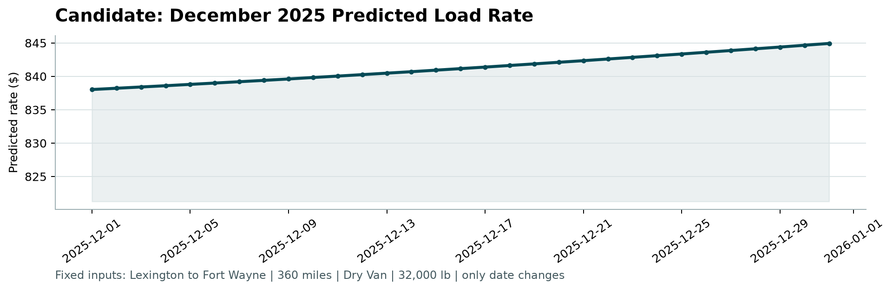
Figure 1. Scorer output for the 31 fixed-route December inputs.

Reproduce the outputs
From the repository root, install the listed dependencies, place the supplied raw CSV inputs in data/, and run:
python -m pip install -r requirements.txt
python train_predict.py
python score.py --predictions validation_predictions.csv --december-predictions data/december_chart_inputs.csv

