

**Shahjalal University of Science and Technology**

**Akhalia, Sylhet**

**Assignment**

**Course Title:** Speech Processing

**Course Code:** CSE 517

**Submitted By:**

Amit Lal Das

M.Sc in CSE

1st Year 2nd Semester

Reg. No: 2021321001

**Submitted To:**

### Associate Professor Dr. Sadia Sultana

Department: CSE

SUST

Date of Submission: 24/02/2022

**Assignment 1**

**Title:** Load a speech signal (.wav file) and find out the sampling frequency. Plot the simple waveform, Linear Magnitude Spectrum, and Log Magnitude Spectrum of the signal.

**Code:**

import matplotlib.pyplot as plt

import numpy as np

import scipy.io.wavfile as wavfile

# Load the speech signal from a .wav file

filename = "abc.wav"

sampling_freq, signal = wavfile.read(filename)

# Find the length of the signal in seconds

signal_length = len(signal) / sampling_freq

# Create a time vector for the signal

time = np.linspace(0, signal_length, len(signal))

# Plot the waveform

plt.subplot(3, 1, 1)

plt.plot(time, signal)

plt.xlabel("Time (s)")

plt.ylabel("Amplitude")

plt.title("Waveform")

sampling_freq, signal_data = wavfile.read(filename)

# Compute the linear magnitude spectrum using the FFT

magnitude_spectrum = np.abs(np.fft.fft(signal_data))

# Compute the corresponding frequency vector

freq_vector = np.fft.fftfreq(len(signal_data), 1/sampling_freq)

# Plot the linear magnitude spectrum

plt.plot(freq_vector[:len(freq_vector)//2], magnitude_spectrum[:len(magnitude_spectrum)//2])

plt.xlabel("Frequency (Hz)")

plt.ylabel("Magnitude")

plt.title("Linear Magnitude Spectrum")

# Show the plot

plt.show()

sampling_freq, signal_data = wavfile.read(filename)

# Compute the linear magnitude spectrum using the FFT

magnitude_spectrum = np.abs(np.fft.fft(signal_data))

# Compute the corresponding frequency vector

freq_vector = np.fft.fftfreq(len(signal_data), 1/sampling_freq)

# Convert the magnitude spectrum to decibels (dB)

log_magnitude_spectrum = 20*np.log10(magnitude_spectrum)

# Plot the log magnitude spectrum

plt.plot(freq_vector[:len(freq_vector)//2], log_magnitude_spectrum[:len(log_magnitude_spectrum)//2])

plt.xlabel("Frequency (Hz)")

plt.ylabel("Magnitude (dB)")

plt.title("Log Magnitude Spectrum")

# Show the plot

plt.show()

**Result:**

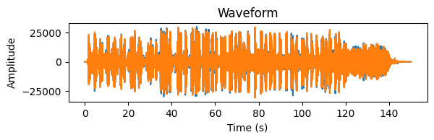

Fig-1: Waveform

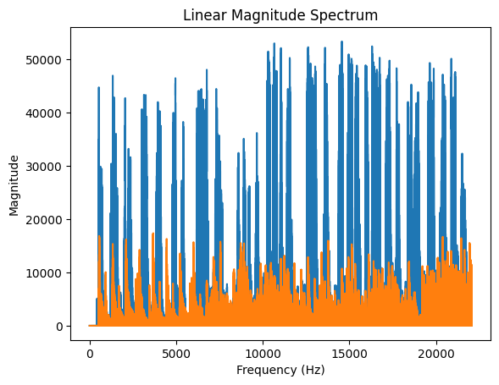

Fig-2: Linear magnitude spectrum

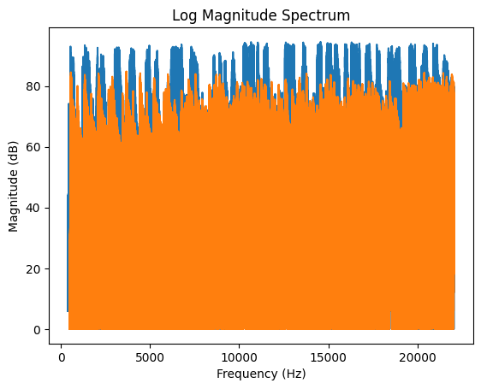

Fig-2: log magnitude spectrum

**Assignment 2**

**Title:** Applying framing of 25 ms with an overlapping of 10 ms. Apply hamming window on each frame. Reconstruct the signal and draw the plot.

**Code:**

import scipy.io.wavfile as wavfile

import scipy.signal as signal

import numpy as np

import matplotlib.pyplot as plt

# Load the audio signal from a .wav file

filename = "abc.wav"

sampling_freq, signal_data = wavfile.read(filename)

# Define the window length and overlap in samples

window_length = int(0.025 * sampling_freq)

overlap = int(0.01 * sampling_freq)

# Segment the signal into frames with the given window length and overlap

num_frames = int(np.ceil(len(signal_data) / overlap))

pad_length = num_frames * overlap - len(signal_data)

padded_signal = np.append(signal_data, np.zeros(pad_length))

indices = np.tile(np.arange(0, window_length), (num_frames, 1)) + np.tile(np.arange(0, num_frames * overlap, overlap), (window_length, 1)).T

frames = padded_signal[indices.astype(np.int32, copy=False)]

# Apply a Hamming window to each frame

hamming_window = signal.hamming(window_length)

hamming_frames = frames * hamming_window

# Perform the overlap-add reconstruction

reconstructed_signal = np.zeros_like(padded_signal)

for i in range(num_frames):

start = i * overlap

end = start + window_length

reconstructed_signal[start:end] += signal.fftconvolve(hamming_frames[i], hamming_window, mode="same")

# Trim the padding from the reconstructed signal

reconstructed_signal = reconstructed_signal[:len(signal_data)]

# Plot the original and reconstructed signals

time_vector = np.arange(len(signal_data)) / sampling_freq

plt.plot(time_vector, signal_data, label="Original Signal")

plt.plot(time_vector, reconstructed_signal, label="Reconstructed Signal")

plt.xlabel("Time (s)")

plt.ylabel("Amplitude")

plt.title("Original vs. Reconstructed Signal")

plt.legend()

# Show the plot

plt.show()

**Result:**

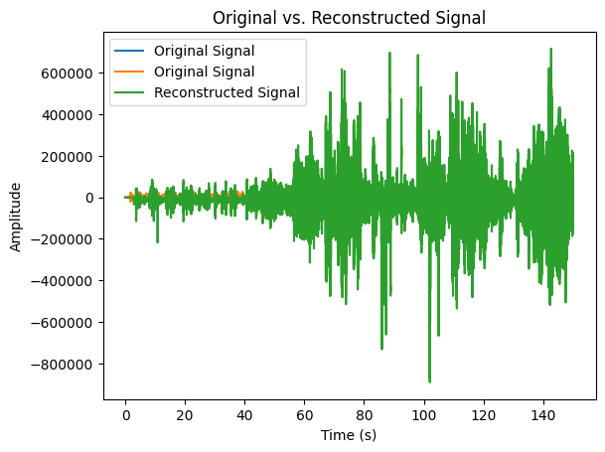

Fig-4: Original vs Reconstructed Signal

**Assignment 3**

**Title:** Apply FFT on a speech signal and draw the frequency spectrum.

**Code:**

import scipy.io.wavfile as wavfile

import numpy as np

import matplotlib.pyplot as plt

# Load the audio signal from a .wav file

filename = "abc.wav"

sampling_freq, signal_data = wavfile.read(filename)

# Compute the one-dimensional FFT of the signal

signal_fft = np.fft.fft(signal_data)

# Compute the two-sided spectrum

magnitude_spectrum = np.abs(signal_fft)

frequency_axis = np.fft.fftfreq(len(signal_data), 1/sampling_freq)

frequency_mask = frequency_axis >= 0

# Plot the frequency spectrum

plt.plot(frequency_axis[frequency_mask], magnitude_spectrum[frequency_mask])

plt.xlabel("Frequency (Hz)")

plt.ylabel("Magnitude")

plt.title("Frequency Spectrum")

# Show the plot

plt.show()

**Result:**

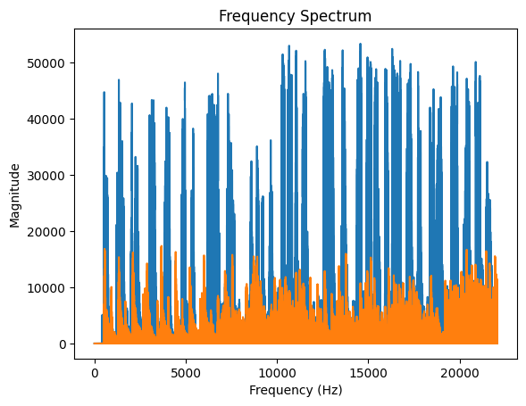

Fig-5: Frequency Spectrum

**Assignment 4**

**Title:** Find out the Pitch (F0) and formants F1, F2, and F3 from a speech signal.

**Code:**

**Result:**

**Assignment 5**

**Title:** Calculate the short-term energy, zero-crossing rate, and MFCCs(Including all steps to calculate MFCC : Theoretical explanation) of a speech signal.

**Code:**

import numpy as np

import matplotlib.pyplot as plt

from scipy.io import wavfile

from scipy.signal import stft, hamming

from python_speech_features import mfcc

# Load the speech signal

sample_rate, signal = wavfile.read('abc.wav')

# Set the parameters

frame_length = int(25 * sample_rate / 1000) # Frame length in samples

frame_step = int(10 * sample_rate / 1000) # Frame step in samples

nfft = 512 # FFT size

num_ceps = 12 # Number of MFCC coefficients to compute

# Calculate the short-term energy and zero-crossing rate

frames = np.array([signal[i:i+frame_length] for i in range(0, len(signal)-frame_length, frame_step)])

energy = np.sum(frames**2, axis=1)

zc_rate = np.sum(np.abs(np.diff(np.sign(frames))), axis=1) / (2 * frame_length)

# Calculate the MFCCs

mfccs = mfcc(signal, sample_rate, winlen=0.025, winstep=0.01, numcep=num_ceps, nfilt=26, nfft=nfft, preemph=0.97)

# Plot the results

plt.figure(figsize=(10, 6))

plt.subplot(3, 1, 1)

plt.plot(signal)

plt.ylabel('Amplitude')

plt.title('Speech Signal')

plt.subplot(3, 1, 2)

plt.plot(energy)

plt.ylabel('Energy')

plt.title('Short-term Energy')

plt.subplot(3, 1, 3)

plt.plot(zc_rate)

plt.ylabel('ZCR')

plt.title('Zero Crossing Rate')

plt.xlabel('Frame Index')

plt.tight_layout()

plt.show()

plt.figure(figsize=(10, 6))

plt.imshow(np.abs(stft(signal, nperseg=frame_length, noverlap=frame_step, window=hamming(frame_length), nfft=nfft)), aspect='auto', origin='lower', cmap='inferno')

plt.xlabel('Time (s)')

plt.ylabel('Frequency (Hz)')

plt.title('STFT')

plt.colorbar()

plt.show()

plt.figure(figsize=(10, 6))

plt.imshow(mfccs.T, aspect='auto', origin='lower', cmap='inferno')

plt.xlabel('Frame Index')

plt.ylabel('MFCC Coefficient Index')

plt.title('MFCCs')

plt.colorbar()

plt.show()

**Result:**

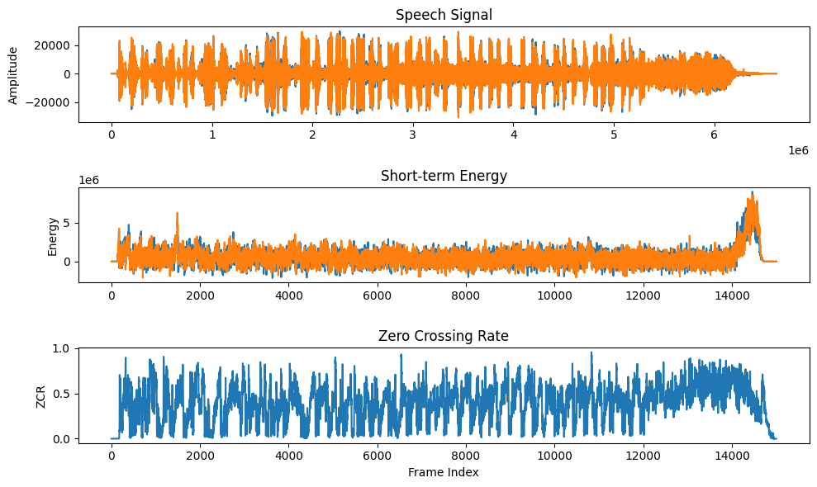

Fig-6: Speech signal, short term energy, zero crossing rate