CENTRIFUGAL COMPRESSOR PERFORMANCE
Index

1.Introduction
2.Applications of Centrifugal Compressors
3.Stepwise Procedure for Configuration In UAS
4.Effect of Process Parameters on Compressor Performance
5.Centrifugal Compressor Performance Curve
6.Importance of Reduced Performance Curve
7.Vibration and Condition Monitoring
8.Annexure 1: Applications of Centrifugal Compressors
9. Annexure 2: Process Stream in Uniformance Asset Sentinel
10.Annexure 3: Excel Spread Sheet for Compressor Performance
11.Annexure 4: Gas Flow Compensation & Nm3/hr to Am3/hr conversion

1.Introduction:

Centrifugal compressors, also called radial compressors, are critical equipment in wide variety of applications in the chemical process industries.
As their name suggests, their primary purpose is to compress a fluid (gas or gas mixture) into a smaller volume simultaneously increasing the pressure and temperature of fluid.
In other words, compressor accept a mass of gas at some initial pressure and temperature and raise that to a higher pressure and temperature.
At the higher discharge pressure and temperature, the gas density is also higher, so that mass of gas occupies a smaller volume i.e. the gas is compressed.

2.Applications of Centrifugal Compressor:

Centrifugal compressors meet various needs, and their main applications are in oil refineries, chemical plants, fertilizer plants, natural gas plants, steel plants, etc. Please refer Annexure 1 for more details about applications of Centrifugal Compressors in various industries.

3.Stepwise Procedure for Configuration In UAS:
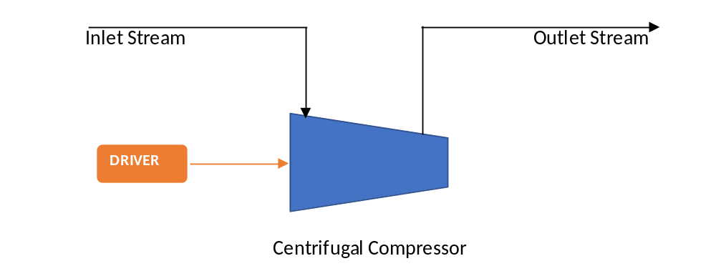
1.Configure Inlet & Outlet Stream.

Inlet(Suction) Stream: | Outlet(Discharge) Stream:
Inputs: | Inputs:
Pressure | Pressure
Temperature | Temperature
Gas Composition | Gas Composition
Outputs: | Outputs:
Specific Heat | Specific Heat
Gas Density | Gas Density
Enthalpy | Enthalpy
Entropy | Entropy
Molecular Weight | Molecular Weight
Compressibility Factor | Compressibility Factor
Refer Annexure 2 for more details about Process Streams.
2.Configure Compressor based on Asset Type.

The following types of centrifugal compressor models can be configured in Uniformance Asset Sentinel.
• Centrifugal Compressor with Constant Speed.
• Centrifugal Compressor with Variable Speed.
• Centrifugal Compressor with Variable Guide Vane.

There are two versions available for Centrifugal Compressor in Uniformance Asset Sentinel.
- Centrifugal Compressor V1 BWR
- Centrifugal Compressor V2 Peng

The Centrifugal Compressor model in Uniformance Asset Sentinel includes version 2.0, which is based on custom process stream to accommodate different thermo dynamic package and components in gas to compress as against fixed BWR thermo model and component list in Compressor Model V1.

Inputs:
1.Suction Pressure
2.Suction Temperature
3.Volumetric Flow Rate(m3/hr)
4.Discharge Pressure
5.Discharge Temperature
6.Compressor Speed (if variable Speed)
7.Inlet Guide Vane Position (if Variable Guide Vane)
8.Gear Box Efficiency
9.Gear Ratio
10.Mechanical Efficiency
11.Reference Parameters

Outputs(main):
1.Poytropic Head
2.Polytropic Efficiency
3.Compressor Shaft Power

Suction Flowrate is required input in m3/hr but in process plants gas flow measures in Nm3/hr.
Please refer the Annexure 4 for Flow compensation and Flow Nm3/hr to Am3/hr conversion.

3.Configure Asset Connection Link Inlet1 & Outlet1 in Attribute Value configuration in Compressor.

This connection will transfer the required information for Compressor from Inlet/Outlet stream.

Centrifugal Compressor Performance Model gives the following Outputs(main):
- Polytropic Head
Polytropic Head is the measure of the amount of energy required to elevate fixed amount gas from one pressure level to a higher-pressure level during Polytropic compression process.
H = ((Zavg*R*T1)/MW) *(n/(n-1)) *((P2/P1) ^(((n-1)/n))-1)
H is Polytropic Head in m
n is the Polytropic Exponent n=LN(P2/P1)/LN(ρd/ρs)
ρs & ρd are the suction density and discharge density respectively
Zavg is the Average Compressibility Factor
T1 is the Suction pressure in K
P1 & P2 are the suction pressure and discharge pressure respectively
MW is the Gas Molecular Weight
R is the Universal Gas Constant
- Polytropic Efficiency
The efficiency relates the actual work done on the gas (during compression process) to the total work input into the compression system (from the driver, including losses etc.)
Polytropic Efficiency for an ideal gas given by equation,
Poly Efficiency = n/(n-1)/k/(k-1)
where n/n-1=ln(P2/P1)/ln(T2/T1)
For real gases, the recommended approach to derive the efficiency using enthalpy difference between the suction enthalpy and discharge enthalpy and Polytropic head.
Polytropic Efficiency = (Polytropic head / Measured head)
The operating head is calculated from the enthalpy of input and outlet process stream:
Measured Head= Measured Discharge Enthalpy – Measured Suction Enthalpy
Measured Discharge Enthalpy= Enthalpy at Discharge temperature and pressure.
Measured Suction Enthalpy= Enthalpy at Suction temperature and pressure.
- Operating Shaft Power
Measured Gas Power(kW)= (Gas Flow in kg/sec) *(Operating Head in kN-m/kg)
Shaft Power(kW)= Measured Gas Power(kW)/ (Mech. Efficiency*GearBox Efficiency)
Shaft Power (all losses inclusive) =Gas Power + Bearing Losses + Seal Losses + 0.02 x Gas Power
The power is directly proportional to both mass flowrate and head.

4.Effect of Process Parameters on Compressor Performance:
The following observations are more specifically applicable for air compressor.
1.Inlet Pressure

Lower inlet pressure:
• Decreases the discharge pressure along the entire curve.
• Decreases the maximum capacity (weight flow).
• Decreases power consumption or horsepower (due to reduced weight flow).

2.Inlet Temperature
Inlet temperature changes produce large changes in performance. In cold weather, a centrifugal can deliver much more weight flow of air than in warm weather if the drive is sized to provide the additional power required.
Lower Temperature:
• Increases the surge pressure.
• Increases the maximum capacity (weight flow) at a given discharge pressure.
• Increases power consumption (horsepower).
Higher Temperature:
• Decreases the surge pressure.
• Decreases the maximum capacity (weight flow) at a given discharge pressure.
• Decreases power consumption (horsepower).

3.Relative Humidity
Humidity has a slight effect on discharge pressure and a greater effect on weight flow.
Higher relative humidity:
• Decreases the discharge pressure at surge.
• Decreases the maximum capacity (weight flow).
• Decreases the flow at which surge occurs.
• Decreases power consumption (horsepower).

4.Cooling Water Temperature/Interstage Temperature
Lower cooling water temperature:
• Increases discharge pressure.
• Increases maximum capacity (weight flow).
• Increases power consumption (horsepower).
Higher cooling water temperature:
• Decreases discharge pressure.
• Decreases maximum capacity (weight flow).
• Decreases power consumption (horsepower).
Barometric Pressure and its effect on Centrifugal Compression process:
At elevated altitudes, lower atmospheric pressure means that the air molecules are less tightly packed together and therefore have lower density. When an air compressor draws in air as part of its intake process it’s typically a fixed volume of air so if the air density is less it means that there are fewer air molecules drawn into the compressor’s cylinders/rotor lobes/vanes. Less air drawn in means less air compressed and less air delivered to the receiver tank and tools per compression cycle.

5.Centrifugal Compressor Performance Curve:

The centrifugal compressor performance curve consisting of the following three important curves

- Differential Pressure (or Polytrophic Head) Vs Inlet Flow rate
- Brake Power Vs Inlet Flow rate
- Efficiency Vs Inlet Flow rate

- Differential Pressure (or Polytrophic Head) Vs Inlet Flow rate
In this curve, the differential pressure is on the vertical axis and Inlet Flow rate is on the horizontal axis. With an increase in compressor inlet flow rate, the head developed by the centrifugal compressor start decreases. The compressor develops maximum differential pressure (head) is called Surge.
The flow and pressure corresponding to the surge point are called surge flow and surge pressure. When the inlet flow rate is increased to the right (Refer below curve), the differential pressure (head) keep on decreases up to a maximum flow rate. It is called as “Stonewall point” or “Stall Point”.
This is maximum operation range of a centrifugal compressor recommended by the compressor manufacturer. The inlet flow rate and differential pressure (head) are related to each other, one cannot be changed without varying the other parameter. The relationship between inlet flow rate and differential pressure (head) is locked until wear or increased shaft seal clearance of the centrifugal compressor.

- Brake Power Vs Inlet Flow rate
In this curve, the Break power is on the vertical axis and Inlet Flow rate is on the horizontal axis (Refer below performance curve). As we seen from the curve, the brake power does not start from zero, the minimum power represents in the curve is to overcome the frictional losses and centrifugal compressor inertia.
From this curve, the required brake power is obtained from the corresponding inlet flow rate.
- Efficiency Vs Inlet Flow rate
As we seen from the performance curve, the efficiency curve is raising as the flow rate increase. Then the curve reaches the maximum point and starts decreasing. The maximum point is called Best Efficiency Point (BEP). It is always preferred to run the centrifugal compressor at the best efficiency point (BEP), but in the practical case, we are not able to match the required centrifugal compressor operating point with compressor BEP.
If the centrifugal compressors run at or near to BEP, not only we get higher efficiency and also the less vibration of the compressor.

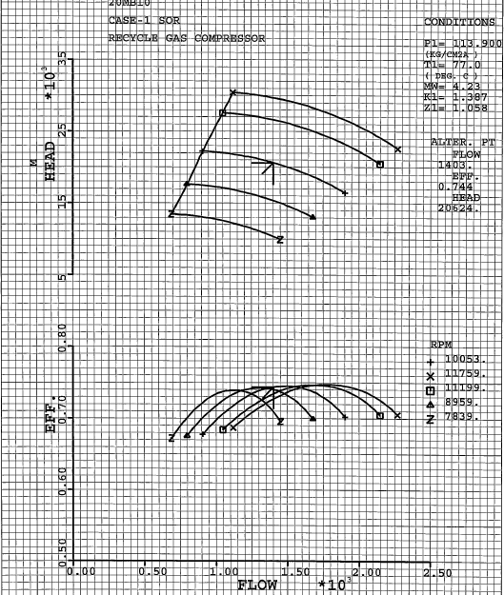
Curve 1: Polytropic Head Vs Volumetric Flowrate
Curve 2: Efficiency Vs Volumetric Flowrate

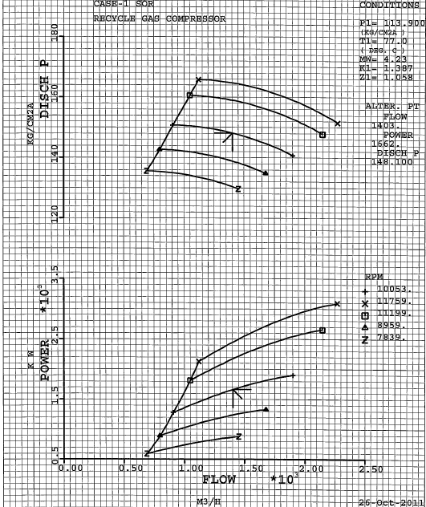
Curve 3: Discharge Pressure Vs Volumetric Flowrate
Curve 4: Power Vs Volumetric Flowrate

6.Importance of Performance Reduced Curve:
- The performance of a variable speed, centrifugal compressor is characterized by two sets of curves that are typically supplied by the compressor manufacturer.
- The first set consists of curves of polytropic head versus volumetric suction flow, each curve corresponding to a different operating (rotational) speed, all at the same suction conditions. The second set consists of corresponding curves for power.
- These sets of curves, referred to as performance maps, are used in the flow-pressure relationship for the centrifugal compressor. The performance maps as supplied by the compressor manufacturer are not directly useful for performance prediction because they only truly apply at the suction conditions and for the rotational speeds at which they were constructed.
- In actual operation, the suction conditions and rotational speed will inevitably differ from those at which the performance maps were constructed. If these differences are not considered, the predictions made by the model will be incorrect and possibly misleading.
- This problem is addressed by transforming the performance maps to a coordinate system in which they are independent of suction conditions and rotational speed. In this coordinate system, called reduced coordinates, the performance maps reduce to (or collapse into) two aggregate curves, one for polytropic head and one for power, which facilitate their use even when the suction conditions and rotational speed differ from those at which the performance maps were constructed.
- Transforming the performance maps to reduced coordinates, however, is not enough. The aggregate performance curves must be represented by functions that have the correct shape and extrapolate reasonably. These functions, referred to as fitting functions, must be fitted to the reduced data, the data obtained by digitizing the performance maps and then transforming to reduced coordinates.
- To obtain a more accurate representation of the aggregate curves, they are divided into three segments designated as the surge, normal operation and stonewall curve segments or regions. Each curve segment is represented by a fitting function that is fitted to the reduced data for that segment. The Uniformance Asset Sentinel Performance Map Fitting too determines the parameters of the reduced coordinates transformation and the parameters of the fitting functions should be copied to Sentinel asset attributes.

To open the Performance Map Fitting Tool
1. In the Uniformance Asset Sentinel installation media, navigate to the Utilities\PerformanceMap Tools\folder.
2. Open the file Sentinel Compressor Performance Maps Fitting Tool.xltm.
This is an Excel macro-enabled template file.

The performance maps must be digitized into a minimum of 11 data points in total for all the performance maps being fitted. In practice, however, at least 30 to 50 data points more or less evenly distributed over the full range of volumetric suction flow, exclusive of any data points that may ultimately be excluded from the fitting process, are required.

7.Vibration and Condition Monitoring

The operation of a compressor with high rotational speed of the components, fluids flowing through, big forces being transmitted and high temperatures makes the number of variables to monitor quite large. Thus, there are many approaches to CM of centrifugal compressors.
Below a few approaches are listed.
• Performance monitoring:
It determines if the equipment operates as expected by monitoring performance-indicating parameters. For compressors, it is typical to calculate and monitor power consumption and efficiencies. Uses measured values of pressure, temperature, Flow, speed, density etc.
• Vibration Monitoring:
Vibration transducers are typically mounted onto the bearings and most often it is the RMS value of the velocity or peak to peak displacement of the vibration that is measured. This is suited for detection of e.g. bearing failures, rotor failures, unbalance, looseness and rubbing.
• Temperature monitoring/Thermography:
Temperature monitoring can be performed with temperature transmitters placed at different locations on the compressor. Typically, at bearings. All rotating machines create heat due to the friction, but lubrication and bearings minimize this. So, under normal operating conditions the temperature created should be under a certain limit. If faulty conditions such as excessive wear, lack of lubrication, increased load, etc. occur the temperature of certain components can increase. This increase can be detected by these methods.

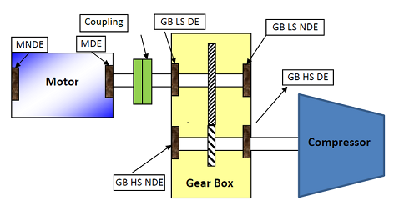

where,
MNDE-Motor Non-Drive End
MDE-Motor Drive End
GB LS DE-Gear Box Low Speed Drive End
GB HS NDE-Gear Box High Speed Non-Drive End
GB LS NDE-Gear Box Low Speed Non-Drive End
GB HS DE-Gear Box High Speed Drive End
The most basic consideration associated with vibration measurements is the direction of measurement (and vibration) they represent. There are three axes for measurement, horizontal, vertical, and axial.

Annexure 1: Applications of Centrifugal Compressors

Sr. No | Industry | Plant Name | Service | Application/Purpose
1 | Petroleum Refining | Hydrotreating | Recycle Gas | Boosting the pressure of process gas  (promotes catalytic reactions)
1 | Petroleum Refining | Reforming | Recycle Gas | Boosting the pressure of process gas  (promotes catalytic reactions)
1 | Petroleum Refining | Hydrocracking | Recycle Gas | Boosting the pressure of process gas  (promotes catalytic reactions)
1 | Petroleum Refining | Refrigeration | Propylene | Boosting the pressure of Propylene
1 | Petroleum Refining | Refrigeration | Ethylene | Boosting the pressure of Ethylene
2 | Petrochemical | Ethylene oxide | Process Gas | Boosting the pressure of process gas  (generates ethylene oxide)
2 | Petrochemical | Ethylene Glycol | Process Gas | Boosting the pressure of process gas  (generates ethylene glycol)
2 | Petrochemical | Ammonia | Air | Boosting the pressure of raw air  (separates nitrogen)
2 | Petrochemical | Ammonia | Synthetic Gas | Boosting the pressure of synthetic gas  (promotes ammonia synthesis reactions)
2 | Petrochemical | Urea | Carbon Dioxide | Boosting the pressure of carbon dioxide  (urea generation, Granulation)
2 | Petrochemical | Methanol | Synthetic Gas | Boosting the pressure of synthetic gas  (promotes methanol synthesis reaction)
3 | Natural Gas | Pipeline Transport | Natural Gas | Boosting the pressure of natural gas  (Pipe line transport)
3 | Natural Gas | Gas Injection | Natural Gas | Boosting gas pressure, injecting oil layers  (promotes recovery of crude oil)
3 | Natural Gas | Liquefaction | Natural Gas | Cooling and liquefying methane and propane
3 | Natural Gas | LNG | Natural Gas | Feed, Flash,Lean,Fuel Gas,Boil-Off Gas,CO2 Injection,Refrigeration,Nitrogen Booster,etc
4 | Chemical & Process | Process Plants | Air, Process Gas | Boosting the pressure for process applications (Instrument,N2 Blower,Combustion,ID,FD Fans)

Annexure 2: Process Stream in Uniformance Asset Sentinel

The Uniformance Asset Sentinel process and equipment monitoring models require thermodynamic properties such as enthalpy, entropy, density, and specific heat.
There are two options available to compute thermodynamic properties:

• Native Uniformance Asset Sentinel Thermodynamic models
• Linked UniSim Thermodynamic models

Native Thermodynamic Models
The property packages supported by Uniformance Asset Sentinel are tuned for real time calculations.

Type | Description
Equation of State | Benedict-Webb-Rubin model which is typically used for hydrocarbon systems.
ASME Steam Table | ASME Steam Tables for water system.  Covers both Saturated and Superheated steam properties.
Water Property | DIPPR model
Air Property | Air mixture property

Linked UniSim Thermodynamic Models
UniSim Design thermo is a high fidelity thermodynamic module.
UniSim Thermo encompasses a wide variety of property calculations, flash methods, databases, and so on. The calculation methods cover all the thermodynamic calculation packages.
The UniSim Thermo program allows users to create a simulation of a stream.
Thermodynamic properties are then calculated based on the specifically chosen components and formulas within the application

Annexure 3: Excel Spread Sheet for Compressor Performance

CENTRIFUGAL COMPRESSOR PERFORMANCE
 | Description | UOM | Value | Formula | Information Source
INPUTS | Volume Flow Rate, Q | m3/hr | 3443 |  | PI/DCS/Datasheet
INPUTS | Gas Density at Suction, ρs | kg/m3 | 9.8494 |  | Stream Output Calculations
INPUTS | Mass Flow Rate, m | kg/hr | 33911.48 | m=Q* ρs
INPUTS |  | kg/sec | 9.420 | m/3600
INPUTS | Suction Pressure, Ps | Bar G | 46.615 |  | PI/DCS/Datasheet
INPUTS | Suction Temperature, Ts | deg C | 45.53 |  | PI/DCS/Datasheet
INPUTS | Suction Enthalpy,Hs | kJ/kg | -2327.5 |  | Thermo Stream Output
INPUTS | Molecular Weight, MW | kg/kmol | 5.7028 |  | Thermo Stream Output
INPUTS | Suction Gas Density, ρs | kg/m3 | 9.8494 |  | Thermo Stream Output
INPUTS | Suction Compressibility, Z1 |  | 1.00043 |  | Thermo Stream Output
INPUTS | Discharge Compressibility, Z2 |  | 1.0042 |  | Thermo Stream Output
INPUTS | Compressibility, Zavg |  | 1.00 | (Z1+Z2)/2
INPUTS | Discharge Pressure, Pd | Bar G | 54.46 |  | PI/DCS/Datasheet
INPUTS | Discharge Temperature, Td | deg C | 62.60 |  | PI/DCS/Datasheet
INPUTS | Discharge Gas Density, ρd | kg/m3 | 10.90 |  | Thermo Stream Output
INPUTS | Discharge Enthalpy, Hd | kJ/kg | -2232.00 |  | Thermo Stream Output
INPUTS | Universal Gas Constant, R |  | 8.314
 | Gear Box Efficiency, GBEff |  | 0.980 |  | Manufacturer Datasheet
 | Mechanical Efficiency, MechEff |  | 0.980 |  | Manufacturer Datasheet
INTERNAL | Polytropic Exponent, n |  | 1.54 | LN(PR/DR) | PR=Pd/Ps & DR= ρd / ρs
INTERNAL | Polytropic Exponent Term, n/(n-1) |  | 2.84 | n/(n-1)
INTERNAL | Pressure Ratio Term, PR^(n-1)/n |  | 1.06 | PR^(n-1)/n | PR=Pd/Ps=Pressure Ratio
OUTPUTS | Operating Head,OPH | kNm/kg | 95.50 | (Hd-Hs)=Discharge Gas Enthalpy-Suction Gas Enthalpy
OUTPUTS |  | kJ/kg | 95.50 | kNm/kg=kJ/kg | Remember Nm=J
OUTPUTS |  | kg-m/kg | 9738.29 | OPH*(1/9.80665) | 1 m=101.97 kJ/kg=kNm/kg
OUTPUTS | Polytropic Head, OPHD | kNm/kg | 74.41
OUTPUTS | Polytropic Head Formula |  | (Zavg*R*Ts)/MW)*Polytropic Exponent Term*Pressure Ratio Term
OUTPUTS | Polytropic Head | kJ/kg | 74.41 | kNm/kg=kJ/kg
OUTPUTS | Polytropic Head | kg-m/kg | 7587.28
OUTPUTS | Compressor Gas Power,CGP | kW | 899.60 | m(kg/sec)*OPH
OUTPUTS | Compressor Shaft Power,CSP | kW | 936.69 | CGP/GBEff*MechEff
OUTPUTS | Polytropic Efficiency,PEFF | % | 77.91 | (OPHD/OPH)*100

Annexure 4: Gas Flow Compensation & Nm3/hr to Am3/hr conversion

The P&ID will be checked to determine if the signal should be compensated by the DCS. If the flow signal available to the PI system could already be compensated (in the DCS) then the UOM reported in PI/DCS tag lists shall be checked for consistency to establish if the compensated signal is available for the models to use. When the UOM for the signal from the PI/DCS confirms that the flow signal is compensated for line pressure/temperature this can be used directly.
Where the field measurement is not compensated the volumetric flow, signal is compensated for both pressure and temperature effects as follows: -

- Flow Compensation with Temp, Pressure and Mol Weight
CompVQ=VQin∗SQRT((MolWtD/MolWtF) ∗((P+1.03323)/(Pd+1.03323)) ∗((Td+273.15)/(T+273.15)))
Where,
CompVQ -Compensated Volume flow rate in Nm3/hr
VQin - Measured Volume flow rate from PI in Nm3/hr
P - Pressure from PI/DCS or the Operating value from PFD in kg/cm2
Pd - Calibrated Pressure if available or Design Pressure from PFD in kg/cm2
T - Temperature from PI/DCS or the Operating value from PFD in degC
Td - Calibrated Temperature if available or Design Temperature from PFD in degC
MolWtD- Calibrated Molecular Weight or of unavailable Design default value from PFD-kg/kmol
MolWtF -Flowing Molecular Weight measured value from LIMS in kg/kmol

B. Conversion of Compensated Volume Flow(Nm3/hr) to m3/hr at Compressor Suction Temp Pressure
Q=VolumeFlowRate_Nm3/hr*(1.033/(Inlet1_Pressure+1.033)) *((Inlet1_Temperature+273.15)/273.15)
Note: If there is considerable difference in Inlet and outlet compressibility, then consider Z1 and Z2 also.

Centrifugal Compressor Subsystems

Process
Mechanical (Bearing and Vibrations, Seal and Lube Oil System)

Dry Seal Gas System
Seal Gas Pressure
Seal Gas Temperature
Seal Gas DP
Seal Gas Flow
Vent Pressure
Vent Flow
HC in Secondary Vent

This is applicable to Primary and Secondary Seal Gas.

