A Performance Monitoring model is used to calculate the operating (actual) performance output, design
(expected) performance output, and deviation between operating performance and design performance output.
Fault models can be configured on process performance outputs like efficiency, capacity, and so on.
CENTRIFUGAL PUMP PERFORMANCE

Index

1. Introduction
2. Applications of Centrifugal Pumps
3. Stepwise Procedure for Configuration In UAS
4. Excel Spread Sheet for Centrifugal Pump Performance
5. Centrifugal Pump Performance Curve
6. Vibration and Condition Monitoring
7. API 610 - Pump Selection & Curve Evaluation Guide
8. NPSH and its Significance

1.Introduction

The centrifugal pumps are by far the most commonly used of the pump types. Among all the installed pumps in a typical petroleum plant, almost 80–90% are centrifugal pumps.
The function of Centrifugal Pump is to increase the pressure of a liquid for the purpose of transporting the liquid from one point to another point through piping system by centrifugal action. The pressure is created by conversion of kinetic energy of liquid into pressure energy.
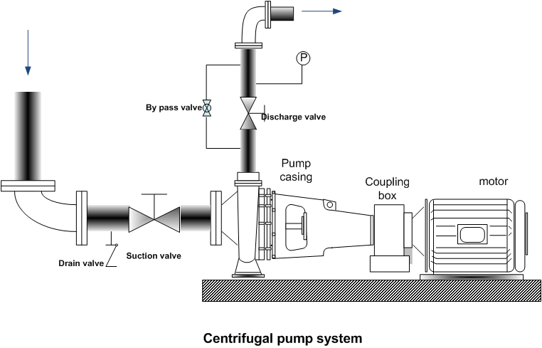

2.Applications of Centrifugal Pumps

Centrifugal pumps are widely used because of their design simplicity, high efficiency, wide range of capacity, head, smooth flow rate, and ease of operation and maintenance.
Due to the variation in flow versus pressure & light to moderate viscous fluid handling ability centrifugal pumps are more flexible and commonly used in process & piping applications.
• Chemical industry: To transport fluids to and from various sites in the chemical plant.
• Petroleum industry: Used in every phase of petroleum production, transportation, refinery.
• Pharmaceutical and medical field: To transfer of chemicals in drug manufacture
• Water supply: To supply water to inhabited areas.
• Drainage: To control the level of water in a protected area.
• Sewage: To collect and treat sewage.
• Irrigation: To make dry lands agriculturally productive.
• Steel mills: To transport cooling water.
• Construction: Bypass pumping, well-point dewatering, remediation, general site pumping.
• Mining: wash water, site dewatering, groundwater control, and water runoff.
3.Stepwise Procedure for Configuration In UAS

The centrifugal pump performance monitoring models are used to:
• Monitor and analyze the performance output
• Determine the condition of centrifugal pump.
The “Centrifugal Pump with constant speed” type of centrifugal pump model is supported in Uniformance Asset Sentinel.
The purpose of the centrifugal pump model is to determine the operating performance, design performance, and deviation performance. The operating performance of a centrifugal pump is determined using measured input data supplied to the condition analysis program through site instrumentation and instrumentation or Historian. The operating performance is calculated for each set of measured input data.
In addition to the measured input data, a number of model parameters must also be supplied by the user through the user interface. The design performance is determined by using performance curves data of pump. The performance curves data is defined in terms of input values of flow rate, head, efficiency, power, and Net Positive Suction Head (NPSH).
The centrifugal pump’s expected baseline performance is calculated by interpolating the pump map data. This calculation is based on the measured pressure ratio and measured flow.
Pump Model Input Data:
The centrifugal pump model input data consists of measured data and static data.
Measured input data is supplied to the model from DCS or Historian by tag mapping. The following are the measured input data attributes.
Pump Model require the following Data inputs (Measured Data + Static Data)
- Volume Flow Rate in m3/hr
- Suction Pressure in barg
- Discharge Pressure in barg
- Fluid Density in kg/m3
- Pumping Temperature in deg C
- Vapour Pressure in bara
- Voltage in Volts
- Current in Ampere
- Power Factor
- Mechanical Efficiency in %
- Electrical Power (If Current, Voltage, PF are not available) in kW
- Speed in RPM

Static Data consists of model parameters and reference data.
Model parameters such as Power Factor and Mechanical Efficiency (%) and reference data consists of mainly the design data supplied by OEM that is the property data and the performance data.
Property data: is the fluid data correlating temperature, density, and vapour pressure. The temperature is expressed in terms of “deg C”, density in “kg/m3”, vapour pressure in “bara”.
Performance data: the reference centrifugal pump map inputs consist of data correlating flow rate, head, efficiency, power, and NPSH. The flow rate is expressed in terms of “m3/hr”, head in “m”, efficiency in “%”, power in “kW”, and NPSH in “m”.

Electric motor datasheet usually provides the efficiency and power factor at full load and at various part loads (for example 50%,75%). The below table can be used as tabular array for real motor inputs.

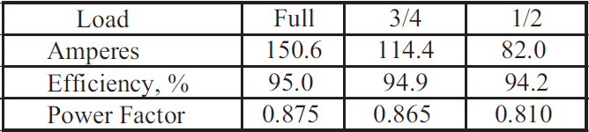

Pump Performance Model gives the following main Outputs:
Output Data
- Operating Head – m
- Operating NPSH - m
- Operating Power - kW
- Operating Efficiency - %
- Design Head - m
- Design NPSH - m
- Design Power - kW
- Design Efficiency - %
- Deviation Efficiency - %
- Deviation Head - % (Percent Deviation Head)
- Deviation NPSH - % (Percent Deviation NPSH)
- Deviation Power - % (Percent Deviation Power)

1.Operating Head:
The pressure of the liquid can be stated in terms of meters (feet) of head of the liquid column (mlc). Thus, the difference between the discharge head and the suction head is termed as ‘differential head’.
The differential head developed by a pump is expressed in ‘m’ of liquid:
In Uniformance Asset Sentinel:
Operating Head(m) = (deltaP) * (10197.162) / (Density)
DeltaP is the Differential Pressure in bar

2.Operating NPSH
The pressure at the inlet to a pump must be high enough to prevent cavitation occurring in the pump.
NPSH_{A} is a function of your system and must be calculated, whereas NPSH_{R} is a function of the pump and must be provided by the pump manufacturer. NPSH_{A} must be greater than NPSH_{R} for the pump system to operate without cavitating.
In Uniformance Asset Sentinel:
Operating NPSH (m LC) = (Ps-Pv) * (10197.162) / (Density)
Ps is the Suction Pressure in bar
Pv is the Vapour Pressure in bar a

NPSHa-Net Positive Suction Head (Available)

The net positive suction head available (NPSHa) is the pressure at the pump suction, above the vapor pressure of the liquid, expressed as head of liquid.
It is the characteristic of Pump Inlet piping, fluid temperature, vapour pressure and it is calculated by process engineer in the operating plant.
NPSHa must be greater than NPSHr for the pump system to operate without cavitating and hence trouble free operation of the pump.

NPASHa= Hss-Hfs-Hvp
=P+Z-Hfs-Hvp

where

Hss= Static Suction Head, expressed in metre of Liquid Column(mLC)
=P+Z,if the pump is going to be installed below the free surface of liquid
=P-Z,if the pump is going to be installed above the free surface of liquid
P=Absolute pressure over free surface of liquid at source
Z=Vertical distance between free surface of liquid at source and centerline for horizontal pump
= Vertical distance between free surface of liquid at source and suction eye impeller for vertical pump
Hfs=Friction loss in suction line, expressed in metre of Liquid Column(mLC)
Hvp=vapour pressure of liquid at suction Temperature, expressed in metre of Liquid Column(mLC)

3.Operating Power

Power is consumed by a pump to move and increase the pressure of a fluid.
The power requirement of the pump depends on a number of factors including the pump and motor efficiency, the differential pressure and the fluid density, viscosity and flow rate.
Operating Power is the hydraulic power which is also known as absorbed power, represents the energy imparted on the fluid being pumped to increase its velocity and pressure.
In Uniformance Asset Sentinel:
OperatingPower = ((Q / 3600) * Density * 9.80665 * OperatingHead / 1000) / (MechEfficiency / 100)

4.Operating Efficiency

In Uniformance Asset Sentinel:
Operating Efficiency = OperatingPower / (ElectricalPower * (MechEfficiency / 100)) * 100
Electric Power:
The power delivered to the electric motor connected to pump is called Electrical Power.
If Electric Motor is the driver for pump, then Power Input is calculated as follows.
P = √3·V·I·cosφ/1000
where,
P is power in kilo-watts
V is applied voltage
I is absorbed current in amps
cosφ is the power factor

Important Notes:
In the existing UAS Centrifugal Pump-Constant Speed model (511.1):
1. Shaft Power attribute is not available. We need to create shaft power calculations by using the Operating Power (Hydraulic Power) and Operating Pump Efficiency. Then for deviation calculations purpose we can compare design shaft power from performance curve and pump shaft power from performance model. But presently our model comparing Operating Power(Hydraulic) and design shaft power and giving deviation % for Power, which is illogical.
2. Motor Efficiency attribute is not available. In existing model, Mechanical efficiency acting two times to balance the effect of motor efficiency.
The motor efficiency should read from Motor Load-Efficiency-Power Factor table.

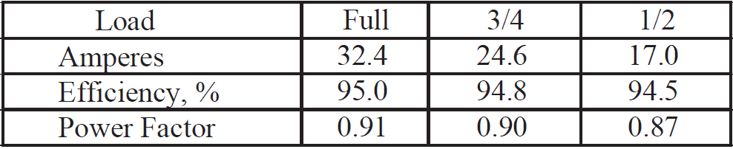
5.Deviation Efficiency - %
Deviation Efficiency % = (Operating Efficiency-Design Efficiency)
6.Deviation Head - % (Percent Deviation Head)
Deviation Head % = ((Operating Head-Design Head)/ Design Head) *100
7.Deviation NPSH - % (Percent Deviation NPSH)
Deviation NPSH % = ((Operating NPSH-Design NPSH)/ Design NPSH) *100
8.Deviation Power - % (Percent Deviation Power)
Deviation Power % = ((Operating Shaft Power-Design Power)/ Design Power) *100

The design performance calculations are based on performance curves data of Centrifugal Pumps.
Design Efficiency, Design Power, Design NPSH, Design Head will be based on Performance data.

4. Excel Spread Sheet for Centrifugal Pump Performance
CENTRIFUGAL PUMP PERFORMANCE-UAS APPROACH
INPUTS | Flowrate | Q | m3/hr | 400
INPUTS | Suction Pressure | Ps | barg | 14.2
INPUTS | Discharge Pressure | Pd | barg | 58.14
INPUTS | Density | ρ | kg/m3 | 745
INPUTS | Vapour Pressure | Pv | bar A | 13.29
INPUTS |  |  | bar g | 12.28
INPUTS | Temperature |  | deg C | 46.60
OTHER INPUTS | Current | I | Ampere | 50
OTHER INPUTS | Voltage | V | Volts | 11000
OTHER INPUTS | Power Factor | PF |  | 0.89
OTHER INPUTS | Mechanical Efficiency | MechEff |  | 98
OTHER INPUTS | Electrical Power | EP | kW | 847.81
 | Shaft Power | Pshaft | kW | 814.24
OUTPUTS | Operating Power |  | KW | 498.15
OUTPUTS | Operating Head |  | MLC | 601.39
OUTPUTS | Operating NPSH |  | MLC | 26.32
OUTPUTS | Operating Efficiency |  | % | 59.96
Important Formulae:
Electric Power=(1.732*V*I*PF)/1000
Operating Power= ((Q / 3600) * Density * 9.80665 * OperatingHead / 1000)/ (MechEff / 100)
Operating Head=(deltaP) * (10197.162) / (Density)
Operating NPSH=(Ps-Pv) * (10197.162) / (Density)……Pv in barg
Operating Efficiency=OperatingPower/(ElectricalPower*( MechEff /100)) *100

5.Centrifugal Pump Performance Curve

The performance of a centrifugal pump is characterized by following graphic plots.
1.Head(pressure) developed by pump versus capacity(flowrate)
2.Pump Efficiency versus capacity(flowrate)
3.Pump Shaft Power versus capacity(flowrate)
4.NPSHr versus capacity(flowrate)
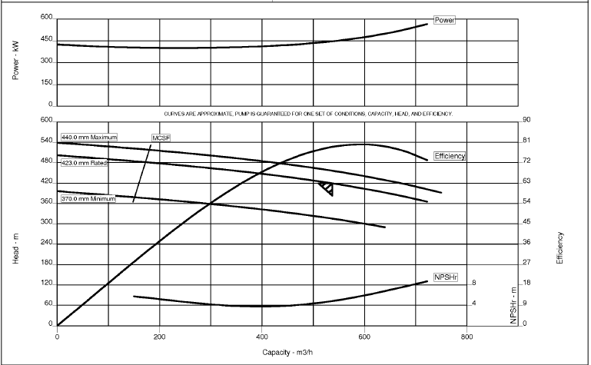

1.Head(pressure) developed by pump versus Capacity(flowrate)
The pressure developed by pump at any capacity(Q) in m of liquid head(H) is plotted on the vertical axis, and the Flowrate or Capacity (Q) in M3/hr is plotted along the horizontal axis.
Centrifugal pump have drooping H-Q curve, indicated that at zero flow maximum head is generated. This is known as shut-off head. With the increase in flow, the head decreases until the minimum head is generated at the maximum capacity.
It is important to realize that the H-Q curve is based on a particular pump impeller diameter running at a specific rotational speed. A larger impeller diameter would produce a higher head and capacity.
Similarly, a smaller diameter impeller will generate a lower H-Q curve for fixed rotational speed.
If we increase the pump speed, the H-Q curve will be higher and lower the speed, curve will be lower.
The manufacturers performance curve are always based on water (Specific Gravity = 1 and Viscosity= 1 cP) as the pumped liquid. When these pumps are used for pumping different liquid, the performance curve need to modify as necessary for specific liquid pumped based on its Density and Viscosity.
If the viscosity of liquid is higher than 10 cSt, the performance curve will have to modified from the water performance curve to handle the higher viscosity liquid.

2.Pump Efficiency versus capacity(flowrate)
The efficiency of pump indicates how effectively the energy supplied to the pump by driver is utilized in generating the pressure head in the liquid.
The pump efficiency is a function of the pump internal geometry and impeller diameter. It does not vary significantly with the impeller speed.
A typical Efficiency curve for centrifugal pump starts off at zero efficiency for zero capacity and reaches the maximum capacity (known as BEP) at some capacity and then drops off as the capacity continues to increase upto the maximum capacity.
The capacity at which best efficiency is attained is called the Best Efficiency Point (BEP).
In most centrifugal pump operation applications, we try to operate the pump at a capacity close to and slightly to left of the BEP. In petroleum industry, there is a preferred operating range for centrifugal pumps that is 40% to 110%

3.Pump Shaft Power versus capacity(flowrate)
Generally, the Shaft Power Vs Capacity is a rising curve, meaning that the Power increases with increase in capacity and usually tapers off at the maximum pump capacity.

4.NPSHr versus capacity(flowrate)
The fourth curve that is part of family curves is the one that shows the variation of NPSH Vs Pump Capacity.
NPSH stands for the net positive suction head required for pump at a particular capacity.
It is a measure of the minimum suction head required at the suction of the pump impeller above the liquid vapour pressure. NPSH is a very important parameter when pumping high vapour pressure liquid.The shape of NPSHr versus Q curve is a gradually rising curve.

6. Vibration and Condition Monitoring of Centrifugal Pump

Vibration monitoring on pumps can be online or offline based on the criticality of its pump. Online vibration measurements would use proximity probes to measure shaft vibrations. The most common type of vibration monitoring is offline using portable data collects and measuring casing vibrations. The vibrations are measured for both the pump and its driver.
Vibration measurements are collected at bearing locations of these machines. While reporting, it is necessary to follow a convention for labeling the various bearings of a machine train from where measurements are made. The general convention followed is to start labeling from where the power comes in.So, for a simple machine train consisting of a motor and pump will be labeled in the following way (Figure 9.1):
• Motor non-drive end bearing – A
• Motor drive end bearing – B
• Pump outboard bearing (next to the coupling) – C
• Pump inboard bearing (away from coupling) – D.
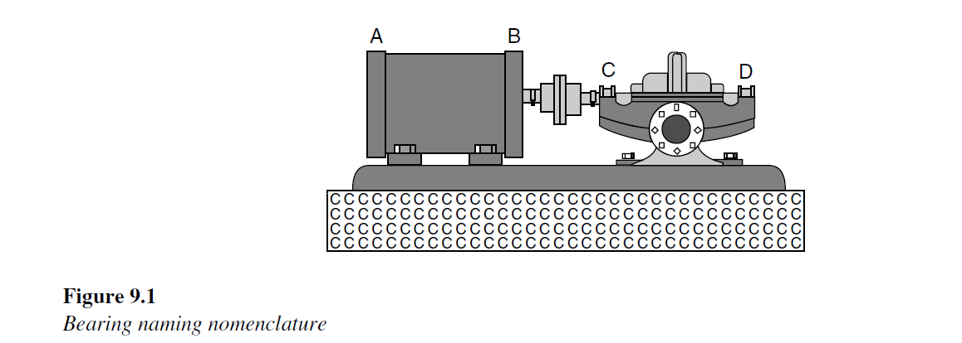
Once having labeled the bearings, it is important that vibrations are taken in three Cartesian directions. In vibration nomenclature, these are vertical, horizontal and axial directions. This is because of the construction of machines; their defects can show up in any of the three planes and hence should be measured.
Vibration reporting is generally done in the manner shown below.
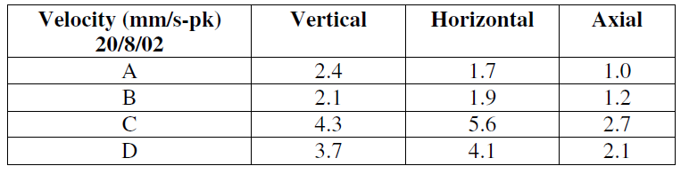
Oil and particle monitoring
The testing of the oil and possible particles in it can be a good indicator of the condition of the pump bearings and the oil program of the company.
There are several tests that can be performed on the lubricant to determine the condition
of the bearing or determine why a bearing failed so appropriate corrective action can be
taken.
These tests include:
• Spectrographic analysis
• Viscosity analysis
• Infrared analysis

7.API 610 - Pump selection & Curve Evaluation Guide

Reference: white paper on “pump selection & curve evaluation guide” www.amarinth.com

API 610 11th edition offers guidelines for pump selection to assist users with selecting pumps that will run uninterrupted for a minimum of 3 years and provide many years of reliable service. Each manufacturers pump has a set of performance curves detailing the head, flow, best efficiency, power and NPSH requirements for the pump. Evaluating and using these curves to select the right pump for the duty is crucial, both in meeting the API 610 standard and ensuring the pump runs optimally over its full lifetime. There can often be some confusion around some of the terminology relating to the curves, specifically that relating to the operating regions – preferred, rated and allowable.
A typical API 610 pump performance curve looks like this:
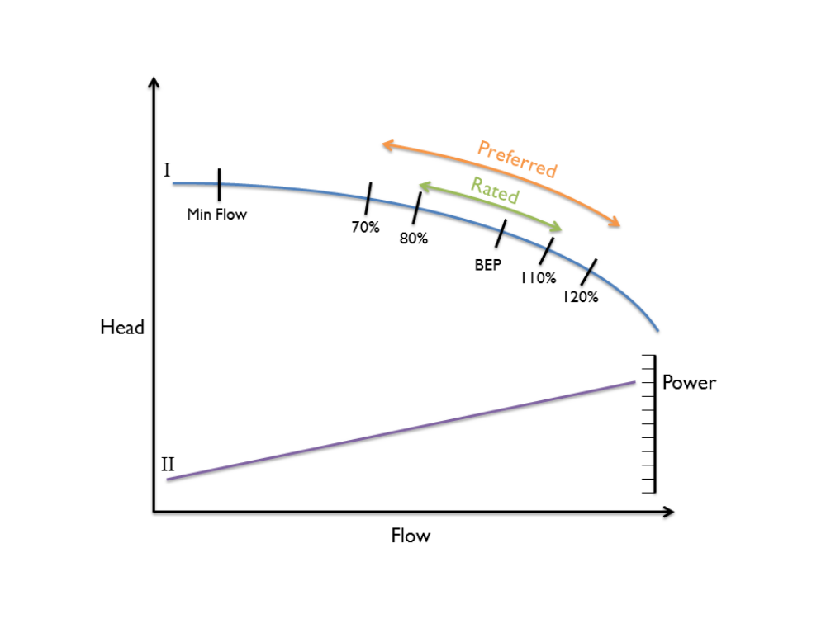

The main curve (I and in blue) is known as the head/flow curve – in simple terms the higher the head the lower the flow and vice-versa. The curve II in purple is known as the power curve.
As the flow increases then the power needed to drive the pump also increases, fairly linearly, and by taking a vertical line through both the head/flow curve and the power curve, you are able to assess how much power is needed to pump the required flow and also assess the generated head at that flow.
Additional points are marked on the graph to assist the user. Min flow is the minimum flow below which the pump should not be operated otherwise it could be in danger of premature failure. There are two types of minimum flow that need to be understood:
Minimum continuous stable flow: This is set by the manufacturer as the “lowest flow at which the pump can operate without exceeding the vibration limits imposed by API 610”
Minimum thermal flow: This is used for higher volatility or hot liquids where cavitation can occur earlier in these liquids. It’s defined as the “lowest flow at which the pump can operate without its operation being impaired by the temperature rise of the pumped liquid”

Every pump has a Best Efficiency Point (BEP) which is the flow at which it is operating at its highest efficiency, and so to achieve the lowest running costs a pump should be selected for a Customer Duty (rated head and flow) where the duty point is as close as possible to the BEP.
Of course, it is not usually possible to get the Customer Duty and BEP totally aligned as the costs of designing a pump for every customers exact duty requirements are prohibitive. Therefore customers’ duty points are known as being to the right of BEP, or to the left of BEP. The further away the customers duty point is from the pump BEP (i.e. its optimal design point), the less efficient it becomes, and quite often the more it will vibrate and generate additional noise, which can lead to premature wear and ultimately early pump failure. This is particularly relevant for high head and high flow machines, but less relevant to low energy pumps (i.e. those defined as operating under 300kW or less than 3600rpm).
To help make sure the customer’s duty does not fall within a region that will lead to premature pump failure, API 610 defines various operating regions and suggests that a customer’s duty point should sit within set regions to ensure the best possible life for the pump. The operating regions defined by API 610 are:
Rated region (see Figure 1):
API 610 recommends that the rated flow is located between 80% - 110% of BEP.
Preferred operating region (see Figure 1):
API 610 states that the preferred operating region should be between 70% - 120% of the BEP.
To understand this further we need to understand the difference between an “Operating” point and a “Rated” point.
Operating point – this is where the pump is expected to operate under normal conditions. There will often be a min and max operating point defined by the customer, but API 610 is most interested in the “normal operating” point.
Rated point – This is a point the customer chooses to rate the pump at (to allow for other losses such as system losses or adjustments that may occur as the pump begins to wear over time). The pump generally will not operate permanently at its rated point, but it is designed and tested by the manufacturer there.
To use an analogy of a car, the normal operating point may be 50mph, but it needs to be rated to handle 70mph, so all the selections and testing would be around the 70mph rather than the 50mph values.
The reason for selecting pumps within one of these regions is that API 610 states that pumps must be designed and constructed for a minimum service life of 20 years and at least 3 years of uninterrupted operation for a Customer Duty in the Preferred operating region. These guidelines apply to all pumps, whether they are relatively small, for example pumping 4 m3/h, or considerably larger, for example pumping 2000 m3/h. In addition, customers’ specifications will often require pumps to operate to the left of BEP, effectively restricting the rated region even further to between 80 – 100%.
The Allowable operating region (see Figure 2):
This is the region set by the manufacturer as the allowable region that the pump is able to operate in whilst conforming to predefined API 610 vibration limits.
To prevent manufacturers setting their Allowable operating regions as wide as possible thus potentially making their selections API 610 compliant, strict vibration limits define where the min and max allowable operating ranges should be. It is well documented that excessive vibration will lead to premature life of a pump and so the vibration limits set by API 610 are used to control the min and max allowable operating region.
This can be found under clause 6.9.3.1 in API 610 11th edition.

API 610 states that vibration levels must be less than 3mm/s for horizontal pumps and less than 5mm/s for vertical pumps within the Preferred operating region and that this can increase by 30% when moving outside the Preferred operating region. For this reason, and because each pump manufacturer will have different manufacturing methods and designs, each manufacturer will have a unique allowable operating range for each pump they offer.

When a pump’s vibration curve) is projected onto the head/flow curve using these vibration limits it shows an operating region that keeps the pump within these vibration limits - the Allowable operating region (see Figure 2). It can be the same, larger, or in some cases smaller than the API 610 Rated or Preferred operating region. In fact for some pumps, the theoretical allowable operating region based on vibration alone can extend below the minimum flow.
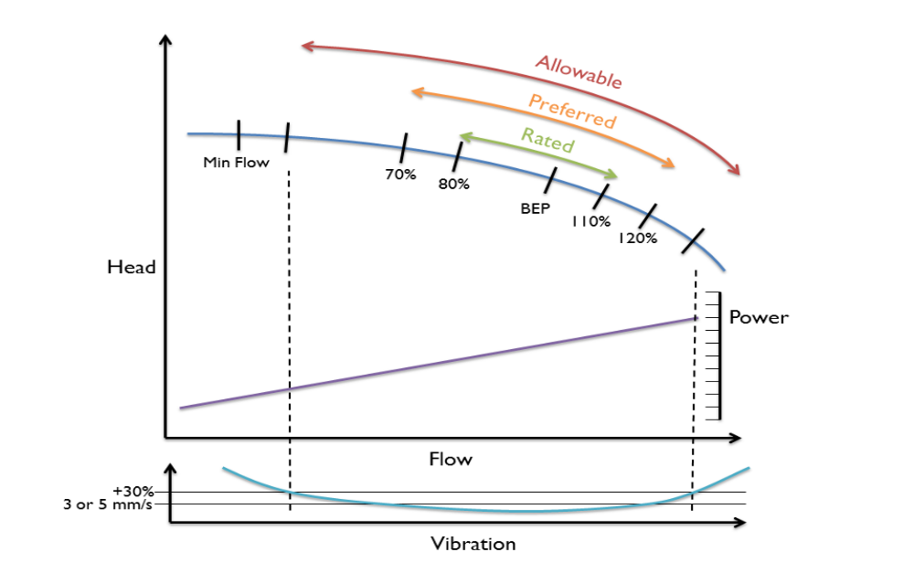
8.NPSH and its Significance

Pump suction side hydraulic calculation is always one of the most important checking done for all pumps. This calculation may determine pump suction line size, suction piping layout, suction vessel elevation and pump type. Addition to allowable suction velocity and pressure drop which have to be in the range defined by project design criteria, Net Positive Suction Head (NPSH) is another parameter that check the adequacy of selected pump in specified service.

There are two types of NPSH. First is NPSH Available which is a function of the hydraulic parameters of system in which the pump operates. NPSHA is the excess pressure of the liquid over its vapor pressure as it arrives at the pump suction nozzle in height of liquid absolute. The second is NPSH Required which is the positive head required at the pump suction to overcome pressure drops in the pump and maintain the majority of the liquid above its vapor pressure.
NPSHR is the specification of pump and it depends on pump mechanical design, so it can be only given by pump vendor. The NPSHR is determined by pumping cold water through the pump with constant impeller size and RPM while reducing the suction head until the pump showed a reduction in discharge head of three percent (3%), due to the low suction head and any formation of bubbles within the pump. This point is called "the point of incipient cavitation".
In designing a pumping system, it is essential to provide adequate NPSHA for proper pump operation. Insufficient NPSHA may seriously restrict pump selection, or even force an expensive system redesign. On the other hand, providing excessive NPSHA may needlessly increase system cost. Cavitation is one of the main causes of pump damage which can happen as a result of vaporization, gas/air entrainment, internal recirculation, and turbulence or combination of them. This note focuses on pump cavitation due to vaporization.
The following solution may be considered to increase the available NPSH:

• Raise the liquid level in the suction vessel
• Increase the suction vessel elevation from ground
• Pressurize the suction vessel
• Place the pump in a pit
• Use vertical can pump.
• Reduce the number of fitting in pump suction side.
• Increase the size of suction line
• Place the pump closer to suction vessel to minimize the suction pipe length.
• Elimination of suction strainer can be considered as an option as approved by client
• Lower the pumping fluid temperature
• Install a booster pump
• Reduce the liquid temperature by injecting cooler fluid at the suction if practical.
• Insulate the piping if temperature rise is substantial.
• Change the location of pump circulation line from suction line to suction vessel if it heats fluid

