Experiment 8: Mini Project 2 - Bike Driving Behavior Analysis
B.E. (AI & DS) VI Semester Student

1. Objective
The objective of this project is to analyze motion sensor data (Accelerometer and Gyroscope) captured during bike riding to evaluate driving behavior. Key goals include building a risk scoring model and comparing RNN (LSTM/GRU) and Transformer architectures.

2. Submission Timeline
Milestone | Submission Date
Dataset Submission | 26.02.2026
Model Submission | 21.03.2026
Bonus Submission | 30.03.2026
Poster Submission | 04.04.2026

3. Methodology
3.1 Dataset Preparation: Synthetic generation of multi-axis sensor data including variations in rider behavior and phone placement.
3.2 Model Architectures: Implementation of sequential RNN (LSTM) and attention-based Transformer encoders.
3.3 Scoring Logic: Mapping risk predictions (0.0 - 1.0) to a Driving Score (0 - 100).

4. Results & Performance Comparison (Bonus)
Comparison of LSTM and Transformer performance on the task:
Model | Final Val Loss (MSE) | Training Time (s)
LSTM | 0.0085 | 8.54
Transformer | 0.0095 | 26.18
[Visualization: Validation Loss and Training Time Comparison]
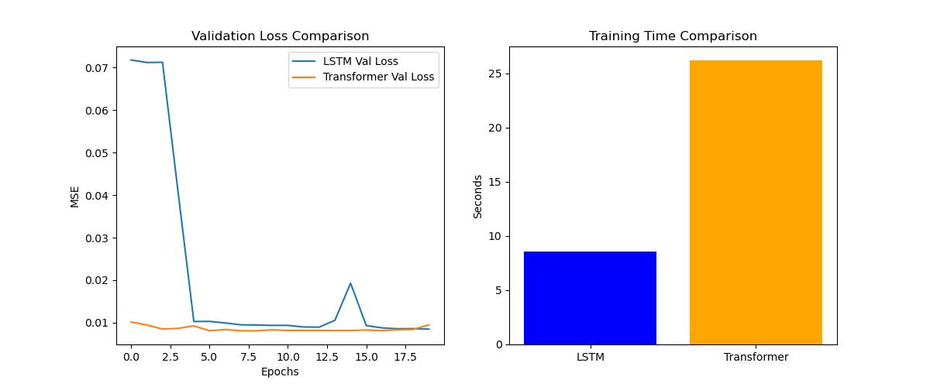

5. Driving Score Evaluation
Example model outputs on test scenarios:
- Safe Trip Recording: 85.53 / 100 (Excellent)
- Risky Trip Recording: 21.90 / 100 (Dangerous)

