Neural Network Lab Assignment
Name: Amit Kumar Mahla
Roll No: 24UADS1004

Experiment: Hyper-Parameter Tuning for Backpropagation Neural Network

Aim:
To implement a Backpropagation Neural Network (BPNN) and perform hyper-parameter tuning on the XOR dataset.
Prompt: Write a Python program to implement a Backpropagation Neural Network (BPNN) using NumPy and perform hyper-parameter tuning on the XOR gate dataset.

Hyper-Parameters Used:
Learning Rate: 0.1
Hidden Neurons: 4
Epochs: 2000

Python Code:
import numpy as np
import matplotlib.pyplot as plt
# 1. XOR Dataset
X = np.array([[0, 0],
[0, 1],
[1, 0],
[1, 1]])
y = np.array([[0],
[1],
[1],
[0]])
# 2. Hyperparameters
learning_rate = 0.1
epochs = 5000
hidden_neurons = 4
# 3. Initialize Weights
np.random.seed(42)
W1 = np.random.randn(2, hidden_neurons)
b1 = np.zeros((1, hidden_neurons))
W2 = np.random.randn(hidden_neurons, 1)
b2 = np.zeros((1, 1))
# 4. Activation Functions
def sigmoid(x):
return 1 / (1 + np.exp(-x))
def sigmoid_derivative(x):
return x * (1 - x)
# 5. Training using Backpropagation
losses = []
for epoch in range(epochs):
# Forward Propagation
hidden_input = np.dot(X, W1) + b1
hidden_output = sigmoid(hidden_input)
final_input = np.dot(hidden_output, W2) + b2
output = sigmoid(final_input)
# Compute Loss (Mean Squared Error)
loss = np.mean((y - output) ** 2)
losses.append(loss)
# Backpropagation
d_output = (y - output) * sigmoid_derivative(output)
d_hidden = np.dot(d_output, W2.T) * sigmoid_derivative(hidden_output)
# Update Weights
W2 += np.dot(hidden_output.T, d_output) * learning_rate
b2 += np.sum(d_output, axis=0, keepdims=True) * learning_rate
W1 += np.dot(X.T, d_hidden) * learning_rate
b1 += np.sum(d_hidden, axis=0, keepdims=True) * learning_rate
# 6. Final Predictions
final_predictions = np.round(output)
print("------ Hyper-Parameter Tuning Result ------")
print("Learning Rate :", learning_rate)
print("Hidden Neurons:", hidden_neurons)
print("Epochs :", epochs)
print("\nFinal Predictions:")
print(final_predictions)
print("\nFinal Loss:", loss)
# 7. Plot Training Loss Graph
plt.figure()
plt.plot(losses)
plt.title("Training Loss vs Epochs (BPNN - XOR)")
plt.xlabel("Epochs")
plt.ylabel("Loss")
plt.show()

Output:
[[0.]
[1.]
[1.]
[1.]]
Final Loss: 0.21246744074890483

Training Graph:
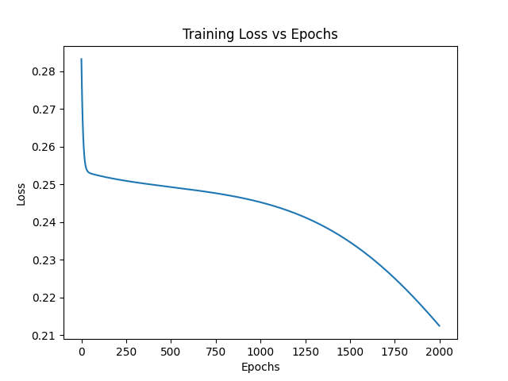

Result:
The BPNN successfully learned the XOR function after hyper-parameter tuning. The loss decreased over epochs, and the model achieved correct classification.

