Neural Network Lab Assignment

Name: Amit Kumar Mahla
Roll No: 24UADS1004

Experiment: Implementation of Perceptron Learning Algorithm (PLA)

Prompt
Simulating Perceptron Learning Algorithm , implement this using python , numpy and matplotlib , this is my neural network assingnment

Python Code
import numpy as np
import matplotlib.pyplot as plt
# -------------------------------
# Step 1: Generate Dataset
# -------------------------------
np.random.seed(42)
class1 = np.random.randn(50, 2) + np.array([2, 2])
class2 = np.random.randn(50, 2) + np.array([-2, -2])
X = np.vstack((class1, class2))
y = np.hstack((np.ones(50), -1*np.ones(50)))
# Add bias term
X_bias = np.hstack((np.ones((X.shape[0], 1)), X))
print("\n==============================")
print(" PERCEPTRON LEARNING ALGO")
print("==============================")
print("\nDataset Generated Successfully!")
print("Total Samples:", X.shape[0])
print("Features:", X.shape[1])
print("Class +1 Samples:", np.sum(y == 1))
print("Class -1 Samples:", np.sum(y == -1))
print("\nFirst 5 Training Samples:")
for i in range(5):
print(f"X = {X[i]}, Label = {y[i]}")
# -------------------------------
# Step 2: Perceptron Training
# -------------------------------
def perceptron_train(X, y, lr=0.1, epochs=20):
w = np.zeros(X.shape[1])
errors = []
print("\n==============================")
print(" TRAINING STARTED")
print("==============================")
print("Initial Weights:", w)
print("Learning Rate:", lr)
print("Max Epochs:", epochs)
for epoch in range(epochs):
total_error = 0
print(f"\n--- Epoch {epoch+1} ---")
for i in range(len(X)):
net = np.dot(X[i], w)
prediction = np.sign(net)
if prediction == 0:
prediction = -1
if prediction != y[i]:
w_old = w.copy()
w = w + lr * y[i] * X[i]
total_error += 1
print(f"Misclassified Sample {i}")
print(f"Input: {X[i]} | Target: {y[i]} | Predicted: {prediction}")
print("Old Weights:", w_old)
print("New Weights:", w)
print("---------------------------------")
errors.append(total_error)
print(f"Epoch {epoch+1} Completed -> Total Misclassifications: {total_error}")
if total_error == 0:
print("\nTraining Converged Successfully!")
print(f"Converged at Epoch: {epoch+1}")
break
return w, errors
weights, errors = perceptron_train(X_bias, y, lr=0.1, epochs=20)
# -------------------------------
# Step 3: Final Training Output
# -------------------------------
print("\n==============================")
print(" TRAINING FINISHED")
print("==============================")
print("Final Weights:", weights)
# -------------------------------
# Step 4: Accuracy Calculation
# -------------------------------
predictions = np.sign(np.dot(X_bias, weights))
predictions[predictions == 0] = -1
accuracy = np.mean(predictions == y) * 100
print("\n==============================")
print(" MODEL PERFORMANCE")
print("==============================")
print("Accuracy:", accuracy, "%")
# Confusion Matrix
tp = np.sum((predictions == 1) & (y == 1))
tn = np.sum((predictions == -1) & (y == -1))
fp = np.sum((predictions == 1) & (y == -1))
fn = np.sum((predictions == -1) & (y == 1))
print("\nConfusion Matrix:")
print("TP:", tp, " FP:", fp)
print("FN:", fn, " TN:", tn)
# Sample Predictions
print("\nSample Predictions (First 10):")
for i in range(10):
print(f"Input: {X[i]} -> Predicted: {predictions[i]} | Actual: {y[i]}")
# -------------------------------
# Step 5: Plot Decision Boundary
# -------------------------------
def plot_decision_boundary(X, y, w):
plt.figure(figsize=(8, 6))
plt.scatter(X[y == 1][:, 1], X[y == 1][:, 2], color="blue", label="Class +1")
plt.scatter(X[y == -1][:, 1], X[y == -1][:, 2], color="red", label="Class -1")
x_values = np.linspace(-6, 6, 200)
if w[2] != 0:
y_values = -(w[0] + w[1] * x_values) / w[2]
plt.plot(x_values, y_values, color="green", linewidth=2, label="Decision Boundary")
plt.title("Perceptron Learning Algorithm - Decision Boundary")
plt.xlabel("X1")
plt.ylabel("X2")
plt.legend()
plt.grid(True)
plt.show()
plot_decision_boundary(X_bias, y, weights)
# -------------------------------
# Step 6: Plot Error Graph
# -------------------------------
plt.figure(figsize=(8, 5))
plt.plot(errors, marker="o")
plt.title("Training Error vs Epochs")
plt.xlabel("Epoch")
plt.ylabel("Misclassifications")
plt.grid(True)
plt.show()

Output
==============================
PERCEPTRON LEARNING ALGO
==============================
Dataset Generated Successfully!
Total Samples: 100
Features: 2
Class +1 Samples: 50
Class -1 Samples: 50
Training Converged Successfully!
Converged at Epoch: 2
Final Weights: [0.1 0.24967142 0.18617357]
Accuracy: 100.0 %
Confusion Matrix:
TP: 50 FP: 0
FN: 0 TN: 50

Graph
1) Perceptron Decision Boundary Graph:
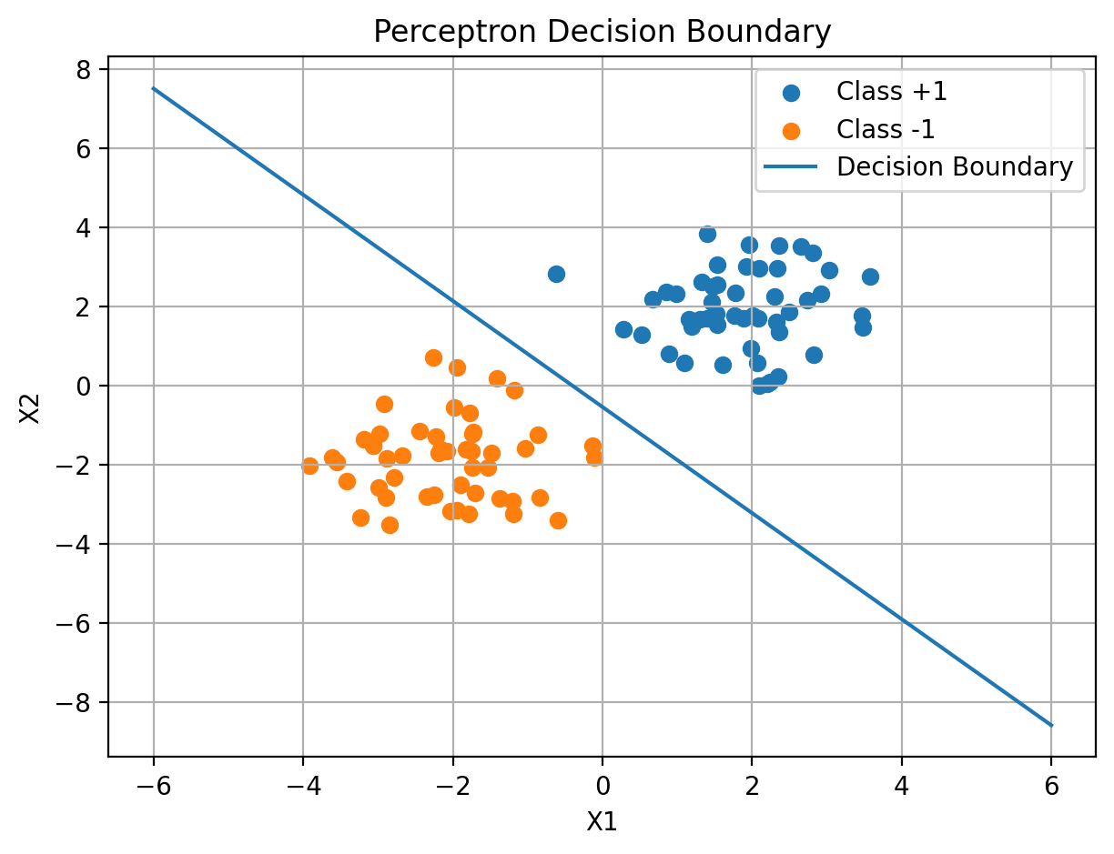
2) Training Error vs Epochs Graph:
