**CBA**

**Payment Approval System**

**PAS Release 1**

**Test Plan**

Functional / E2E Integration

Revision: B

|  |  |  |  |
| --- | --- | --- | --- |
| **Revision** | **Change Date** | **By** | **Description** |
| A | 21/08/2021 | Amit Malpure | First draft |
| B | 22/08/2021 | Amit Malpure | Final |
|  |  |  |  |

|  |  |
| --- | --- |
| **Document Information** | |
| **Document Number:** |  |
| **Issue Date:** | 22/08/2021 |
| **Revision Number:** | B |
| **Status:** | Final |
| **Author:** | Amit Malpure |
| **Approver:** |  |
|  |  |

|  |  |  |  |  |
| --- | --- | --- | --- | --- |
| **Document Approval** | | | | |
| **Name** | **Organization** | **Role** | **Date** | **Signature** |
| **Prepared by**  Amit Malpure | CBA | Lead – Principal SDET | 22/08/2021 |  |
| **Reviewed by** | CBA | Test Project Manager |  |  |
| **Reviewed by** | CBA | Technical Delivery Manager |  |  |
| **Reviewed by** | CBA | Senior Program Manager |  |  |
| **Reviewed by** | CBA | Technical Design Authority |  |  |
| **Approved By** | CBA |  |  |  |

s

Table of Contents

1. Introduction 4

1.3. Purpose 4

1.4. Applicable Documents 4

1.5. Glossary, Acronyms and Abbreviations 4

2. Executive Summary 5

2.3. Project Description 5

2.4. Test Scope 5

2.5. Out of Scope 5

2.6. Test Objective 5

3. Test Approach 6

3.3. Automating test cases 6

3.4. Test Deliverables 6

3.5. Test Cases 7

4. Use Case example walkthrough 12

5. Test Environment 13

6. Roles and Responsibilities 13

7. Defect Management Process 14

8. Test Risks, Dependencies and Assumptions 15

9. Test Entry \ Exit Criteria 15

9.3. Testing Entry Criteria 15

9.4. Test Exit Criteria 15

10. Test Tools 15

# Introduction

## Purpose

The purpose of this plan is to describe the approach for the Functional/E2E Integration Testing of the Payment Approval System – Release 1.

The documents elaborate testing scope, test approach and the test cases. Also it talks about roles and responsibilities, test environments and tools to be used.

## Applicable Documents

|  |
| --- |
| System Functional Description Release 1 |
| Test Strategy Rev E |
| Statement of Works Rev D |
| System Architecture Description Release 1 Rev C |
| Glossary and Acronyms |

## Glossary, Acronyms and Abbreviations

PAS – Payment Approval System

CPS – Card Payment System

Please see *Glossary and Acronyms* for a list of defined terms and acronyms used in this report.

# Executive Summary

## Project Description

The Payment Approval System validates all payments initiated by the Card Payment System. PAS gets requests from CPS based on which more details are fetched from customer and merchant database. PAS validates the data using the Fraud Decisioning Engine and send appropriate response back to CPS.

# The Card Payment System enables customers / users to make payments using credit cards and debit cards.

## Test Scope

Following are the features in scope of this test plan:

* PAS Integration Layer
* Integrations with external systems
  + CPS
  + DW

## Out of Scope

Following are the features in scope of this test plan:

* CPS
* Non-functional Testing

## Test Objective

* Ensure the Application Under Test conforms to functional requirements.
* Ensure the AUT meets the quality specifications defined by the client.
* Bugs/issues are identified and fixed before go live.
* Verify system integration with end-to-end scenarios.

# Test Approach

This Test Plan is a reference source for all parties involved in PAS Release 1 Functional/E2E Integration testing, who will be required to follow and support the approach outlined in this document.

Functional/E2E Integration Testing will use a combination of manual and automation testing.

## Automating test cases

#### Where possible, execute automated regression test suite (developed in EIT / scrum) in the SIT test environments. Tests that are not automated will be run manually.

Java, Apache CXF, Selenium will be used for creating and executing automation scripts.

## Test Deliverables

* Test Plan (This document)
* Test Cases and Test Steps (This document)
* Defect Reports
* Test Summary Report

## Test Cases

The test cases for all the functionalities in scope for Release 1 are detailed below:

|  |  |
| --- | --- |
| **Test Case Id** | **TC_001** |
| **Test Case Title** | Verify successful Payment for Adult NSW Customer |
| **Test Priority** | High |
| **Core / Regression** | Y |
| **Precondition** | CPS is up and running  DW is up and running |
| **Test Steps** | Initiate card payment using CPS for:  Adult Customer with DOB  NSW Customer  NSW Merchant |
| **Data reference** | PAS_Test_Data.xlsx: TC_001 |
| **Expected Result** | Payment should be approved. |

|  |  |
| --- | --- |
| **Test Case Id** | **TC_002** |
| **Test Case Title** | Verify successful Payment for Minor NSW Customer |
| **Test Priority** | High |
| **Core / Regression** | Y |
| **Precondition** | CPS is up and running  DW is up and running |
| **Test Steps** | Initiate card payment using CPS for:  Minor Customer with DOB  NSW Customer  NSW Merchant  Transaction amount < $5000 |
| **Data reference** | PAS_Test_Data.xlsx: TC_002 |
| **Expected Result** | Payment should be approved. |

|  |  |
| --- | --- |
| **Test Case Id** | **TC_003** |
| **Test Case Title** | Verify failed Payment for non-NSW Merchant |
| **Test Priority** | High |
| **Core / Regression** | Y |
| **Precondition** | CPS is up and running  DW is up and running |
| **Test Steps** | Initiate card payment using CPS for:  Adult Customer with DOB  NSW Customer  VIC Merchant  Transaction amount > $20000 |
| **Data reference** | PAS_Test_Data.xlsx: TC_003 |
| **Expected Result** | Payment should not be approved. |

|  |  |
| --- | --- |
| **Test Case Id** | **TC_004** |
| **Test Case Title** | Verify failed Payment for minor customer |
| **Test Priority** | High |
| **Core / Regression** | Y |
| **Precondition** | CPS is up and running  DW is up and running |
| **Test Steps** | Initiate card payment using CPS for:  Minor Customer with DOB  NSW Merchant  Transaction amount > $5000 |
| **Data reference** | PAS_Test_Data.xlsx: TC_004 |
| **Expected Result** | Payment should not be approved. |

|  |  |
| --- | --- |
| **Test Case Id** | **TC_005** |
| **Test Case Title** | Verify successful Payment for minor customer and QLD merchant |
| **Test Priority** | High |
| **Core / Regression** | Y |
| **Precondition** | CPS is up and running  DW is up and running |
| **Test Steps** | Initiate card payment using CPS for:  Minor Customer with DOB  QLD Merchant  Transaction amount < $5000 |
| **Data reference** | PAS_Test_Data.xlsx: TC_005 |
| **Expected Result** | Payment should be approved. |

|  |  |
| --- | --- |
| **Test Case Id** | **TC_006** |
| **Test Case Title** | Verify successful Payment for DOB unknown customer |
| **Test Priority** | High |
| **Core / Regression** | Y |
| **Precondition** | CPS is up and running  DW is up and running |
| **Test Steps** | Initiate card payment using CPS for:  Customer with unknown DOB  NSW Merchant |
| **Data reference** | PAS_Test_Data.xlsx: TC_006 |
| **Expected Result** | Payment should be approved. |

|  |  |
| --- | --- |
| **Test Case Id** | **TC_007** |
| **Test Case Title** | Verify failed Payment for unknown customer postcode |
| **Test Priority** | High |
| **Core / Regression** | Y |
| **Precondition** | CPS is up and running  DW is up and running |
| **Test Steps** | Initiate card payment using CPS for:  Customer with unknown post code  NSW Merchant  Transaction amount > $10000 |
| **Data reference** | PAS_Test_Data.xlsx: TC_007 |
| **Expected Result** | Payment should not be approved. |

|  |  |
| --- | --- |
| **Test Case Id** | **TC_008** |
| **Test Case Title** | Verify failed Payment for unknown customer postcode |
| **Test Priority** | High |
| **Core / Regression** | Y |
| **Precondition** | CPS is up and running  DW is up and running |
| **Test Steps** | Initiate card payment using CPS for:  Customer with unknown post code  NSW Merchant  Transaction amount <= $10000 |
| **Data reference** | PAS_Test_Data.xlsx: TC_008 |
| **Expected Result** | Payment should be approved. |

|  |  |
| --- | --- |
| **Test Case Id** | **TC_009** |
| **Test Case Title** | Verify failed Payment for unknown customer postcode and DOB |
| **Test Priority** | High |
| **Core / Regression** | Y |
| **Precondition** | CPS is up and running  DW is up and running |
| **Test Steps** | Initiate card payment using CPS for:  Customer with unknown post code and DOB  NSW Merchant  Transaction amount <= $10000 |
| **Data reference** | PAS_Test_Data.xlsx: TC_009 |
| **Expected Result** | Payment should be approved. |

|  |  |
| --- | --- |
| **Test Case Id** | **TC_010** |
| **Test Case Title** | Verify successful Payment for non-NSW Merchant |
| **Test Priority** | High |
| **Core / Regression** | Y |
| **Precondition** | CPS is up and running  DW is up and running |
| **Test Steps** | Initiate card payment using CPS for:  Adult Customer with DOB  NSW Customer  VIC Merchant  Transaction amount <= $20000 |
| **Data reference** | PAS_Test_Data.xlsx: TC_010 |
| **Expected Result** | Payment should be approved. |

# Use Case example walkthrough

Test Case Title: Verify successful Payment for Adult NSW Customer

Step 1: Check CPS and DW are up and running

Step 2: Find an Adult customer in DW with following details:

Cust DOB: 10 Jan 2000 (DOB before year 2002)

Cust Postcode: 2051 (Any NSW postcode, starting with 2)

Step 3: Find a merchant in DW with following details:

Merchant Postcode: 2051 (Any NSW postcode, starting with 2)

Step 4: Send a payment request using following data

Cust Id = 123

Tran Id = 100001

Tran Amount = 2000

Merchant Id = 456

Step 5: Validate result

Payment should be successful.

# Test Environment

The following test environment will be available for test execution:

* SIT
* UAT
* STG / Preprod
* Hosted in Azure
* Accessibile via VPN

# Roles and Responsibilities

|  |  |
| --- | --- |
| **Roles** | **Responsibilities** |
| **Senior Program Manager** | * Accountable for the definition & management of program scope * Ensures that the program outcomes meet the jointly agreed needs of the business. * Ownership of effective and professionally run steering committee and core team meetings. |
| **Test Manager** | * Overall Management of the Testing effort * Sign off on the Test Plan and Test Completion Report. * Escalation point for Project Test leads. * Confirm correct testing approach is being followed. |
| **Test Lead** | * Functional Test Coordination * Host/Attend the Triage Meetings * Managing Test execution. * Managing raising of Defects * Escalation of any Issues or Risks. |
| **Test Team members** | * Test Execution * Test Data Set up. * Recording of Observations and test results. * Escalation of any Issues or Risks. |

# Defect Management Process

The following Jira defect Management flow will be used during testing:

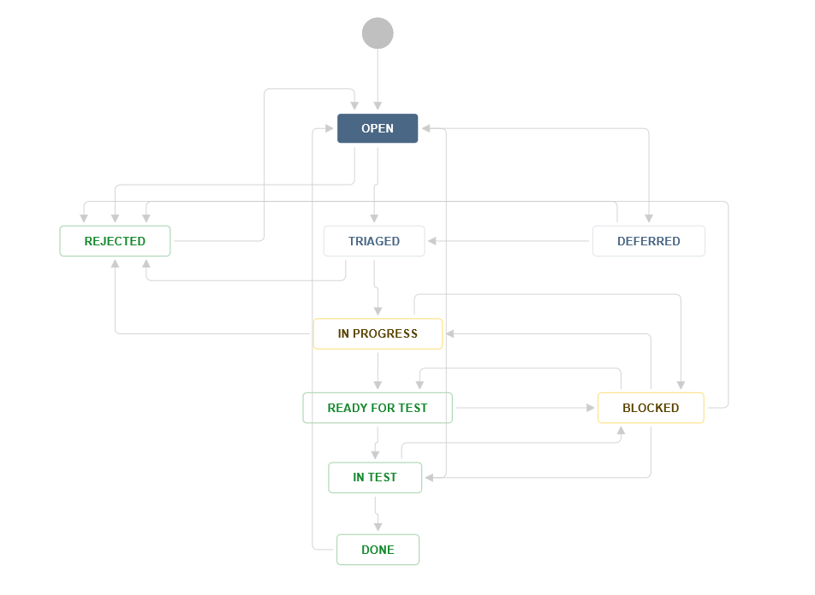

# Test Risks, Dependencies and Assumptions

* CPS is up and running and connected to PAS
* DW is up and running and connected to PAS
* Approval of Test plan by product owner
* Availability of required test resources

# Test Entry \ Exit Criteria

# Testing Entry Criteria

|  |  |
| --- | --- |
| **#** | **Checklist** |
| 1 | All requirements and test case coverage are signed off |
| 2 | All required software has been deployed to test environment |
| 3 | All required test resources are available |
| 4 | No major defects in EIT |
| 5 | Handover to System Test Gateway has passed |

# Test Exit Criteria

| **#** | **Checklist** |
| --- | --- |
| 1 | There are no defects with Severity = 4 AND Priority = HIGH |
| 2 | All test cases have been executed |

# Test Tools

* Testrail – Test management
* Jira – Defect management
* Jenkins – CICD
* Postman – Test execution
* Eclipse / IntelliJ
* Java
* Apache CXF libraries
* Selenium libraries