INTRODUCTION

Project Description

The project “Exam Suite” is developed in Java, which mainly focuses on basic Exam operations. “Exam Suite” is a windows application written for 32bit Windows operating systems, designed to help users to write exams. The software Exam Suite has 3 main modules.
- Login Module
- Insertion to Database Module
- Extracting from Database Module

SYSTEM ANALYSIS

EXISTING SYSTEM:

System Analysis is a detailed study of the various operations performed by a system and their relationships within and outside of the system. Here the key question is what all problems exist in the present system? What must be done to solve the problem? Analysis begins when a user or manager begins a study of the program using existing system.

During analysis, data collected on the various files, decision points and transactions handled by the present system. The commonly used tools in the system are Data Flow Diagram, interviews, etc. Training, experience and common sense are required for collection of relevant information needed to develop the system. The success of the system depends largely on how clearly the problem is defined, thoroughly investigated and properly carried out through the choice of solution. A good analysis model should provide not only the mechanisms of problem understanding but also the frame work of the solution. Thus it should be studied thoroughly by collecting data about the system. Then the proposed system should be analyzed thoroughly in accordance with the needs.

PROPOSED SYSTEM:

Proposed system is an Exam Suite. According to designate we can create an account, writing exam using that account. Our proposed system has the following advantages.

- User friendly Interface
- Fast access to database
- Less error
- Storage Capacity

SYSTEM DESIGN

OUTPUT FORM DESIGN
Computer output is the most important and direct source of information to the user. Efficient, intelligible output design should improve the system relationship with the user and help in decision-making. The outputs provide in the system are the softcopy report available for printing. Printouts should be designed around the output requirement of the user. The output devices to consider depend on the factor such as compatibility of the device with the system, response time requirement and number of copies needed.

INPUT FORM DESIGN

Input Design is the process of converting user originated computer based format. Inaccurate input data are the most common cause of errors in data processing .Errors entered by data entry operators can be controlled by input design. The goal of designing input data is to make data entry as easy, logical and free from errors as far as possible. In this system, the input screens are developed according to the user requirements.

Menu Tree

Main Module
System

Module I
Login
Module II
Sign Up

Module III
Exam
Module IV
Result

Registered User
Registration
Questions
Result published

DATABASE DESIGN

The general theme behind a database is to handle information as an integrated whole. A database is a collection of interrelated data stored with minimum redundancy to serve many users quickly and effectively. After designing the input and output, the analyst must concentrate on database design or how data should be organized around user requirements. The general objective is to make information access, easy quick, inexpensive and flexible for other users. During database design the following objectives are concerned:-

- Controlled Redundancy
- Easy to learn and use
- More information and low cost
- Accuracy
- Integrity

TABLES USED

Name: Question
Primary key: scode, qno

Fieldname | Type | Size
Scode | Varchar2 | 5
Qno | Varchar2 | 5
Qdesc | Varchar2 | 25
Choice1 | Varchar2 | 30
Choice2 | Varchar2 | 30
Choice3 | Varchar2 | 30
Answer | Varchar2 | 30

Name: Registration
Primary key: Email

Fieldname | Type | Size
Email | Varchar2 | 5
Fname | Varchar2 | 5
Lname | Varchar2 | 25
Dob | Number | 10
Quali | Varchar2 | 15
Ph | Number | 15
password | Varchar2 | 10

Name: Result

Fieldname | Type | Size
Email | Varchar2 | 10
Exam | Varchar2 | 10
Percent | Number | 5
Status | Varchar2 | 10

DATA FLOW DIAGRAM

Context Diagram

User
System

Result

LEVEL 1: Skeleton Structure

Login
0.1

Main System
0.3

Database Connection
0.2

LEVEL 2:
Data Base
Sing up
users
Exam Results
Exam

Add
Employee

Edit
Emplyee

Delete
Employee

LEVEL 3:
Database

System

Password /
User name

SYSTEM IMPLEMENTATION

ABOUT OPERATING SYSTEM
Windows XP is a line of operating systems developed by Microsoft for use on general-purpose computer systems, including home and business desktops, notebook computers, and media centers. The letters "XP" stand for experience. Windows XP is the successor to both Windows 2000 and Windows Me, and is the first consumer-oriented operating system produced by Microsoft to be built on the Windows NT kernel and architecture
The most common editions of the operating system are Windows XP Home Edition, which is targeted at home users, and Windows XP Professional, which has additional features such as support for Windows Server domains and two physical processors, and is targeted at power users and business clients. Windows XP Tablet PC Edition is designed to run the ink-aware Tablet PC platform. Two separate 64-bit versions of Windows XP were also released, Windows XP 64-bit Edition for IA-64 (Itanium) processors and Windows XP Professional x64 Edition for x86-64 processors.
Windows XP is known for its improved stability and efficiency over previous versions of Microsoft Windows. It presents a significantly redesigned graphical user interface, a change Microsoft promoted as more user-friendly than previous versions of Windows. New software management capabilities were introduced to avoid the "DLL hell" that
Plagued older consumer versions of Windows. It is also the first version of Windows to use product activation to combat software piracy, a restriction

That did not sit well with some users and privacy advocates. Windows XP has also been criticized by some users for security vulnerabilities, tight
Integration of applications such as Internet Explorer and Windows Media Player, and for aspects of its user interface.

ABOUT THE LANGUAGE

Java is a programming language developed by Sun Microsystems and is based on the concepts of C and C++. The syntax for Java is similar to C.

HISTORY OF JAVA

In November 1995, Sun Microsystems introduced a new programming language to the world- Java. Until then the word “Java” could only mean an island in Indonesia or a particular blend of coffee.

Though its initial development began as early as 1991, it took some time for the final working version to reach the market. The basic objective behind developing the language was to create software that could be embedded in consumer electronic devices. Efforts were taken to produce a portable, platform in dependable language, and the result of this led to the birth of a new language. James Gosling and a team of other programmers were the pioneers behind this development. It was initially called “Oak” but was later renamed to “Java”. Slowly but gradually it was found that Internet users had similar problems of portability and platform independence and were looking for software that could address these issues. Java language was found to be small, secure and portable. Thus Java, which was initially developed to cater

To small-scale problems, was found capable of addressing large-scale problems across the Internet.

FEATURES OF JAVA

The Java Language is
- Simple
- Object Oriented
- Platform-Independent
- Robust
- Secure
- Distributed
- Multithreaded

  - Simple
The designers of Java were trying to develop a language that a programmer could learn quickly. They also wanted the language to be familiar to most programmers, for ease of migration. Hence the Java designers removed a number of complex features that existed in C and C++. Java does not have features such as pointer manipulation, operator overloading etc. Java does not use the ‘go to’ statement, or header filed. Constructs like ‘struct’ and ‘union’ have also been removed from Java.

- Platform-Independent
Platform-independence refers to the ability of the program to migrate from one computer to another without any

Difficulty. Java is platform independent at the source level as well as at the binary level.
Java is strongly typed language. This means that you need to declare the type for any variable. The java data types are consistent across all the development platforms. Java has its own foundation class libraries. This allows the programmer to write code that can be mobbed from one machine to another, with out having to rewrite it.
In short, platform independence at the source level allows the user to move the source code from one system to another, compile the code, and run it clearly on the system.
Platform independence at the binary level allows the user to run the compiled binary file on multiple platforms without recompiling the code.

- Robust
Java is strictly a typed language. Hence it requires explicit method declaration. Java checks your code at the time of compilation and also at the time of interpretation. Thus it eliminates certain types of programming errors.
Java does not have pointers and pointer arithmetic. It checks all access to arrays and strings at the runtime. It also checks the casts of objects from one type to another at runtime.
In traditional programming environments, the programmer had to manually allocate memory. By the end of the program, the programmer had to explicitly free this memory. Problems arose when the programmer forgot to de allocate the memory. In Java the programmer doesn’t need to bother about memory de allocation. It’s done automatically, as Java provides

Garbage collections for un used objects. Java’s exception handling feature simplifies the task of error handling and recovery.

- Secure:
Viruses are a great cause of worry in the world of computers. Prior to the advent of Java, programmers had to first scan files, before downloading and executing them. Often this precaution was no guarantee against viruses. Also there were many malicious programs that programmers need to look out for.
These programs could search the contents of your local file system and retrieve sensitive data.
Java provides a controlled environment for the execution of the program. It never assumes that the code is safe for execution. And since java is more than a programming language, it provides several layers of security control.
In the first layer, the data and methods are encapsulated in the class. They can be accessed only through the interface that the class provides. Java does not allow any pointer arithmetic. Hence it does not allow direct access to the memory. It disallows array overflow, prevents reading memory out of bounds, and provides garbage collection. All these features help minimize safety and portability problems.

In the second layer the compiler ensures that the code is safe and follows the protocols set by Java before compiling the code.
The third layer is safety provided by the Interpreter. The verifier thoroughly screens the byte codes to ensure they obey the rules before executing them.
The fourth layer takes care of loading the classes. The class loader ensures that the class doesn’t violate the access restrictions, before loading it to the system.

- Distributed
Java can be used to develop applications that are portable across multiple platforms and operating systems. Java is designed to support network applications.

- Multithreaded
Java programs use a process called ‘multithreading’ to perform many tasks simultaneously. Java provides the master solution for synchronizing multiple processes. The built in support for threads enables interactive applications on the internet to run simultaneously

SYSTEM CONFIGURATION

HARDWARE REQUIREMENTS

Processor : Intel Pentium IV 2.4 GHZ or above
Clock speed : 500 MHZ
System bus : 32 bits
RAM : 256MB of RAM
HDD : 40 GB or higher
Monitor : SVGA COLOR
Keyboard : 108Keys
Mouse : 2 button mouse

SOFTWARE REQUIREMENTS

OS : MS WINDOWS XP SP2
Environment : Java Runtime Environment 1.5
Front end : Core Java J2SDK1.5
Back end : Microsoft Access 2003

ABOUT MS-ACCESS

Access is a relational database program .Access is used to enter, edit, and analyze lists of data. Relational databases minimize redundant data

Advantages of Access
- Duplicate data is minimized
- Information is more accurate
- Data entry is faster and easier
- Information can be viewed and sorted in multiple ways.
- Information is more secure
- Information can be shared among several users
- Information retrieval is faster and easier

APPENDIX

SOURCE CODE

LogFom.java

import java.awt.*;
import java.awt.event.*;
import javax.swing.*;
import java.sql.*;
class LogFom extends JFrame implements ActionListener
{
JLabel lnl,pwl,ch,ch1,nusr;
JTextField lnt;
JPasswordField pwt;
JButton ok,can,btnr;
Container c;
String ln,psw;

Connection conn;
PreparedStatement pstmt;

public void setup()
{
c=getContentPane();
resize(350,230);
Dimension d=size();
setLocation(d.width,d.height);
setTitle("Exam Suite");
c.setLayout(null);

lnl=new JLabel("LOGIN EMAIL");
lnt=new JTextField();
lnl.setBounds(20,20,80,30);
lnt.setBounds(150,20,180,30);

Pwl=new JLabel("PASSWORD");
pwt=new JPasswordField();

pwl.setBounds(20,70,80,30);
pwt.setBounds(150,70,180,30);

ok=new JButton("OK");
ok.setBounds(50,120,100,30);

can=new JButton("CANCEL");
can.setBounds(180,120,100,30);

nusr=new JLabel("For new user please ");
nusr.setBounds(140,165,150,30);

btnr=new JButton("Sign up");
btnr.setBounds(255,169,77,20);

c.add(lnl);
c.add(lnt);
c.add(pwl);
c.add(pwt);
c.add(ok);
c.add(can);
c.add(nusr);
c.add(btnr);

ok.addActionListener(this);
can.addActionListener(this);
btnr.addActionListener(this);
setVisible(true);
}

public void actionPerformed(ActionEvent ae)
{
String s=ae.getActionCommand();

if(s.equals("OK"))
{

try
{
pstmt=conn.prepareStatement("select * from registration");
ln=lnt.getText();
System.out.println("ln1 "+ln);
psw=pwt.getText();
System.out.println("psw "+psw);
ResultSet rs=pstmt.executeQuery();
int flag=0;
while(rs.next())
{
String one=rs.getString("email");
Stringtwo=rs.getString("password");
if(ln.equals(one) && psw.equals(two))
{
flag=1;
Rules ru=new Rules(one);
ru.setUp();
setVisible(false);
dispose();
}

}
if(flag==0)
{
JOptionPane.showMessageDialog (this, "Invalid Username or Password.");
"Exam Suite ", JOptionPane.PLAIN_MESSAGE);
lnt.setText("");
pwt.setText("");

}
}
catch(SQLException e)
{
System.out.println("sql exception");
}

}

if(s.equals("CANCEL"))
{
System.exit(0);
}

if(s.equals("Sign up"))
{
new SignUp().setUp();
setVisible(false);
}
}

LogFom()
{

try
{
Class.forName("sun.jdbc.odbc.JdbcOdbcDriver");
conn=DriverManager.getConnection("jdbc:odbc:ExamSuite","","");
}
catch(ClassNotFoundException e)
{
System.out.println("class not exception");
}
catch(SQLException e)
{
System.out.println("sql exception");
}

this.setDefaultCloseOperation(JFrame.EXIT_ON_CLOSE);
}

public static void main(String args[])
{
LogFom lf=new LogFom();
lf.setup();
}}
SignUp.java

import javax.swing.*;
import java.awt.*;
import java.awt.event.*;
import java.sql.*;
public class SignUp extends JFrame implements ActionListener
{

JLabel jlb,jlfna,jllna,jldob,jlqu,jlph,jlpw,jlem;
JTextField jtfna,jtlna,jtdob,jtqu,jtph,jtem;
JPasswordField jtpw;
JButton jbsav,jblog;
Container c;
Connection conn;
PreparedStatement pstmt;

SignUp()
{
try
{
Class.forName("sun.jdbc.odbc.JdbcOdbcDriver");
conn=DriverManager.getConnection("jdbc:odbc:ExamSuite","","");
}
catch(ClassNotFoundException e)
{
System.out.println("class not exception");
}
catch(SQLException e)
{
System.out.println("sql exception");
}

this.setDefaultCloseOperation(JFrame.EXIT_ON_CLOSE);
}

public void setUp()
{
c=getContentPane();
setSize(900,700);
setTitle("Exam Suite");
c.setBackground(Color.white);
c.setLayout(null);

jlb=new JLabel(new ImageIcon("uit.jpg"));
jlb.setBounds(0,0,900,120);

jlfna=new JLabel("First Name");
jlfna.setBounds(260,170,120,30);

jtfna=new JTextField();
jtfna.setBounds(440,170,120,30);

jllna=new JLabel("Last Name");
jllna.setBounds(260,230,120,30);

jtlna=new JTextField();
jtlna.setBounds(440,230,120,30);

jldob=new JLabel("Date of Birth");
jldob.setBounds(260,290,120,30);

jtdob=new JTextField();
jtdob.setBounds(440,290,120,30);

jlqu=new JLabel("Qualification");
jlqu.setBounds(260,350,120,30);

jtqu=new JTextField();
jtqu.setBounds(440,350,120,30);

jlph=new JLabel("Phone No.");
jlph.setBounds(260,410,120,30);

jtph=new JTextField();
jtph.setBounds(440,410,120,30);

jlem=new JLabel("E mail");
jlem.setBounds(260,470,120,30);

jtem=new JTextField();
jtem.setBounds(440,470,120,30);

jlpw=new JLabel("Password");
jlpw.setBounds(260,530,120,30);

jtpw=new JPasswordField();
jtpw.setBounds(440,530,120,30);

jbsav=new JButton("Save");
jbsav.setBounds(260,590,100,30);

jblog=new JButton("Go to Login");
jblog.setBounds(460,590,100,30);

c.add(jlb);
c.add(jlfna);
c.add(jtfna);
c.add(jllna);
c.add(jtlna);
c.add(jldob);
c.add(jtdob);
c.add(jlqu);
c.add(jtqu);
c.add(jlph);
c.add(jtph);
c.add(jlem);
c.add(jtem);
c.add(jlpw);
c.add(jtpw);

c.add(jbsav);
c.add(jblog);

jbsav.addActionListener(this);
jblog.addActionListener(this);

setVisible(true);

}

public void actionPerformed(ActionEvent ae)
{
String s=ae.getActionCommand();
Object obj=ae.getSource();
String email=new String(" ");
if(s.equals("Save"))
{
try
{
pstmt=conn.prepareStatement("insert into registration values(?,?,?,?,?,?,?)");

String fname=jtfna.getText();
pstmt.setString(2,fname);
String lname=jtlna.getText();
pstmt.setString(3,lname);
String dob=jtdob.getText();
pstmt.setString(4,dob);
String qual=jtqu.getText();
pstmt.setString(5,qual);
String ph=jtph.getText();
pstmt.setString(6,ph);
email=jtem.getText();
pstmt.setString(1,email);
String pw=jtpw.getText();
pstmt.setString(7,pw);

pstmt.executeUpdate();
}
catch(SQLException se)
{
JOptionPane.showMessageDialog (this, "Error in saving the file",
"Exam Suite - SQL Error", JOptionPane.PLAIN_MESSAGE);

}

JOptionPane.showMessageDialog (this, "Successful Registration ",
"Exam Suite ", JOptionPane.PLAIN_MESSAGE);
jtfna.setText("");
jtlna.setText("");
jtdob.setText("");
jtqu.setText("");
jtph.setText("");
jtem.setText("");
jtpw.setText("");

}

if(s.equals("Go to Login"))
{
new LogFom().setup();
setVisible(false);
}

}

}

Rules.java

import javax.swing.*;
import java.awt.*;
import java.awt.event.*;

public class Rules extends JFrame implements ActionListener
{
JLabel jlb;
JPanel jp=new JPanel();
JTextArea jtru,jTextArea;
JButton jbcon;
Container c;
JScrollPane jsp,scrollablePane;
String em;
Rules(String email)
{
em=email;
this.setDefaultCloseOperation(JFrame.EXIT_ON_CLOSE);

}

public void setUp()
{
c=getContentPane();
setSize(900,700);
setTitle("Exam Suite");
c.setBackground(Color.white);
c.setLayout(null);
jp.setLayout(new FlowLayout());
jp.setBackground(Color.white);
jp.setBounds(150,210,600,300);

jlb=new JLabel(new ImageIcon("uit.jpg"));
jlb.setBounds(0,0,900,120);

String str="\n\t EXAM RULES\n\n"+
"This is a simple user friendly software developed using Java.\n"+
"It can be applied to schools ,colleges etc to conduct exams.\n"+
"The procedure for using this software is very easy. Select one \n"+
"of the exams listed in the menu.After selecting the choice the \n"+
"exam will be started by clicking continue button.The questions\n"+
"and options are displayed on the screen.We can choose one\n"+
"of the answer.After completing the exam the results are \n"+
"displayed on the screen.\n";

jtru=new JTextArea(str,14,35);
jtru.setFont(new Font("Arial",Font.PLAIN+Font.BOLD,16));
jsp = new JScrollPane(jtru);
jp.add(jsp);
c.add(jp);
jbcon=new JButton("Continue");
jbcon.setBounds(400,550,100,30);
c.add(jlb);
//c.add(jsp);
c.add(jbcon);
jbcon.addActionListener(this);
setVisible(true);
}
public void actionPerformed(ActionEvent ae)
{
String s=ae.getActionCommand();
if(s.equals("Continue"))
{
new SelectExam(em).setUp();
setVisible(false);
}
}

}

SelectExam.java

import javax.swing.*;
import java.awt.*;
import java.awt.event.*;
import java.sql.*;
public class SelectExam extends JFrame implements ActionListener
{
JPanel jpl = new JPanel();
JLabel lbse,jlqn,jlqd,jlb;
JTextField jtex;
JComboBox jcbse;
JRadioButton jone,jtwo,jthree;
ButtonGroup g = new ButtonGroup();
JButton jbse,jbse1;
Container c;
Connection conn;
PreparedStatement pstmt;
int qn=0,count=0,ans=0;
String com="empty",seven="empty",email,exam;

SelectExam(String eml)
{
try
{
Class.forName("sun.jdbc.odbc.JdbcOdbcDriver");
conn=DriverManager.getConnection("jdbc:odbc:ExamSuite","","");
}
catch(ClassNotFoundException e)
{
System.out.println("class not exception");
}
catch(SQLException e)
{
System.out.println("sql exception");
}
email=eml;
this.setDefaultCloseOperation(JFrame.EXIT_ON_CLOSE);
}

public void setUp()
{
c=getContentPane();
setSize(900,700);
setTitle("Exam Suite");
c.setBackground(Color.white);
c.setLayout(null);

//jpl.setLayout(null);
//jpl.setBounds(250,600,350,350);

jlb=new JLabel(new ImageIcon("uit.jpg"));
jlb.setBounds(0,0,900,120);

lbse=new JLabel("Select an Exam:");
lbse.setBounds(240,150,140,30);

String se[]={"C","C++","Java"};
jcbse=new JComboBox(se);
jcbse.setBounds(350,150,120,30);

jtex=new JTextField();
jtex.setBounds(350,150,120,30);

jbse=new JButton("Continue");
jbse.setBounds(500,150,100,30);

jlqn=new JLabel(" ");
jlqn.setBounds(255,235,30,30);

jlqd=new JLabel(" ");
jlqd.setBounds(280,235,600,30);

jone = new JRadioButton("",false);
jone.setBounds(280,275,600,25);
jone.setBackground(Color.white);
jtwo = new JRadioButton("",false);
jtwo.setBounds(280,295,600,25);
jtwo.setBackground(Color.white);
jthree = new JRadioButton("",false);
jthree.setBounds(280,315,600,25);
jthree.setBackground(Color.white);
g.add(jone);g.add(jtwo);g.add(jthree);
jbse1=new JButton("Next");
jbse1.setBounds(350,600,100,30);

c.add(jlb);
c.add(lbse);
c.add(jcbse);
c.add(jtex);
c.add(jbse);
c.add(jlqn);
c.add(jlqd);
//jone.setVisible(false);
//jtwo.setVisible(false);
//jthree.setVisible(false)
//jpl.setBackground(Color.white);
c.add(jbse1);
//c.add(jpl);
jbse.addActionListener(this);
jbse1.addActionListener(this);
jone.addActionListener(this);
jtwo.addActionListener(this);
jthree.addActionListener(this);
setVisible(true);
jbse1.setVisible(false);
jtex.setVisible(false);
}

public void actionPerformed(ActionEvent ae)
{
String s=ae.getActionCommand();
Object obj=ae.getSource();

if(s.equals("Continue"))
{
try{
pstmt=conn.prepareStatement("select * from question where scode= ?");
exam=""+jcbse.getSelectedItem();
pstmt.setString(1,exam);

ResultSet rs=pstmt.executeQuery();
while(rs.next())
{

jbse1.setVisible(true);
jlqd.setText("To start Exam please click the next button");
count++;
}
System.out.println(count);
}
catch(SQLException e)
{
System.out.println("sql exception");
}

jbse.setVisible(false);
jtex.setVisible(true);
jtex.setText(" "+jcbse.getSelectedItem());
jtex.setEditable(false);
jcbse.setVisible(false);
}
if(s.equals("Next"))
{
// jone.setVisible(true);
// jtwo.setVisible(true);
// jthree.setVisible(true);

c.add(jone);
c.add(jtwo);
c.add(jthree);
jone.setSelected(false);
jtwo.setSelected(false);
jthree.setSelected(false);

if(com.equals("empty") || seven.equals("empty"))
{
}
else if(com.equals(seven))
{
ans++;
System.out.println("Continue: "+ans);
}

qn=qn+1;
if(qn<=count)
{
try
{
pstmt=conn.prepareStatement("select * from question where scode= ? AND qno=?");
String sc=""+jcbse.getSelectedItem();
pstmt.setString(1,sc);
pstmt.setString(2,""+qn);
System.out.println("SC "+sc);

ResultSet rs=pstmt.executeQuery();
while(rs.next())
{
Stringone=rs.getString("scode");
Stringtwo=rs.getString("qno");
Stringthree=rs.getString("qdesc");
Stringfour=rs.getString("choice1");
Stringfive=rs.getString("choice2");
String six=rs.getString("choice3");
seven=rs.getString("answer");
System.out.println("Answers: "+seven);

jlqn.setText(two);
jlqd.setText(three);
jone.setText(four);
jtwo.setText(five);
jthree.setText(six);
System.out.println(one);
System.out.println(two);
System.out.println(three);
System.out.println(four);
System.out.println(five);
System.out.println(six);

}
}
catch(SQLException e)
{
System.out.println("sql exception");
}
}
else
{
System.out.println("Complete");
//System.out.println("Complete: "+ans);
System.out.println("Percentage: "+ans+"0");
String elig;
if(ans>=5)
elig="Eligible";
else
elig="Not Eligible";

try
{
pstmt=conn.prepareStatement("insert into result values(?,?,?,?)");
pstmt.setString(1,email);
pstmt.setString(2,exam);
pstmt.setString(3,""+ans+"0");
pstmt.setString(4,elig);
pstmt.executeUpdate();
}
catch(SQLException se)
{
JOptionPane.showMessageDialog (this, "Error in saving the data",
"Exam Suite - SQL Error", JOptionPane.PLAIN_MESSAGE);
}
Result r = new Result(email,exam);
r.setUp();
setVisible(false);
dispose();
}

}
if(obj==jone)
{
com=jone.getText();
System.out.println(com);
}
if(obj==jtwo)
{
com=jtwo.getText();
System.out.println(com);
}
if(obj==jthree)
{
com=jthree.getText();
System.out.println(com);
}
}

Result.java

import javax.swing.*;
import java.awt.*;
import java.awt.event.*;
import java.sql.*;
public class Result extends JFrame implements ActionListener
{

JLabel jlb,jlna,jlex,jlpr,jlst,res;
JTextField jtna,jtex,jtpr,jtst;
JButton jbexit,jbhm;
Container c;
Connection conn;
PreparedStatement pstmt;
String email,exam,fn,ln,name,per,st;

Result(String eml,String ex)
{
email=eml;
exam=ex;
try
{
Class.forName("sun.jdbc.odbc.JdbcOdbcDriver");
conn=DriverManager.getConnection("jdbc:odbc:ExamSuite","","");

pstmt=conn.prepareStatement("select * from registration where email= ?");
pstmt.setString(1,email);
ResultSet rs=pstmt.executeQuery();
while(rs.next())
{
fn=rs.getString("fname");
ln=rs.getString("lname");
}
pstmt=conn.prepareStatement("select * from result where email= ? and exam=?");
pstmt.setString(1,email);
pstmt.setString(2,exam);
rs=pstmt.executeQuery();
while(rs.next())
{
per=rs.getString("percent");
st=rs.getString("status");
}

}
catch(ClassNotFoundException e)
{
System.out.println("class not exception");
}
catch(SQLException e)
{
System.out.println("sql exception");
}
name=fn+" "+ln;
this.setDefaultCloseOperation(JFrame.EXIT_ON_CLOSE);
}

public void setUp()
{
c=getContentPane();
setSize(900,700);
setTitle("Exam Suite");
c.setBackground(Color.white);
c.setLayout(null);
jlb=new JLabel(new ImageIcon("uit.jpg"));
jlb.setBounds(0,0,900,120);
res=new JLabel("RESULT");
res.setBounds(400,150,120,30);
jlna=new JLabel("Name");
jlna.setBounds(260,230,120,30);
jtna=new JTextField(name);
jtna.setBounds(440,230,120,30);

jlex=new JLabel("Exam");
jlex.setBounds(260,290,120,30);
jtex=new JTextField(exam);
jtex.setBounds(440,290,120,30);
jlpr=new JLabel("Percentage");
jlpr.setBounds(260,350,120,30);
jtpr=new JTextField(per+"%");
jtpr.setBounds(440,350,120,30);
jlst=new JLabel("Status");
jlst.setBounds(260,410,120,30);
jtst=new JTextField(st);
jtst.setBounds(440,410,120,30)
jbexit=new JButton("Exit");
jbexit.setBounds(260,500,100,30)
jbhm=new JButton("Logout");
jbhm.setBounds(460,500,100,30)
c.add (res);c.add(jlb);
c.add(jlna); c.add (jtna);
c.add(jlex); c.add(jtex);
c.add (jlpr); c.add (jtpr);
c.add (jlst);
c.add (jtst);
c.add(jbexit);
c.add (jbhm);
jbexit.addActionListener(this);
jbhm.addActionListener(this);
setVisible (true);
}
public void actionPerformed(Action Event ae)
{
String s=ae.getActionCommand ();
if (s.equals("Exit"))
System.exit (0);
if (s.equals ("Logout"))
{
new LogFom().setup();
setVisible(false);
dispose ();}}}

SCREEN SHOTS

Exam Suite: Login

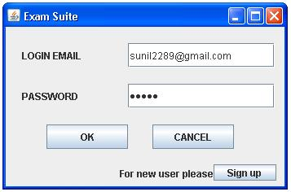

Exam Suite: Sign up

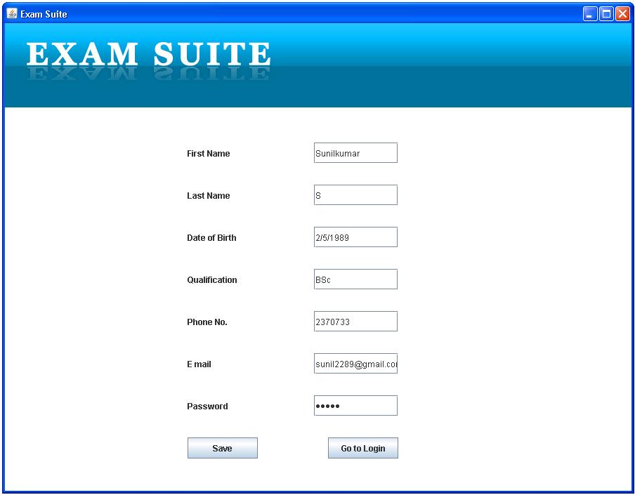

Exam Suite: Rules

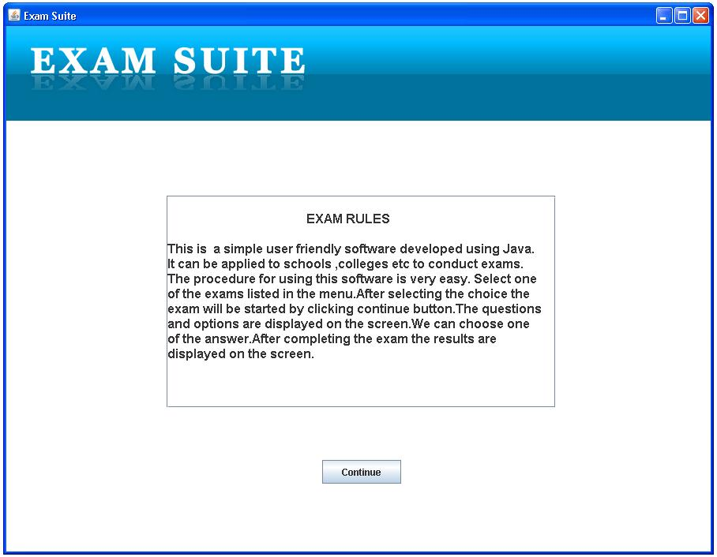

Exam Suite: Select Exam

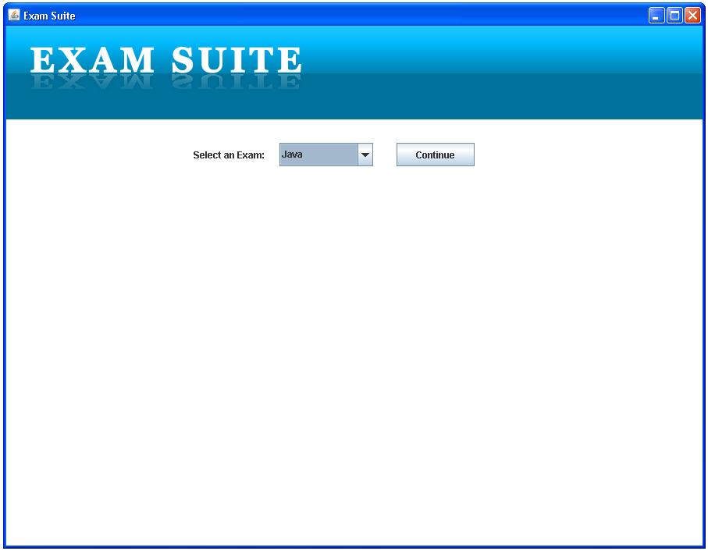

Exam Suite: Start Exam

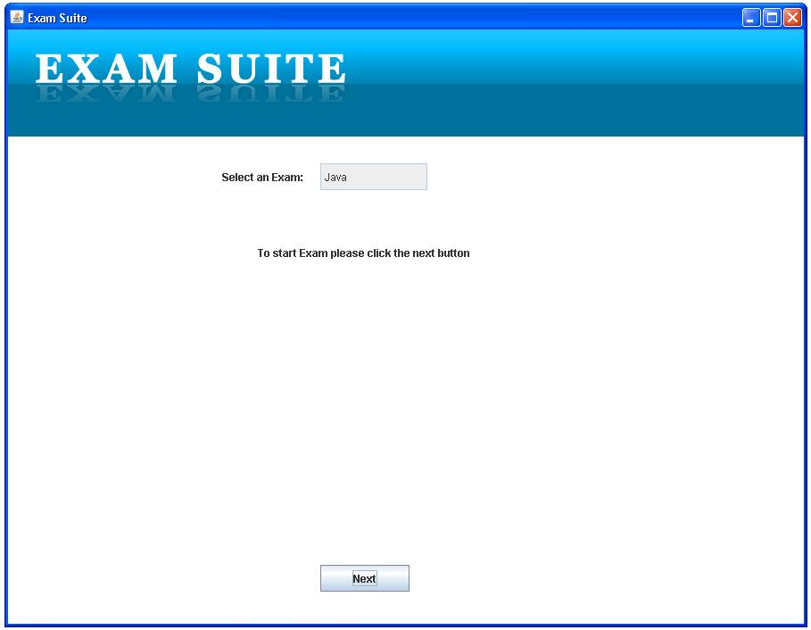

Exam Suite: Exam

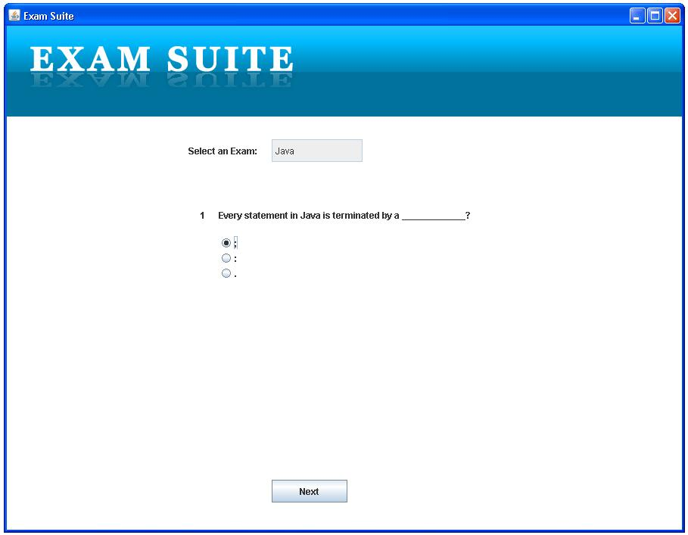

Exam Suite: Exam

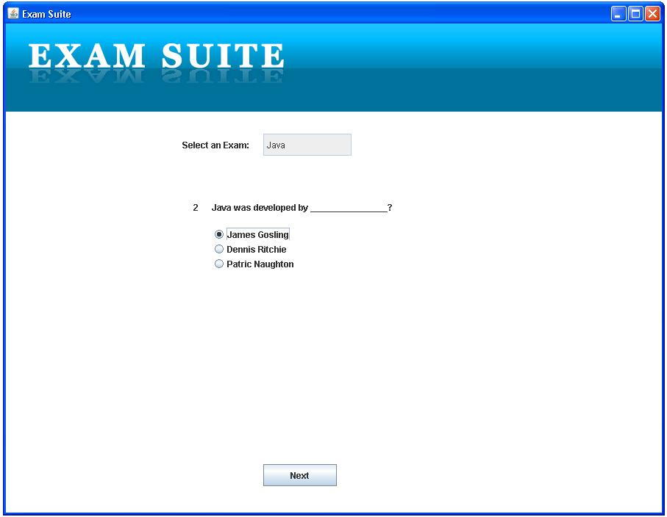

Exam Suite: Exam

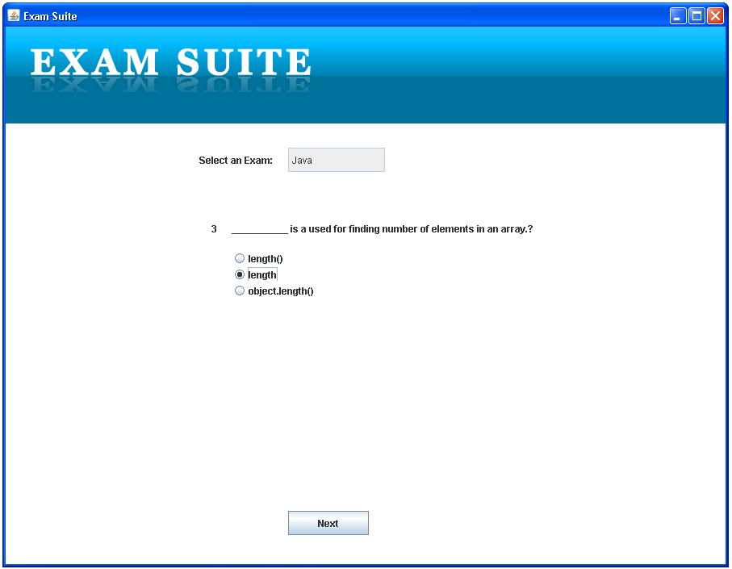

Exam Suite: Exam

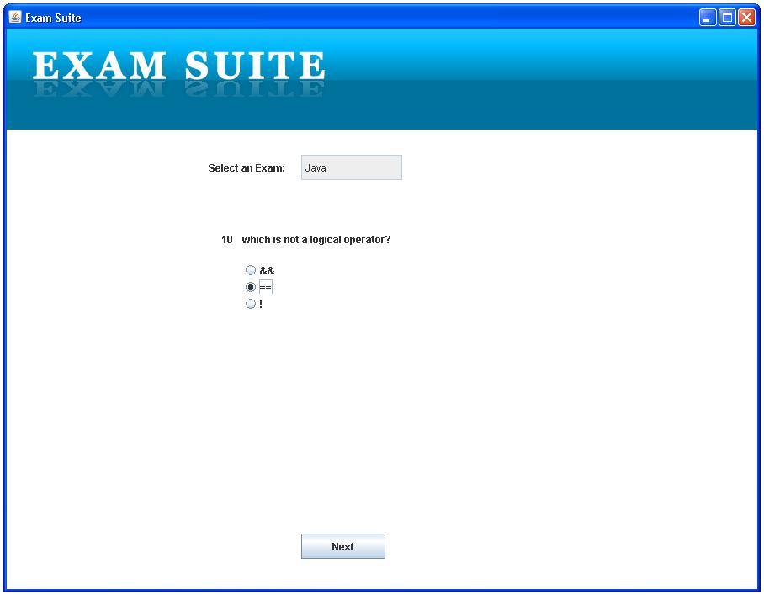

Exam Suite: Result

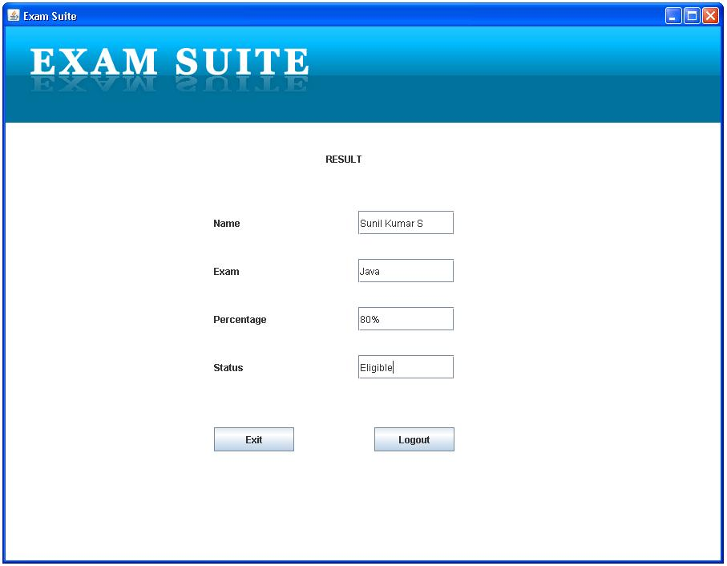

CONCLUSION

The “Exam Suite” is a great improvement over the manual system like hand written exams. The computerization of the system has speed up the process and it is time consuming. It is very difficult to keep answer papers and all such things. The system was thoroughly checked and tested with dummy data. The system avoids data redundancy and inconsistency. It provides security and integrity. Data is easily retrieved. Thus the system is user friendly.

FUTURE ENHANCEMENT

The proposed system is purely an Exam Suite we will make this project as online where every customer using their E-mail ID can view their result details; they can’t edit or make changes in their account.

Also, we can include online, updating by the authorized person.
When making online, Exam procedures and latest news about the Exam will be seen in our software. Any comments can be included by the user.

REFERENCE

Books

- Java 2 Complete Reference.
- Core Java 2 Seventh Edition by Cay S. Horstmann and Gary Cornell.
- Advanced Java by Balaguruswamy.
- Programming using Java by David. J. ECK
- Java Design Patterns by James W. Cooper

