INTRODUCTION
Vehicle Management System is software which is helpful for bus operators, who wants to operate many bus trips in a day. Vehicle Management System is a windows application written for 32-bit Windows operating systems which focused in the area of adding, editing and deleting the passengers, staff and the bus routes. In this software a person can be register as a user and he can manage the bus routes and the staff, passengers’ details. He can add a bus and its details including bus route details. User can also add the details of the staff and their duty time in the system.
There are mainly 5 modules in this software
- Bus Management
- Route Management
- Employee Management
- Passenger Management

In Bus module a user can add a new bus details to the database. He can set the details of the route and the timing also. Bus details like the type, engine number, seating capacity and the route in which the bus is going to be operated are added. Whenever the user wants to modify these details he can update new values through this software. Route Management module deals with the route management of the bus. A user can add the route and if he wants he can change it or delete that route. The main advantage is that this module is helpful for the agents to get details of the route and the details of the bus which have trip to that route. He can also get the information of the number of seats available in a particular day. Employee details of any bus can add to the database and this is helpful to the bus operators in the case of the salary and bates for the employee. An operator can add the personal details and if we want to edit or delete he can done modification using the Vehicle Management System. This is very helpful for the passenger also; if they have any complaint against staff he can approach the operator and easily identify the employee. Details of every passenger are stored in the system. A user can add a passenger only one time and if he came again operator can identify that person. Operator can add, edit and delete the details of the passenger.

SYSTEM ANALYSIS

EXISTING SYSTEM:
System Analysis is a detailed study of the various operations performed by a system and their relationships within and outside of the system. Here the key question is- what all problems exist in the present system? What must be done to solve the problem? Analysis begins when a user or manager begins a study of the program using existing system.

During analysis, data collected on the various files, decision points and transactions handled by the present system. The commonly used tools in the system are Data Flow Diagram, interviews, etc. Training, experience and common sense are required for collection of relevant information needed to develop the system. The success of the system depends largely on how clearly the problem is defined, thoroughly investigated and properly carried out through the choice of solution. A good analysis model should provide not only the mechanisms of problem understanding but also the frame work of the solution. Thus it should be studied thoroughly by collecting data about the system. Then the proposed system should be analyzed thoroughly in accordance with the needs.
System analysis can be categorized into four parts.
- System planning and initial investigation
- Information Gathering
- Applying analysis tools for structured analysis
- Feasibility study
- Cost/ Benefit analysis

In the existing system all the jobs of the bus route management is done manually. This is very difficult to the operators who want to handle hundreds of trips and many buses in a day. The currents system is that an operator wants to keep the physical records of the bus route in his office and a separate record for the passengers’ and for the booked seats. In current system there is no way to store the details of the employees’ working in the bus. So many complaints against staff can arise from the passengers’ side. More over there is no detailed record of the bus and routes in which they service

PROPOSED SYSTEM
The proposed system is very useful for the operators and passengers. This avoids the overheads for the operators. They can minimize the working stress and can keep essential documents related to the bus and the passengers as a softcopy. The advantage of the proposed system is the reduction in the cost of the office equipments and the transaction is done quickly. Any operator can answer if any seats for a particular route in a particular day are available or not.
Our proposed system has several advantages
- User friendly interface
- Fast access to database
- Less error
- More Storage Capacity
- Search facility
- Look and Feel Environment
- Quick transaction

FEASIBILITY ANALYSIS

Whatever we think need not be feasible .It is wise to think about the feasibility of any problem we undertake. Feasibility is the study of impact, which happens in the organization by the development of a system. The impact can be either positive or negative. When the positives nominate the negatives, then the system is considered feasible. Here the feasibility study can be performed in two ways such as technical feasibility and Economical Feasibility.

Technical Feasibility:
We can strongly says that it is technically feasible, since there will not be much difficulty in getting required resources for the development and maintaining the system as well. All the resources needed for the development of the software as well as the maintenance of the same is available in the organization here we are utilizing the resources which are available already.
Economical Feasibility
Development of this application is highly economically feasible .The organization needed not spend much m money for the development of t he system already available. The only thing is to be done is making an environment for the development with an effective supervision. I f we are doing so , we can attain the maximum usability of the corresponding resources .Even after the development , the organization will not be in a condition to invest more in t he organization .There fore , the system is economically feasible.

HARDWARE CONFIGURATION

Processor : Pentium III 630MHz
RAM : 128 MB
Hard Disk : 20GB
Monitor : 15” Color monitor
Key Board : 122 Keys

SOFTWARE CONFIGURATION

Operating System : Windows NT,
Windows 98,
Windows XP.
Language : Java 2 Runtime Environment
Database : MS Access2007.

SYSTEM REQUIREMENTS

This management system can be used in windows 98, Windows2000, Windows XP and Windows NT, supported for other platform such as Applet, Macintosh and UNIX.
The system must be running Windows 98, Windows 98 or Windows NT4.0 operating system and must meet the following hardware requirements.
- For Windows 95 based computers , a 486 / 66 MHz or higher processor with 8MB
- For Windows 98 based computers , a 500/88MHz or higher processor with 32 Mb of RAM
- For Windows NT based computers , a 488 / 66 MHz or higher processor with 16 MB of RAM
- For Windows 200 based computers , a 700/850 MHz or higher processor with 512 MB of Ram

DATA FLOW DIAGRAM
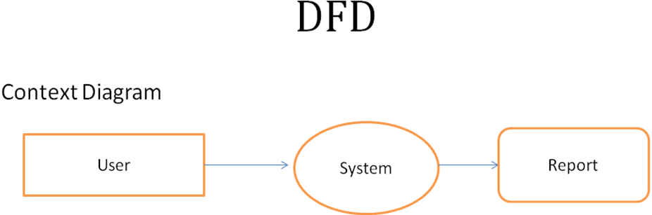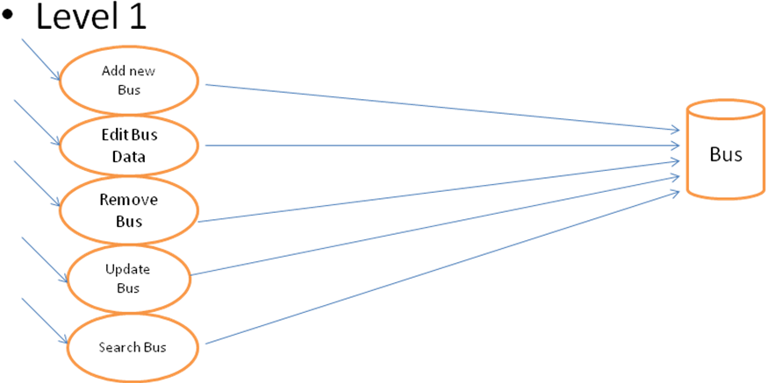

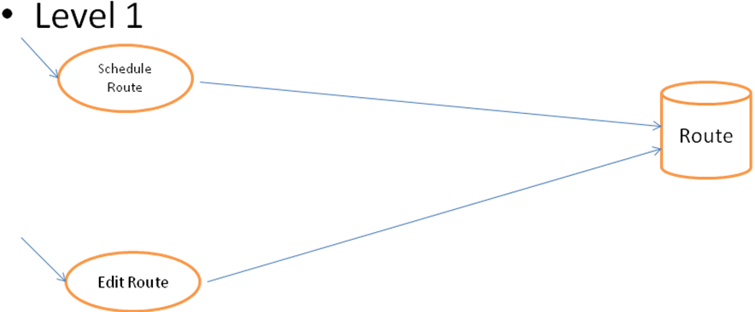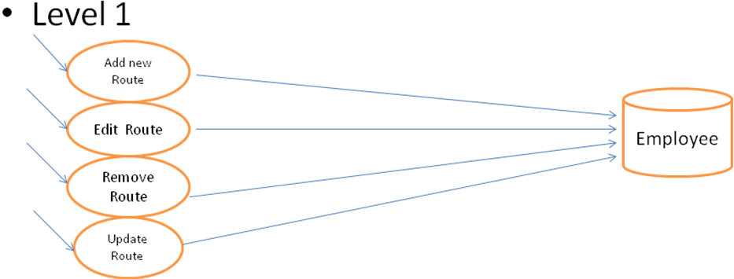

SYSTEM DESIGN
INPUT DESIGN
Input design is the process of converting user-oriented input to a computer based format. Input design is a part of overall system design, which requires very careful attention .Often the collection of input data is the most expensive part of the system. The main objectives of the input design are …
1. Produce cost effective method of input
2. Achieve highest possible level of accuracy
3. Ensure that the input is acceptable to and understood by the staff.
Input Data
The goal of designing input data is to make entry easy, logical and free from errors as possible. The entering data entry operators need to know the allocated space for each field; field sequence and which must match with that in the source document. The format in which the data fields are entered should be given in the input form .Here data entry is online; it makes use of processor that accepts commands and data from the operator through a key board. The input required is analyzed by the processor. It is then accepted or rejected. Input stages include the following processes
- Data Recording
- Data Transcription
- Data Conversion
- Data Verification
- Data Control
- Data Transmission
- Data Correction
One of the aims of the system analyst must be to select data capture method and devices, which reduce the number of stages so as to reduce both the changes of errors and the cost .Input types, can be characterized as.
- External
- Internal
- Operational
- Computerized
- Interactive
Input files can exist in document form before being input to the computer. Input design is rather complex since it involves procedures for capturing data as well as inputting it to the computer.
OUTPUT DESIGN

Outputs from computer systems are required primarily to communicate the results of processing to users. They are also used to provide a permanent copy of these result for latter consultation .Computer output is the most important and direct source of information to the users. Designing computer output should proceed in an organized well through out the manner. The right output must be available for the people who find the system easy o use. The outputs have been defined during the logical design stage. If not, they should defined at the beginning of the output designing terms of types of output connect, format, response etc,

Various types of outputs are
- External outputs
- Internal outputs
- Operational outputs
- Interactive outputs
- Turn around outputs
All screens are informative and interactive in such a way that the user can ful fill his requirements through asking queries.

DATABASE DESIGN

The general theme behind a database is to handle information as an integrated whole. A database is a collection of interrelated data stored with minimum redundancy to serve many users quickly and effectively. After designing input and output, the analyst must concentrate on database design or how data should be organized around user requirements. The general objective is to make information access, easy quick, inexpensive and flexible for other users. During database design the following objectives are concerned:-

- Controlled Redundancy
- Data independence
- Accurate and integrating
- More information at low cost
- Recovery from failure
- Privacy and security
- Performance
- Ease of learning and use

TABLES USED

USERS
FieldName | DataType | Key
Name | Text | -
Category | Text | -
Username | Text | -
Password | Text | -

BOOKING
FieldName | DataType | Key
Booking_No | Number | Primary
Pass_No | Text | -
PassName | Text | -
Bus_RegNo | Text | -
SeatNo | Text | -
Date_of_Travel | Text | -
Time_of_Travel | Text | -
Pass_From | Text | -
Destination | Text | -
Amount | Text | -

BUSES
FieldName | DataType | Key
Bus_RegNo | Text | Primary
BusNo | Text | -
Model | Text | -
Capacity | Number | -
DateBought | Date/Time | -
Insurance_Status | Text | -
Date_Insured | Date/Time | -
Insurance_Expiry | Date/Time | -

Emp
FieldName | DataType | Key
empNo | Text | Primary
Sname | Text | -
Fname | Text | -
Lname | Text | -
Gender | Text | -
DOB | Date/Time | -
Designation | Text | -
Telephone | Number | -
E_Mail | Text | -
Address | Text | -

Passenger
FieldName | DataType | Key
Pass_No | Text | Primary
Pass_Name | Text | -
Address | Text | -
Tel_No | Number | -
Date_of_Travel | Date/Time | -
Depot | Text | -
To | Text | -
Pay_Status | Text | -
Booked_Status | Text | -

Payment
FieldName | DataType | Key
Payment_No | Text | Primary
Pass_No | Text | -
Pass_Name | Text | -
Payment_Mode | Text | -
Date_Payment | Date/Time | -
Amount_Paid | Currency | -
Received_By | Text | -

Route
FieldName | DataType | Key
Route_No | Text | Primary
RouteName | Text | -
Depot | Text | -
Destination | Text | -
Distance | Text | -
Fare_Charged | Number | -

Schedules
FieldName | DataType | Key
Route_Name | Text | -
empNo | Text | -
Driver_Name | Text | -
Trip_No | Number | -
Date_Scheduled | Date/Time | -
Dept_Time | Text | -

Trips
FieldName | DataType | Key
Trip_No | Text | Primary
Bus_RegNo | Text | -
Route_No | Text | -
S_Date | Text | -

Validator
FieldName | DataType | Key
Bus_No | Text | -
DriverNo | Text | -
RouteNo | Text | -
Date_Schedule | Text | -
Trip_No | Text | -

SYSTEM IMPLEMENTATION

Implementation is the stage in the project where the theoretical design is turned into a working system. The implementation phase constructs, installs and operates the new system. The most crucial stage in achieving a new successful system is that it will work efficiently and effectively.
There are several activities involved while implementing a new project. They are
- End user training
- End user Education
- Training on the application software
- System Design
- Parallel Run And To New System
- Post implementation Review
End user Training:
The successful implementation of the new system will purely upon the involvement of the officers working in that department. The officers will be imparted the necessary training on the new technology
End User Education:
The education of the end user start after the implementation and testing is over. When the system is found to be more difficult to under stand and complex, more effort is put to educate the end used to make them aware of the system, giving them lectures about the new system and providing them necessary documents and materials about how the system can do this.

Training of application software:
After providing the necessary basic training on the computer awareness, the users will have to be trained upon the new system such as the screen flows and screen design type of help on the screen, type of errors while entering the data, the corresponding validation check at each entry and the way to correct the data entered. It should then cover information needed by the specific user or group to use the system.

Post Implementation View:
The department is planning a method to know the states of t he past implementation process. For that regular meeting will be arranged by the concerned officers about the implementation problem and success

SOFTWARE TESTING

Is the menu bar displayed in the appropriate contested some system related features included either in menus or tools? Do pull –Down menu operation and Tool-bars work properly? Are all menu function and pull down sub function properly listed ?; Is it possible to invoke each menu function using a logical assumptions that if all parts of the system are correct, the goal will be successfully achieved .? In adequate testing or non-testing will leads to errors that may appear few months later.
This create two problem
1. Time delay between the cause and appearance of the problem.
2. The effect of the system errors on files and records within the system
The purpose of the system testing is to consider all the likely variations to which it will be suggested and push the systems to limits.
The testing process focuses on the logical intervals of the software ensuring that all statements have been tested and on functional interval is conducting tests to uncover errors and ensure that defined input will produce actual results that agree with the required results. Program level testing, modules level testing integrated and carried out.
There are two major type of testing they are
- White Box Testing.
- Black Box Testing.

White Box Testing
White box some times called “Glass box testing” is a test case design uses the control structure of the procedural design to drive test case.
Using white box testing methods, the following tests where made on the system
a) All independent paths within a module have been exercised once. In our system, ensuring that case was selected and executed checked all case structures. The bugs that were prevailing in some part of the code where fixed
b) All logical decisions were checked for the truth and falsity of the values.

Black box Testing
Black box testing focuses on the functional requirements of the software. This is black box testing enables the software engineering to derive a set of input conditions that will fully exercise all functional requirements for a program. Black box testing is not an alternative to white box testing rather it is complementary approach that is likely to uncover a different class of errors that white box methods like..
1) Interface errors
2) Performance in data structure
3) Performance errors
4) Initializing and termination errors

FORMS USED

Login

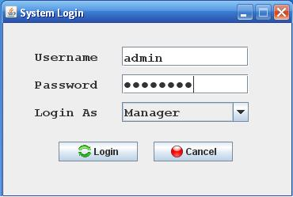

Add New User

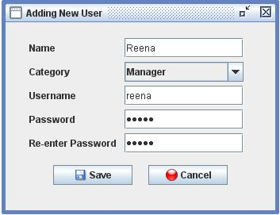

Bus Details
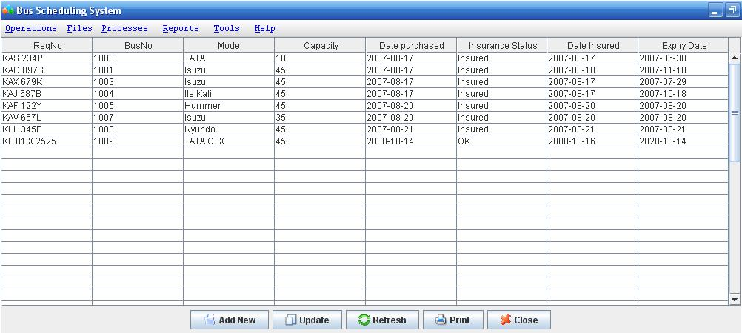

New Bus Details
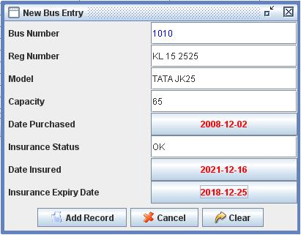

Update Bus Details
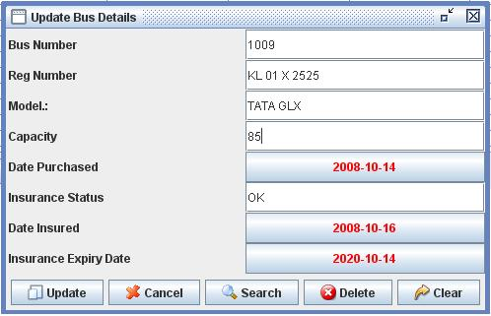

Employees Details
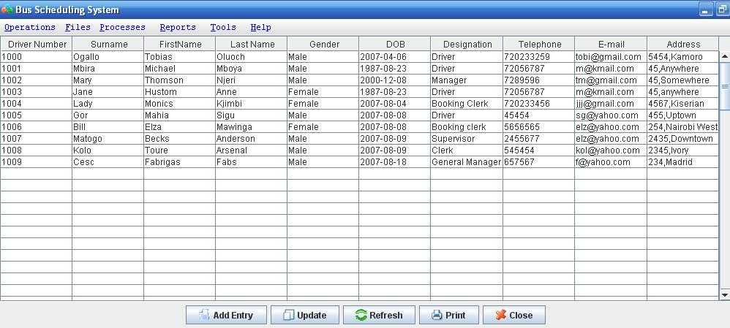

Add New Employee
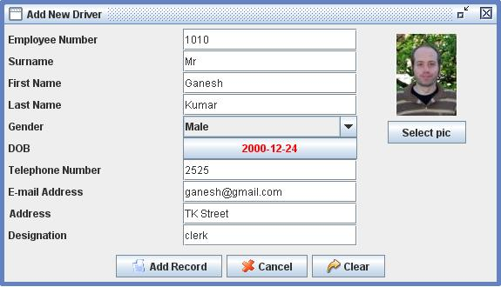

Update Employee details
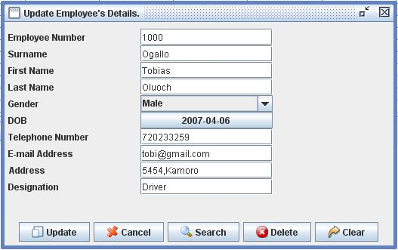

Route Report
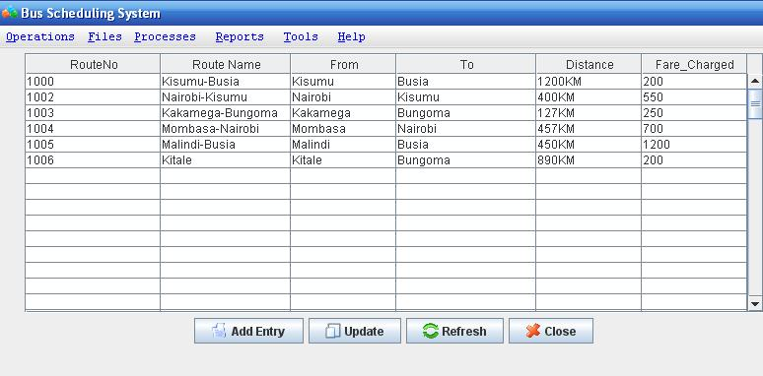

Add New Route
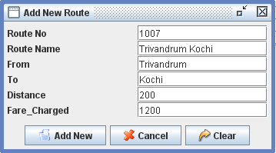
Update New Route
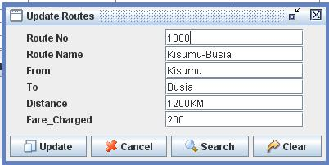

Add New Passengers
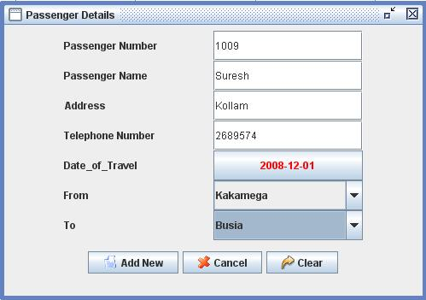

Update passenger details
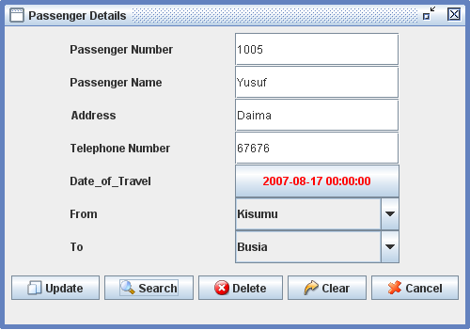

Scheduling Process
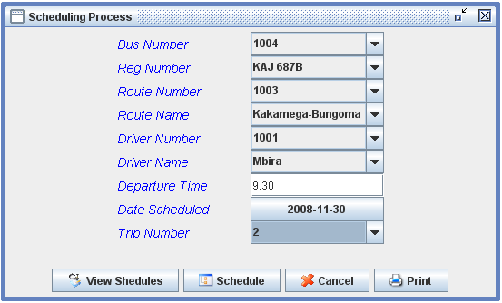

Payment Process
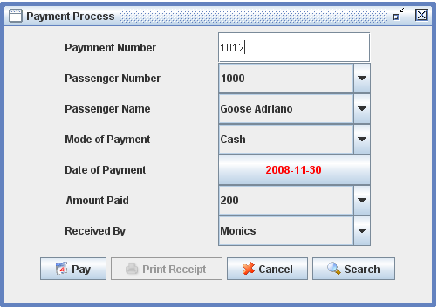

Booking Process
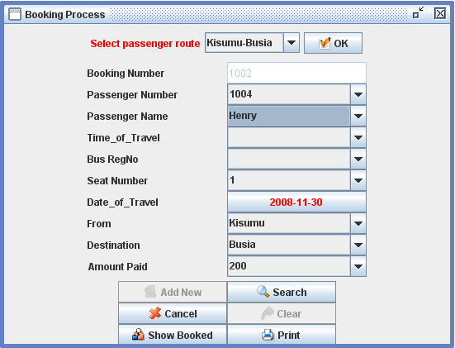

Buses Report
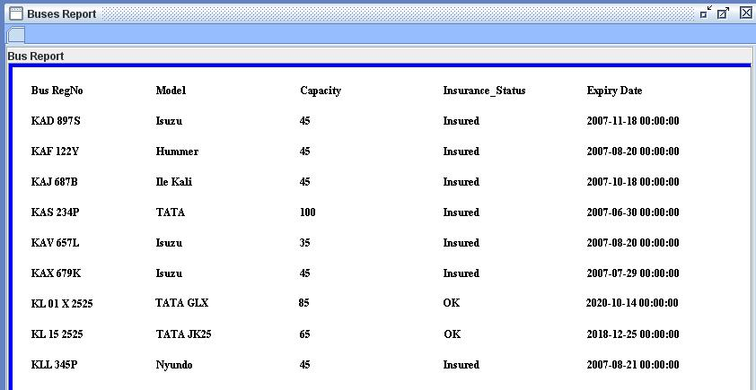

Employees Report
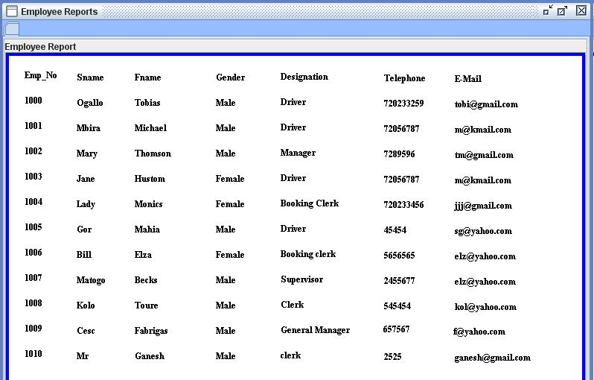

Booking Report

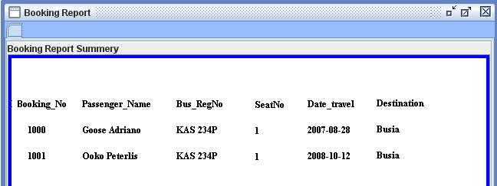

CONCLUSION

Our project is only a humble venture to satisfy the needs in a library. Several user friendly coding have also adopted. This package shall prove to be a powerful package in satisfying all the requirements of the organization.

The objective of software planning is to provide a frame work that enables the manger to make reasonable estimates made within a limited time frame at the beginning of the software project and should be updated regularly as the project progresses. Last but not least it is no the work that played the ways to success but ALMIGHTY

BIBLIOGRAPHY
- Head First Java 2nd Edition
- http://java.sun.com/javase/technologies/desktop/
- http://www.roseindia.net/jdbc/jdbc-access/CreateTable.shtml
- http://www.jdbc-tutorial.com/
- Java and Software Design Concepts by APress

