
- Introduction to Maven
Maven is a simple build automation tool which is basically used with java projects. Maven is also defined as a comprehensive project management tool. It aims to provide the developers a complete and detailed build life cycle framework of an application.
Maven also ease up the task of developers in checking a build status, generating reports (basically javadocs) and setting up the automated build process and monitor the same.
The ease of source code compilation, distribution, documentation, collaboration with different teams and other vital tasks are seamless by using maven.
Maven aims to describe 2 important things:
- How a software is built.
- The dependencies, plug-ins & profiles that the project is associated in a standalone or a distributed environment.
The maven can also be used in building & managing the projects written using C#, ruby and other programming languages as well.

- Understanding the problem without Maven
1) Adding set of Jars in each project: In case of struts, spring, hibernate frameworks, we need to add set of jar files in each project. It must include all the dependencies of jars also.
2) Creating the right project structure: We must create the right project structure in servlet, struts etc, otherwise it will not be executed.
3) Building and Deploying the project: We must have to build and deploy the project so that it may work.
- What it does?
Maven simplifies the above mentioned problems. It does mainly following tasks.
- It makes a project easy to build
- It provides uniform build process (maven project can be shared by all the maven projects)
- It provides project information (log document, cross referenced sources, mailing list, dependency list, unit test reports etc.)
- It is easy to migrate for new features of Maven.
Apache Maven helps to manage
- Builds
- Documentation
- Reporting
- SCMs
- Releases
- Distribution

Difference between Ant and Maven

Ant | Maven
Ant doesn't has formal conventions, so we need to provide information of the project structure in build.xml file. | Maven has a convention to place source code, compiled code etc. So we don't need to provide information about the project structure in pom.xml file.
Ant is procedural you need to provide information about what to do and when to do through code. You need to provide order. | Maven is declarative, everything you define in the pom.xml file.
There is no life cycle in Ant. | There is life cycle in Maven.
It is a tool box. | It is a framework.
It is mainly a build tool. | It is mainly a project management tool.
The ant scripts are not reusable. | The maven plugins are reusable.

How to install Maven on windows
You can download and install maven on windows, linux and MAC OS platforms. Here, we are going to learn how to install maven on windows OS.
To install maven on windows, you need to perform following steps:
- Download maven and extract it
- Add JAVA_HOME and MAVEN_HOME in environment variable
- Add maven path in environment variable
- Verify Maven

1) Download Maven
Download Maven latest Maven from http://maven.apache.org For example: apache-maven-3.1.1-bin.zip
Extract it. Now it will look like this:
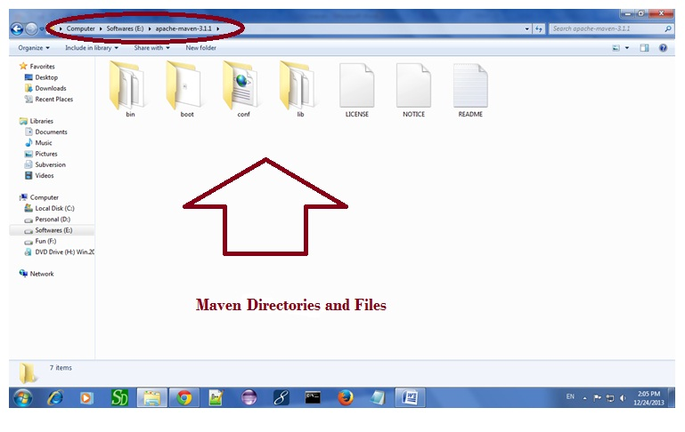

2) Add MAVEN_HOME in environment variable
Right click on MyComputer -> properties -> Advanced System Settings -> Environment variables -> click new button
Now add MAVEN_HOME in variable name and path of maven in variable value. It must be the home directory of maven i.e. outer directory of bin. For example: E:\apache-maven-3.1.1 .It is displayed below:
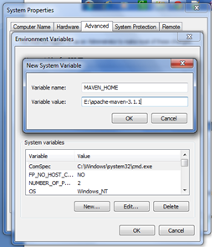
Now click on OK button.

3) Add Maven Path in environment variable
Click on new tab if path is not set, then set the path of maven. If it is set, edit the path and append the path of maven.
Here, we have installed JDK and its path is set by default, so we are going to append the path of maven.
The path of maven should be %maven home%/bin. For example, E:\apache-maven-3.1.1\bin .
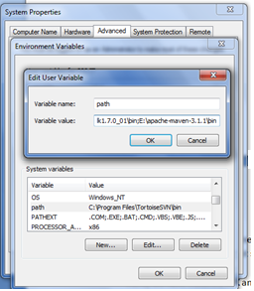

4) Verify maven
To verify whether maven is installed or not, open the command prompt and write:
mvn −version

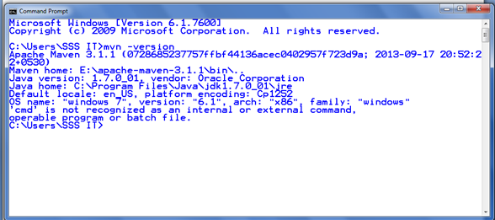

What is POM?
The easiest way to describe a POM in a maven project is, it is nothing but the core element of any maven project. Basically any maven project consists of one configurable file called pom.xml, which stands for the abbreviation Project Object Model. This pom.xml will always be located in the root directory of any maven project. This file represents the very basic and fundamental unit in maven.
The pom.xml basically contains the information related to the project which is built or to be built in. It contains all the necessary information about the configuration details, dependencies included and plug-ins included in the project. In simple, it contains the details of the build life cycle of a project.
- Elements of maven pom.xml file
For creating the simple pom.xml file, you need to have following elements:
Element | Description
project | It is the root element of pom.xml file.
modelVersion | It is the sub element of project. It specifies the modelVersion. It should be set to 4.0.0.
groupId | It is the sub element of project. It specifies the id for the project group.
artifactId | It is the sub element of project. It specifies the id for the artifact (project). An artifact is something that is either produced or used by a project. Examples of artifacts produced by Maven for a project include: JARs, source and binary distributions, and WARs.
version | It is the sub element of project. It specifies the version of the artifact under given group.

Sample Pom.xml File
A typical pom.xml of simple java project will look like as shown in the below figure.
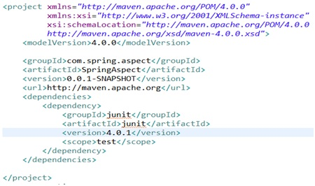
A pom.xml will always start with the root element called <project> under which all the other required configurations will be made. Developers should ensure to define the below list of elements which are known as maven co-ordinates before defining a pom.xml file :
- groupId - as the name itself shows that this is an id which is unique for any project in an organization.
- artifactId - Even though the name says as “id”, this is basically defines the name of any project.
- version - This element is used to derive the version of any project in order to classify the versions as and when the major changes/implementations are carried during the development phase of a project.
Whenever it comes for executing a task for a project, maven scans through the entries made in the pom. Xml file. This will enable the maven to read all the configurations made, build profiles defined, repositories configured and all other important details and then executes the task accordingly.
NOTE: Actually pom.xml was earlier used in the name of project.xml in maven 1. As the maven 2 version was introduced, this was renamed to pom.xml

Super POM
All the maven projects pom.xml files always extends the super pom.xml file. This super pom.xml basically defines a set of default configurations which is shared and used by all the maven projects. This super pom.xml is not required to be written by the developers. This will come as a default one with the maven installation.
A typical super pom.xml can be found in the attached file. Click on th link below to download.

Goals in Maven
Goal in maven is nothing but a particular task which leads to the compiling, building and managing of a project. A goal in maven can be associated to zero or more build phases. Only thing that matters is the order of the goals defined for a given project in pom.xml. Because, the order of execution is completely dependent on the order of the goals defined.
- Maven pom.xml file with additional elements
Element | Description
packaging | defines packaging type such as jar, war etc.
name | defines name of the maven project.
url | defines url of the project.
dependencies | defines dependencies for this project.
dependency | defines a dependency. It is used inside dependencies.
scope | defines scope for this maven project. It can be compile, provided, runtime, test and system.

Maven Repository
A maven repository is a directory of packaged JAR file with pom.xml file. Maven searches for dependencies in the repositories. There are 3 types of maven repository:
- Local Repository
- Central Repository
- Remote Repository
Maven searches for the dependencies in the following order:
Local repository then Central repository then Remote repository.
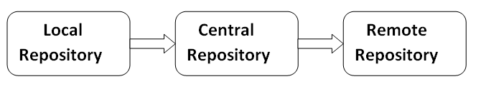
If dependency is not found in these repositories, maven stops processing and throws an error.

1) Maven Local Repository
Maven local repository is located in your local system. It is created by the maven when you run any maven command.
By default, maven local repository is %USER_HOME%/.m2 directory. For example: C:\Users\SSS IT\.m2.
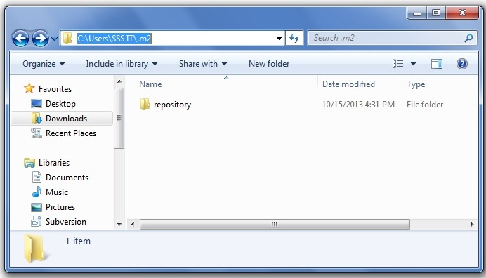

We can change the location of maven local repository by changing the settings.xml file. It is located in MAVEN_HOME/conf/settings.xml, for example: E:\apache-maven-3.1.1\conf\settings.xml.
settings.xml
- ...
- <settings xmlns="http://maven.apache.org/SETTINGS/1.0.0"
- xmlns:xsi="http://www.w3.org/2001/XMLSchema-instance"
- xsi:schemaLocation="http://maven.apache.org/SETTINGS/1.0.0 http://maven.apache.org/xsd/settings-1.0.0.xsd">
- <localRepository>e:/mavenlocalrepository</localRepository>

- ...
- </settings>
As you can see, now the path of local repository is e:/mavenlocalrepository.

2) Maven Central Repository
Maven central repository is located on the web. It has been created by the apache maven community itself.
The path of central repository is: http://repo1.maven.org/maven2/.
The central repository contains a lot of common libraries that can be viewed by this url http://search.maven.org/#browse.

3) Maven Remote Repository
Maven remote repository is located on the web. Most of libraries can be missing from the central repository such as JBoss library etc, so we need to define remote repository in pom.xml file.
Let's see the code to add the jUnit library in pom.xml file.
pom.xml
- <project xmlns="http://maven.apache.org/POM/4.0.0"
- xmlns:xsi="http://www.w3.org/2001/XMLSchema-instance"
- xsi:schemaLocation="http://maven.apache.org/POM/4.0.0
- http://maven.apache.org/xsd/maven-4.0.0.xsd">

- <modelVersion>4.0.0</modelVersion>

- <groupId>com.javatpoint.application1</groupId>
- <artifactId>my-application1</artifactId>
- <version>1.0</version>
- <packaging>jar</packaging>

- <name>Maven Quick Start Archetype</name>
- <url>http://maven.apache.org</url>

- <dependencies>
- <dependency>
- <groupId>junit</groupId>
- <artifactId>junit</artifactId>
- <version>4.8.2</version>
- <scope>test</scope>
- </dependency>
- </dependencies>
- </project>
You can search any repository from Maven official website mvnrepository.com.

Maven Build Life Cycle
The sequence of steps which is defined in order to execute the tasks and goals of any maven project is known as build life cycle in maven. Maven 2.0 version is basically a build life cycle oriented and clearly says that these steps are well defined to get the desired output after the successful execution of the build life cycle.
Maven comes with 3 built-in build life cycles as shown below :
- Clean - this phase involves cleaning of the project (for a fresh build & deployment)
- Default - this phase handles the complete deployment of the project
- Site - this phase handles the generating the java documentation of the project.
Now we will dig more into the detailed phases involved in the above mentioned built-in build life cycles.

Build Life Cycle of clean phase
As mentioned above, this clean phase is used to clean up the project and make it ready for the fresh compile and deployment. The command used for the same is mvn post-clean. When this command is invoked, maven executes the below tasks via executing the below commands internally :
- mvn pre-clean
- mvn clean
- mvn post-clean
This maven’s clean is a goal and on executing it cleans up the output directory (target folder) by deleting all the compiled files.
NOTE : whenever a maven command for any life cycle is invoked, maven executes the phases till and up to the invoked phase. E.g. when 'mvn clean' is invoked, maven will execute only the phase clean. But, no compile/deployment/site phase is invoked.
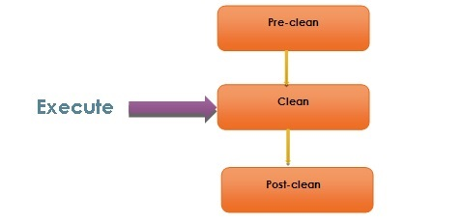

Build Lifecycle (Default)
Below is the list of phases in the build lifecycle (default) of maven. These phases will be invoked through the maven commands.
Lifecycle Phase | Description
validate | Validates and ensures that the project is fine and perfect considering all the required information is made available for the build
generate-sources | Generating any source code to include the same in the compilation process
process-sources | Processing the source code in case some filter needs to be applied
generate-sources | Generating any source code to include the package
process-resources | Process of copying the resources to the destination folder and getting ready for the packaging
compile | Compilation of the project source code.
process-classes | To perform the bytecode enhancements for the class files generated from the compilation
generate-test-sources | Copying and processing the resources in the test destination directory.
test-compile | Compile the source code in the test destination directory
test | Executing/running the tests using some suitable test framework. Note: these test cases are not considered for packaging and deploying
prepare-package | To perform any final changes/validations before it is sent for final packaging.
package | Packaging the successfully compiled and tested code to some distributable format - JAR, WAR, EAR
pre-integration-test | To perform actions before integration tests are executed. This may require to set up some environmental changes for the app.
integration-test | Deploy the application to an environment where integration tests can be run.
post-integration-test | Basically, cleaning up the environment which was made in pre-integration-test phase.
verify | Performs action for a quality check and ensures the required criteria being met
install | Installing the application in the local repository. Any other project can use this as a dependency.
deploy | The final package will be copied to a remote repository, may be as a formal release and also made available to the other developers too.

Site Lifecycle (site)
Apart from cleaning, compiling the source code, building a deployable format of the application, maven has phase which does more than these phases. This phase is one of the vital features provided by maven which generates the detailed documentation of any java project.
This project documentation has a dedicated phases involved as listed below :
- pre-site
- site
- post-site
- site-deploy
The command used in maven to generate javadocs for a given project is 'mvn site'. Basically, when this command is invoked, maven calls 'Doxia' document generation and other report generating plugins.
Doxia is basically a framework used for content generation by maven. This generates contents both in static and dynamic ways.
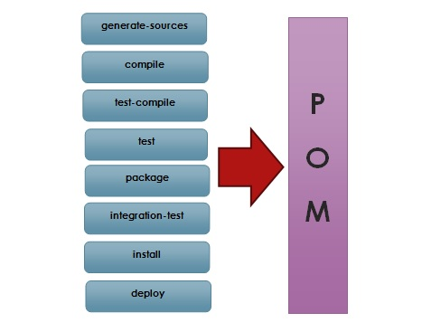

- Running Maven Tools
Maven Phases
Although hardly a comprehensive list, these are the most common default lifecycle phases executed.
- validate: validate the project is correct and all necessary information is available
- compile: compile the source code of the project
- test: test the compiled source code using a suitable unit testing framework. These tests should not require the code be packaged or deployed
- package: take the compiled code and package it in its distributable format, such as a JAR.
- integration-test: process and deploy the package if necessary into an environment where integration tests can be run
- verify: run any checks to verify the package is valid and meets quality criteria
- install: install the package into the local repository, for use as a dependency in other projects locally
- deploy: done in an integration or release environment, copies the final package to the remote repository for sharing with other developers and projects.
There are two other Maven lifecycles of note beyond the default list above. They are
- clean: cleans up artifacts created by prior builds
- site: generates site documentation for this project
Phases are actually mapped to underlying goals. The specific goals executed per phase is dependant upon the packaging type of the project. For example, packageexecutes jar:jar if the project type is a JAR, and war:war if the project type is - you guessed it - a WAR.
An interesting thing to note is that phases and goals may be executed in sequence.
- mvn clean dependency:copy-dependencies package
This command will clean the project, copy dependencies, and package the project (executing all phases up to package, of course).
Generating the Site
- mvn site
This phase generates a site based upon information on the project's pom. You can look at the documentation generated under target/site.

