**Clean Code, Chapter 5: Formatting**

The chapter “Formatting” emphasized the importance of writing clean and well formatted code. It is directly related to the communication of developers who is working in the same code base, so the well written and formatted code will be more maintainable and readable.

Below are some basic rules for writing formatted code.

**Vertical Formatting:** Vertical formatting is all about better readability. The vertical space (single line space) should be there between related sections of code like between classes, methods and constructors etc. Related code should be placed close together. Functions that depend on each other should be vertically close.

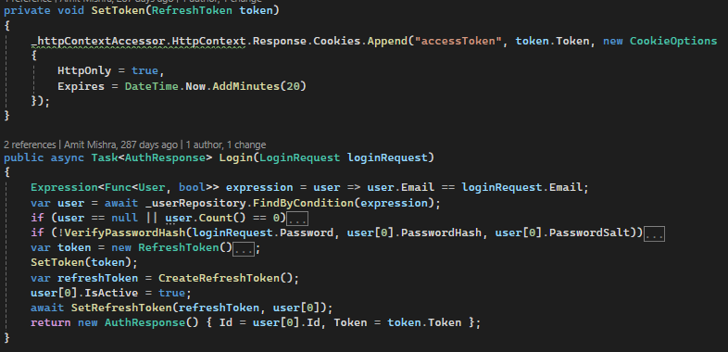

**Horizontal Formatting:** Horizontal formatting is also about code readability. Developers should use proper one space gap between required things like between operators and operands, and between comma separated variables etc.

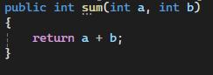

**Indentation:** Indentation allows developers to read, write and understand complex code in an easier way. For example, reading a class will be harder if there will be no indentation, by seeing the indent block of code developers can see which code block comes under a class or under a method.

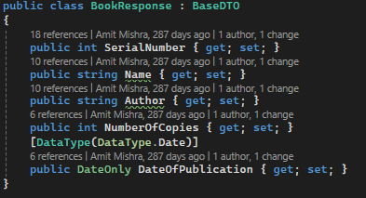

**Newspaper Metaphor Rule:** The metaphor rule is all about writing the code in a way that the code should be formatted like a newspaper. Most important parts like functions of logic should stand out by the heading of the function or class. This approach of writing code enables developers to read code in easier way.