Table of Contents

**1.0** **Login Screen** 3

**2.0 Admin Screens** 5

**3.0 User Screens** 8

Guestbook is application developed using the Spring boot, maven, spring security, Bootstrap, html and css.

* Can be accessed by Admin or Users(Guests).
* Users will be provided pre populated credentials.
* Users can add or view the feedback.
* Once user adds feedback it goes for Admin approval.
* After admin approves the feedback its visible to users.
* Admin can view all feedback
* Admin can approve the newly added user feedback
* Admin can edit the feedback
* Admin can delete the feedback.

# **Login Screen**

1. Initial login Screen:

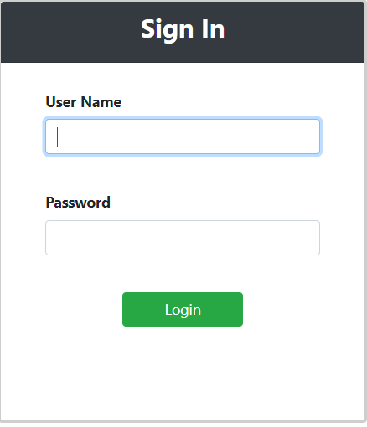

1. Input Form Validation:

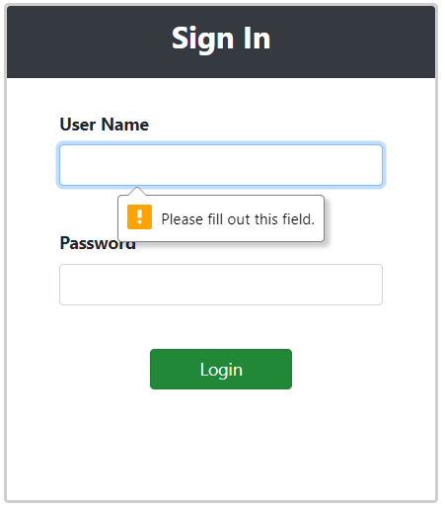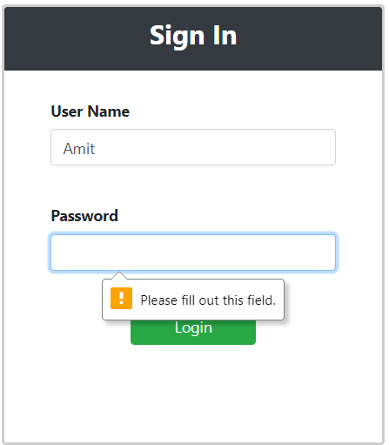

1. Username and Password Validation:

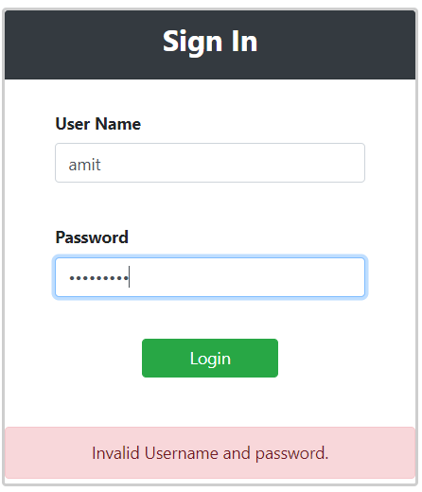

1. Sign out:

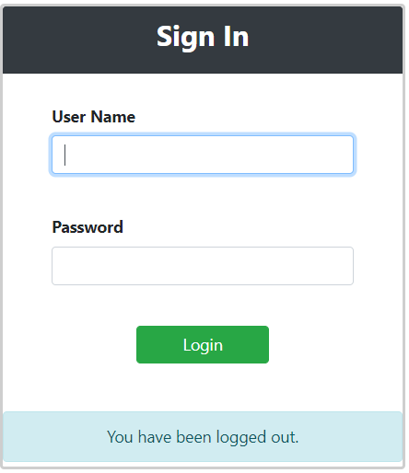

# **2.0 Admin Screens**

1. Admin Welcome Screen:

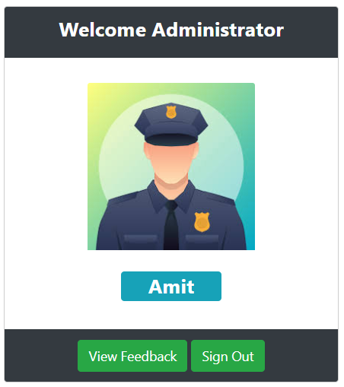

1. View Feedback Screen for Admin:

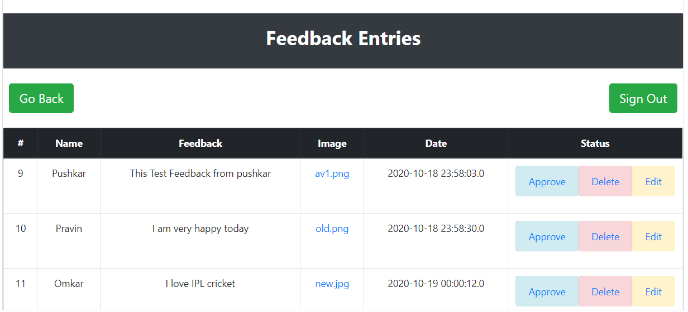

1. Feedback Approval by Admin:

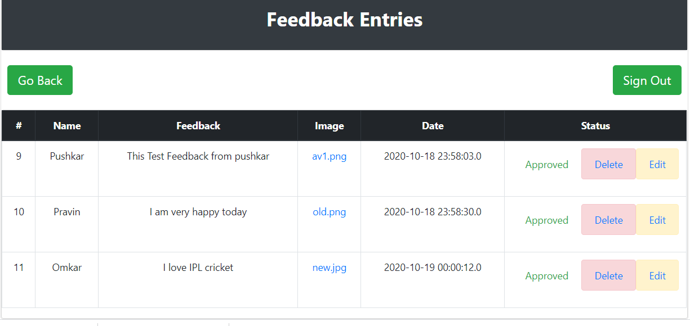

1. Delete Feedback by Admin:

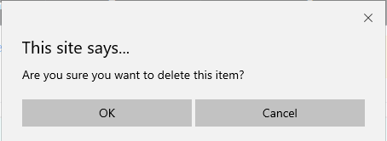

1. After Deleting the Feedback:

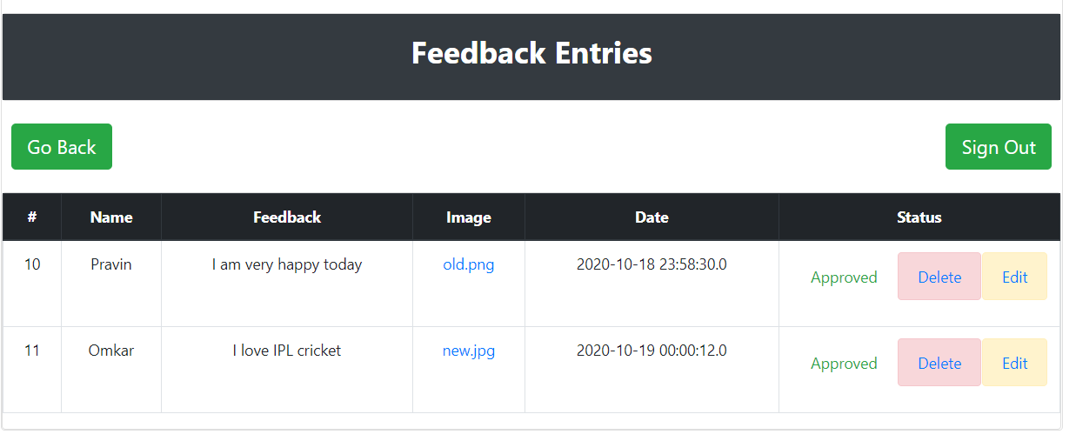

1. Edit Feedback by Admin:

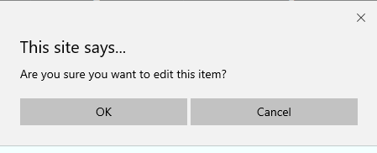

1. Edit feedback form for Admin:

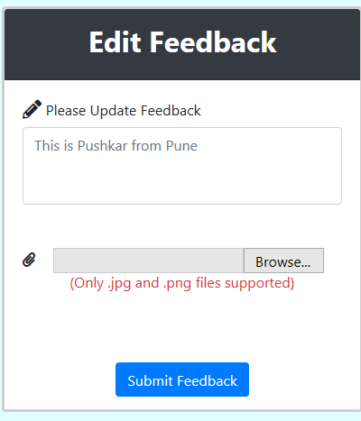

# **3.0 User Screens**

1. Welcome User:

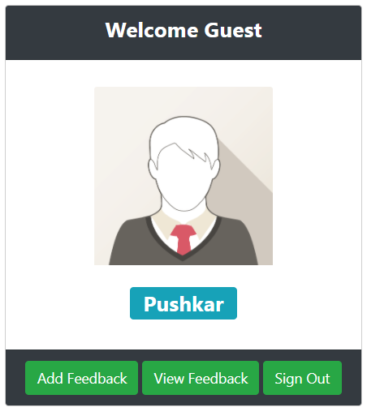

1. Add Feedback User:

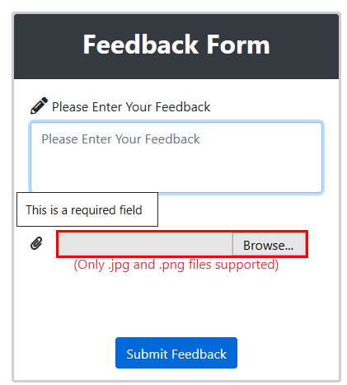 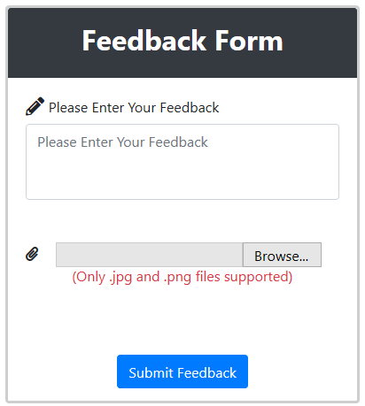

1. File upload user / validation (Only jpg and png files are allowed)

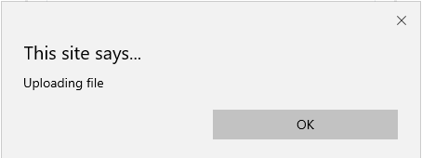 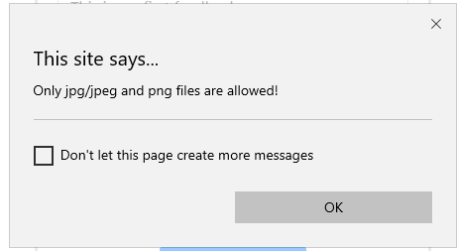

1. User feedback pending for Admin approval:

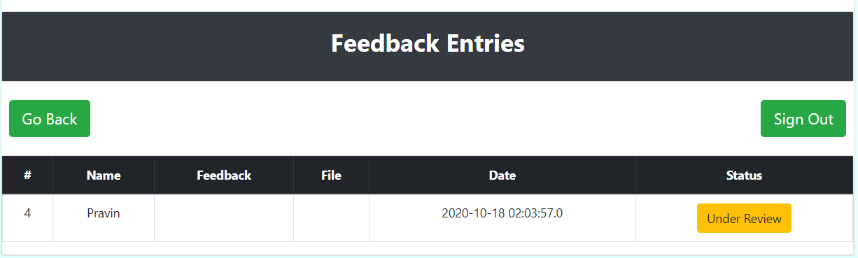

1. After admin approval:

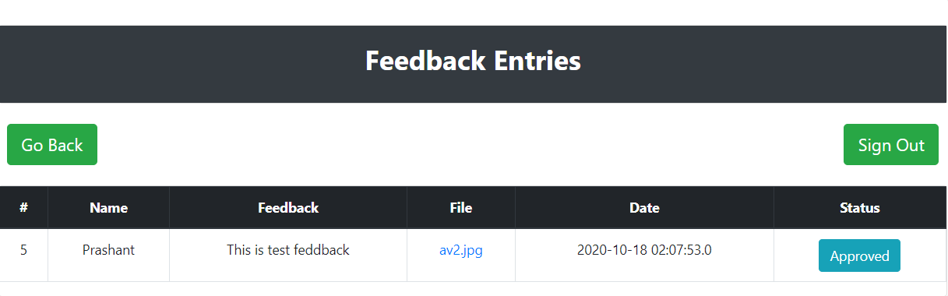

1. Download the attached feedback image:

