**FAQ for User**

1. **How User will Login into the application?**a) User will receive Username and Password on their email address and will click on Login button.  
   b) If User does not have their email address registered, then they can get their Username Password from Admin (AAO/EMS) from Estate Management Section and will login through Login button.

  
**How user will access the Allotment section?**a) Once User logged into the application(estatepagpb.org) with their Username and Password, then for first time they will be asked to change their password. User need to enter their existing password in Old Password and then can enter their new password and click on **Add/Update** Button.  
  
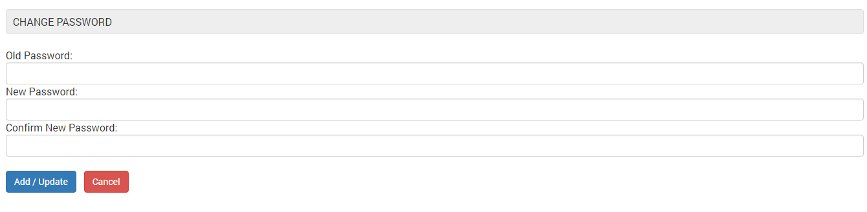  
  
b) After Password change, User will be navigated to My Applications Page. User will click on View button  
  
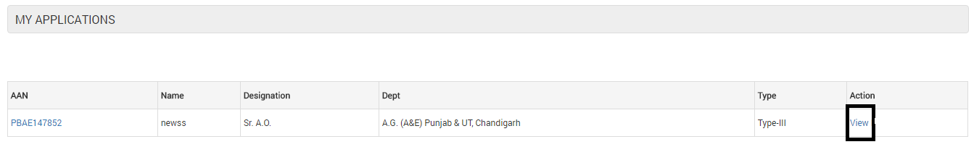  
  
c) On Submission screen, User will verify his/her details and if all details are fine, User will click on **Accept** button.  
  
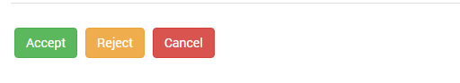  
d) In case the details mentioned on Submission screen got any discrepancy, then User will click on Reject button and fill all the details that are not correct and click on **Submit** button   
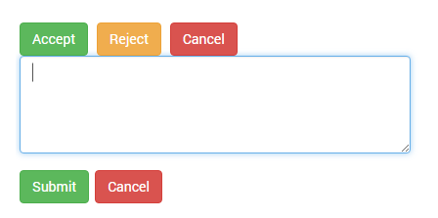  
e) After clicking **Accept** button, User will be navigated to Allotment Screen  
f) If User is not allotted any Quarter then **Apply for new Allotment** option will be enabled  
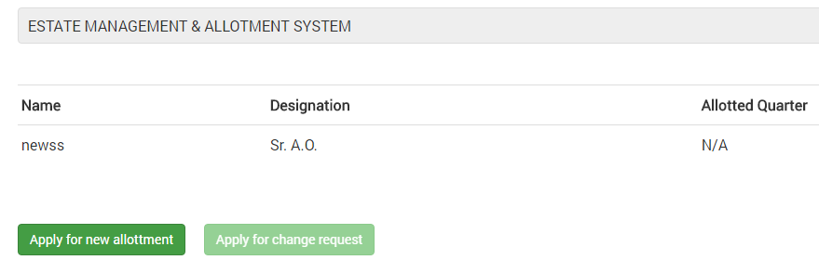  
g) Once the User allotted new Quarter, then **Apply for Change request** option will be enabled.  
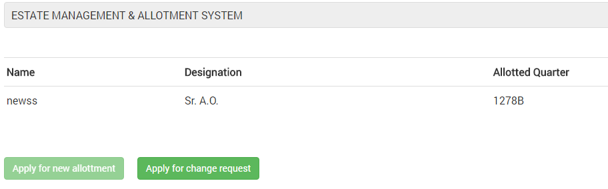  
h) On clicking Apply for Change Request option, following option will be displayed.  
  
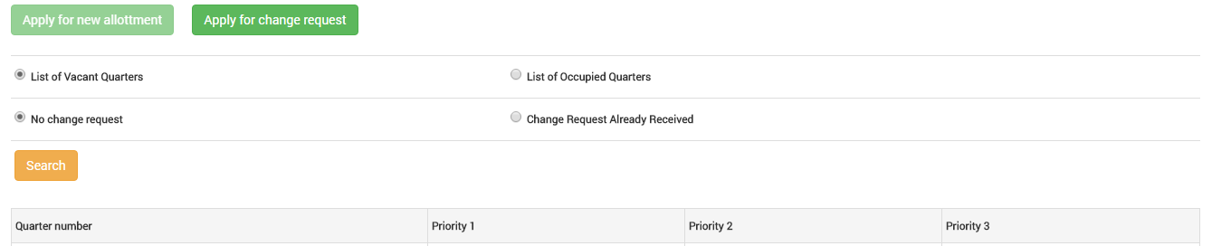  
  
g) User can select Quarter option as , List of Vacant Quarters and No request already received  
h) User can select Quarter option as , List Vacant Quarters and Change request already received  
i) User can select Quarter option as , List of Occupied Quarters and No request already received  
j) User can select Quarter option as , List of Occupied Quarters and Change request already received  
k) User can select three option as Priority 1, Priority 2, Priority 3 from the list that is displayed and click on **Save** button  
l) In case user want to change his option without saving, he/she can use Reset button

1. **User is not able to use Apply for New Allotment or Apply for Change Request option?**If user has already used their new allotment and change request, in that case these options will be coming disabled.
2. **Where User can see Priority List?**User can view Priority list under Circulars section.

**\*\*\* For any other question or query contact EMS section. Numbers mentioned below.\*\*\***

**Sr.AO (EMS) – 0172-2759224 and A.A.O. (EMS) 0172-2759232**