- Register an AWS account (for your reference免费玩AWS-CSDN博客)
- Deploy API Access Key on your Windows Computer (for your reference AWS创建API Access Key-CSDN博客)
- Download https://amitofo.icu/EC2-WireGuardVPN.zip
- Unzip downloaded file to your favorite folder on Windows 10/11
Go into setup folder, double click on WireGuard_setup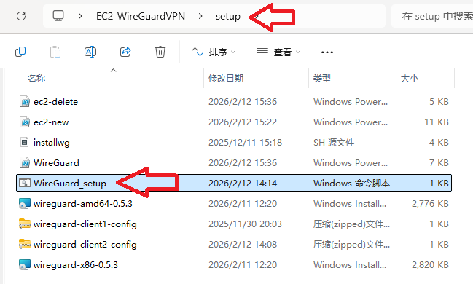
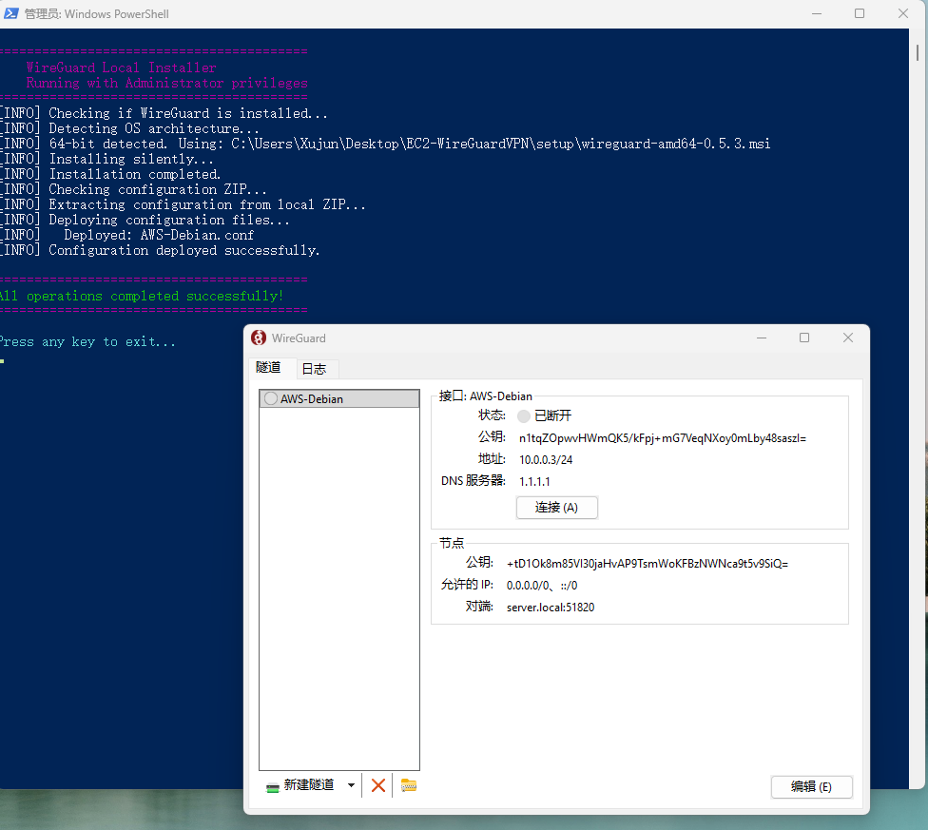
WireGuard VPN client is installed on your computer correctly when seeing the above, feel safe to close them.
- To Turn ON WireGuard VPN tunnel – double click on EC2-WireGuardVPN-ON
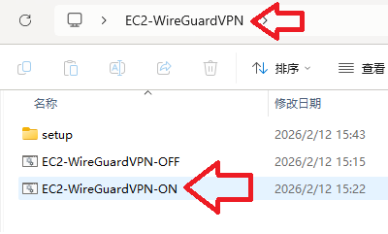
Wait 20 -30 seconds to let it complete
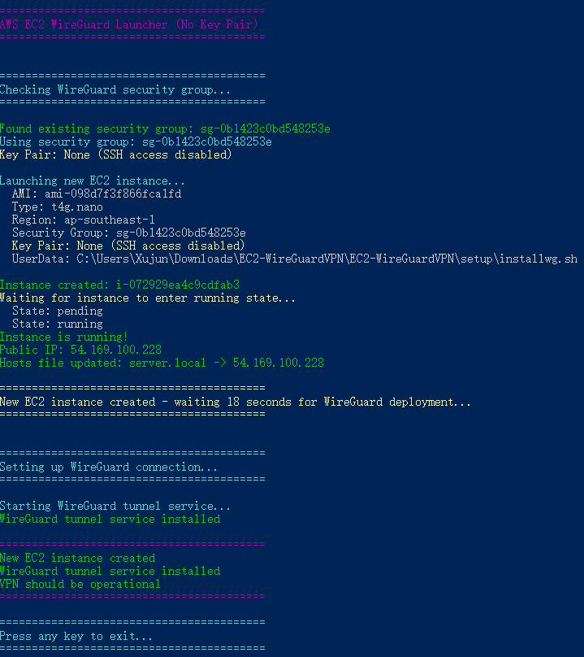
Congratulations! WireGuard VPN tunnel should be well established with your EC2 instance on AWS cloud when seeing the above.
- To Turn OFF WireGuard VPN tunnel – double click on EC2-WireGuardVPN-OFF
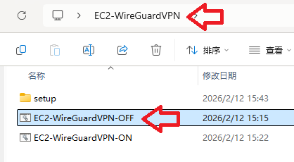
Wait 10 – 20 seconds to let it complete
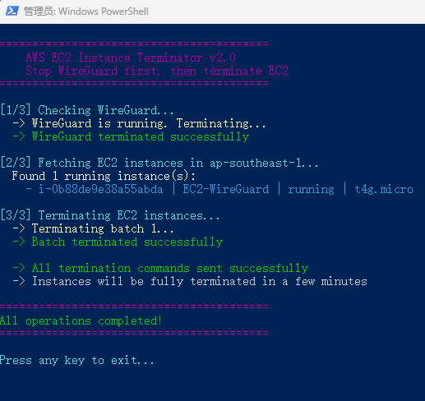
Congratulations! All running EC2 instances should be terminated on AWS cloud when seeing the above.
Tips
- A public IP address that is assigned to EC2 instance might be blocked randomly by government censorship in some countries, to fix this just repeat steps 7 and 6 which will force EC2 to obtain a different public IP address dynamically.
- Monitor your EC2 status and Cost Bills on AWS cloud directly to avoid surprise.

