**BANNER ID:_______________**

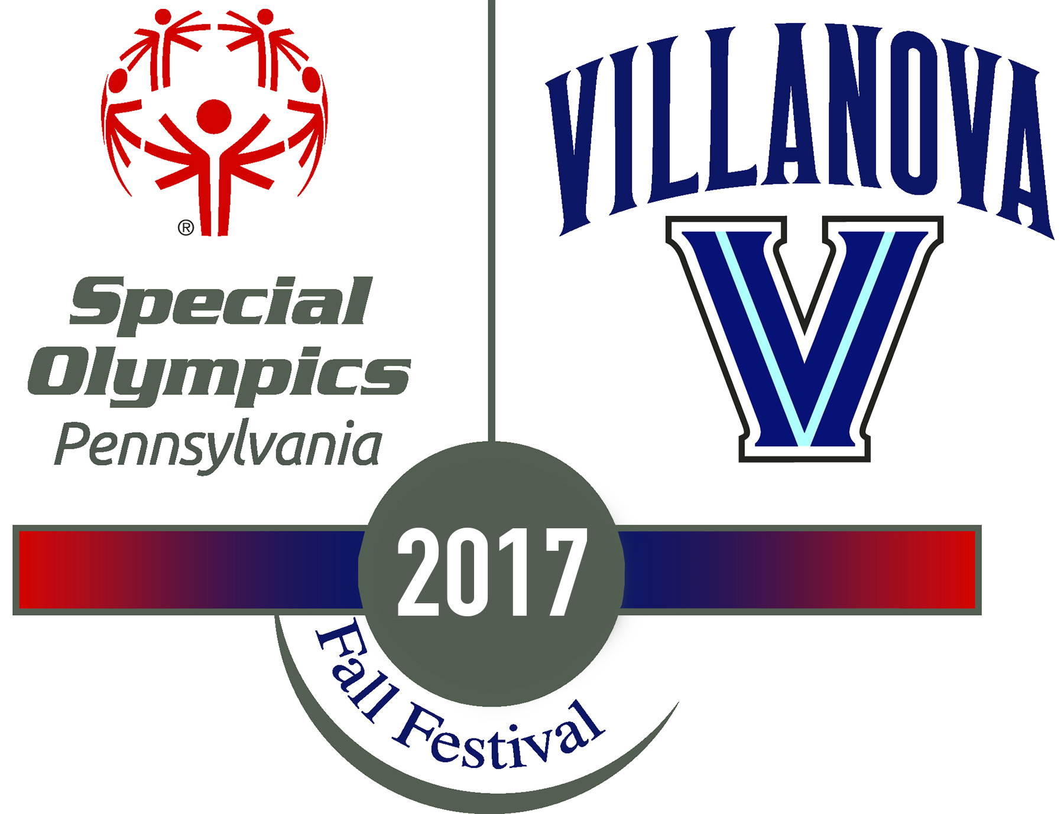

**2017 Fall Festival Volunteer Coordinator Application**

Name: __________________________

Email: __________________________

Please be sure to fill out your banner ID at the top of each page! You will be asked for more logistical information when you are ready to submit your application online. See the next page for application questions!

**APPLICATIONS ARE DUE: MONDAY, SEPTEMBER 11th by 5:00 PM!**

**BANNER ID:_______________**

Please answer each of the following questions in 250 words or less.

**1A. For new applicants, why do you want to be a VC? (If you are a returning VC, please write "N/A" and proceed to the next question.)**

**1B. For returning VCs, why do you want to be a part of the VC program again? (If you are a new applicant, please write "N/A" and proceed to the next question.)**

**2. One of the mottoes of the Unified movement through Special Olympics is, "Play Unified. Live Unified." How do you think this motto embodies the greater mission of Special Olympics?**

**3. What qualities do you have that would make you a successful VC? Please list 3 and explain.**

**4. If you had unlimited resources, how would you make this year's Fall Festival the best yet?**

**5. If you could travel back to any time period, when and where would you go? Why?**

*Thank you so much for applying to be a Volunteer Coordinator for the 2017 Special Olympics Fall Festival! Decision letters will be available on Friday, September 15, 2017 on the second floor of Dougherty. If selected to move on in the process, you will sign up for an interview slot when you pick up your letter. If you have any questions, please email volunteercoordinator@villanovaspo.com*