ALB (Application load balancer)

1. **Create EC2 Instances**

Launch at least two EC2 instances with web server software installed (e.g., Apache, Nginx)

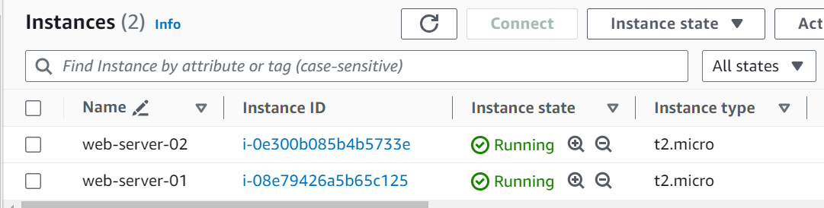

Ensure they belong to the same security group allowing traffic on the web server’s port (e.g., port 80 for HTTP).

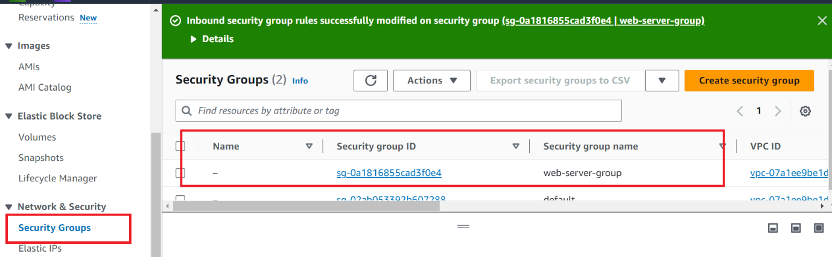

Check Inbound Rules

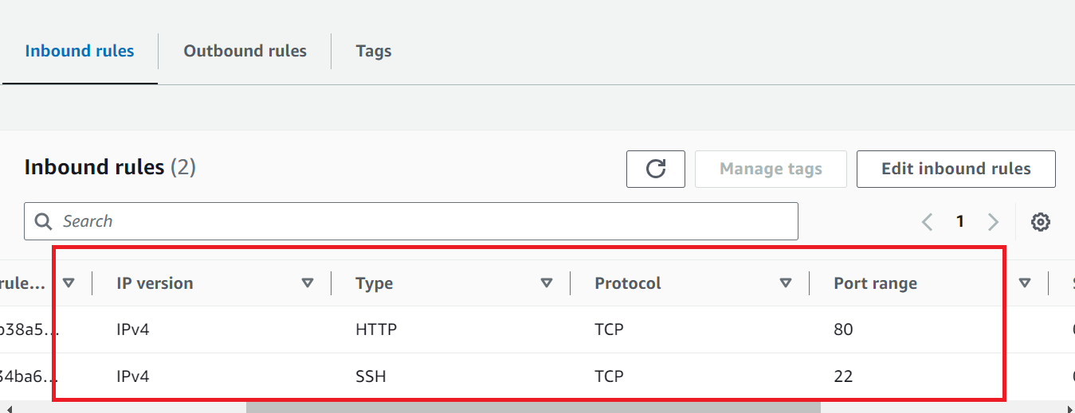

**Create a Target Group**

* In the AWS Management Console, navigate to the EC2 service.
* Create a target group, specifying the target type (e.g., instances) and the protocol and port (e.g., HTTP on port 80).

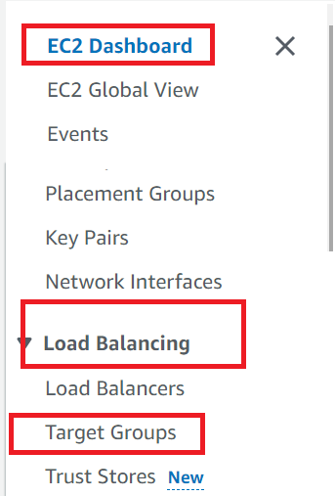

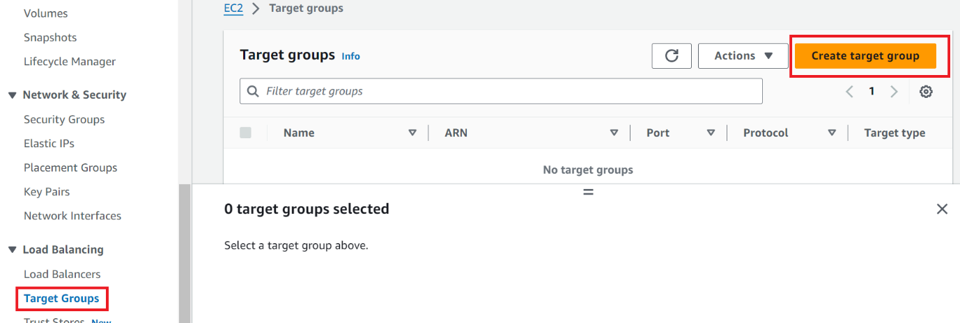

Provide Target group name

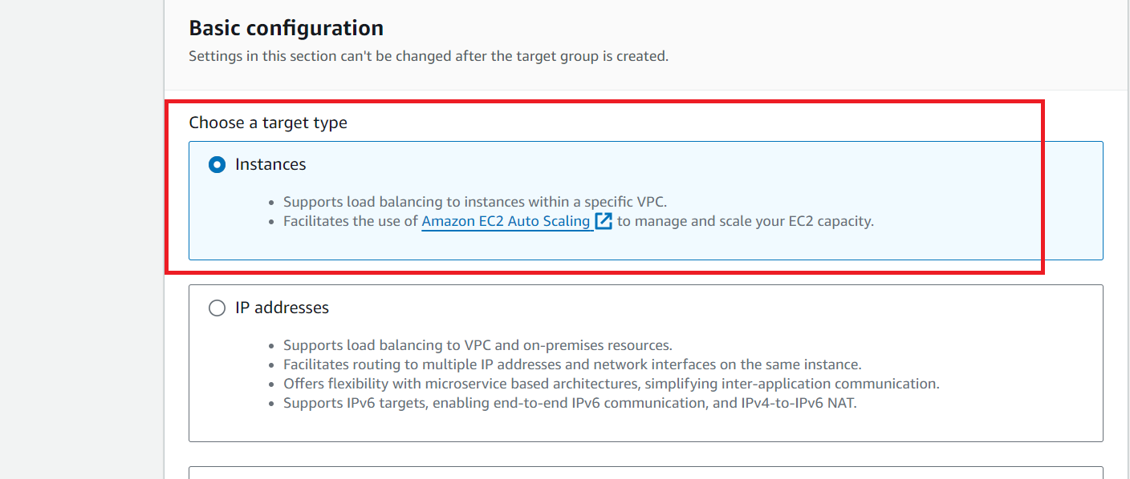 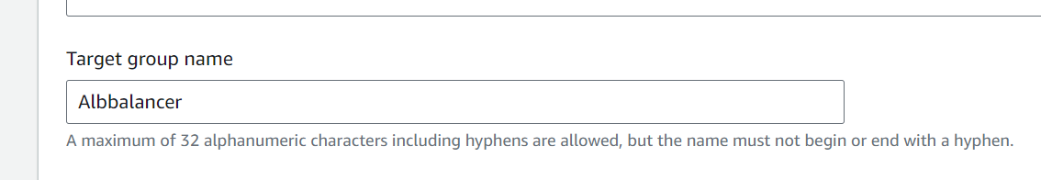

Select VPC

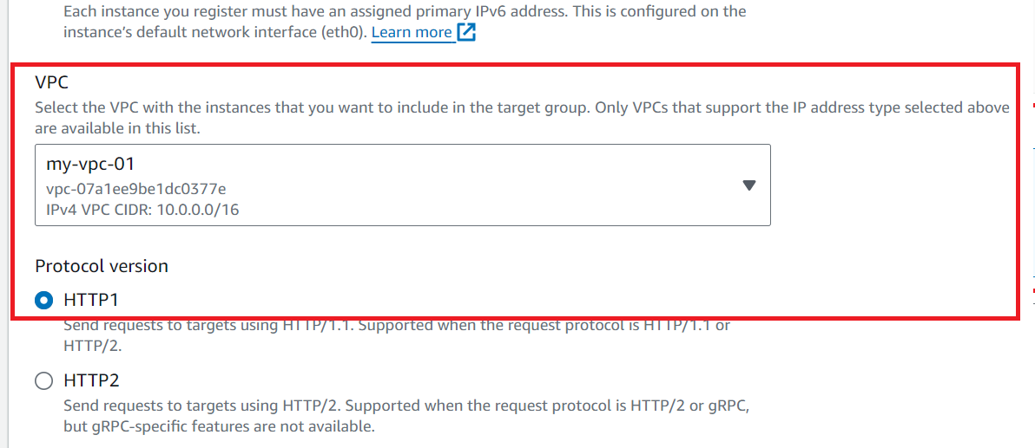

Press next

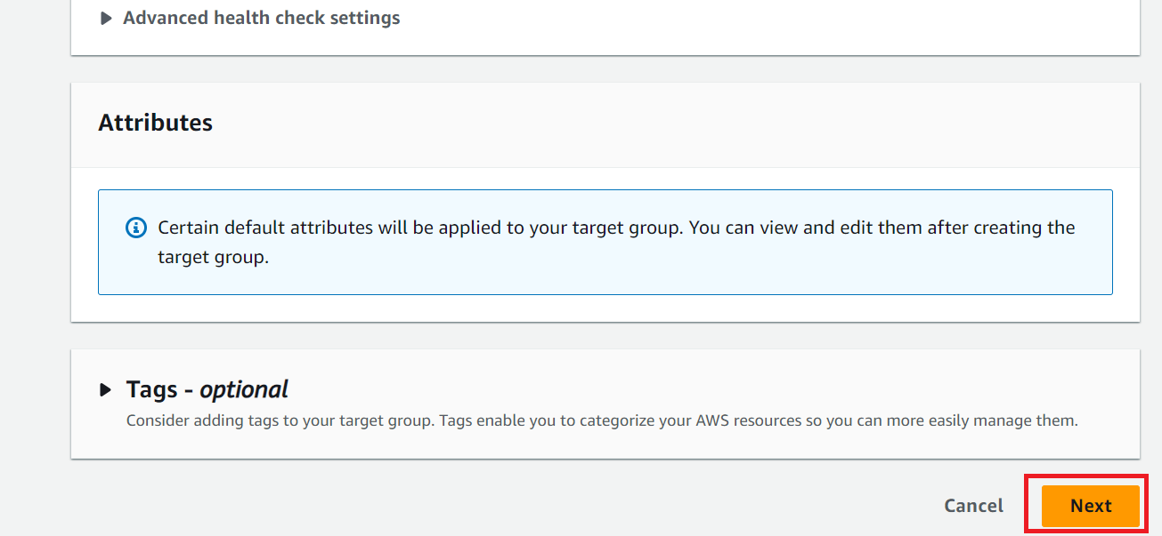

Create Target Group

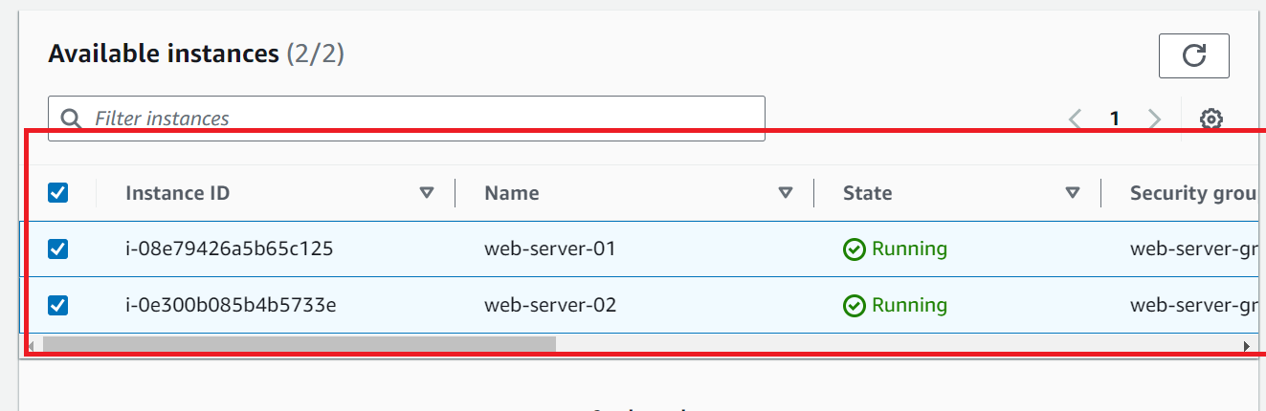

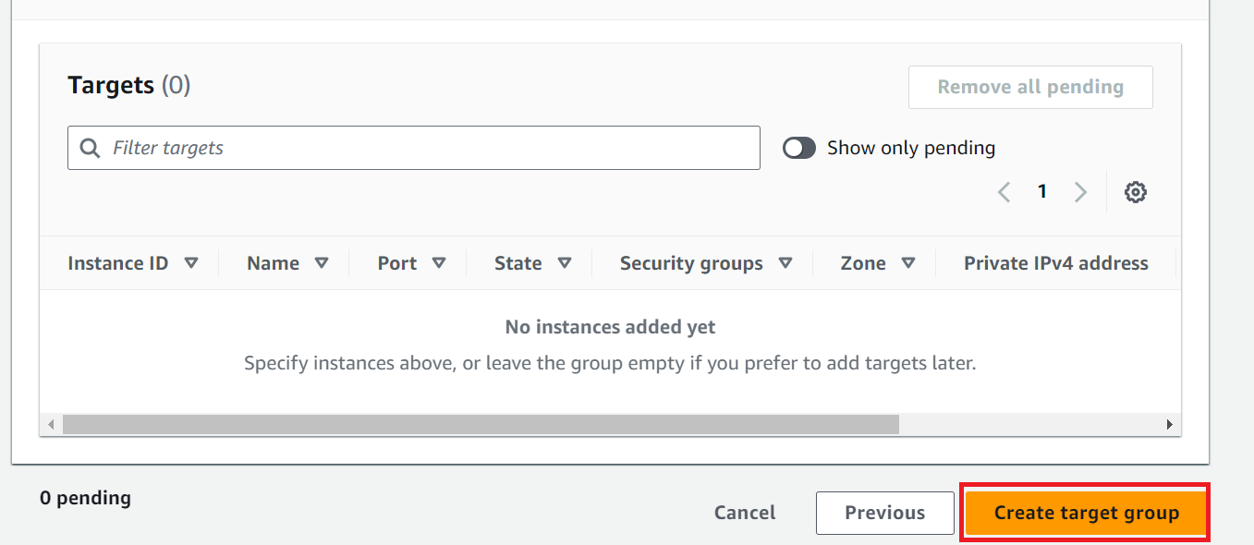

**Register EC2 Instances**

Register the EC2 instances you created in the target group.

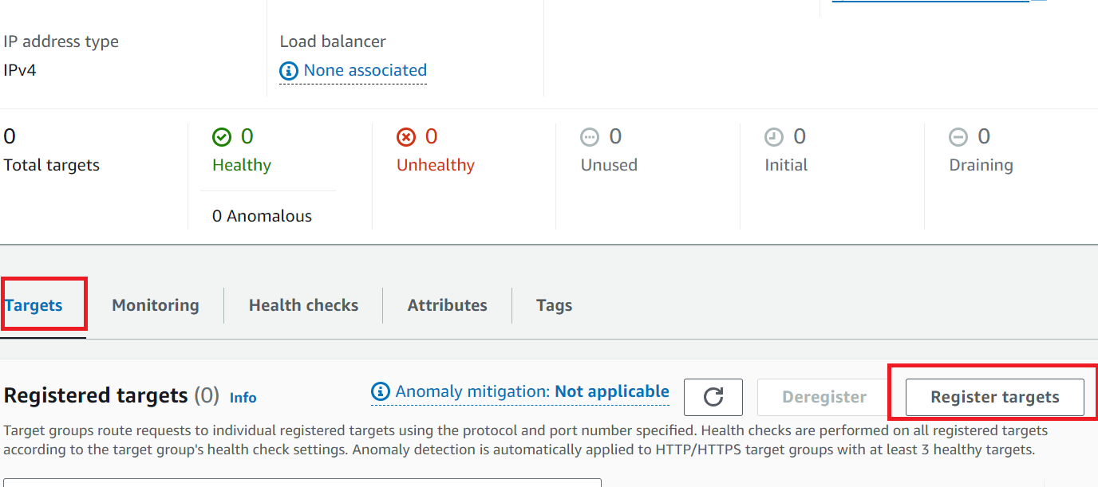

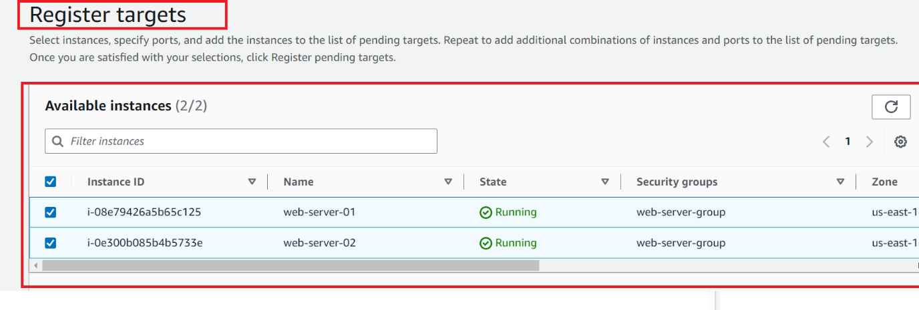

**Create an Application Load Balancer (ALB)**

* In the AWS Management Console, navigate to the EC2 service.

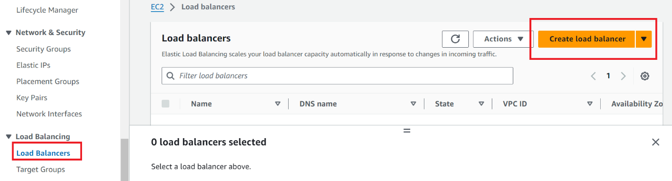

Create an Application Load Balancer (ALB) and configure listeners (e.g., HTTP on port 80).

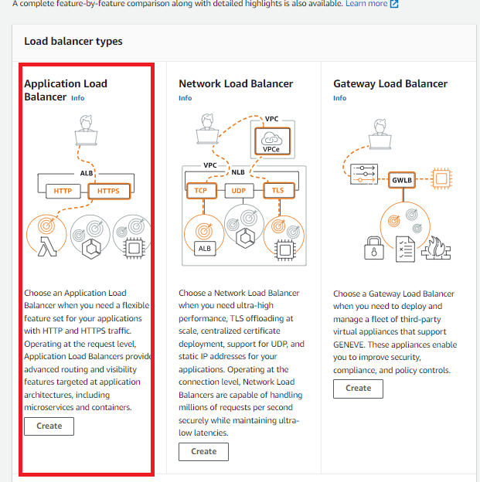

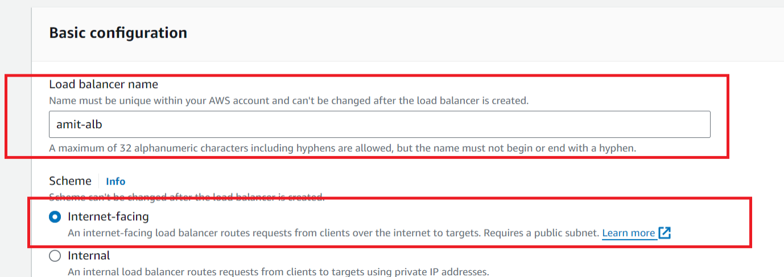

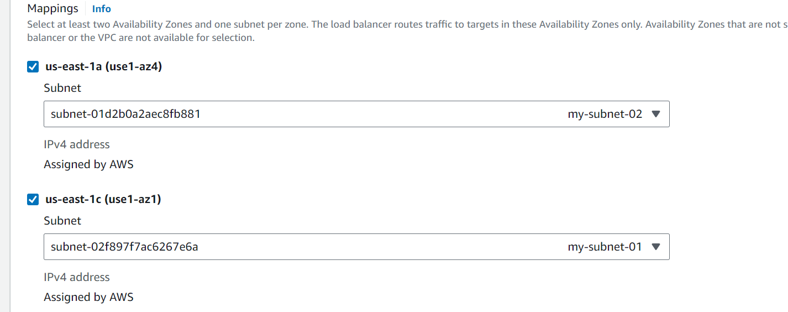

Select security group, which ec2 is using

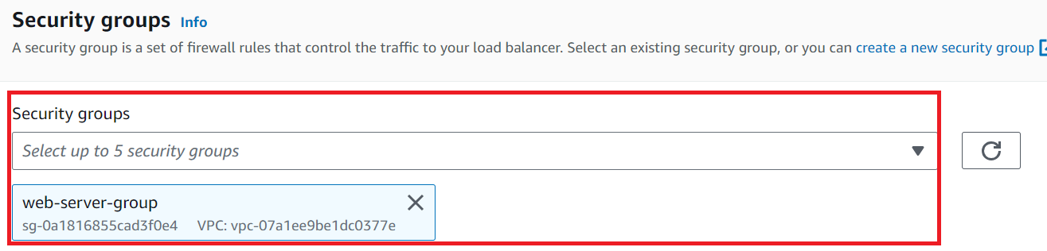

Listeners and routing

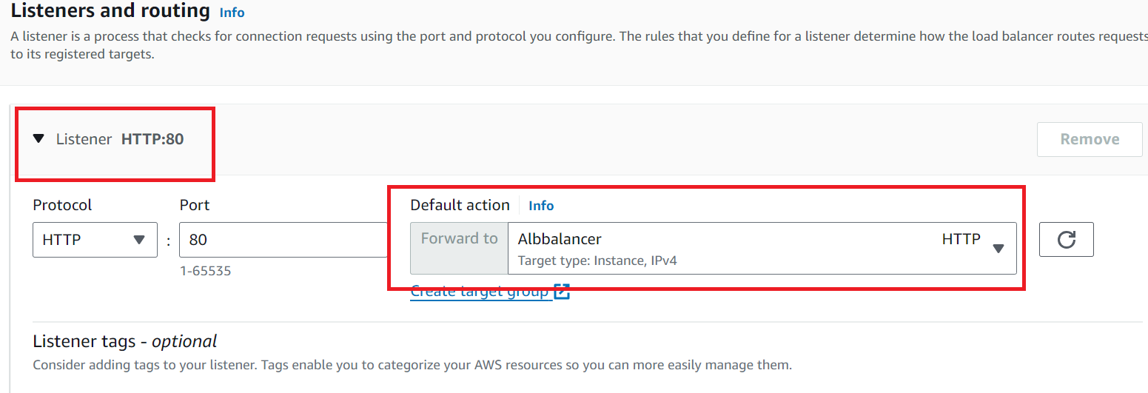

Create load balancer

