Lab: S3 Lambda

1. Create two buckets with default configuration
   1. Amit23comp
   2. Amit23comp-replica
2. Create a new policy in iam , Change source and destination bucket name using arn

{

"Version": "2012-10-17",

"Statement": [

{

"Sid": "putObject",

"Effect": "Allow",

"Action": [

"s3:PutObject"

],

"Resource": [

"arn:aws:s3:::amit23comp-replica/*"

]

},

{

"Sid": "getObject",

"Effect": "Allow",

"Action": [

"s3:GetObject"

],

"Resource": [

"arn:aws:s3:::amit23comp/*"

]

}

]

}

Create a role

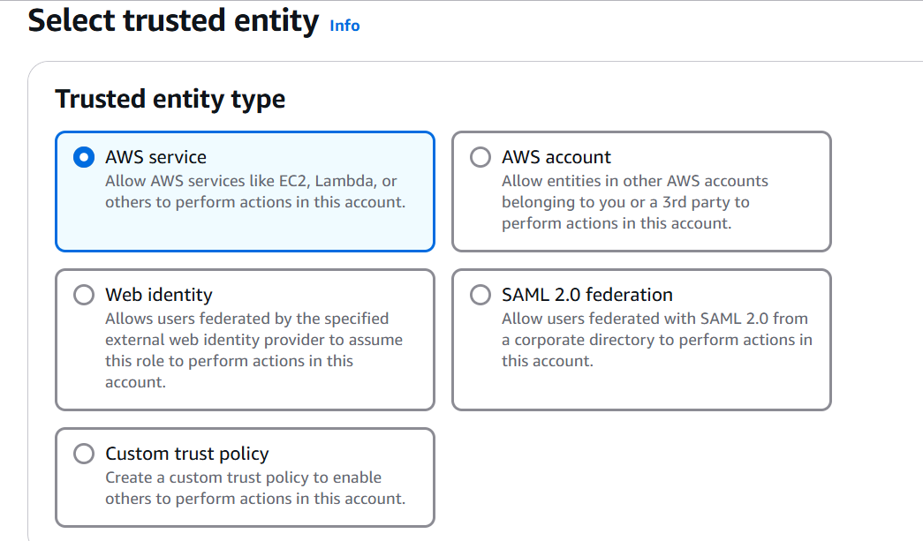

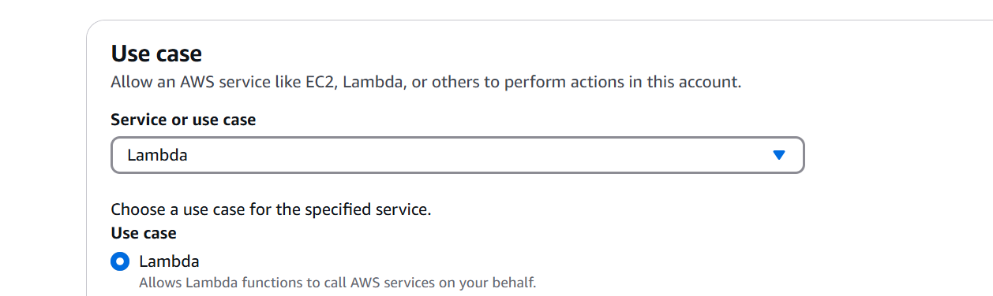

Select your policy

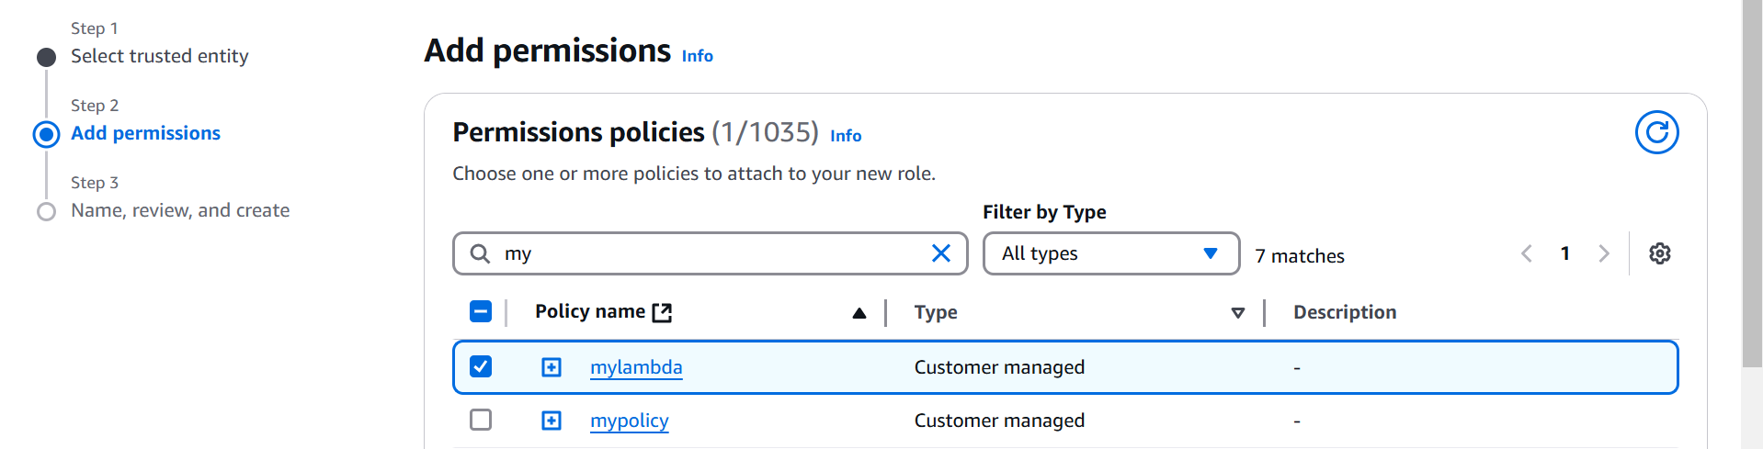

Check for lambda service

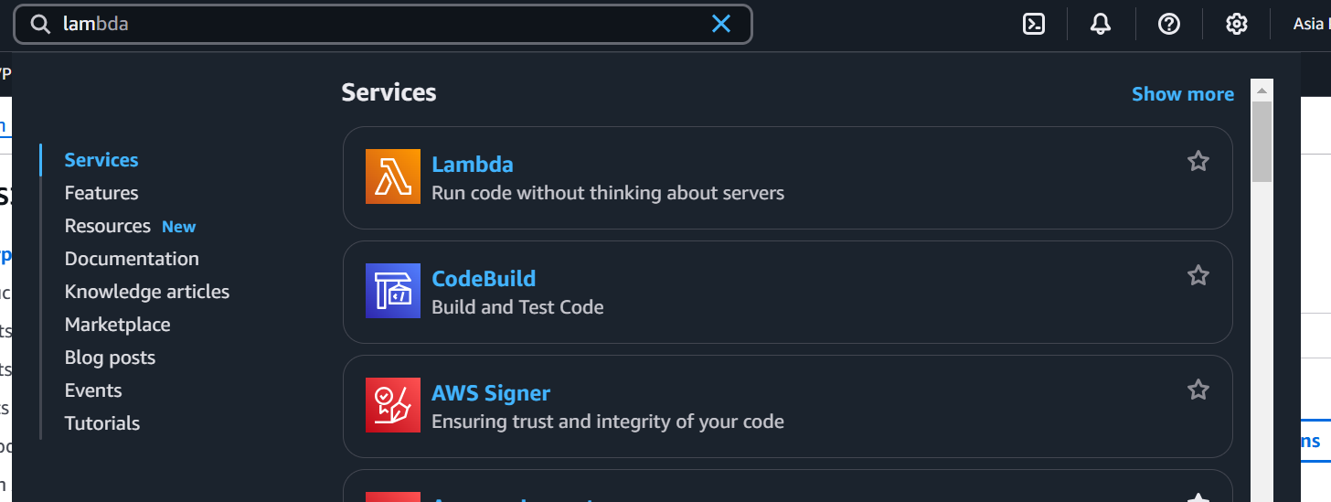

Create a function

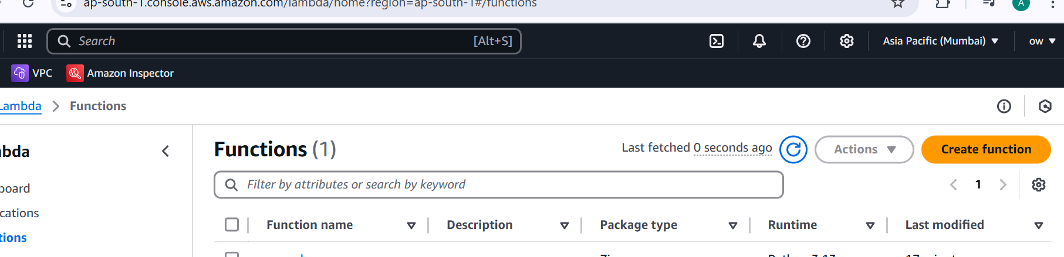

Provide function name and python3.13

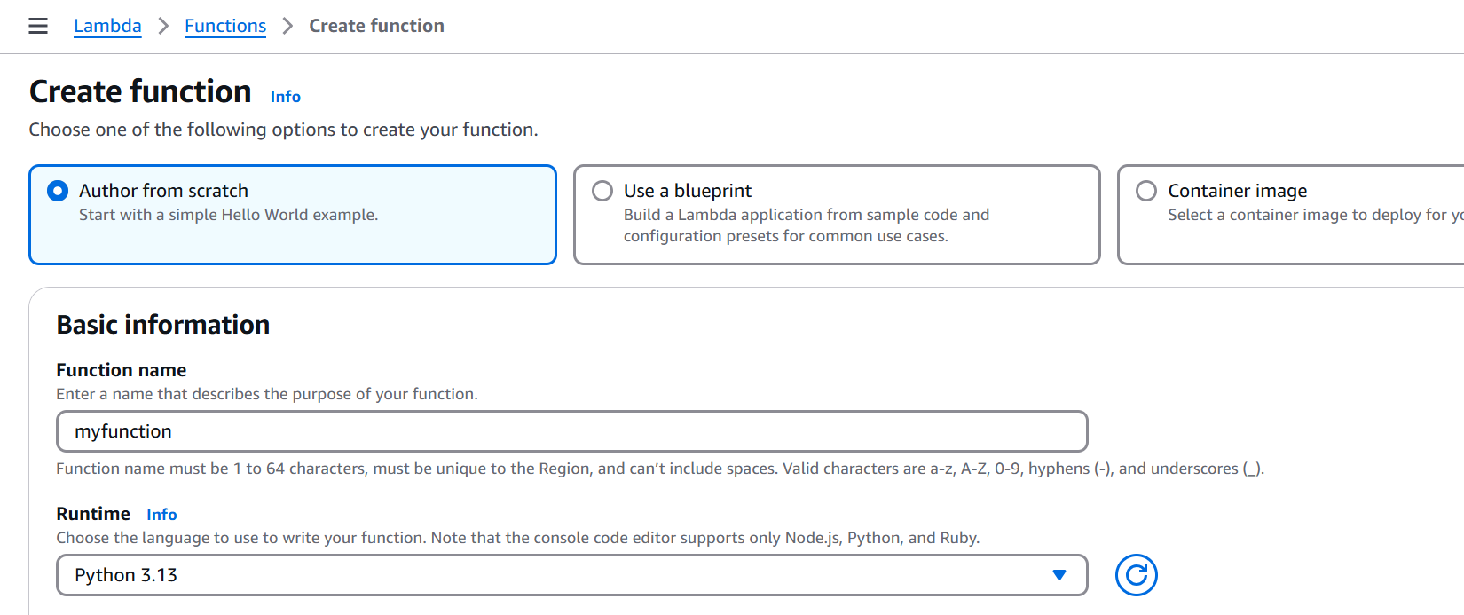

Provide the role

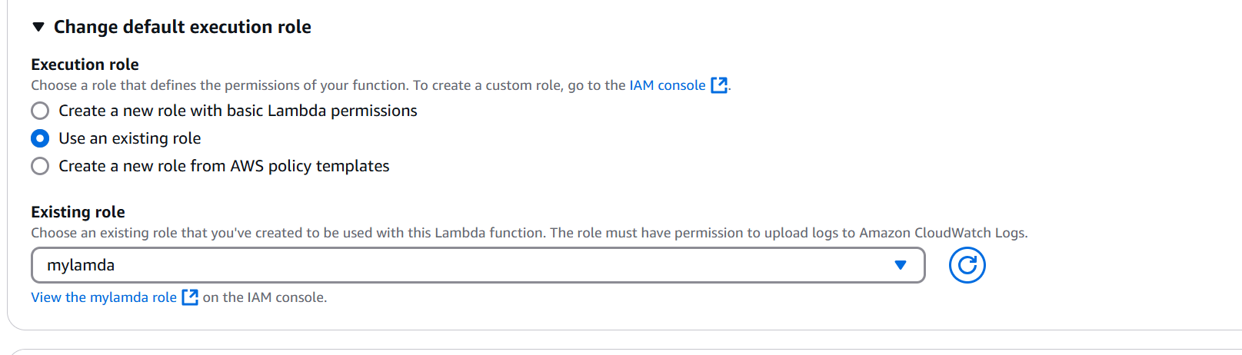

Copy the code

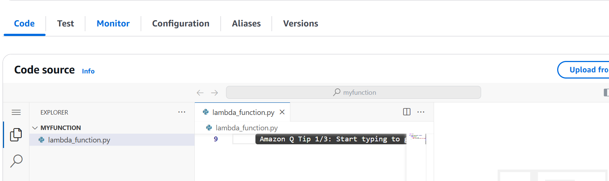

import boto3

import botocore

import os

import logging

# Set up logging

logger = logging.getLogger()

logger.setLevel(logging.INFO)

# Initialize S3 resource

s3 = boto3.resource('s3')

def lambda_handler(event, context):

    logger.info("New files uploaded to the source bucket.")

    # Retrieve the key and bucket name from the event

    try:

        key = event['Records'][0]['s3']['object']['key']

        source_bucket = event['Records'][0]['s3']['bucket']['name']

    except KeyError as e:

        logger.error("Missing key information in event: %s", e)

        return

    # Get the destination bucket from environment variables

    destination_bucket = os.getenv('destination_bucket')

    if not destination_bucket:

        logger.error("Destination bucket environment variable  is not set.")

        return

    # Define the source object

    source = {'Bucket': source_bucket, 'Key': key}

    try:

        # Copy the file

        s3.meta.client.copy(source, destination_bucket, key)

        logger.info("File '%s' copied from '%s' to '%s' successfully!", key, source_bucket, destination_bucket)

    except botocore.exceptions.ClientError as error:

        logger.error("Error copying file: %s", error)

    except botocore.exceptions.ParamValidationError as error:

        logger.error("Parameter validation error: %s", error)

Click on Deploy

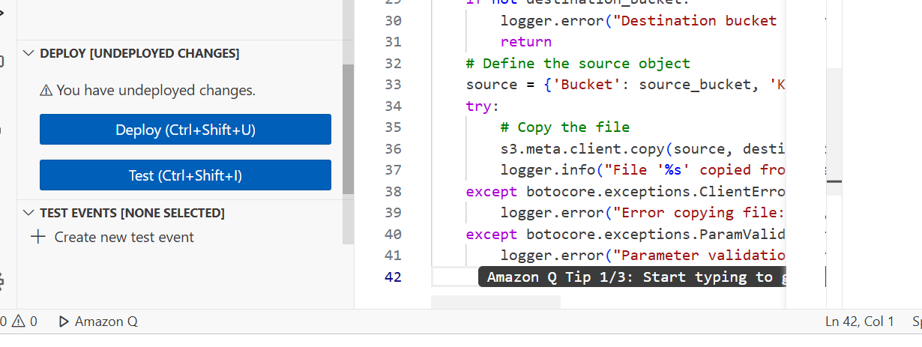

Click on Configuration

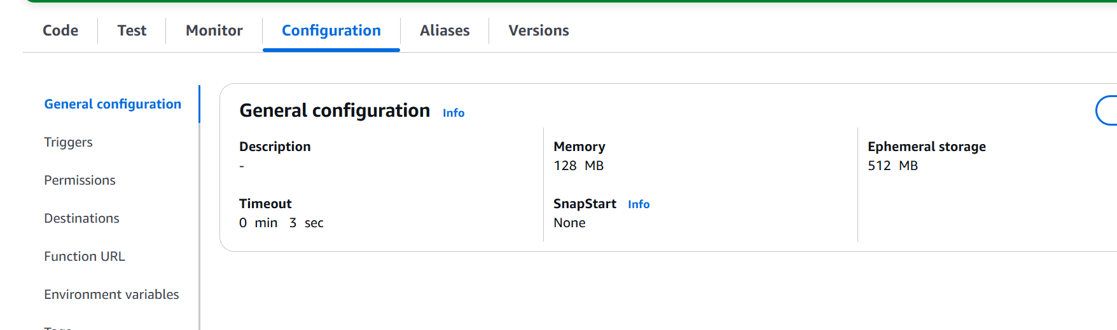

Click on Environment variables

Key :destination_bucket

Value: awsbucketamit-replica

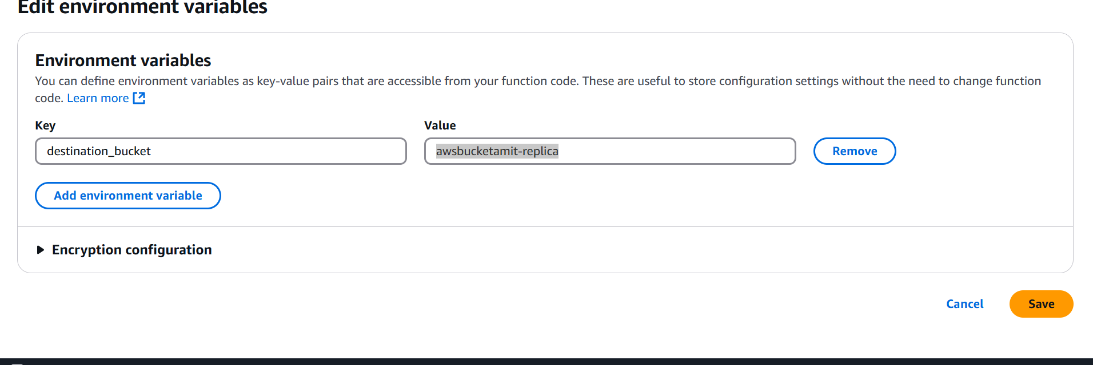

Click on Add triggers

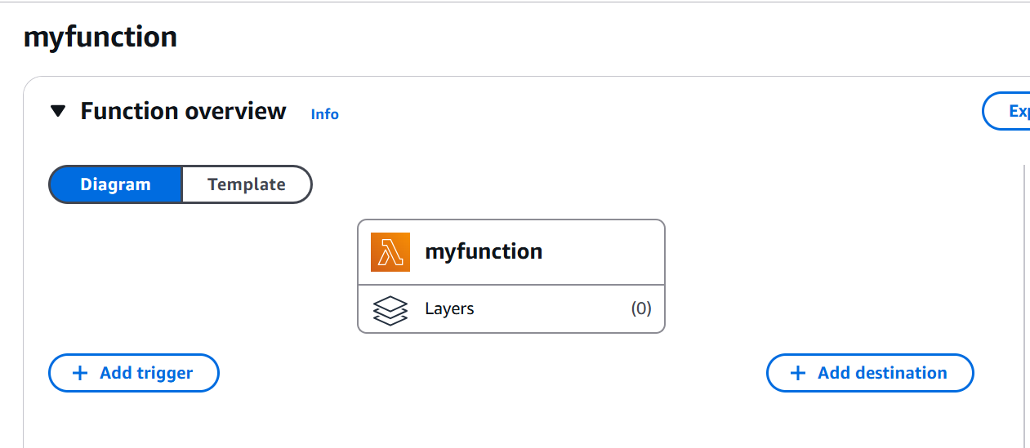

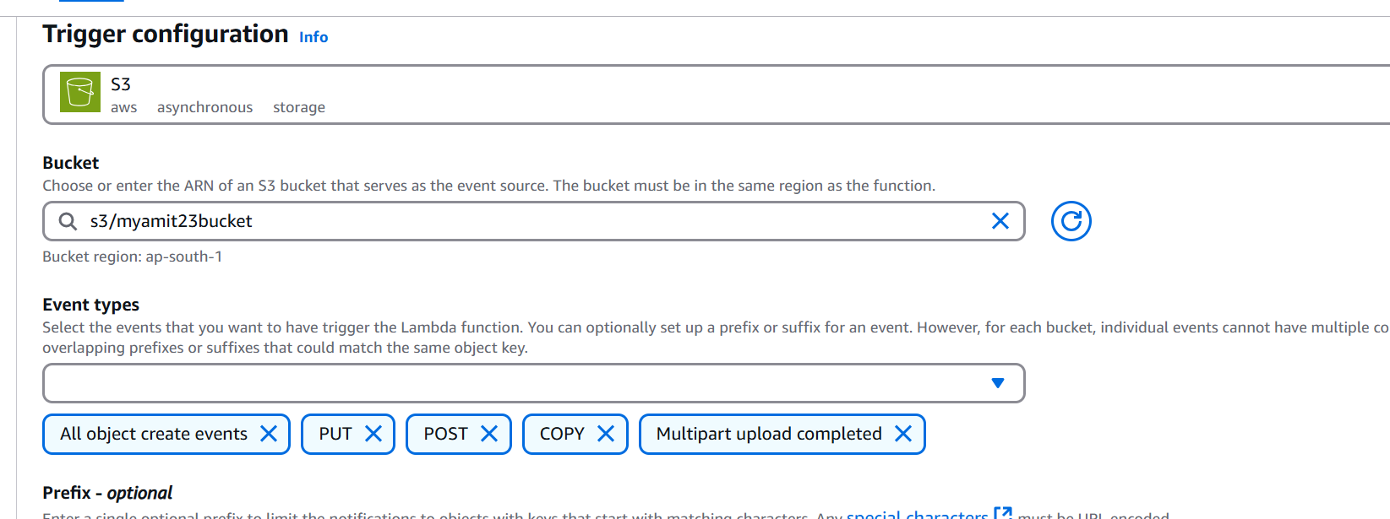

**Upload a jpg file in source bucket.**

Create a test.

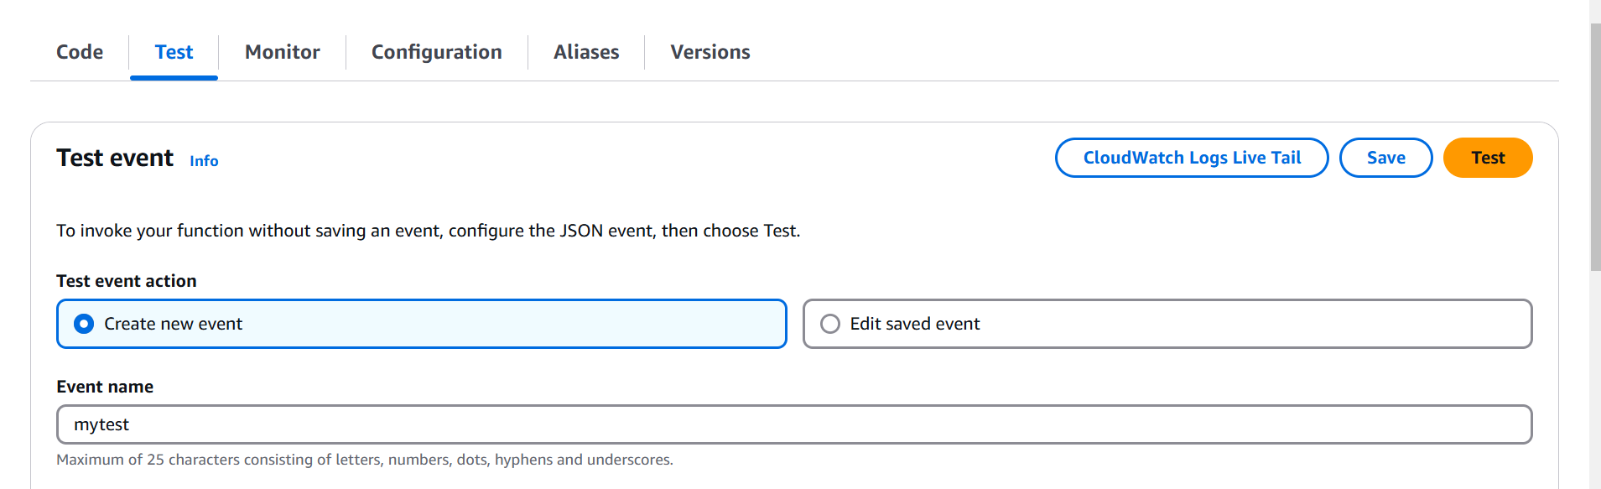

Json

{

"Records": [

{

"s3": {

"bucket": {

"name": "provide the source bucket name"

},

"object": {

"key": "object name which you uploaded"

}

}

}

]

}

Save and Test

# Updated and Rectified Lab Steps for S3 Lambda

1. Create Two Buckets:  
Create two S3 buckets with default configuration:  
 - Source: myamit23bucket  
 - Destination: awsbucketamit-replica

2. Create an IAM Policy:  
Go to IAM → Policies → Create Policy and paste the JSON (update bucket ARNs accordingly).

3. Create an IAM Role:  
Go to IAM → Roles → Create Role. Choose Lambda as trusted entity, attach the policy created above.

4. Create a Lambda Function:  
Name it s3CopyFunction, select Python 3.13, and attach the IAM role.

5. Paste the Lambda Code:  
Use the provided Python code that uses boto3 to copy from source to destination bucket.

6. Deploy the Function:  
Click Deploy to apply the code changes.

7. Add Environment Variable:  
Go to Configuration → Environment variables:  
 - Key: destination_bucket  
 - Value: awsbucketamit-replica

8. Add S3 Trigger:  
Attach a trigger for PUT events from source bucket.

9. Upload Test File:  
Upload a file to the source bucket to trigger the function.

10. Create Test Event:  
Manually test with a JSON simulating an S3 PUT event using the file key.

11. Rectification Steps:  
 - Verify logs in CloudWatch  
 - Check destination bucket for copied file  
 - Validate error handling for missing env or bad bucket name