Use Java sonar repos

Create feed

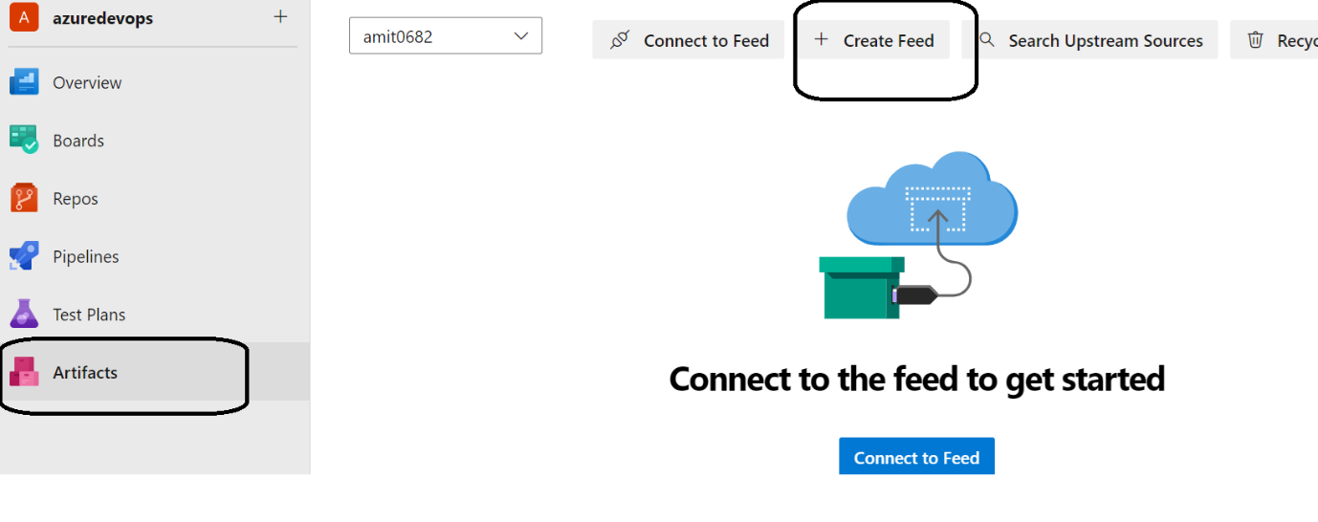

Create the feed

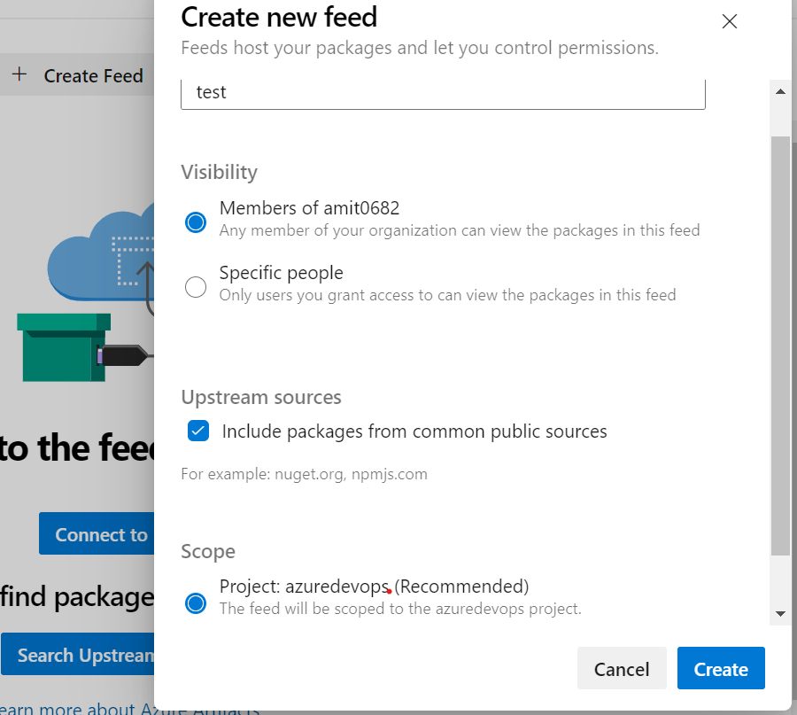

Click on connect to feed option

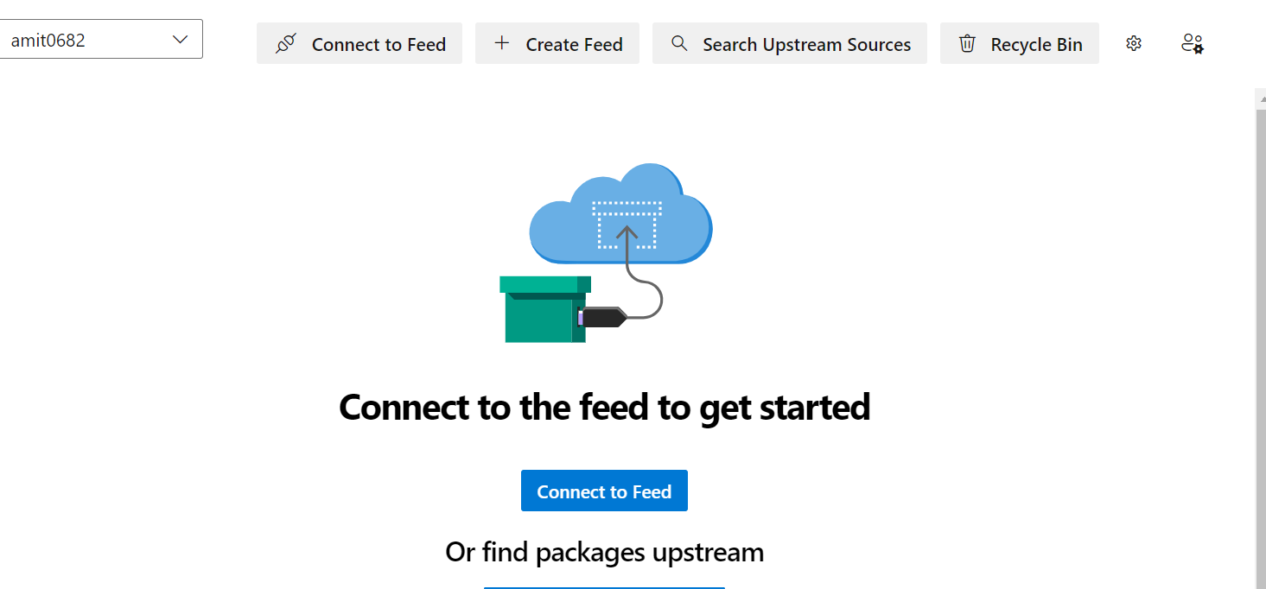

Select maven

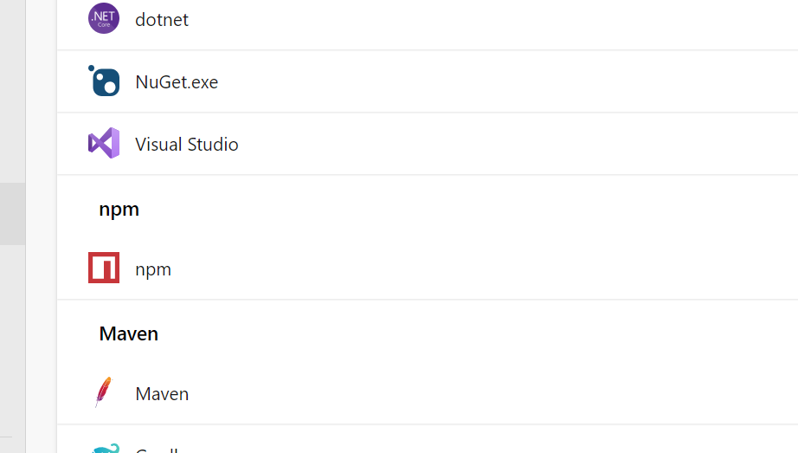

Add this section

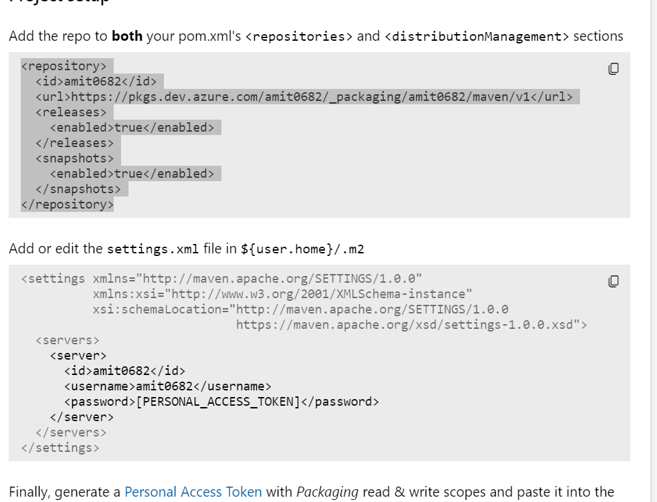

Code:Change artifact name from amit0682 to your feed name

trigger:

- master

stages:

- stage: Build

  displayName: 'Build'

  jobs:

  - job: MavenJob

    pool:

      name: myvm

    steps:

    - task: Maven@4

      inputs:

        mavenPomFile: 'pom.xml'

        publishJUnitResults: true

        testResultsFiles: '**/surefire-reports/TEST-*.xml'

        javaHomeOption: 'JDKVersion'

        mavenVersionOption: 'Default'

        mavenAuthenticateFeed: false

        effectivePomSkip: false

    - publish: /home/amit/drop

      artifact: drop

      displayName: 'Publish Build Artifact'

- stage: Test

  displayName: 'Test'

  dependsOn: Build

  jobs:

  - job: TestJob

    pool:

      name: myvm

    steps:

    - download: current

      artifact: drop

      displayName: 'Download Build Artifact'

    - script: |

        # Your testing commands/scripts here

        ls /home/amit/drop  # Example command to list the downloaded build artifact

      displayName: 'Run Tests'

- stage: AnalyzeCode

  displayName: 'Analyze Code'

  dependsOn: Test

  jobs:

  - job: SonarCloudJob

    pool:

      name: myvm

    steps:

    - task: SonarCloudPrepare@1

      inputs:

        SonarCloud: 'sonaraccess'

        organization: 'amitopenwriteup'

        scannerMode: 'Other'

    - publish: /home/amit/drop

      artifact: sonar-report

      displayName: 'Publish Sonar Report'

- stage: PublishArtifacts

  displayName: 'Publish Artifacts'

  dependsOn: AnalyzeCode

  jobs:

  - job: PublishArtifactsJob

    pool:

      name: myvm

    steps:

    - download: current

      artifact: drop

      displayName: 'Download Build Artifact'

    - task: PublishBuildArtifacts@1

      inputs:

        PathtoPublish: '/home/amit/drop'

        ArtifactName: 'amit0682'

        publishLocation: 'Container'

For updating the feed

**Sign in to Azure DevOps:** Open your terminal or command prompt and sign in to Azure DevOps using Azure CLI

az login

**set organization and project details**

az devops configure --defaults organization=https://dev.azure.com/my-org project=my-project

**Update the feed**

az artifacts feed update --feed-name my-feed --visibility public --description "Updated feed description"