1)Create a project in gitlab with repo name ansibleproj

2) Create Docker file inside that

Dockerfile

FROM ubuntu:latest

USER root

# Set timezone environment variable

ARG DEBIAN_FRONTEND=noninteractive

ENV TZ=Etc/UTC

RUN apt-get update && \

apt-get install -y tzdata ansible git && \

ln -fs /usr/share/zoneinfo/${TZ} /etc/localtime && \

dpkg-reconfigure -f noninteractive tzdata && \

apt-get clean

# Set the home directory to a writable path

ENV HOME=/tmp

# Create a writable `.ansible` directory

RUN mkdir -p /tmp/.ansible/tmp && chmod -R 777 /tmp/.ansible

3)Create Credentials for gitlab

Manage Jenkins->Security->Credentials

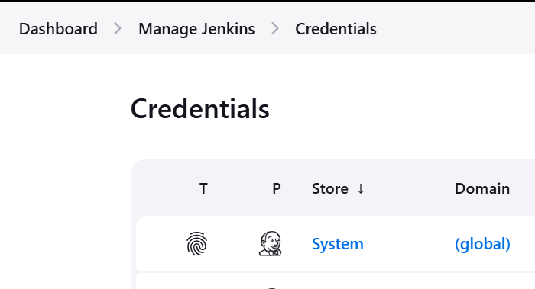

Click on System->Global Credentials

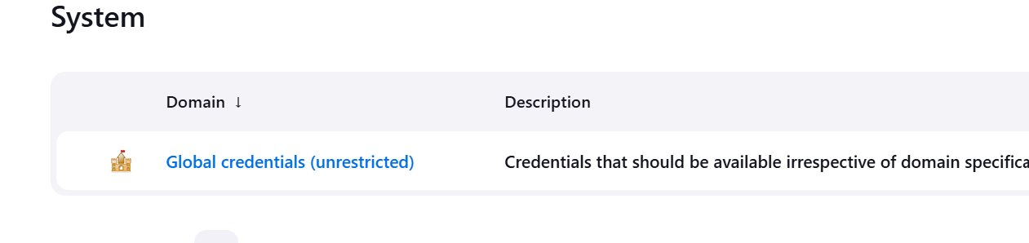

Add Credentials



Provide ssh private key and userid

Root user: cat /root/.ssh/id_rsa

Labuser: cat /home/labuser/.ssh/id_rsa

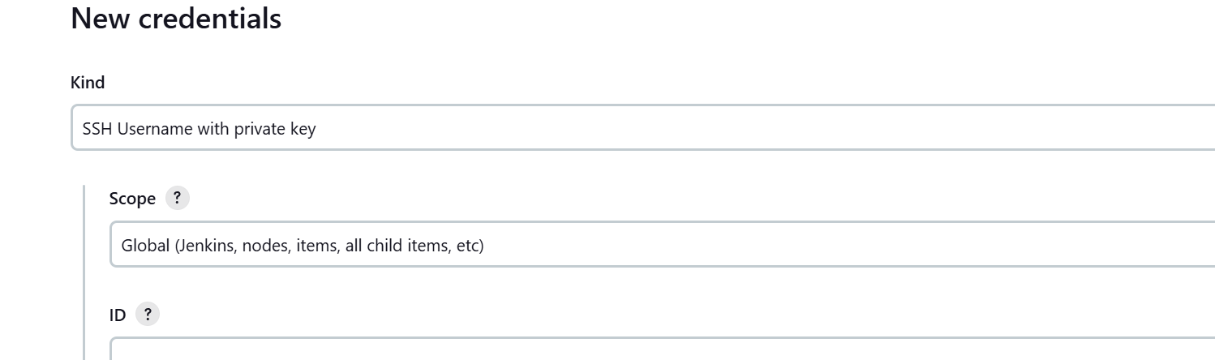

Now from pipeline syntax option

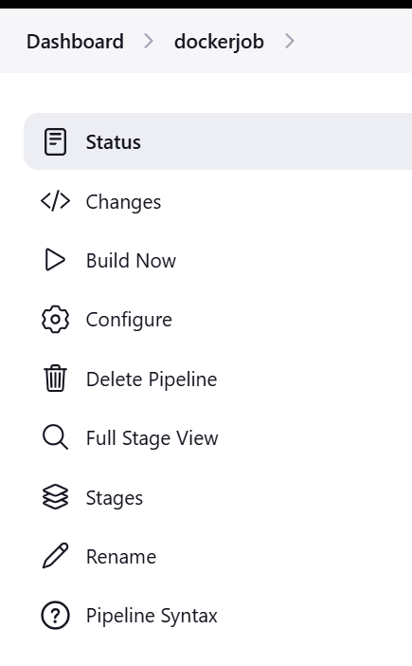

Fill entry and generate code

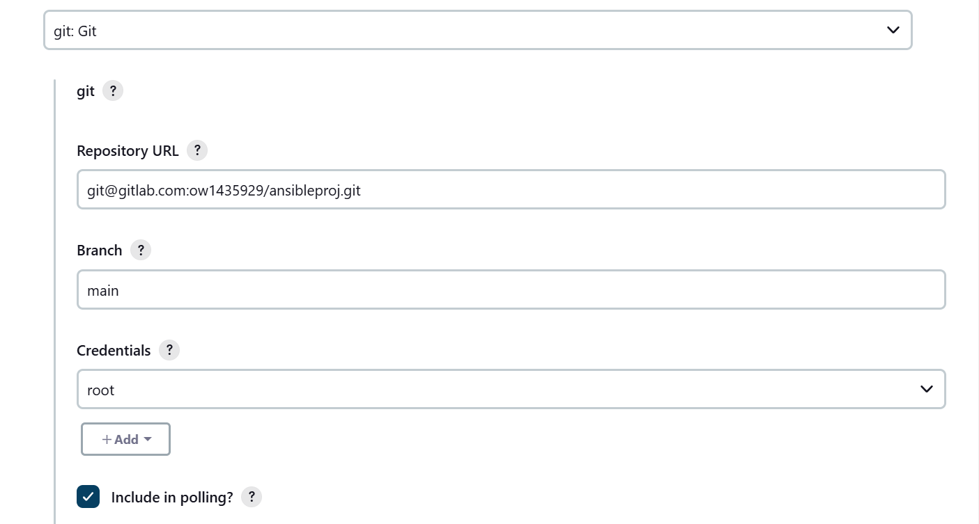

Replace line highlighted in red and add to gitlab repo

pipeline {

agent {

dockerfile {

filename 'Dockerfile'

}

}

environment {

ANSIBLE_LOCAL_TEMP = '/tmp/.ansible/tmp'

}

stages {

stage('Checkout') {

steps {

git branch: 'main', credentialsId: 'ada46996-16ba-4545-b9c5-f308a0cf747a', url: 'git@gitlab.com:ow1435929/ansibleproj.git'

}

}

stage('Run Ansible Playbook') {

steps {

sh 'ansible-playbook -i inventory playbook.yaml'

}

}

}

}

Add inventory and playbook.yaml in gitlab repo

inventory

[local]

localhost ansible_connection=local

playbook.yaml

---

- name: Check SSH service status

hosts: localhost

become: true

tasks:

- name: Check SSH service status

service:

name: ssh

state: started

register: ssh_service_status

- name: Print SSH service status

debug:

msg: "SSH service is {{ ssh_service_status.state }}"

Create a pipeline job in Jenkins , ->select option pipeline from scm

