Click on View all products

Create a Service account and provide permission
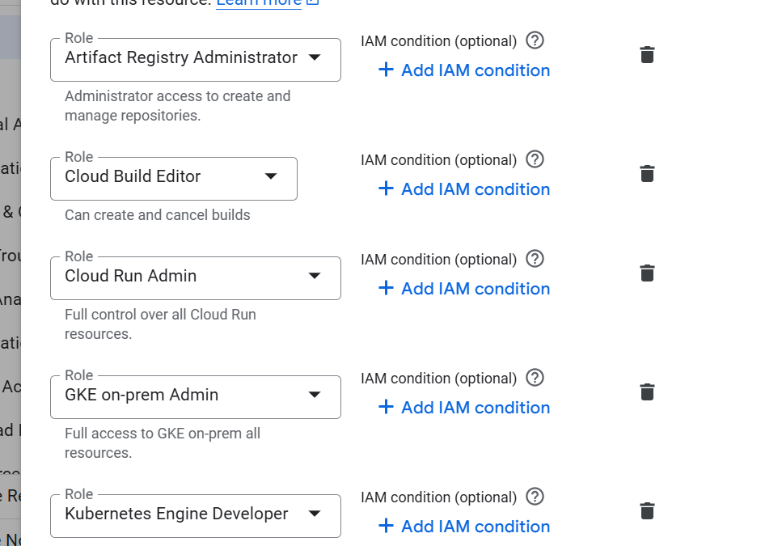
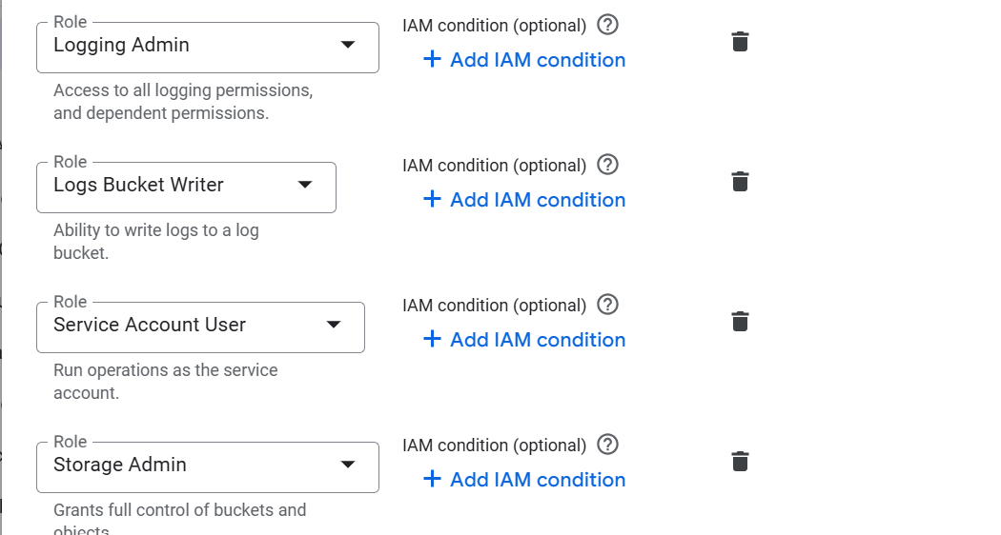

Go to my github and fork the project
https://github.com/amitopenwriteup/cicdproject
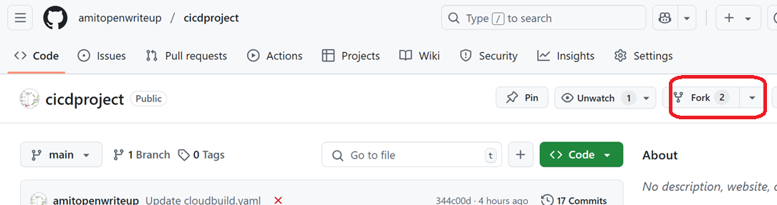

On GCP console, Click on View all products

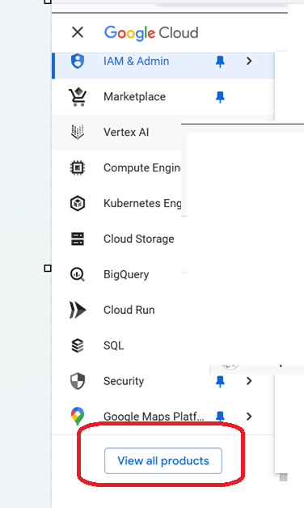

Go to CICD and Click on Cloud build
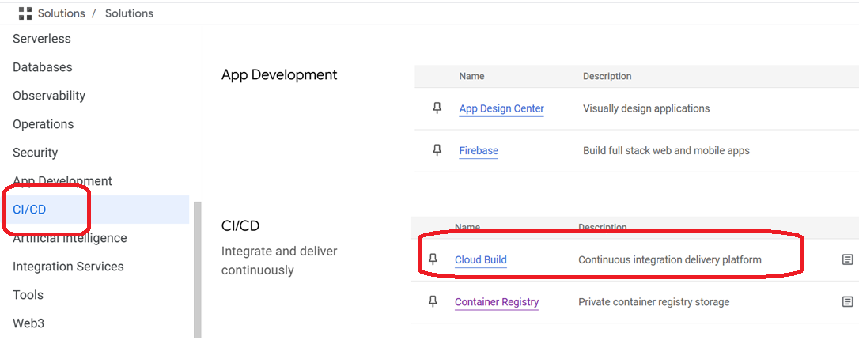

Click on 1st gen
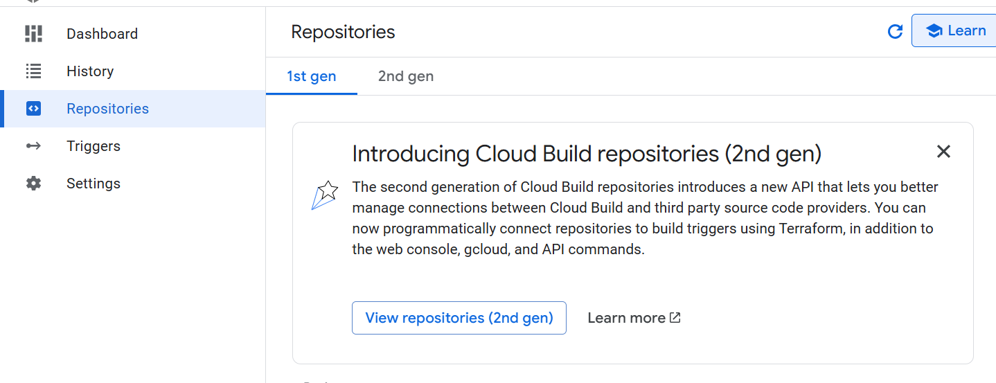

Select the region and click on connect repository
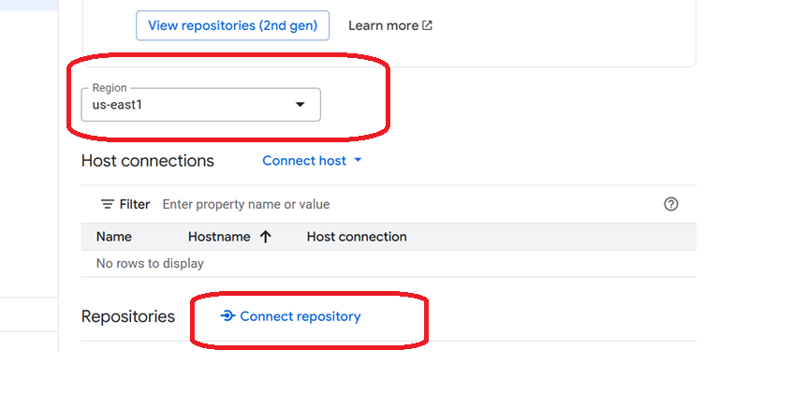

Select github and continue
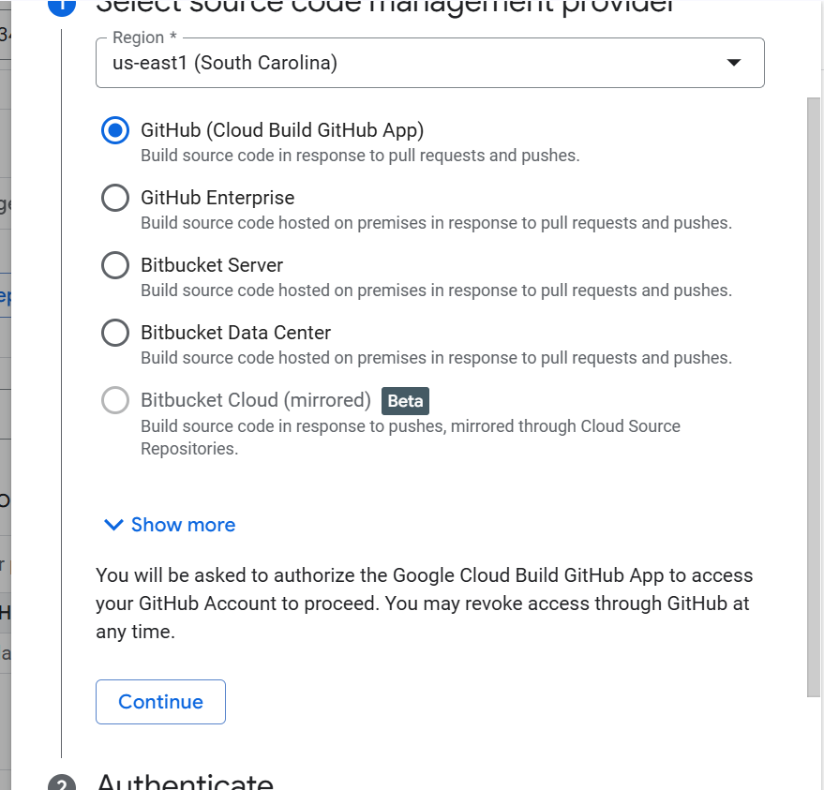

Authenticate and select your repository
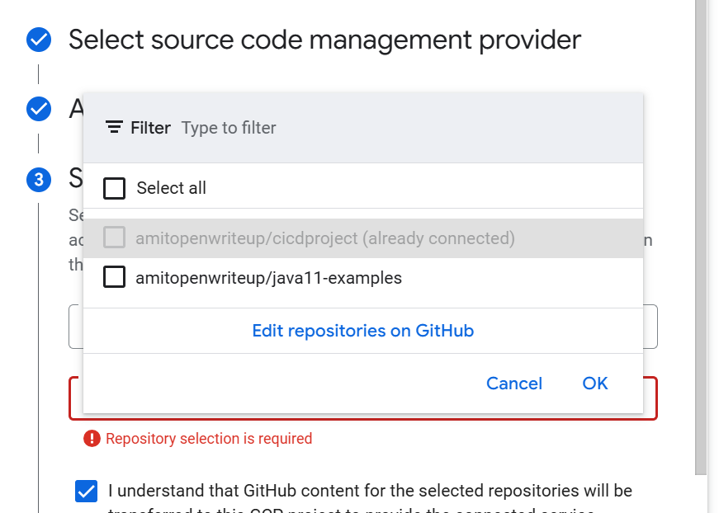

Click on connect

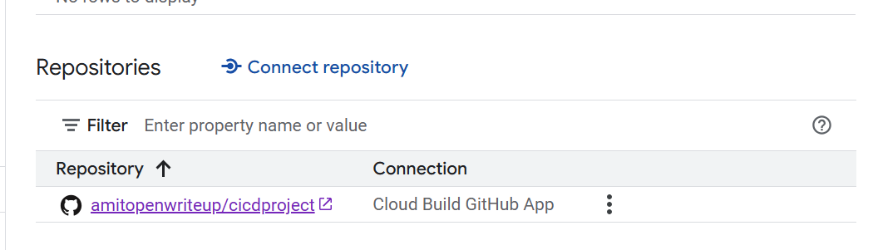

Click on Triggers
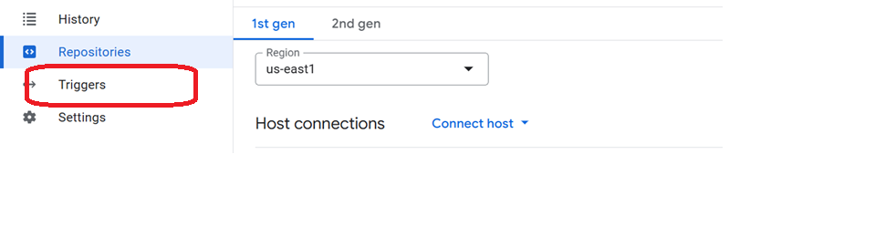
Click on Create Trigger
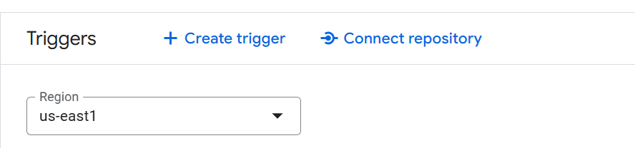

Provide name and event
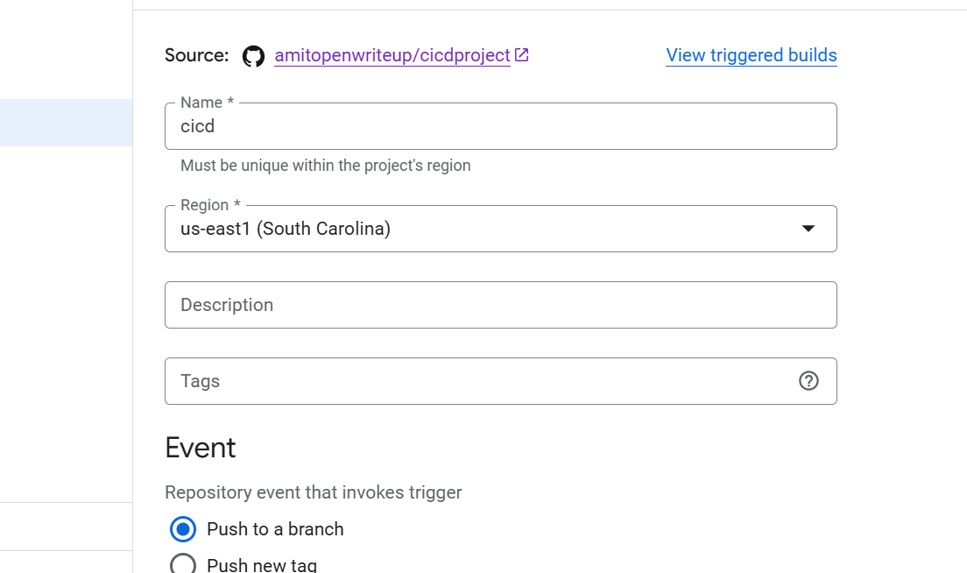

Select repo and branch
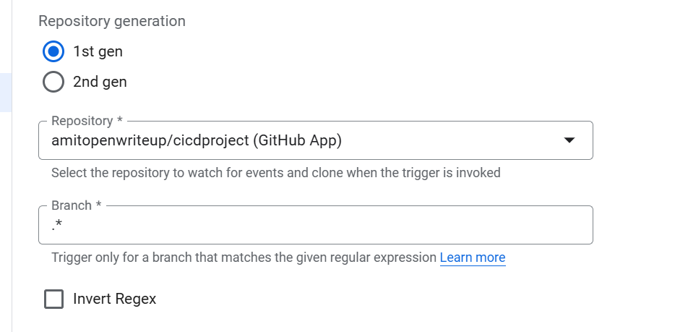

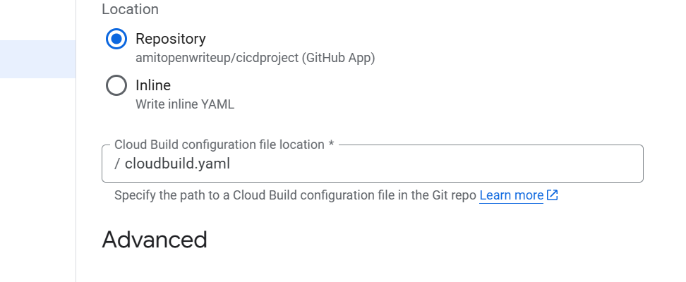

Select your service account
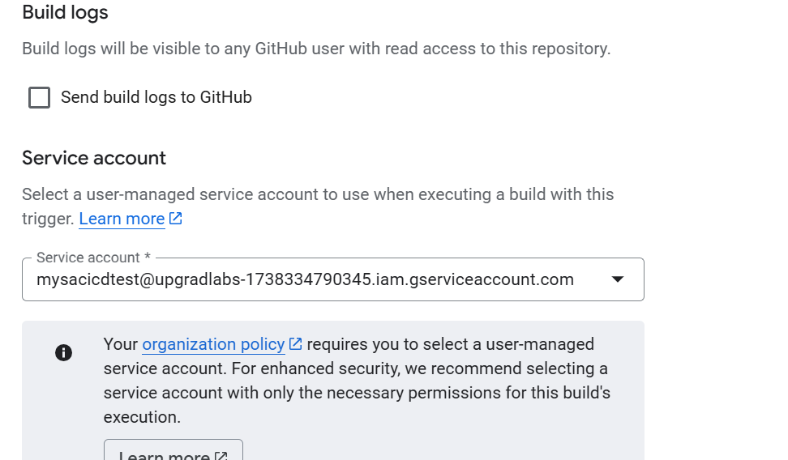

Click on save
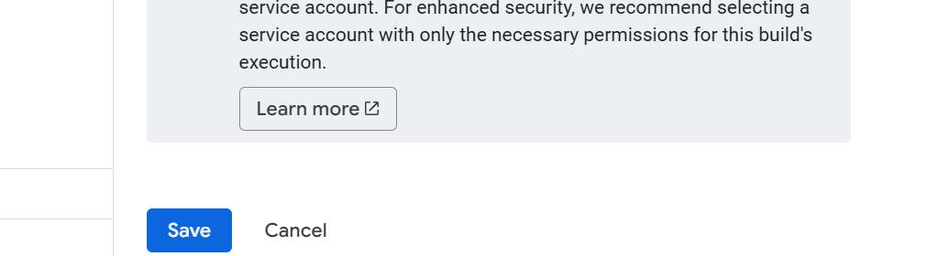

Click on Run
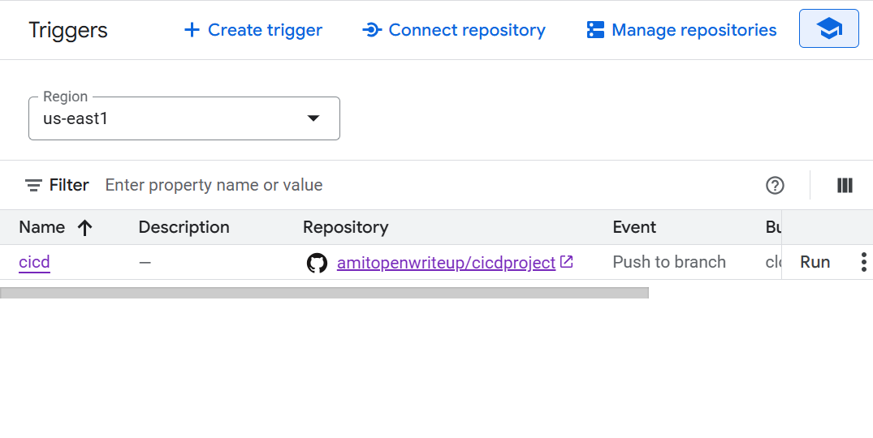

Run trigger
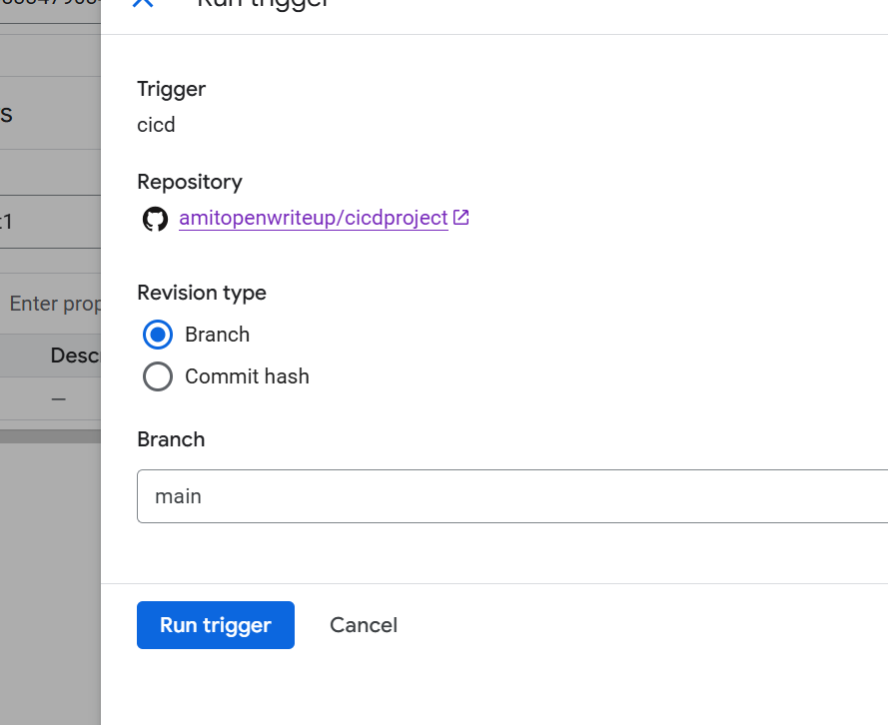

steps:
# Step 1: Install dependencies in a virtual environment
- name: 'python:3.9'
entrypoint: 'sh'
args:
- '-c'
- |
python -m venv venv && \
. venv/bin/activate && \
pip install --upgrade pip && \
pip install -r requirements.txt

# Step 2: Run tests in the same environment
- name: 'python:3.9'
entrypoint: 'sh'
args:
- '-c'
- |
. venv/bin/activate && \
python -m unittest discover tests

# Step 3: Build Docker image
- name: 'gcr.io/cloud-builders/docker'
args:
- 'build'
- '-t'
- 'us-east1-docker.pkg.dev/upgradlabs-1738334790345/mydockerrgisty/myapp:$BUILD_ID'
- '.'

# Step 4: Push Docker image to Artifact Registry
- name: 'gcr.io/cloud-builders/docker'
args:
- 'push'
- 'us-east1-docker.pkg.dev/upgradlabs-1738334790345/mydockerrgisty/myapp:$BUILD_ID'
logsBucket: "gs://amit23compow"

