Click on View all products

Create a Service account and provide permission

Go to my github and fork the project

<https://github.com/amitopenwriteup/cicdproject>

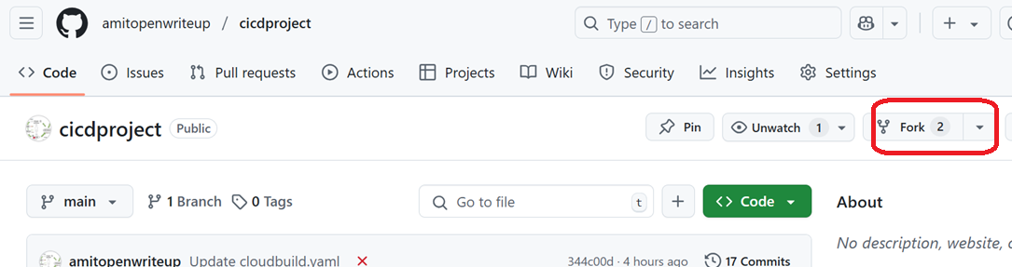

On GCP console, Click on View all products

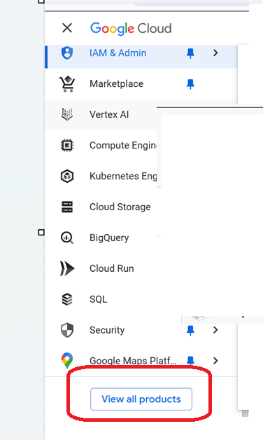

Go to CICD and Click on Cloud build

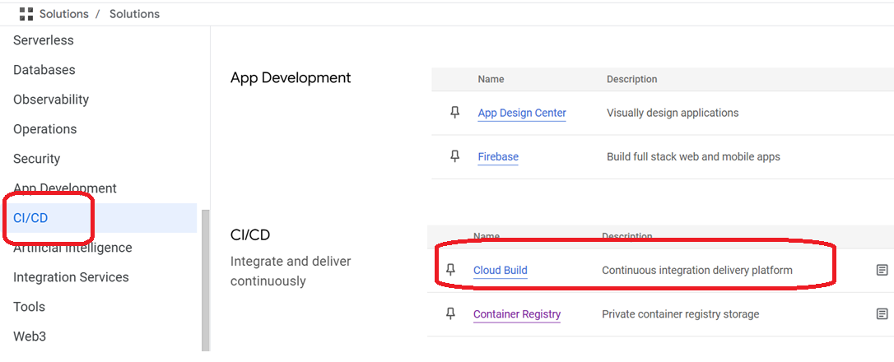

Click on 1st gen

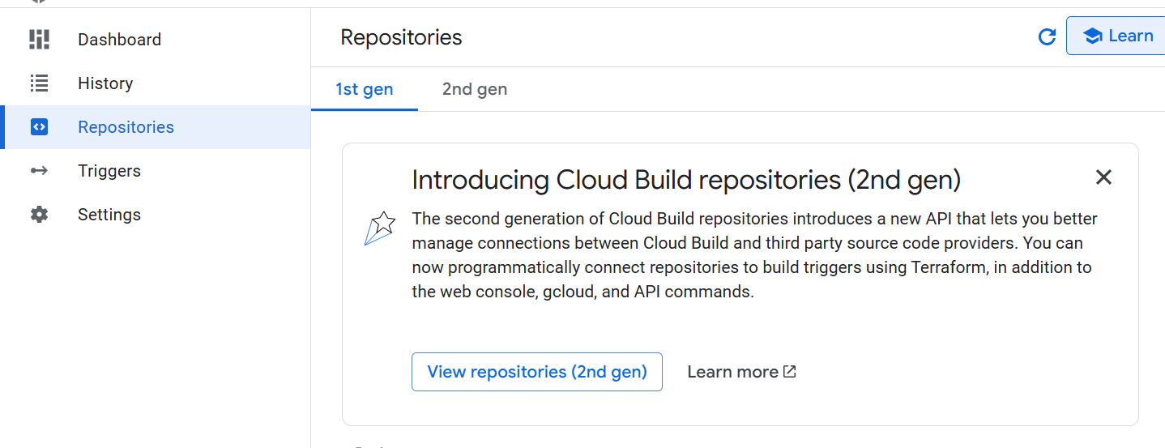

Select the region and click on connect repository

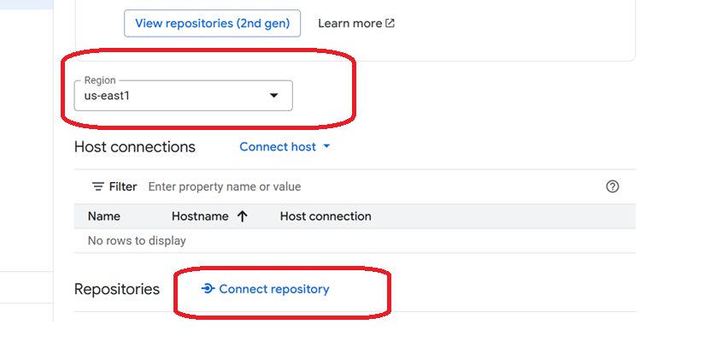

Select github and continue

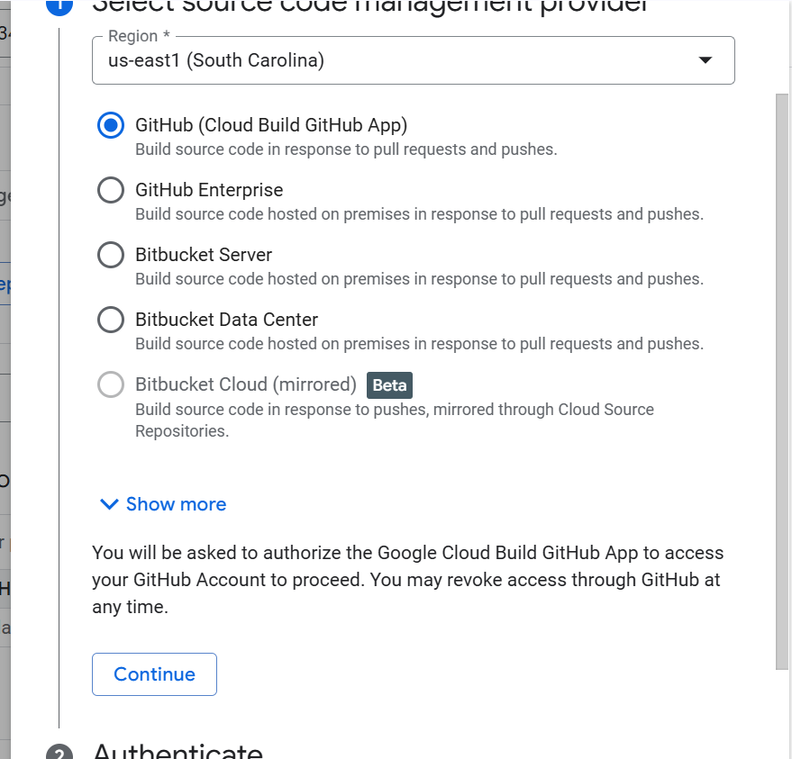

Authenticate and select your repository

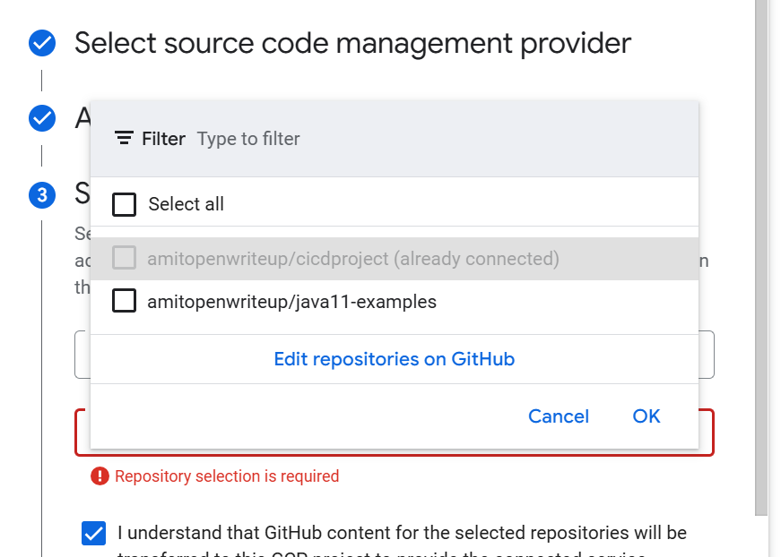

Click on connect



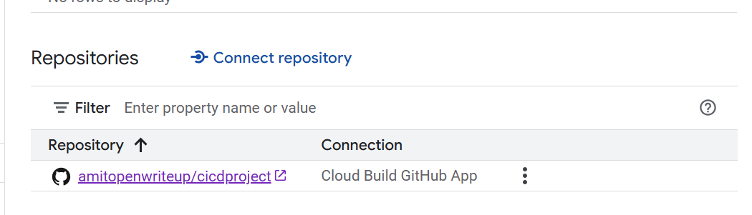

Click on Triggers

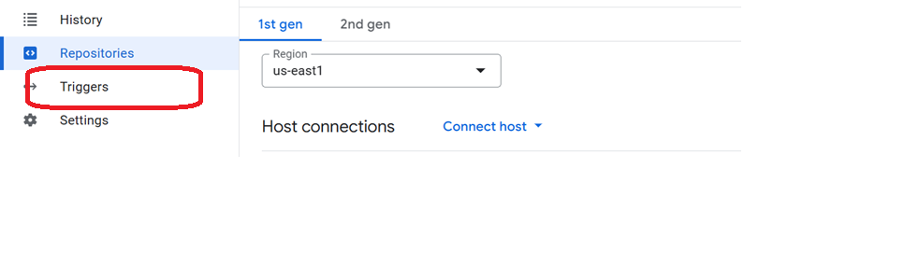

Click on Create Trigger

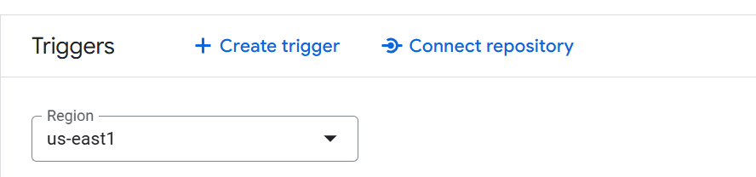

Provide name and event

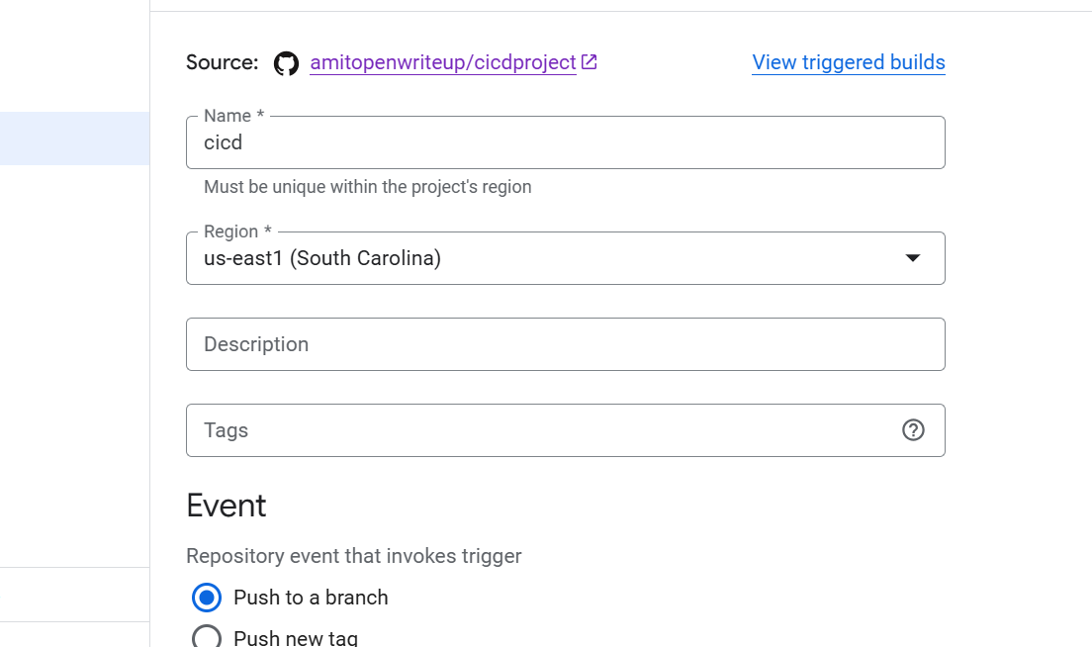

Select repo and branch

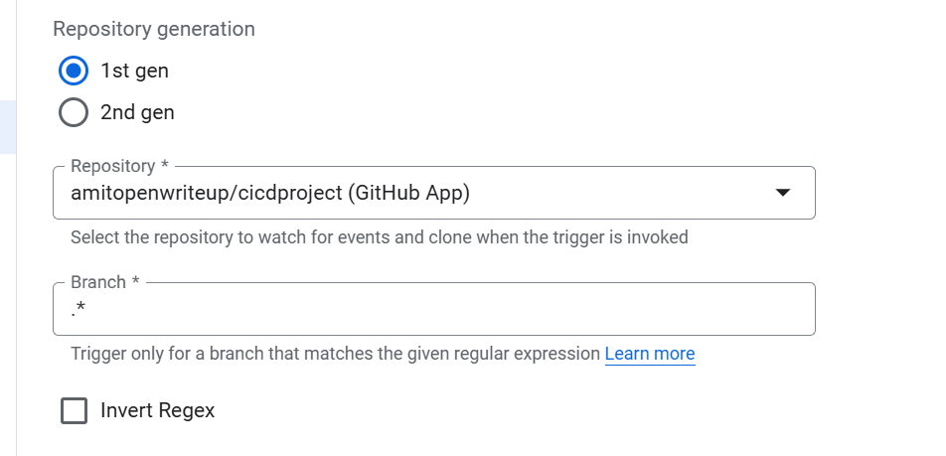

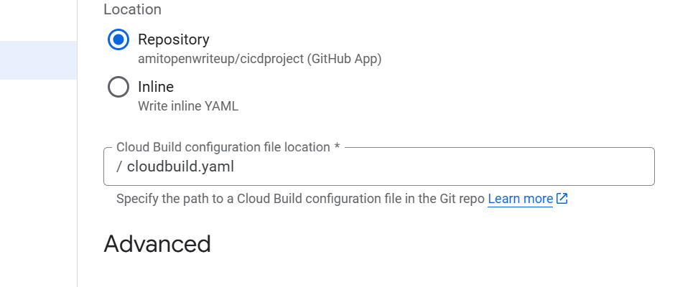

Select your service account

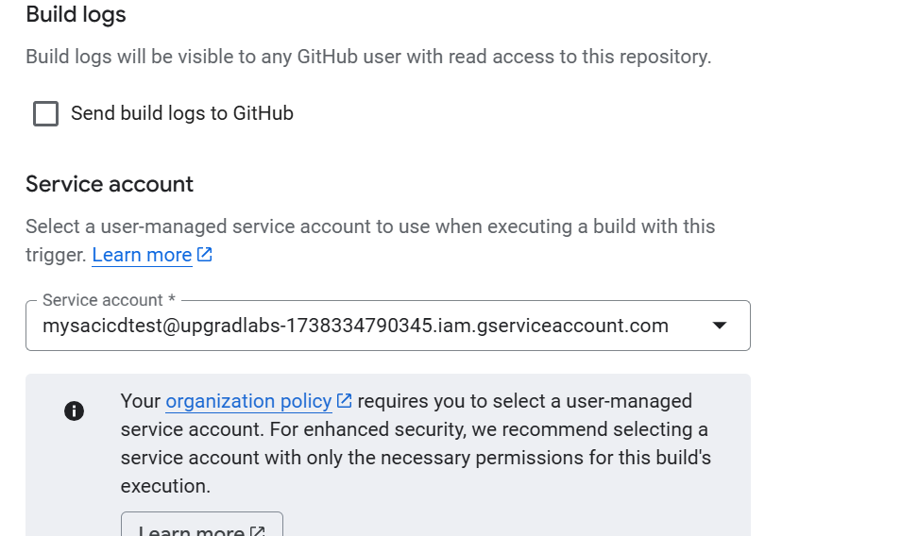

Click on save

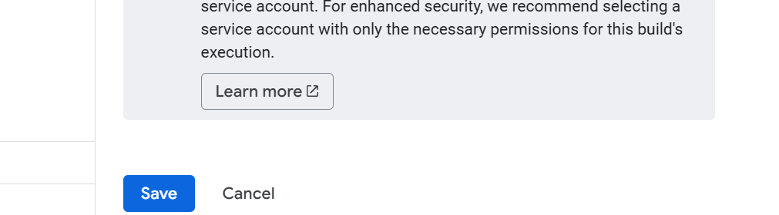

Click on Run

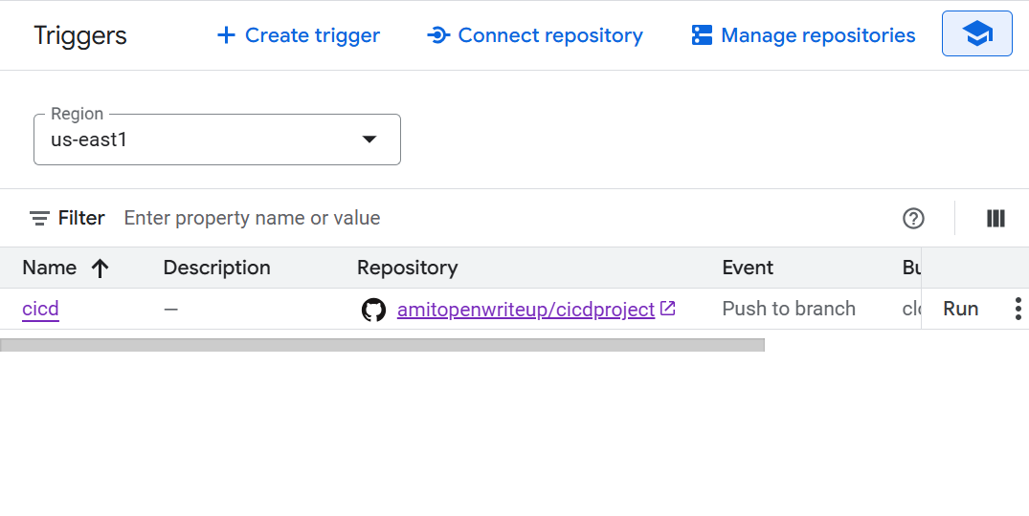

Run trigger

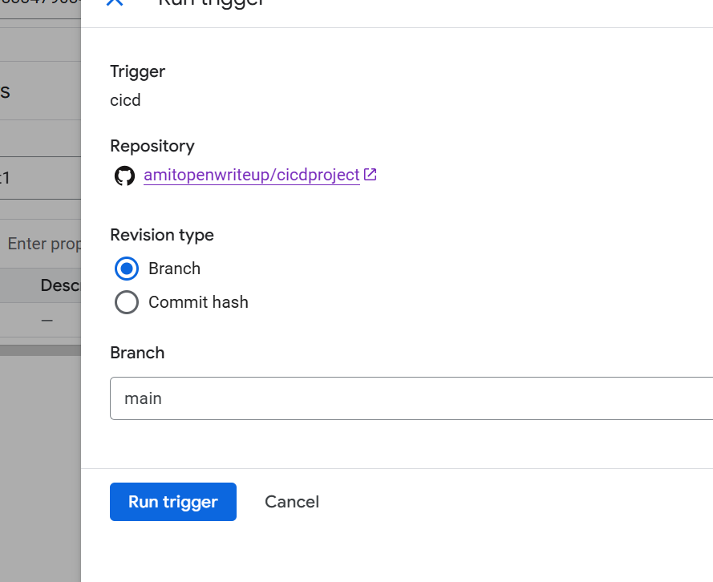

steps:

# Step 1: Install dependencies in a virtual environment

- name: 'python:3.9'

entrypoint: 'sh'

args:

- '-c'

- |

python -m venv venv && \

. venv/bin/activate && \

pip install --upgrade pip && \

pip install -r requirements.txt

# Step 2: Run tests in the same environment

- name: 'python:3.9'

entrypoint: 'sh'

args:

- '-c'

- |

. venv/bin/activate && \

python -m unittest discover tests

# Step 3: Build Docker image

- name: 'gcr.io/cloud-builders/docker'

args:

- 'build'

- '-t'

- 'us-east1-docker.pkg.dev/upgradlabs-1738334790345/mydockerrgisty/myapp:$BUILD_ID'

- '.'

# Step 4: Push Docker image to Artifact Registry

- name: 'gcr.io/cloud-builders/docker'

args:

- 'push'

- 'us-east1-docker.pkg.dev/upgradlabs-1738334790345/mydockerrgisty/myapp:$BUILD_ID'

logsBucket: "gs://amit23compow"