Dashboards, Charts and Alerts:

To use Cloud Monitoring to monitor Compute instance

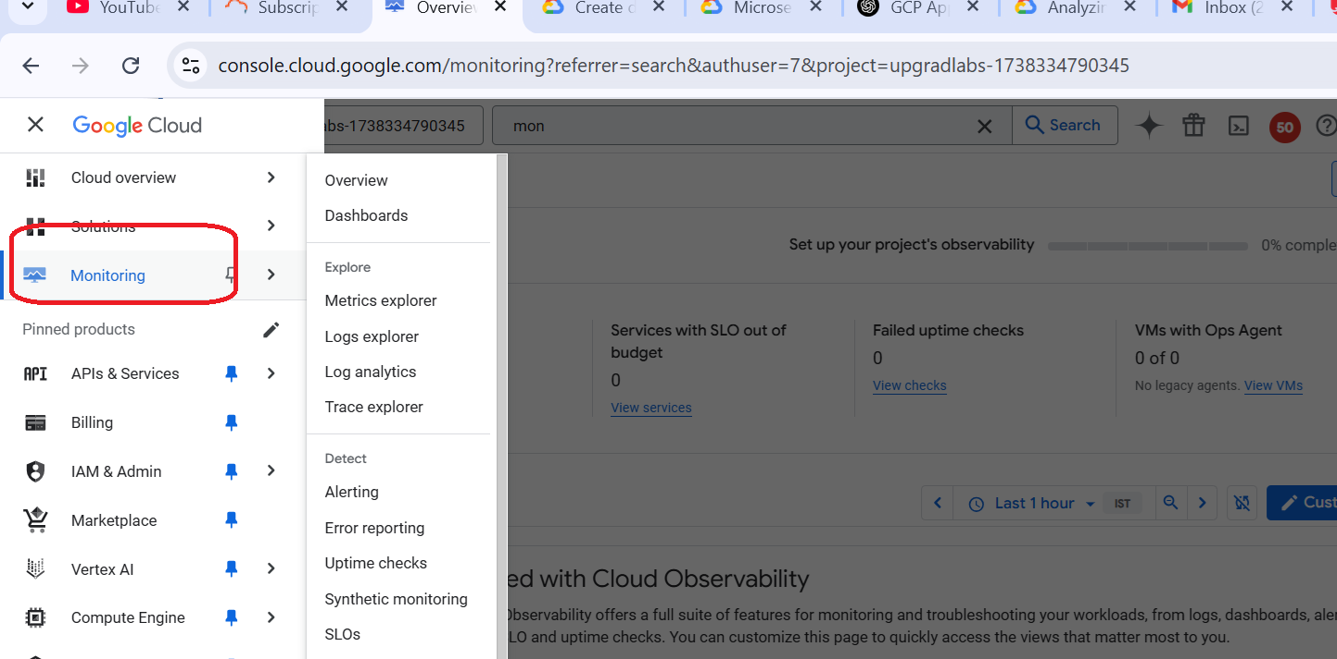

Click on Dashboard

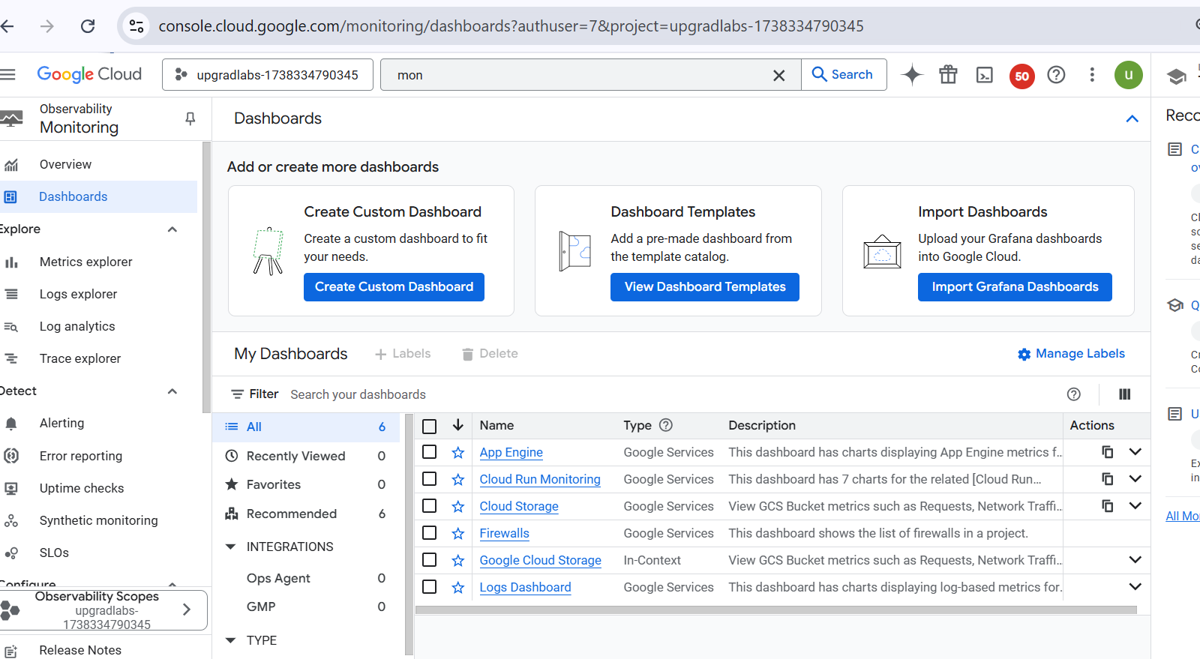

Click on Create Custom dashboard

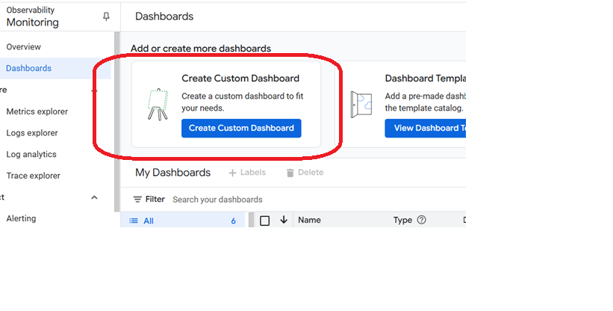

Click on add widgets

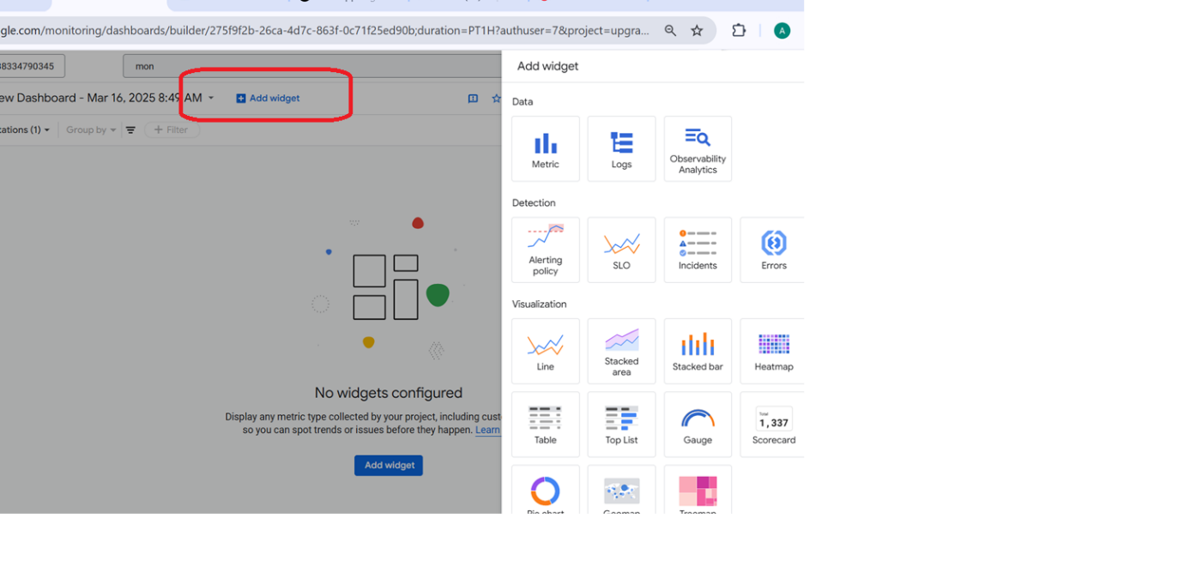

Select metrics as per your need

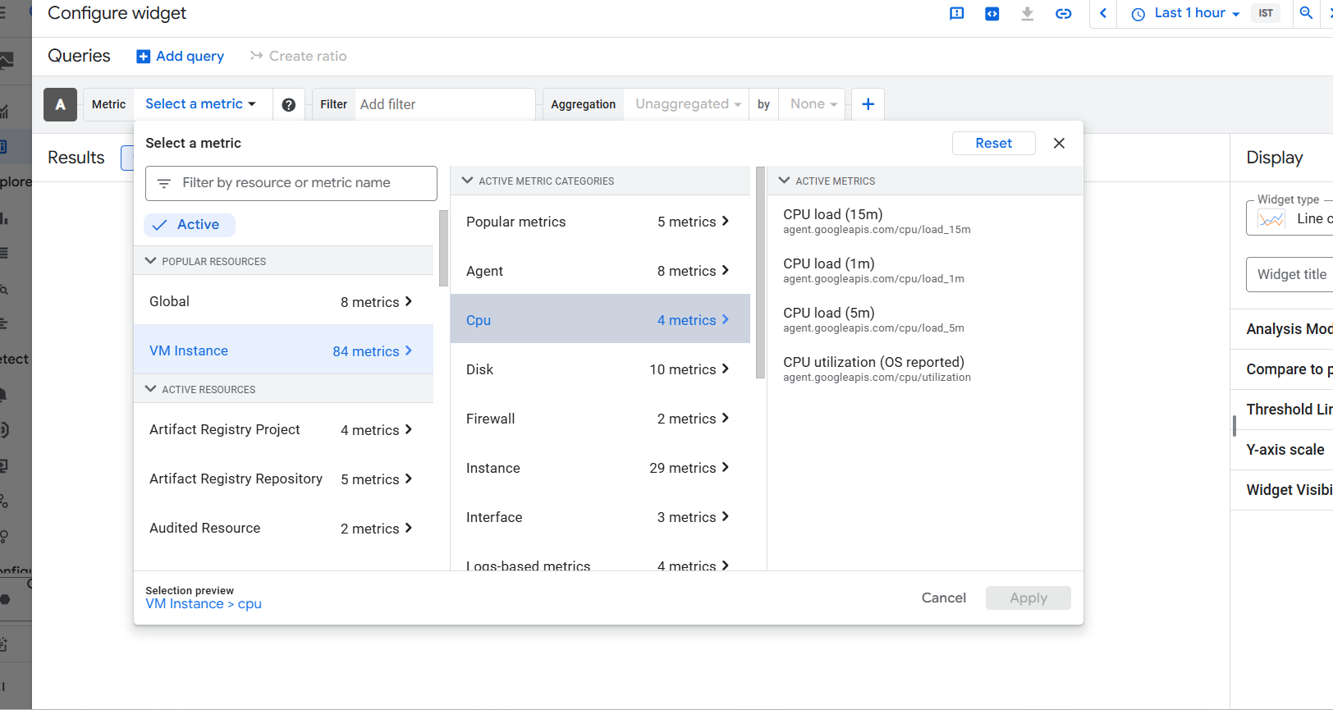

Click on apply

Lab2: Log explorer

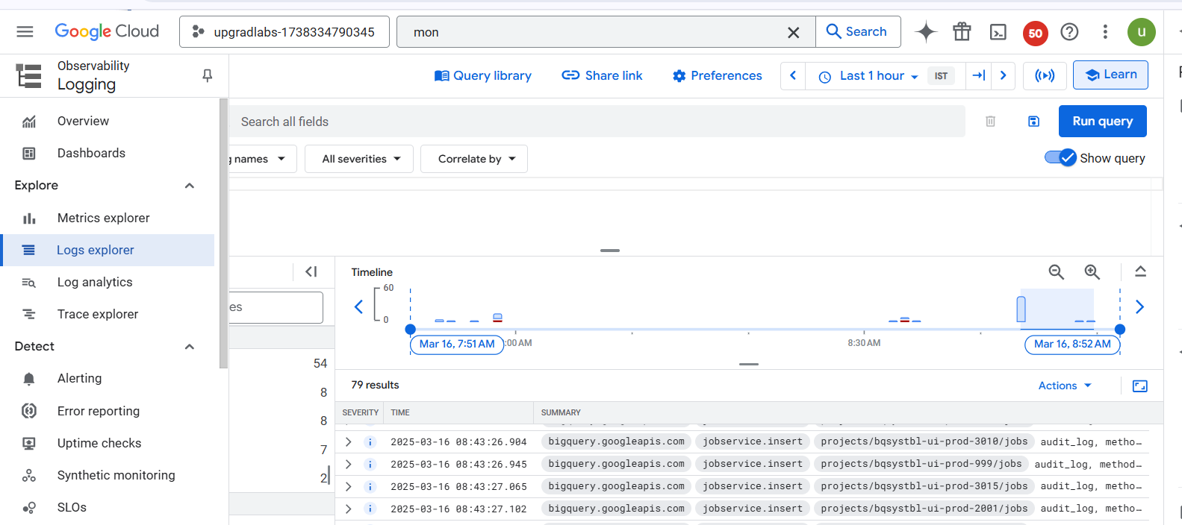

Check for service account

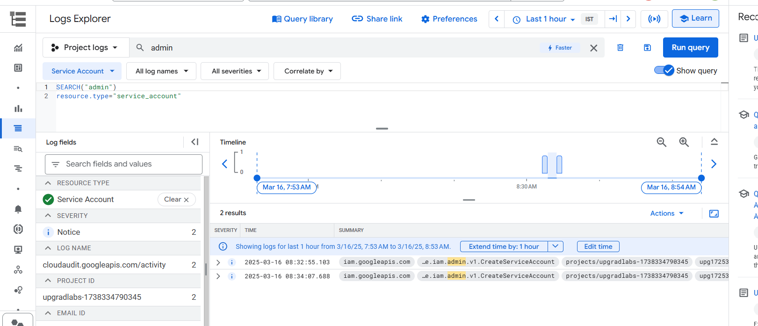

Run the query, you must be able to see service account are created