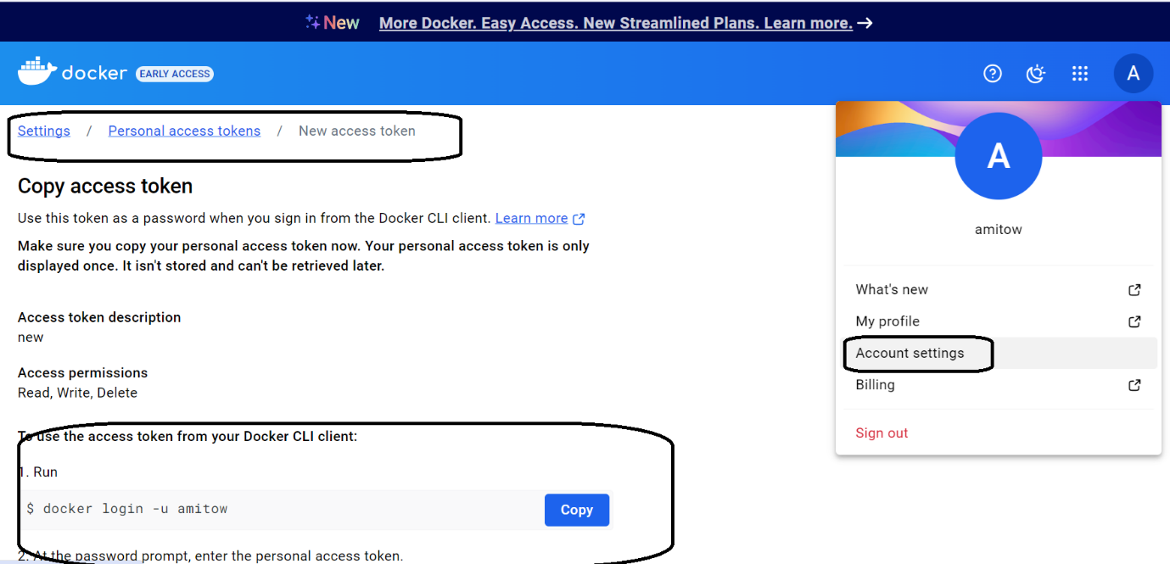

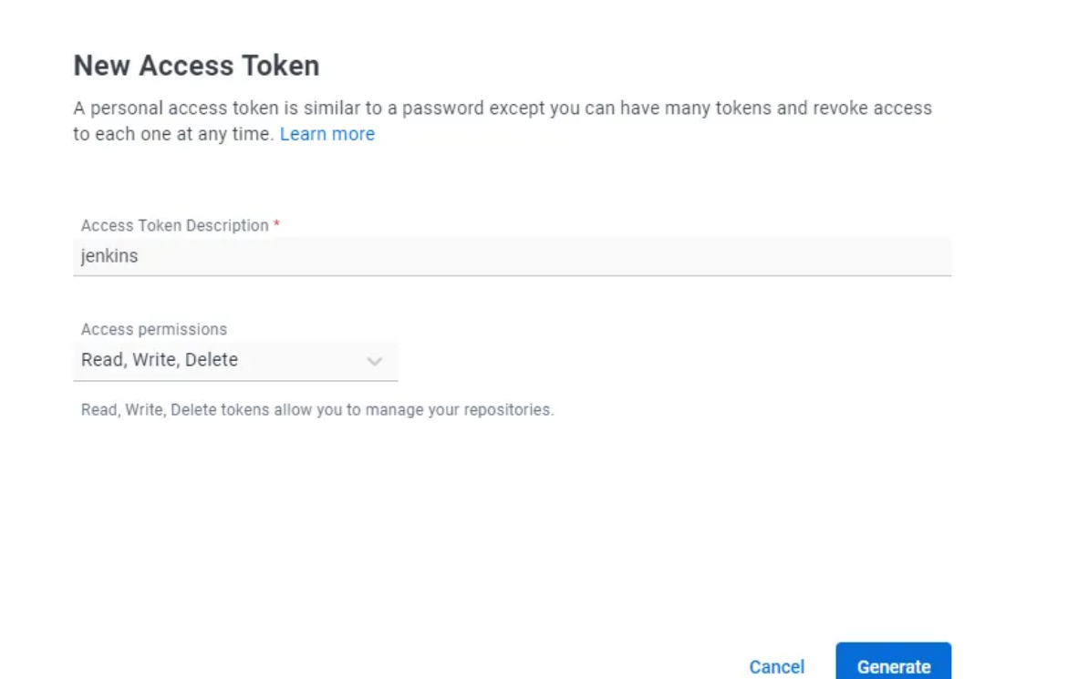

* In your Jenkins server go to Manage Jenkins -> Credentials -> System -> Global credentials -> + Add credentials. Enter your Docker Hub username, the token you created and a brief description of the credentials.

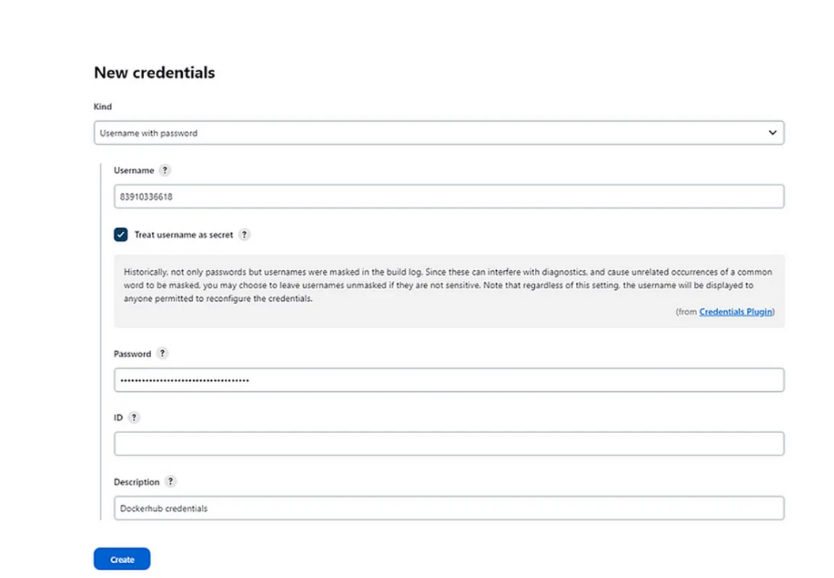

Create the environment variables used in the Jenkinsfile for the Docker image and for the Docker Hub credentials.

* Go to Manage Jenkins -> Configure System and under ‘Global properties’ add them as shown in the picture below.
* Name: DOCKER_BFLASK_IMAGE
* Value: [your-dockerhub-username/repository-name]
* Name: DOCKER_REGISTRY_CREDS
* Value: ID generated when adding the Docker Hub credentials into Jenkins.

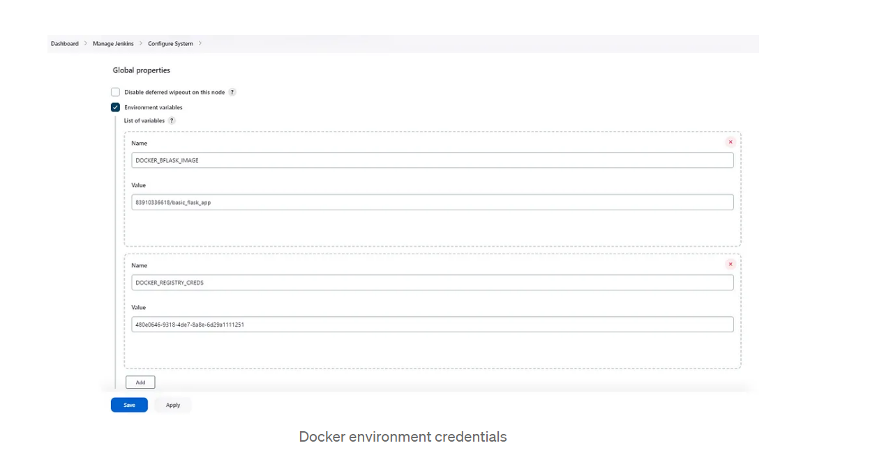

Create a new Jenkins job.

* In your Dashboard go to New Item -> Pipeline and enter the name of your project.

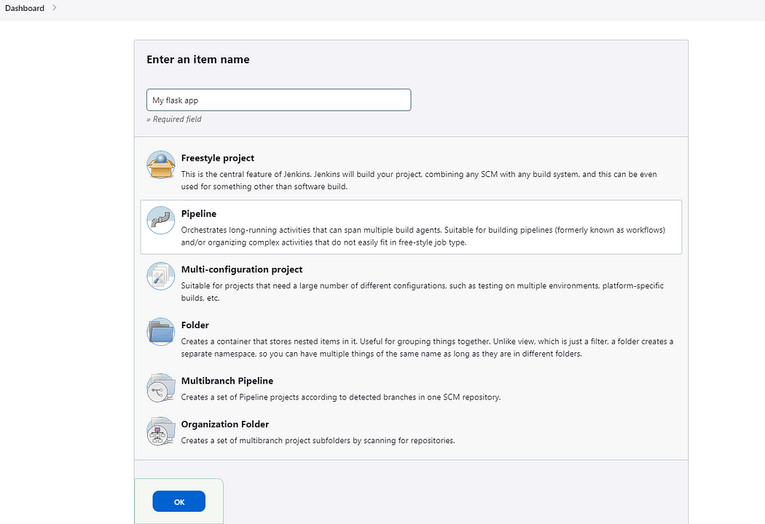

Jenkins’ projects

* Select ‘Github project’ and add your Github repository.

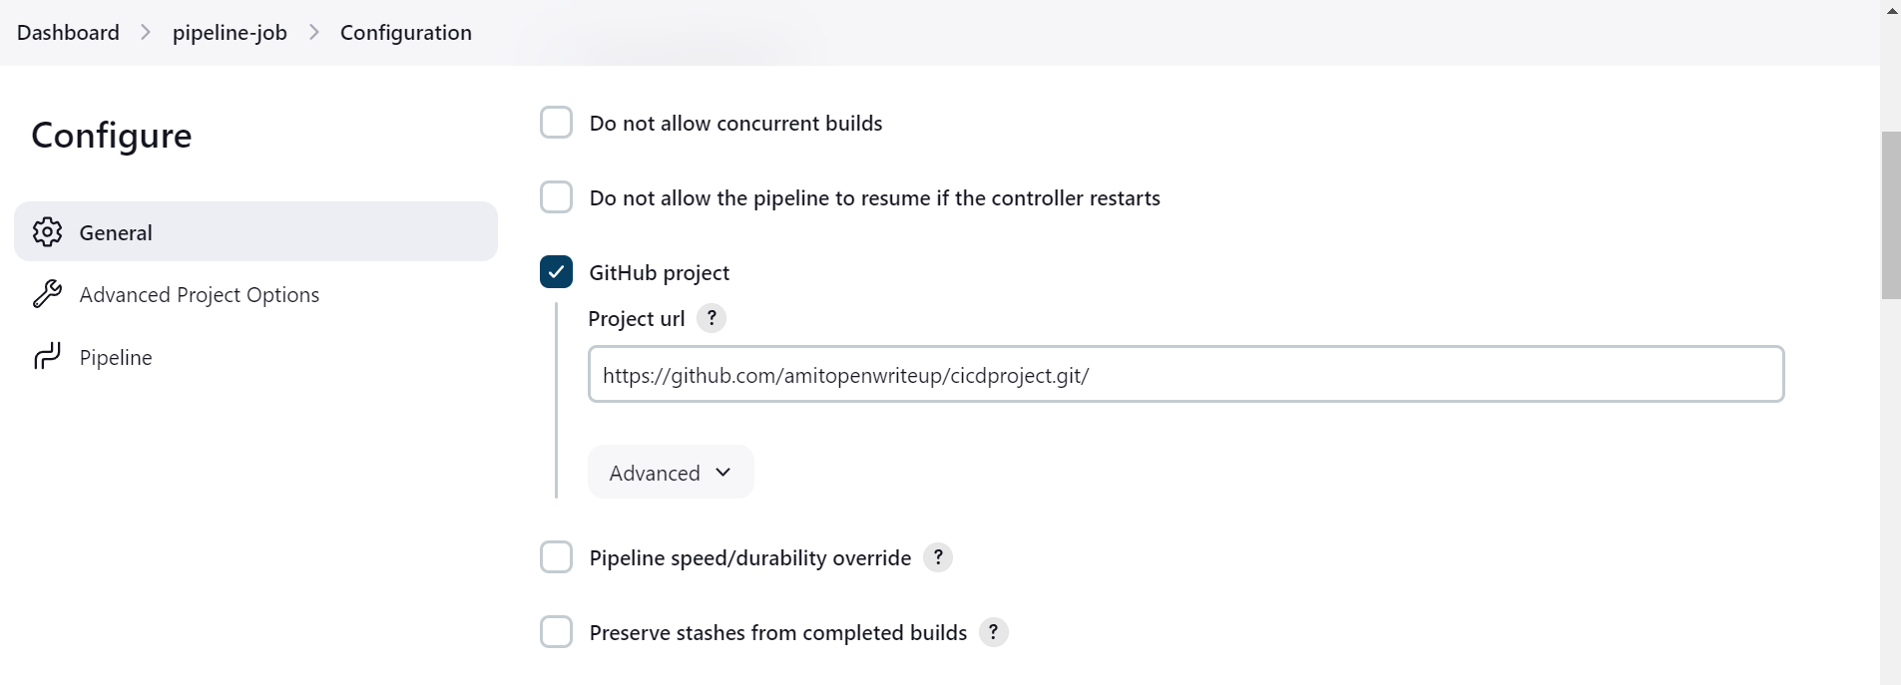

Jenkins pipeline configuration

* In the Pipeline section, under SCM select ‘Git’ and enter your repository again.
* **Note:** In case it is a private repository you would need to provide your Github credentials.

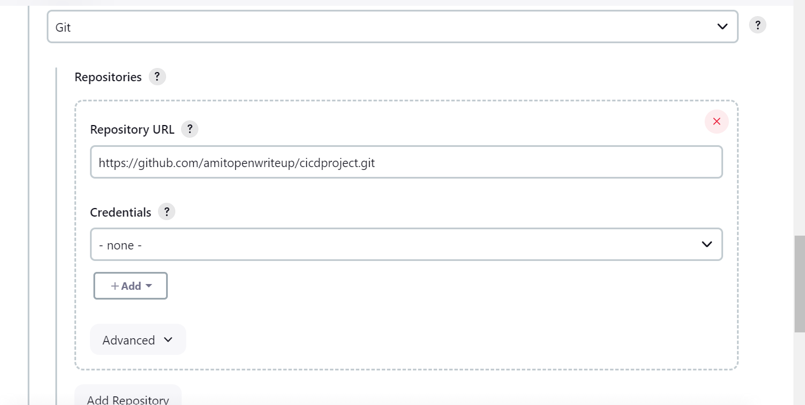

Jenkins SCM configuration

