**Step 1: Open the Web Console**

* Access the **web console** of the Storage Gateway appliance.

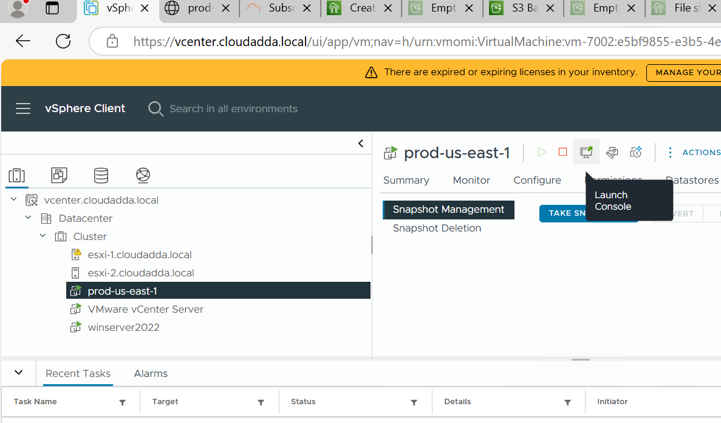

**Step 2: Open the Console**

* If not already opened, open the **console window** for the appliance.

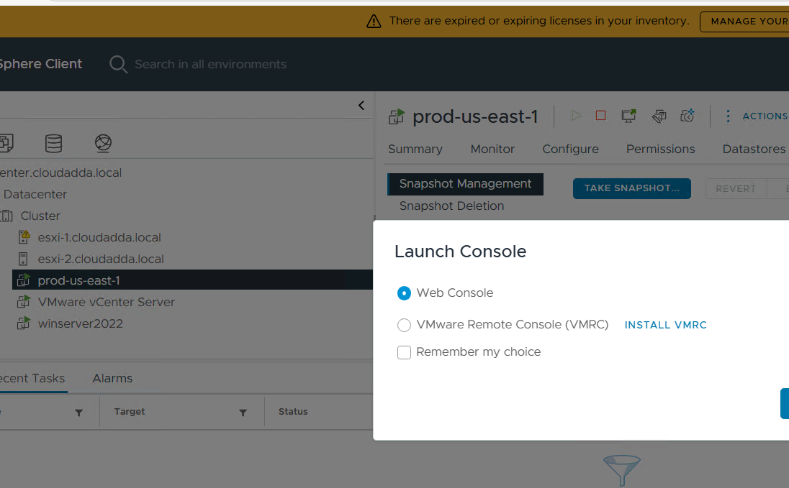

**Step 3: Log in to the Appliance**

* Use the default credentials:
  + **Username:** admin
  + **Password:** password

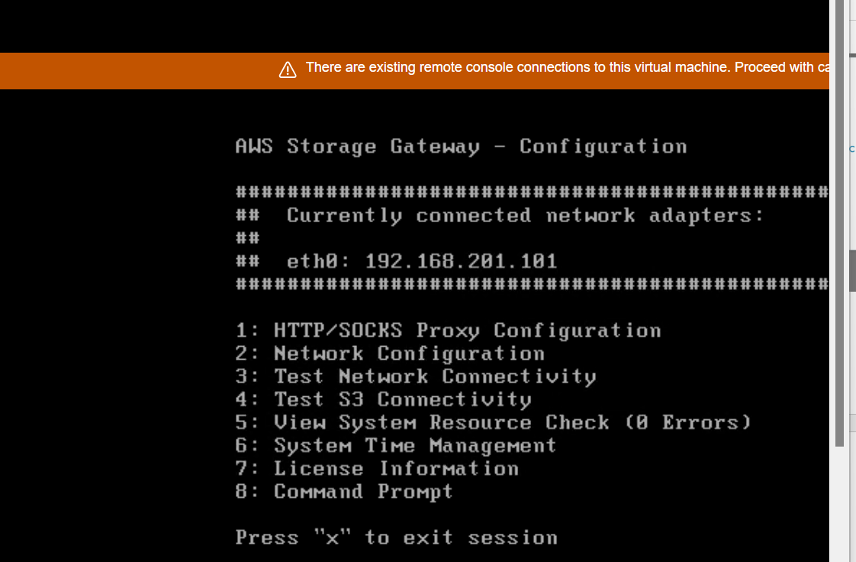

**Step 4: Configure Network Settings**

* Press **2** to enter **Network Configuration**.

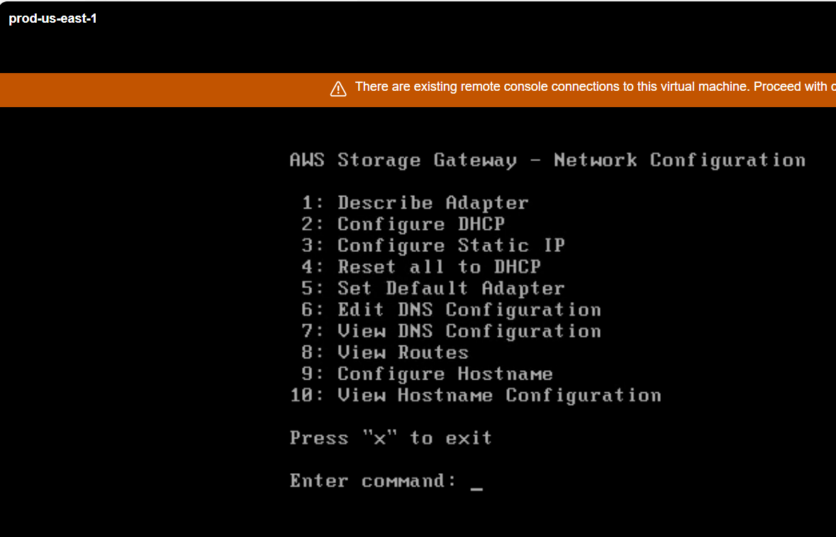

**Step 5: Check Network Adapter Details**

* Press **1** to display **adapter information**.

.

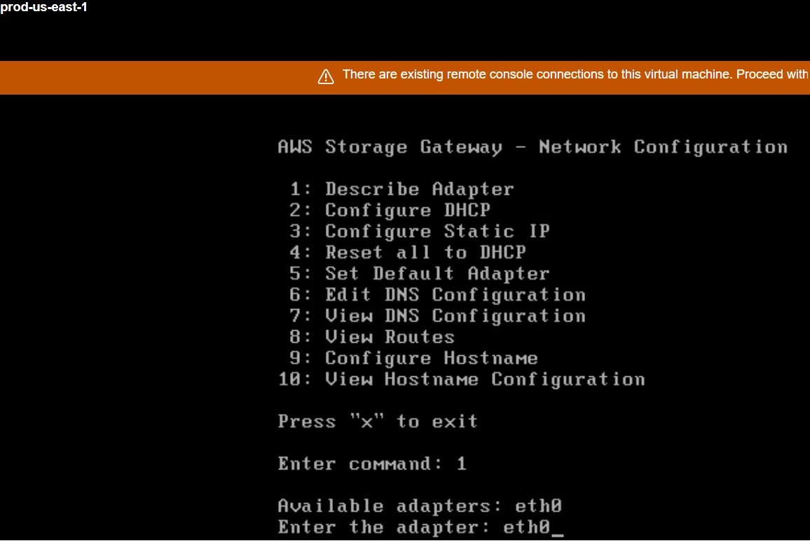

**Step 6: Note Down the IP Address**

Identify and **note down the assigned IP address** for use in Lab 2