**Step 1: Access CloudWatch**

1. Go to the **AWS Management Console**.
2. Navigate to the **CloudWatch** service.

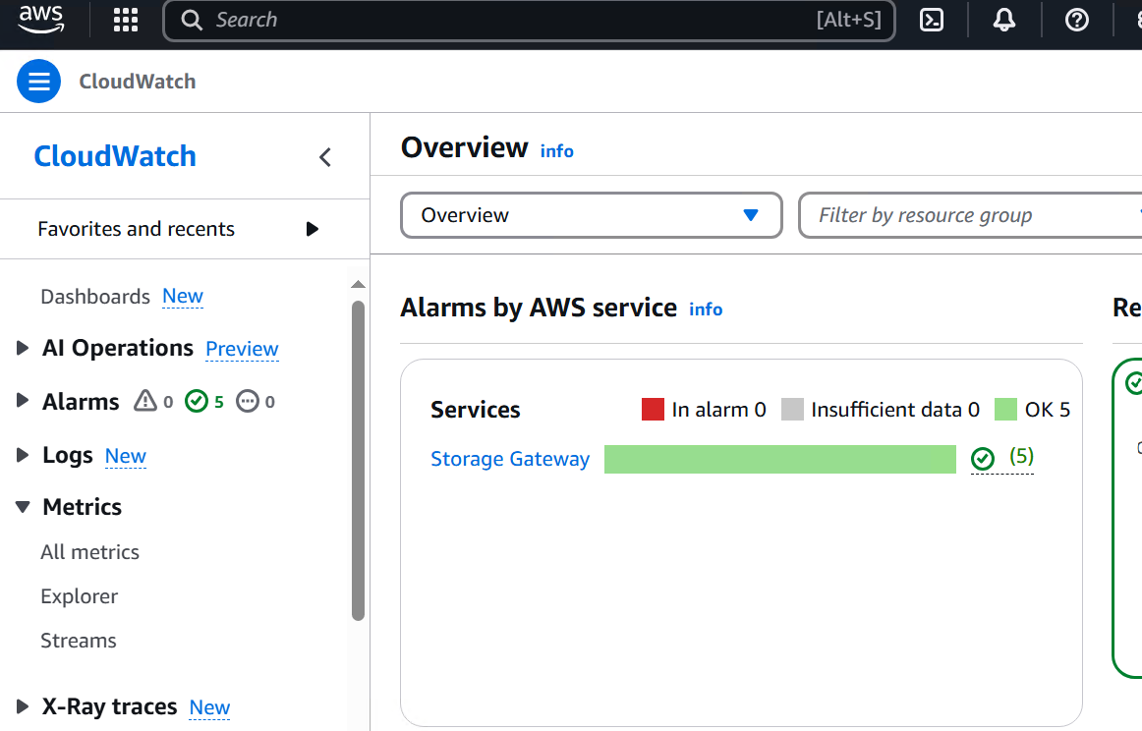

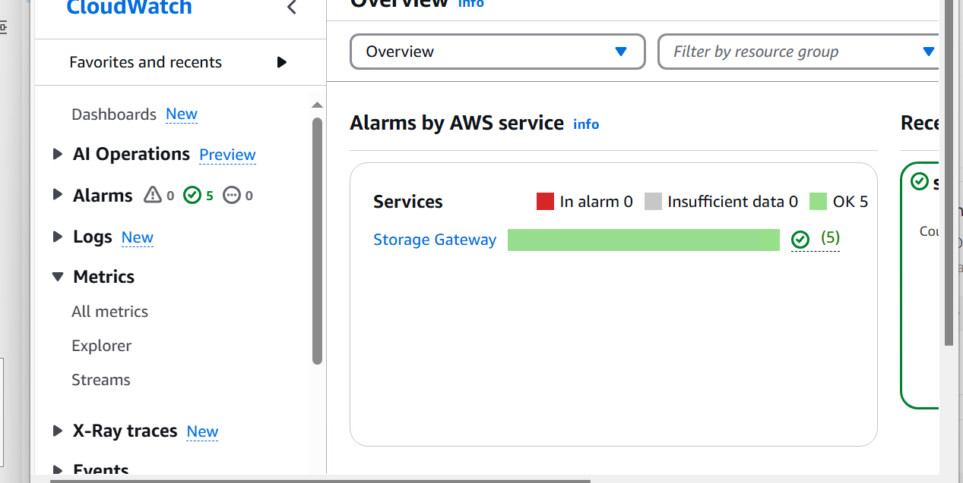

**Step 2: Create a CloudWatch Alarm**

1. **In the CloudWatch Console, click Alarms.**
2. **Click Create alarm.**

To get notified of potential issues:

1. In the **CloudWatch Console**, click **Alarms**.
2. Click **Create alarm**.

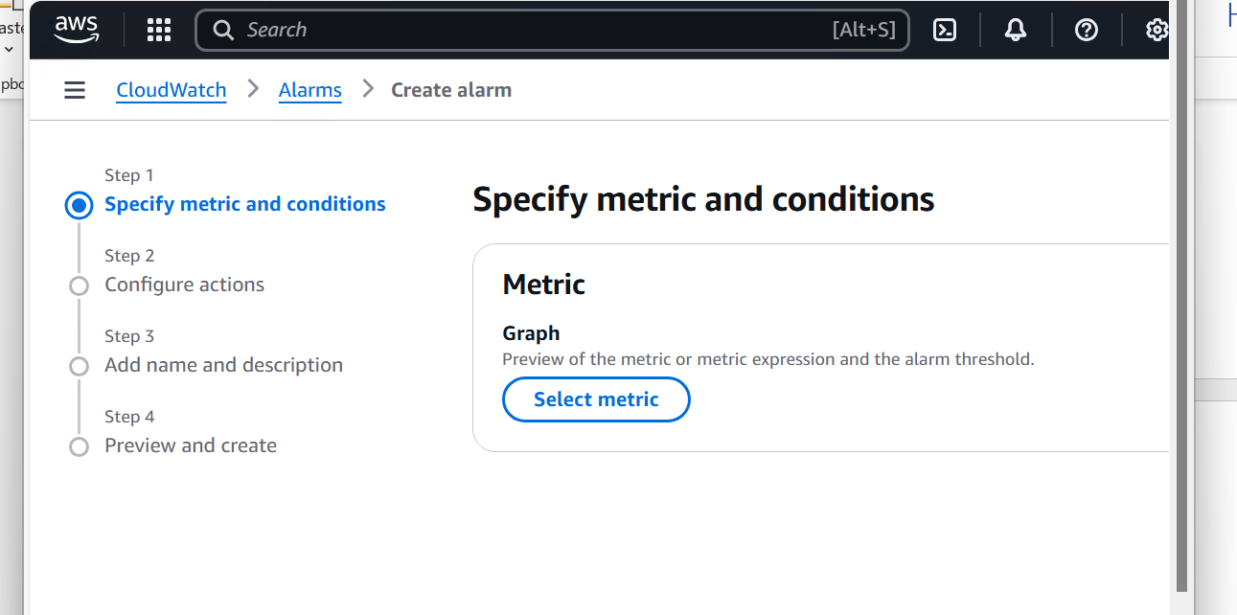

Find and select CloudBytesUploaded for the **mygw** gateway (as shown in Screenshot).

**Step 3: Select Metric**

1. Find and select **CloudBytesUploaded** for your **mygw** gateway.
2. Click **Select metric**.

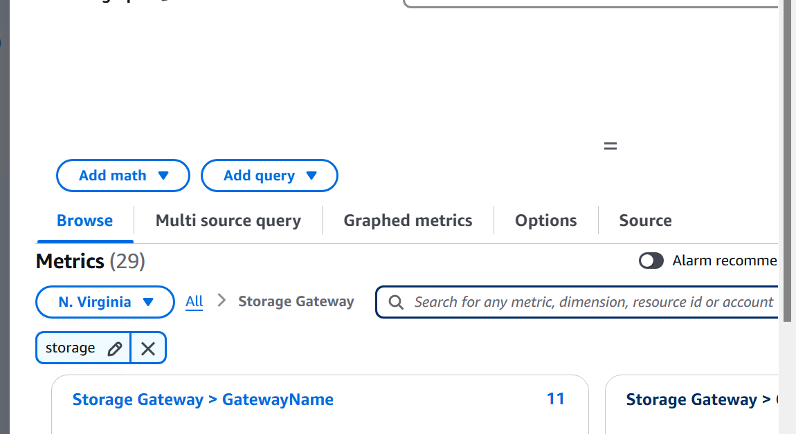

**Step 3: Configure Conditions**

1. Set the **Statistic** to **Sum** or **Average** (depending on your use case).
2. Choose a **Threshold type**:
   * **Static threshold:** Set a fixed limit (e.g., trigger when uploaded bytes exceed a certain value).
   * **Anomaly detection:** Use machine learning-based thresholds.
3. Set the **Threshold value** (e.g., trigger if CloudBytesUploaded is **greater than 1GB** in a given period).

SNS

