Aws S3 lab:

1. Check for S3 resource, and create bucket

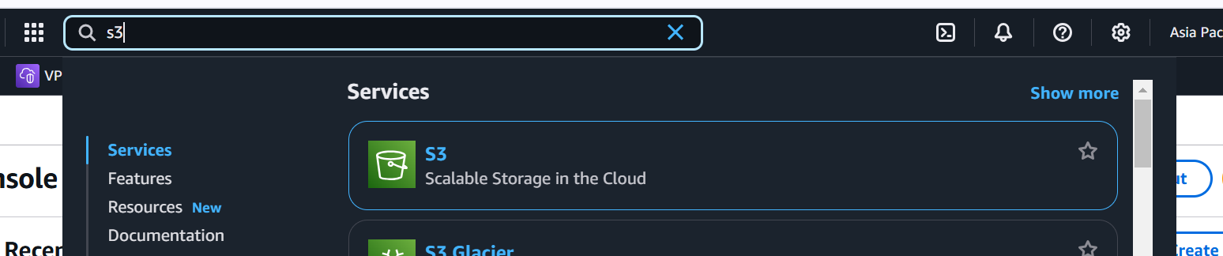

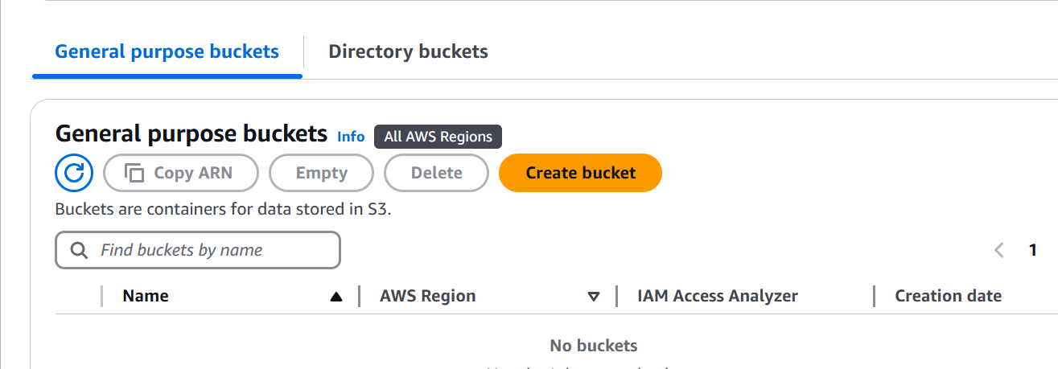

1. Create a general purpose bucket
2. Note bucket would be created in a Region, but bucket name will be globally unique
3. Ownership

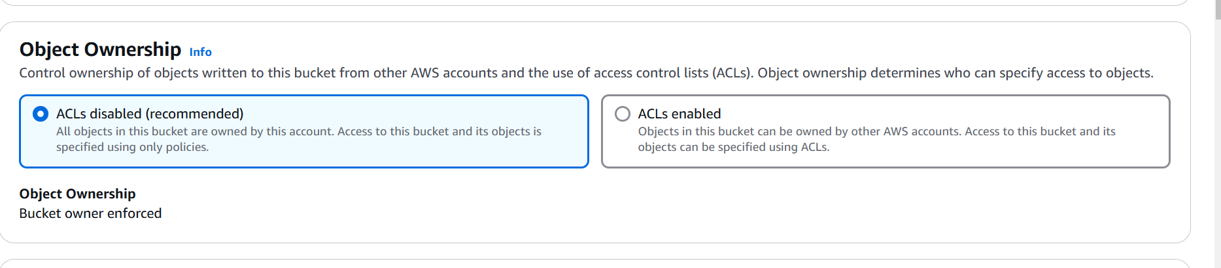

1. Block all public access

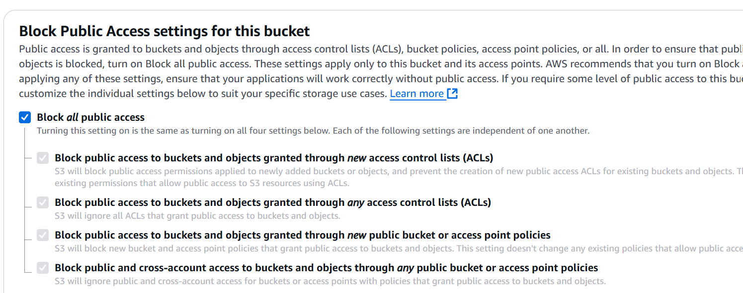

1. Versioning

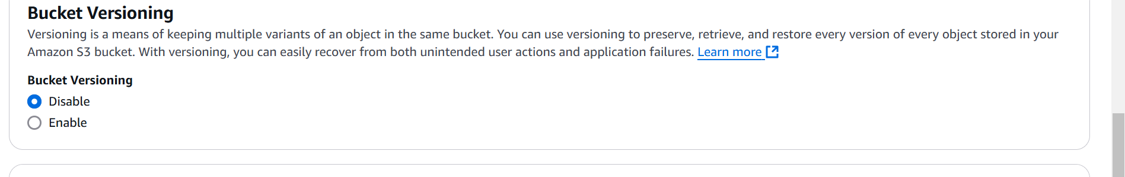

1. Encryption

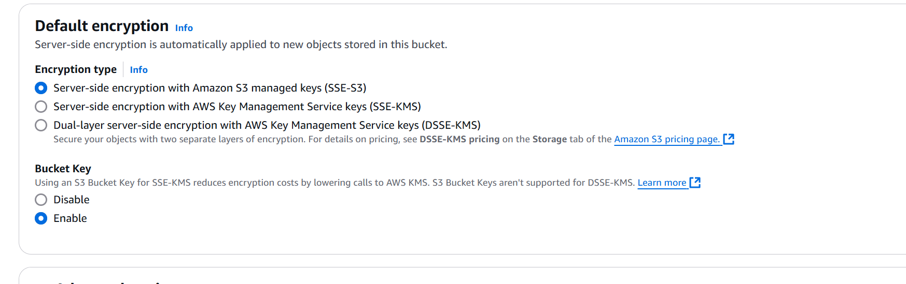

Create the bucket

