1. Create an Amazon S3 bucket.
2. Create a Lambda function that returns the object type of objects in an Amazon S3 bucket.
3. Configure a Lambda trigger that invokes your function when objects are uploaded to your bucket.
4. Test your function, first with a dummy event, and then using the trigger.

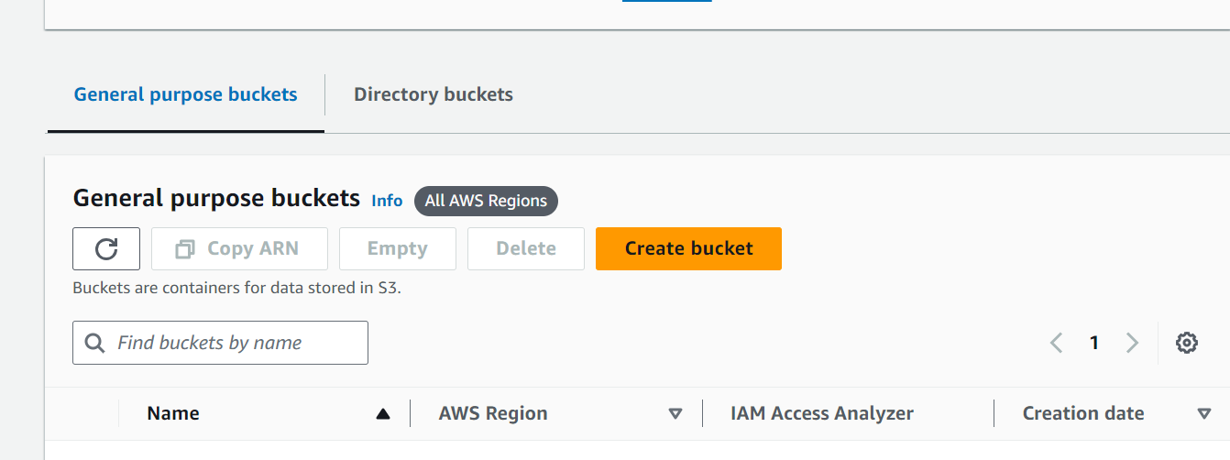

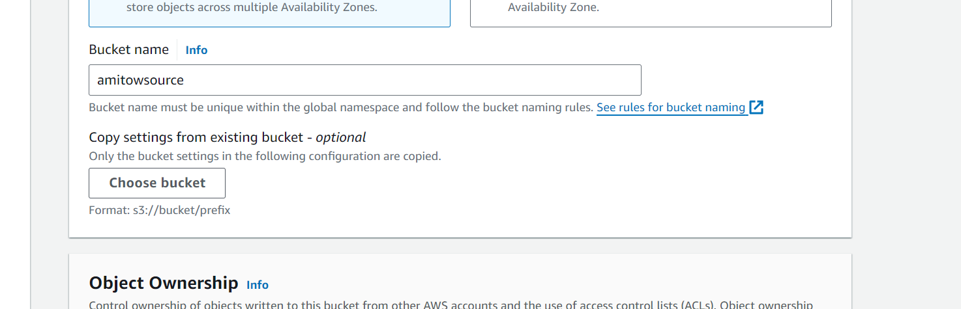

Create Policy

1. Open the [Policies page](https://console.aws.amazon.com/iam/home#/policies) of the IAM console.
2. Choose **Create Policy**.
3. Choose the **JSON** tab, and then paste the following custom policy into the JSON editor.

{

"Version": "2012-10-17",

"Statement": [

{

"Effect": "Allow",

"Action": [

"logs:PutLogEvents",

"logs:CreateLogGroup",

"logs:CreateLogStream"

],

"Resource": "arn:aws:logs:*:*:*"

},

{

"Effect": "Allow",

"Action": [

"s3:GetObject"

],

"Resource": "arn:aws:s3:::*/*"

}

]

}

1. Choose **Next: Tags**.
2. Choose **Next: Review**.
3. Under **Review policy**, for the policy **Name**, enter **s3-trigger-tutorial**.
4. Choose **Create policy**.

**Create an execution role**

1. Open the [Roles page](https://console.aws.amazon.com/iam/home#/roles) of the IAM console.
2. Choose **Create role**.
3. For the type of trusted entity, choose **AWS service**, then for the use case, choose **Lambda**.
4. Choose **Next**.
5. In the policy search box, enter **s3-trigger-tutorial**.
6. In the search results, select the policy that you created (s3-trigger-tutorial), and then choose **Next**.
7. Under **Role details**, for the **Role name**, enter **lambda-s3-trigger-role**, then choose **Create role**.

**To create the Lambda function**

1. Open the [Functions](https://console.aws.amazon.com/lambda/home#/functions) page of the Lambda console.
2. Make sure you're working in the same AWS Region you created your Amazon S3 bucket in. You can change your Region using the drop-down list at the top of the screen.
3. Choose **Create function**.
4. Choose **Author from scratch**
5. Under **Basic information**, do the following:
   1. For **Function name**, enter s3-trigger-tutorial
   2. For **Runtime**, choose **Python 3.12**.
   3. For **Architecture**, choose **x86_64**.
6. In the **Change default execution role** tab, do the following:
   1. Expand the tab, then choose **Use an existing role**.
   2. Select the lambda-s3-trigger-role you created earlier.
7. Choose **Create function**.

**Deploy the function code**

**To deploy the function code**

1. Choose the **Python** tab in the following box and copy the code.
2. In the **Code source** pane on the Lambda console, paste the code into the **lambda_function.py** file.

# Copyright Amazon.com, Inc. or its affiliates. All Rights Reserved.

# SPDX-License-Identifier: Apache-2.0

import json

import urllib.parse

import boto3

print('Loading function')

s3 = boto3.client('s3')

def lambda_handler(event, context):

#print("Received event: " + json.dumps(event, indent=2))

# Get the object from the event and show its content type

bucket = event['Records'][0]['s3']['bucket']['name']

key = urllib.parse.unquote_plus(event['Records'][0]['s3']['object']['key'], encoding='utf-8')

try:

response = s3.get_object(Bucket=bucket, Key=key)

print("CONTENT TYPE: " + response['ContentType'])

return response['ContentType']

except Exception as e:

print(e)

print('Error getting object {} from bucket {}. Make sure they exist and your bucket is in the same region as this function.'.format(key, bucket))

raise e

1. Choose **Deploy**.

**To create the Amazon S3 trigger**

1. In the **Function overview** pane, choose **Add trigger**.

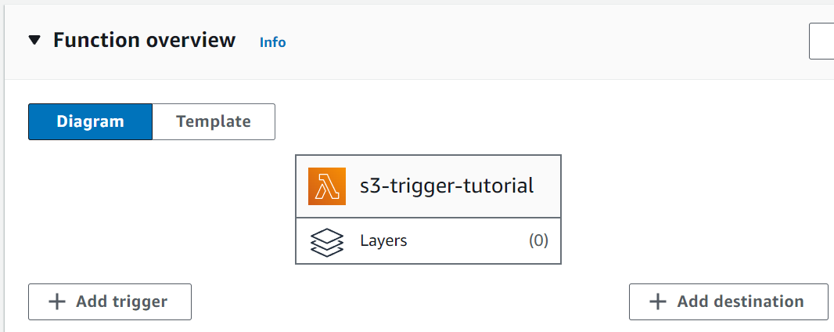

1. Select **S3**.
2. Under **Bucket**, select the bucket you created earlier in the tutorial.
3. Under **Event types**, be sure that **All object create events** is selected.
4. Under **Recursive invocation**, select the check box to acknowledge that using the same Amazon S3 bucket for input and output is not recommended.
5. Choose **Add**.

**Note**

**To upload an object to your Amazon S3 bucket**

1. Open the [Buckets](https://console.aws.amazon.com/s3/buckets) page of the Amazon S3 console and choose the bucket that you created earlier.
2. Choose **Upload**.
3. Choose **Add files** and use the file selector to choose an object you want to upload. This object can be any file you choose.
4. Choose **Open**, then choose **Upload**.

**To verify the function invocation using CloudWatch Logs**

1. Open the [CloudWatch](https://console.aws.amazon.com/cloudwatch/home) console.
2. Make sure you're working in the same AWS Region you created your Lambda function in. You can change your Region using the drop-down list at the top of the screen.

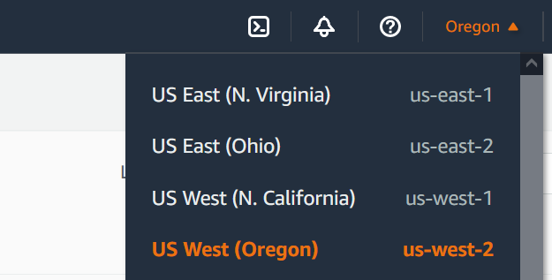

1. Choose **Logs**, then choose **Log groups**.
2. Choose the log group for your function (/aws/lambda/s3-trigger-tutorial).
3. Under **Log streams**, choose the most recent log stream.
4. If your function was invoked correctly in response to your Amazon S3 trigger, you’ll see output similar to the following. The CONTENT TYPE you see depends on the type of file you uploaded to your bucket.
5. 2022-05-09T23:17:28.702Z 0cae7f5a-b0af-4c73-8563-a3430333cc10 INFO CONTENT TYPE: *image/jpeg*

**Clean up your resources**

You can now delete the resources that you created for this tutorial, unless you want to retain them. By deleting AWS resources that you're no longer using, you prevent unnecessary charges to your AWS account.

**To delete the Lambda function**

1. Open the [Functions page](https://console.aws.amazon.com/lambda/home#/functions) of the Lambda console.
2. Select the function that you created.
3. Choose **Actions**, **Delete**.
4. Type **delete** in the text input field and choose **Delete**.

**To delete the execution role**

1. Open the [Roles page](https://console.aws.amazon.com/iam/home#/roles) of the IAM console.
2. Select the execution role that you created.
3. Choose **Delete**.
4. Enter the name of the role in the text input field and choose **Delete**.

**To delete the S3 bucket**

1. Open the [Amazon S3 console.](https://console.aws.amazon.com/s3/home)
2. Select the bucket you created.
3. Choose **Delete**.
4. Enter the name of the bucket in the text input field.
5. Choose **Delete bucket**.