create imagestream yaml file

apiVersion: image.openshift.io/v1

kind: ImageStream

metadata:

name: my-docker-imagestream

spec:

lookupPolicy:

local: false

tags:

- name: latest

from:

kind: DockerImage

name: docker.io/amitow/nginx:1.14.1

oc create -f is.yaml

oc get is

oc describe is my-docker-imagestream

**Json format: [Upload to okd dashboard]**

{

"apiVersion": "image.openshift.io/v1",

"kind": "ImageStream",

"metadata": {

"name": "my-docker-imagestream-guid"

},

"spec": {

"lookupPolicy": {

"local": false

},

"tags": [

{

"name": "1.14.1",

"from": {

"kind": "DockerImage",

"name": "docker.io/amitow/nginx:1.14.1"

}

}

]

}

}

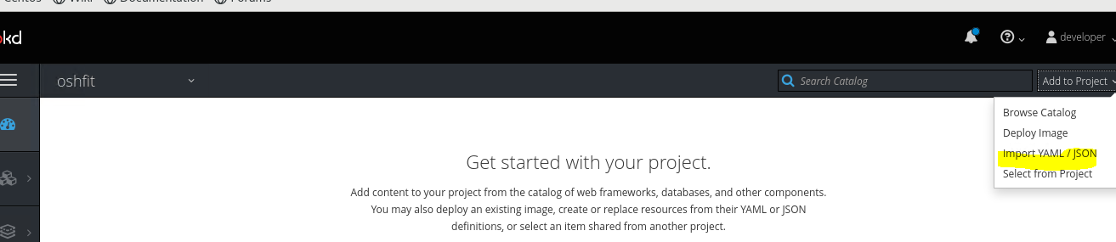

Deploy the image

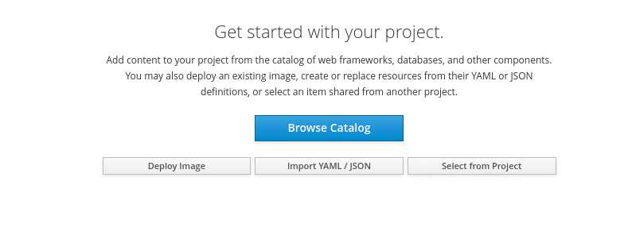

Select the image Stream from dropdown

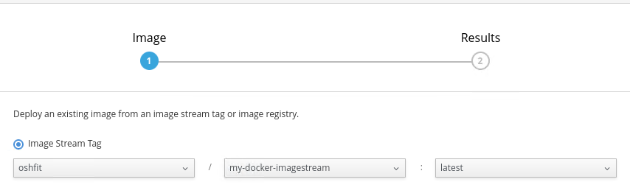

Click on Deploy and check the logs and events