Github link

https://github.com/amitopenwriteup/github-api-global-lib.git

Branch : main

Add the shared libary

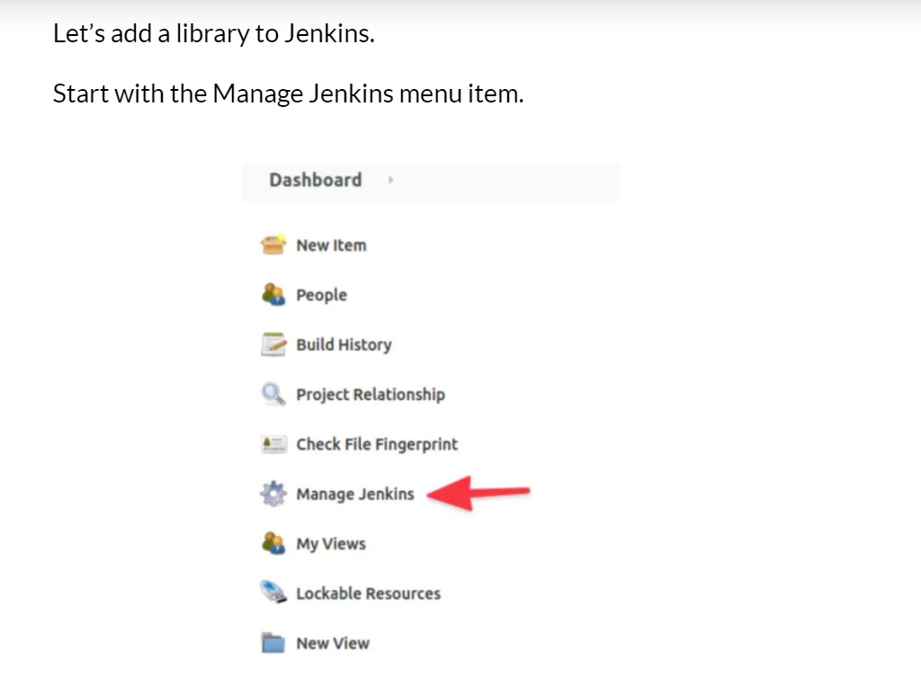

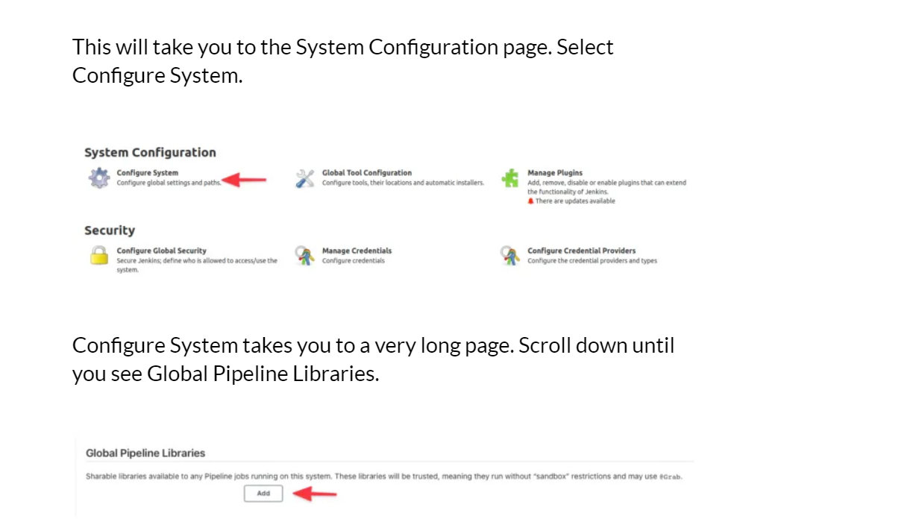

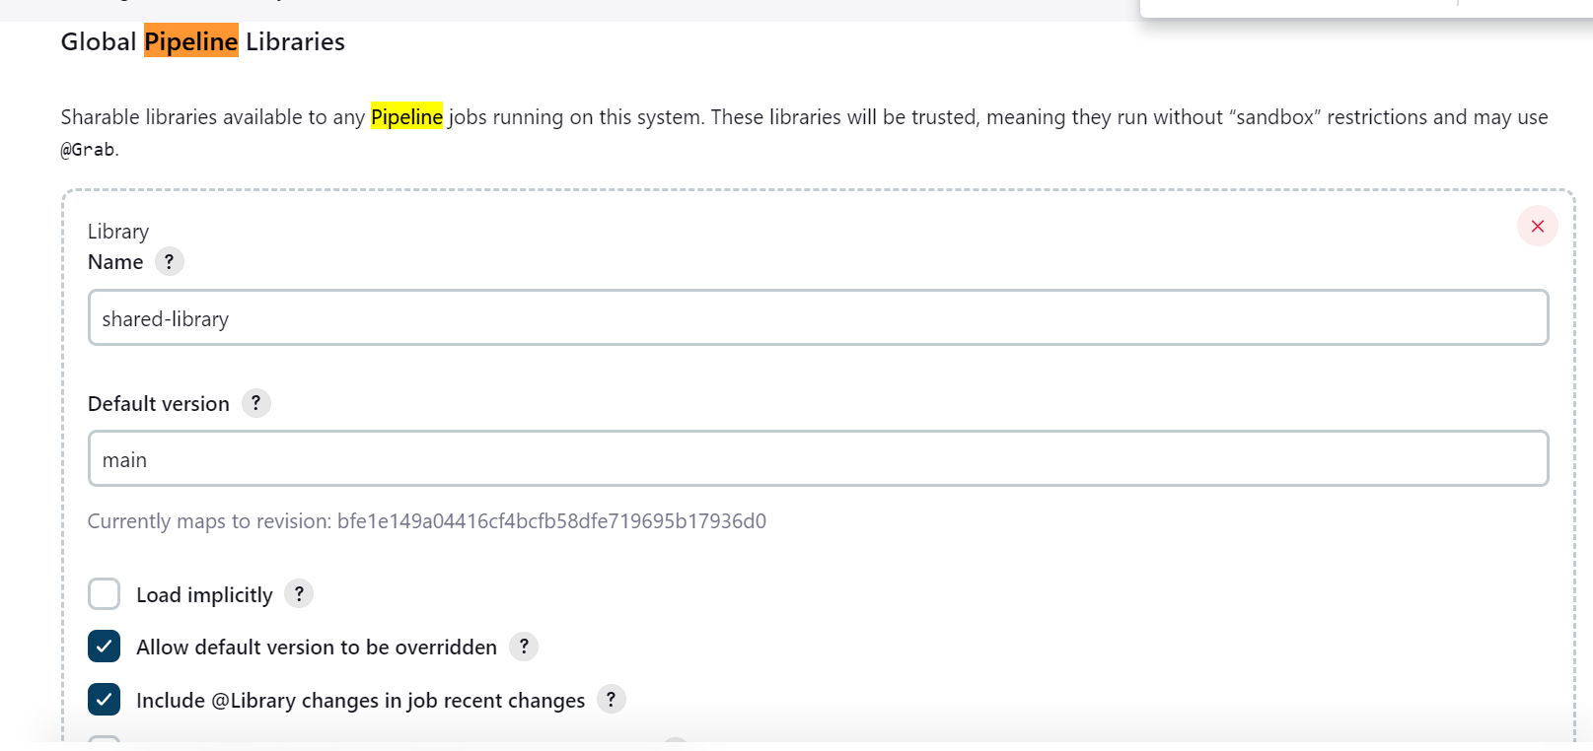

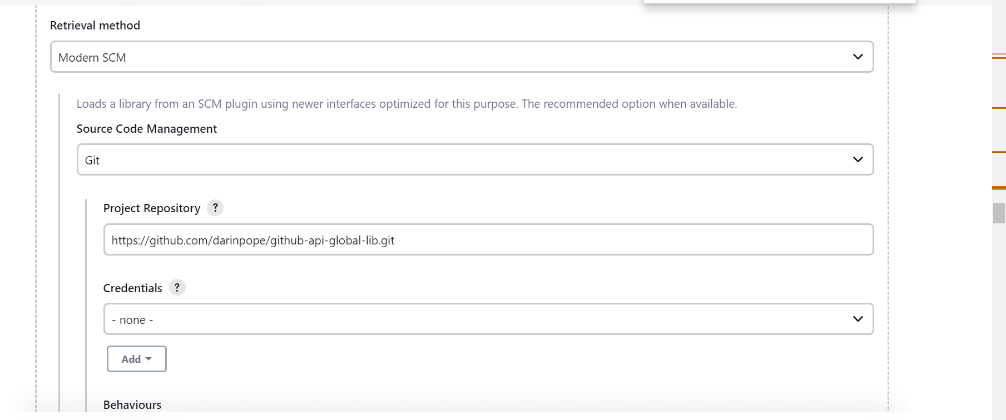

Create a pipeline job

@Library('shared-library') _

def config = [name: 'Newman', dayOfWeek: 'Friday']

pipeline {

agent any

stages {

stage('Example') {

steps {

helloWorld(config)

}

}

}

}