Name : Amit Pandey

Assessment :

Pseudo code 10 Marks

Q1 : Write a Pseudo code for verify if number entered is prime number.

Ans:

Begin

Declare input i, m,x and flag as a number

m=0, flag=0 and x=3

m=n/2

if x is equal to 0 or x is equal to 1 then

print “entered input its not a prime nos”

else

for i=2; i<=m; i++

if x mod I is equal to 0 then

print “its not a prime nos”

flag=1

break

end if

end for

if flag equals to 0 then

print “it’s a prime nos”

end if

end if

End

Q2: Write a Pseudo code for transferring amount from one account to another. [Should validate whether both accounts exists]

Begin

Declare credit amount , uaccount1, baccount1 ,uaccount2 and baccount2 as numbers

Amount=500

Uaccount1=3434534

Uaccount2=3464654

Get baccount1 from the debit bank database

Get baccount2 from the credit bank database

If uaccount1 is not null and uaccount2 is not null then

If uaccount1 equals to baccount1 then

If uaccount2 equals to baccount2 then

Perform the transfer activity

Print “Transfer complete”

Else

Print “Invalid account”

End if

Else

Print “Invalid account”

End if

Else

Print “Invalid account”

End if

End

RDBMS: 30 Marks

Q1. Write SQL Query to create following tables [DO NOT CREATE PRIMARY / FOREIGN KEYS ]

Customer: CustomerId, Fullname, address, city, pan number

Account: accountNo, accType, balance, customerId

Create table Customer (

CustomerId varchar (20) not null ,

Fullname Varchar2 (20) not null,

Address varchar2 (50) not null,

city varchar2 (10) not null,

Pan varchar2(20) not null

);

Create table account (

accountNo varchar (20) not null,

accType Varchar2 (20) not null,

balance Number (20,2) not null,

customerid varchar2 (20) not null

);

Q2. Write SQL to insert following records in Customer & Account tables:

|  |  |  |  |  |
| --- | --- | --- | --- | --- |
| C1002 | Rajiv Bhatia | Xyz Path, Chandni chowk | Delhi | AXNSS 1234 A |
| C1003 | Alia Bhatt | Khar | Mumbai | SZAXS 5656 B |
| C1004 | Vijay Deol | Bandra | Mumbai | APOI 5675 A |
| C1005 | Ajay Deol | Bandra | Mumbai | AUIO 7676 K |

|  |  |  |  |
| --- | --- | --- | --- |
| SB122666 | Savings | 67000 | C1002 |
| CB565556 | Current | 786928.98 | C1002 |
| SB876565 | Savings | 547899.90 | C1004 |
| SB565722 | Savings | 67600 | C1003 |
| SB757676 | Savings | 66197.88 | C1003 |
| SB166778 | Current | 16000 | C1008 |

Customer

insert into customer (CustomerId,Fullname,Address,city,Pan ) values('C1002','Rajiv Bhatia','Xyz Path Chandni chowk','Delhi','AXNSS1234A');

insert into customer (CustomerId,Fullname,Address,city,Pan ) values('C1003','Alia Bhatt','Khar','Mumbai','SZAXS5656B');

insert into customer (CustomerId,Fullname,Address,city,Pan ) values('C1004','Vijay Deol','Bandra','Mumbai','APOI5675A');

insert into customer (CustomerId,Fullname,Address,city,Pan ) values('C1005','Ajay Deol','Bandra','Mumbai','AUIO7676K');

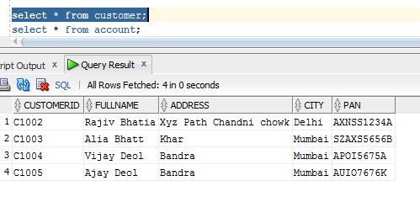

Account

insert into account (accountNo,accType,balance,customerid) values('SB122666','Savings','67000','C1002');

insert into account (accountNo,accType,balance,customerid) values('CB565556','Current','786928.98','C1002');

insert into account (accountNo,accType,balance,customerid) values('SB876565','Savings','547899.90','C1004');

insert into account (accountNo,accType,balance,customerid) values('SB565722','Savings','67600','C1003');

insert into account (accountNo,accType,balance,customerid) values('SB757676','Savings','66197.88','C1003');

insert into account (accountNo,accType,balance,customerid) values('SB166778','Current','16000','C1008');

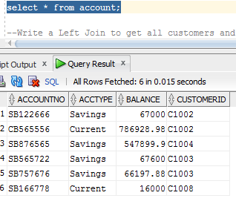

Q3. Write a Left Join to get all customers and accounts. Join should display all customers [Even those who DO NOT have any account].

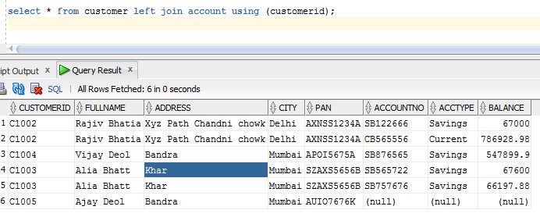

UML 10 Marks

Q1. For RDBMS Question #1, Create Class Diagram for Both tables.

Customer

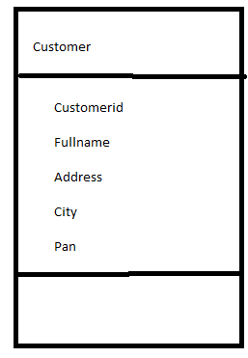

Account

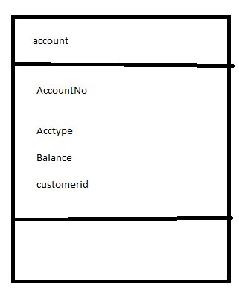

Q2. Create an Activity Diagram to explain fund transfer.

HINT: Fund transfer is possible from Any account type to any other account type.

Must validate existence of both account

Must validate account balance before transfer

Must update balance after transaction completes.

