Queries in Database

create table ItemMaster (ItemId varchar2(5) Primary Key,

Name varchar2(20),

Category varchar2(20) default 'Electronics',

Price Number(8,2),

ItemInStock Number(3));

insert into ItemMaster (ItemId ,Name , Category ,Price ,ItemInStock) values ('E1001','Ear Phone', 'Electronics',700.00,5);

insert into ItemMaster (ItemId ,Name , Category ,Price ,ItemInStock) values ('E1011','Speaker', 'Electronics',1700.00,15);

insert into ItemMaster (ItemId ,Name , Category ,Price ,ItemInStock) values ('E1021','Charger', 'Electronics',2700.00,52);

insert into ItemMaster (ItemId ,Name , Category ,Price ,ItemInStock) values ('E1031','Power Backup', 'Electronics',3700.00,35);

commit;

create table OrderMaster (CustomerId Number(6),

OrderId Number(6),

ItemId varchar2(5));

Create sequence Order_seq start with 1001 increment by 10;

commit;

Home Page

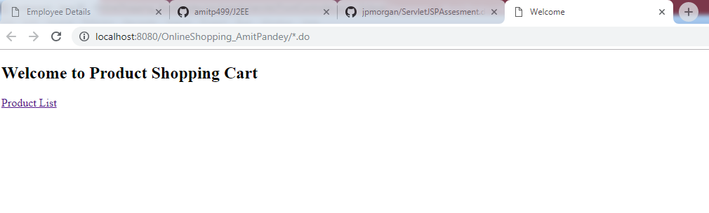

Product List

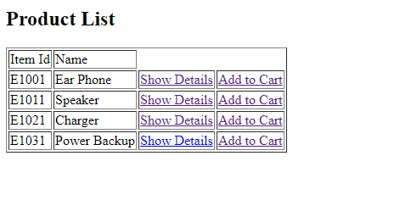

Show Details:

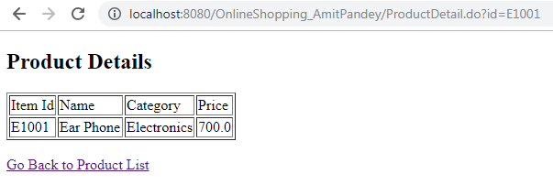

Add Single Product on Cart:

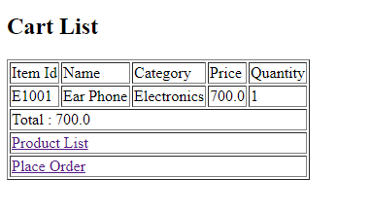

Place Single Order:

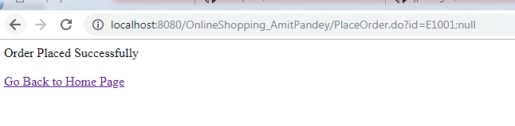

DB Screenshot : Post Placing Order

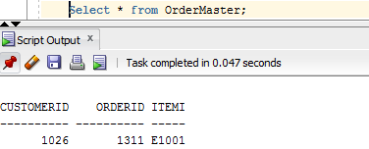

Adding multiple products on Cart:

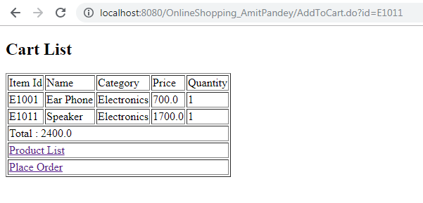

Placing multiple orders:

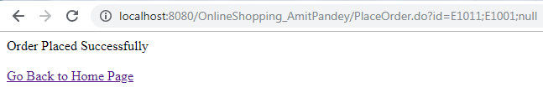

DB Screenshot- Placing multiple orders:

