**Online Shopping Problem Statement**

# Assessment Parameters (Total Marks -100) Time : 3 hours

* *Complete flow of the application with exception handling -60%*
* *Comments/best practice, coding standards- 10%*
* *Execution of the application (Output) – 20%*
* *Responsive UI (Design) – 10%*
* *Screen Shot should be submitted along with the solution*
* *The solution(Project) created by the trainee should have the name like AppName_Empid_EmpName Ex:OnlineShopping_9879871_ZaraKhan*

A shopping mart needs a web-based software to provide a simple portal to customer to do online shopping. The portal is expected to show the list of the items (Electronics goods) with two options for each item to select. The ‘Show Details’ is expected to show all the details of an item like Category, price, number of items available for purchase etc. The ‘Add to Cart’ is expected to add the item into the Cart. Customer should be able to view the cart and finalize order.

**ItemList.jsp**

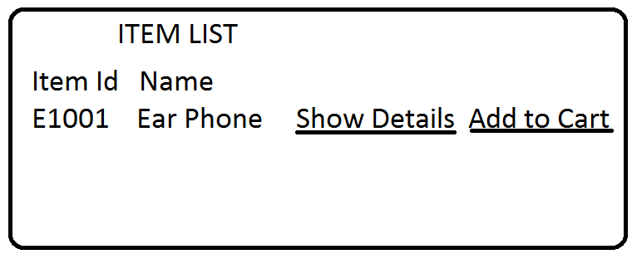

**ItemDetails.jsp**

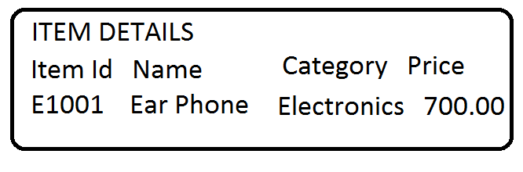

**Cart.jsp**

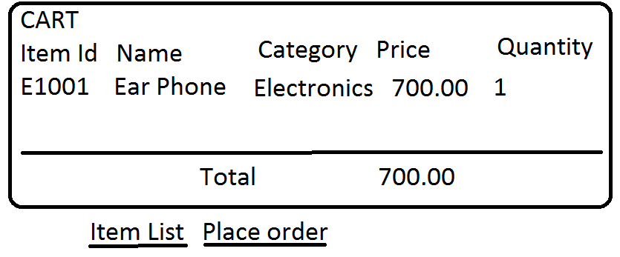

**Design the table structure as given below…**

**ItemMaster**

ItemId varchar2(5) Primary Key,

Name varchar2(20),

Category varchar2(20) default ‘Electronics’,

Price Number(8,2),

ItemInStock Number(3)

**OrderMaster**

CustomerId Number(6),

OrderId Number(6),

ItemId varchar2(5),

**Create sequence Order_seq;**

**(Note: In case of CustomerId for now, insert a static value in the table as Login scope is not present.)**

|  |  |
| --- | --- |
| Show the list of the items (Electronics goods) as per UI | 10 |
| Showing Items Details as per UI | 10 |
| Adding to Cart as per UI | 10 |
| View the cart as per UI | 10 |
| Placing the order and showing the Order placed success Page. Processing the correct SQL statement for inserting Order details into database. | 20 |
| Session Management to be implemented as per requirement. | 10 |
| Exception handling with common error page | 10 |
| Displaying success message as per the given format | 10 |

Ensure the usage of MVC pattern with Layered Architecture. **(10 marks)**

**Note:**

* Use DAO Support classes for persisting data.
* Use appropriate package structure for each of the applications components
* Design Responsive UI with Bootstrap and CSS, JQuery
* Validation should be performed using Javascript and HTML5.