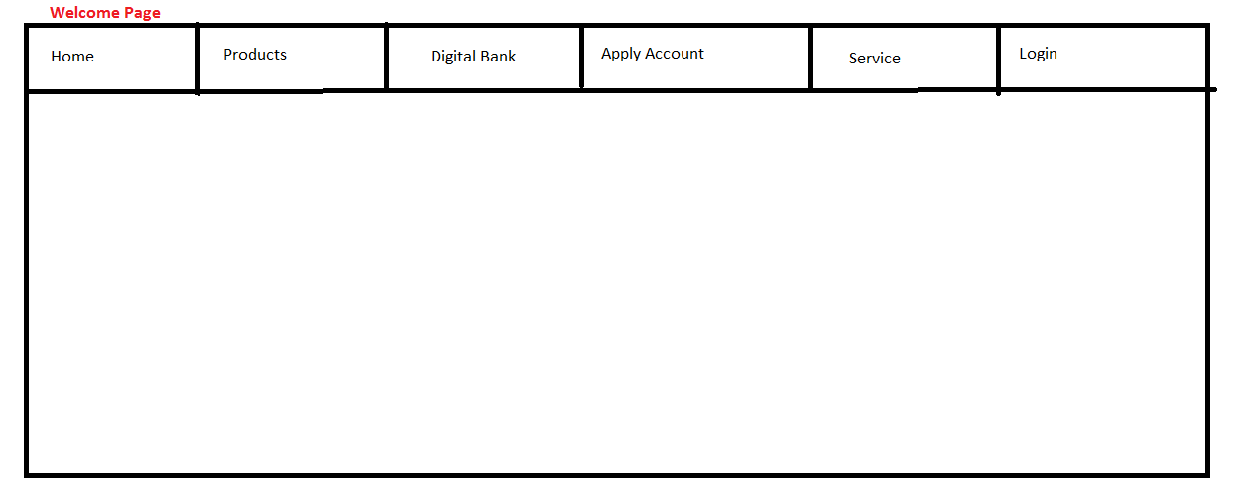

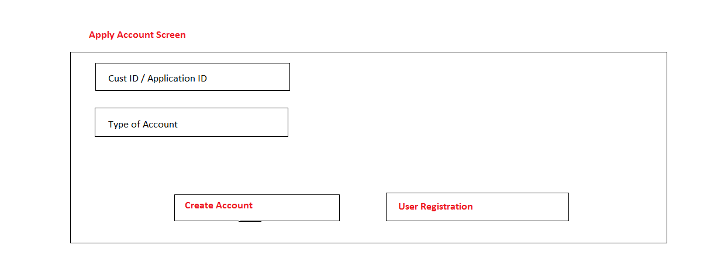

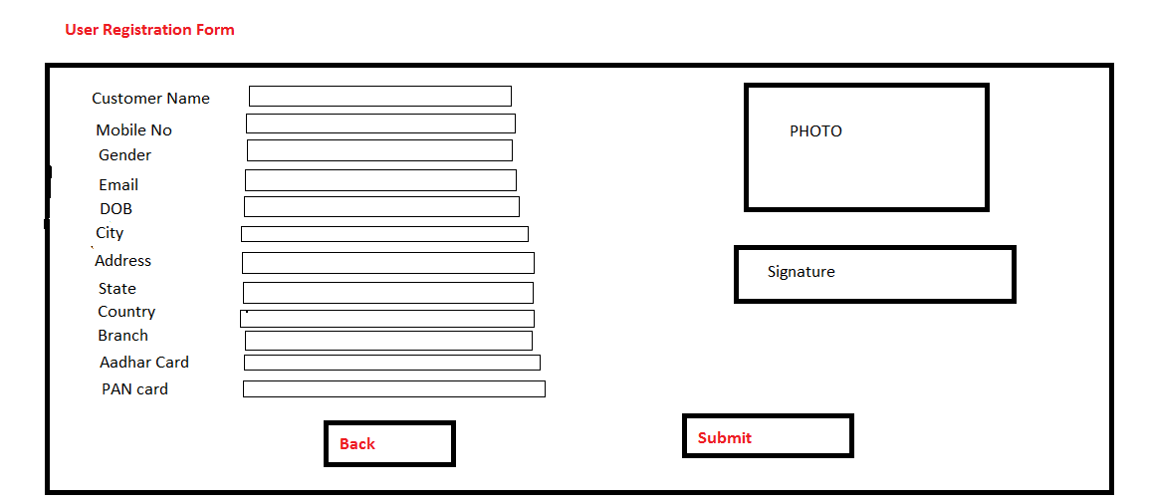

*Validation Message 1 -* After user clicks on “Submit” button on User Registration screen and after successful validation

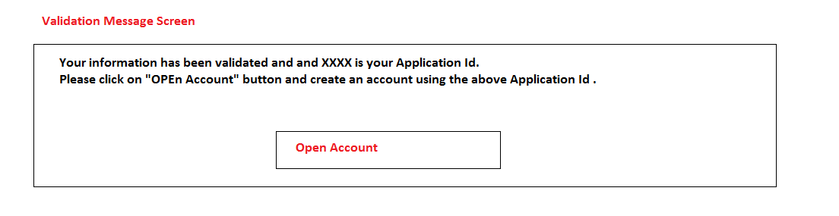



*Validation Message 2 -* After user clicks on “Create Account” button on Apply Account screen.

(Assumption – user is being created for first time from User Registration page)

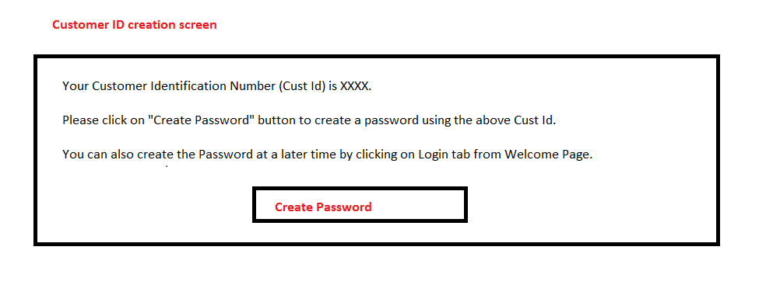

**Forgot Password:**

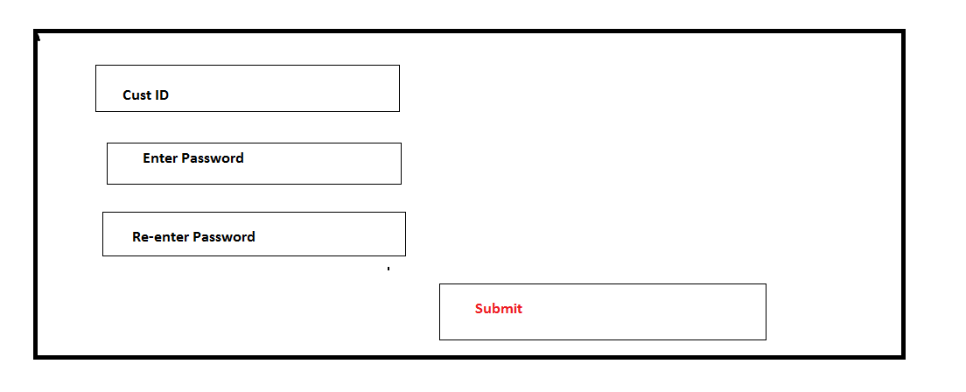

**Login:**

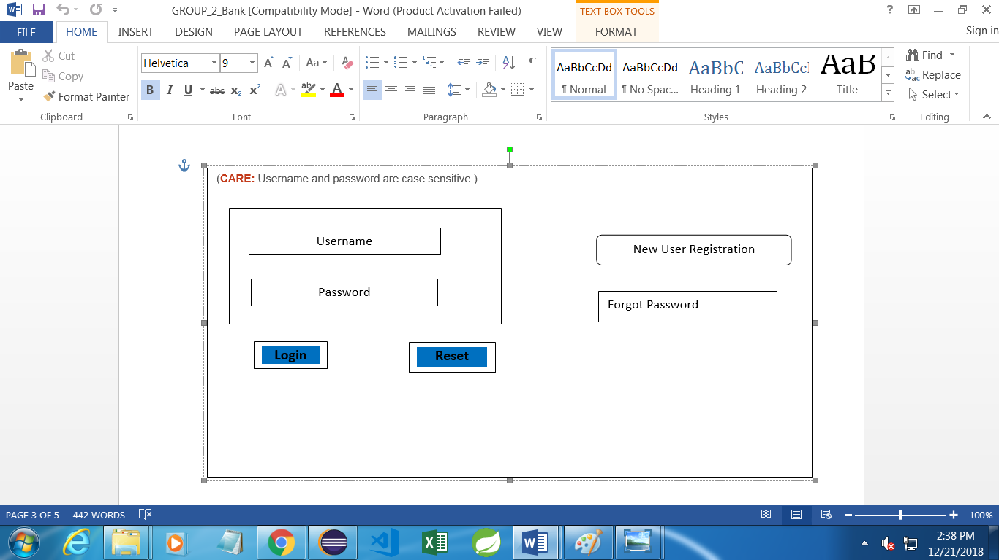

**Account Summary**

**Transactions**

**Available Balance**

**Branch**

**Account No. / Nick Name**

**Account Statement**

**Select options for the statement period**

1. By month 2. By date 3.By 6 Months

End Date

Start Date

**My Profile:**

|  |  |  |
| --- | --- | --- |
| **My Profile** | **E-SERVICES** | **Fund Transfer** |

Profile details:



Profile details:

**FUND TRANSFER**

FUND TRANSFER

BACK

NEXT

Select Payee:

Pay Mode:

Amount:

Payee Acc. Type:

SAME ACCOUNT

BACK

NEXT

IFSC Code:

Account Type:

Payee Name:

Account number:

Confirm Acc. No:

ADD PAYEE

OTHER ACCOUNT