**MANAV RACHNA INTERNATIONAL**

**INSTITUTE OF RESEARCH AND**

**STUDIES**



***FACULTY OF COMPUTER***

***APPLICATIONS***

*PRACTICAL FILEOF*

**PYTHONPROGRAMMINGLAB**

(MCA-DS-357)

**SUBMITTED TO SUBMITTED BY**

**Ms. Neda Fatima Name: Atul Sharma**

**Class: MCA-1**

**Roll no: 22/FCA/MCA/016**

INDEX

**S.no. Program name page no.**

|  |  |  |
| --- | --- | --- |
| **1** | Write a program in python to print your name. |  |
| **2** | Write a program in python to present different variables with different data types. |  |
| **3** | Write a program in python to display current date and time. |  |
| **4** | Write a program in python to show all arithmetic operations in python. |  |
| **5** | W.A.P in python which accepts the radius of a circle from the user and compute area and circumference of circle. |  |
| **6** | Write a program in python that accepts integer n and computes the value of n+ nn + nnn. |  |
| **7** | Write a program in python to print current month. |  |
| **8** | Write a program in python which accepts the first name and last name of the user and print the name in reverse order. |  |
| **9** | Write a program in python to find the largest no. using if statement. |  |
| **10** | Write a program in python to display whether the user is eligible to vote by taking age of the user. |  |
| **11** | Write a program in python to display largest of three numbers. |  |
| **12** | Write a Python program to calculate number of days between two dates. |  |
| **13** | Create a program that asks the user to enter their name and their age. Print out a message addressed to them that tells them the year that they will turn 100 years old. |  |
| **14** | Ask the user for a number. Depending on whether the number is even or odd, print out an appropriate message to the user.  Hint: how does an even / odd number. |  |

|  |  |  |
| --- | --- | --- |
| **15** | Write a Python program which accepts a sequence of comma-separated numbers from user and generate a list and a tuple with those numbers. |  |
| **16** | Write a Python program to calculate the sum of three given numbers, if the values are equal then return thrice of their sum. |  |
| **17** | Write a Python program to test whether a passed letter is a vowel or not. |  |
| **18** | Take a list, say for example this one: a = [1, 1, 2, 3, 5, 8, 13, 21, 34, 55, 89] and write a program that prints out all the elements of the list that are less than 5.  a) Instead of printing the elements one by one, make a new list that has all the elements less than 5 from this list in it and print out this new list. b) Ask the user for a  number and return a list that contains only elements from the original list a that are smaller than that number given by the user. |  |
| **19** | Create a program that asks the user for a number and then prints out a list of all the divisors of that number. (If you don’t know what a divisor is, it is a number that divides evenly into another number. For example, 13 is a divisor of 26 because 26 / 13 has no remainder.) |  |
| **20** | Take two lists, say for example these two: a = [1, 1, 2, 3, 5, 8, 13, 21, 34, 55, 89] b = [1, 2, 3, 4, 5, 6, 7, 8, 9, 10, 11, 12, 13] and write a program that returns a list that lists (without duplicates). Make sure your program works on two lists of different sizes and contains only the elements that are common between them. |  |
| **21** | Ask the user for a string and print out whether this string is a palindrome or not. (A palindrome is a string that reads the same forwards and backwards. |  |
| **22** | Let’s say I give you a list saved in a variable: a = [1, 4, 9, 16, 25, 36, 49, 64, 81, 100]. Write one line of Python that takes this list a and makes a new list that has only the even elements of this list in it. |  |
| **23** | Generate a random number between 1 and 9 (including 1 and 9). Ask the user to guess the number, then tell them whether they guessed too low, too high, or exactly right. (Hint: remember to use the user input lessons from the very first exercise) |  |

|  |  |  |
| --- | --- | --- |
| **24** | Ask the user for a number and determine whether the number is prime or not. (For those who have forgotten, a prime number is a number that has no divisors.). |  |
| **25** | Write a program (function!) that takes a list and returns a new list that contains all the elements of the first list minus all the duplicates. |  |
| **26** | Write a function that takes an ordered list of numbers (a list where the elements are in order from smallest to largest) and another number. The function decides whether or not the given number is inside the list and returns (then prints) an appropriate Boolean. |  |
| **27** | Implement a function that takes as input three variables, and returns the largest of the three. Do this without using the Python max() function! |  |
| **28** | Make a mini project based on concepts above list of practical.  Suggested mini projects are: a) Write a password generator in Python. Be creative with how you generate passwords strong passwords have a mix of lowercase letters, uppercase letters, numbers, and symbols. The passwords should be random, generating a new password every time the user asks for a new password. Include your run-time code in a main method. |  |

Q1)Write to print your name.

Ans)

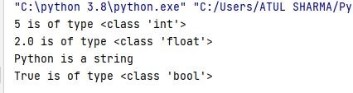name = input(**"Enter name: "**) print(**"Hi, my name is "** + name) Output:

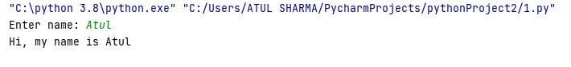

Q2)Write a programme in python to present different variables with different data types. Ans)

num1 = 5

print(num1, **'is of type'**, type(num1))

num2 = 2.0

print(num2, **'is of type'**, type(num2)) name = **'Python'** print(name+**" is a string"**) a = True

print(a, **'is of type'**, type(a))

Ouput:

Q3)Write to display current date and time. Ans) import datetime x=datetime.datetime.now() print(x) Output:



Q4)Write a programme in python to show all arithmetic operations in python. Ans)

num1 = input(**'Enter first number:'**) num2 = input(**'Enter second number:'**) sum= float(num1) + float(num2) sub=float(num1) - float(num2) multiply=float(num1) * float(num2) divide= float(num1) / float(num2) print(sum) print(sub) print(multiply) print(divide)

Output:

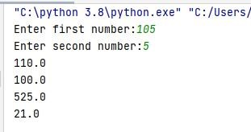

Q5)Write which accepts the

radius of a circle from the user and compute area and circumference of circle.

Ans)

r = float(input (**"Input the radius of the circle : "**)) area=3.14*r*r

print (**"The area of the circle with radius "** + str(r) + **" is: "** + str(area)) Output:

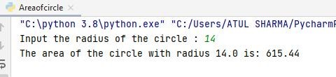

Q6)Write a programme in python that accepts integer n and computes the value of n+nn+nnn. Ans)

n=int(input(**"input an integer"**)) n1=int(**"%s"**%n) n2=int(**"%s%s"**%(n,n)) n3=int(**"%s%s%s"**%(n,n,n)) print(n1+n2+n3)

Output:

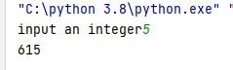

Q7)Write to print current month. Ans) import calendar year = int(input("enter year")) month =int(input("enter month")) print(calendar.month(year, month)) Output:

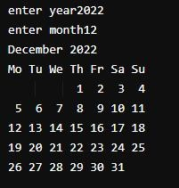

Q8)Write a programme in python which accepts the first name and last name of the user and print the name in reverse order. Ans)

firstname = input(**"Input your First Name : "**) lastname = input(**"Input your Last Name : "**) print (lastname + **" "** + firstname)

Output:

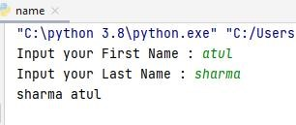

Q9)Write to find the largest no. using if statement. Ans)

a=int(input(**"enter value of a"**)) b=int(input(**"enter value of b"**)) if a>b: print(a,**"is largest"**)

else:

print(b,**"is largest"**)

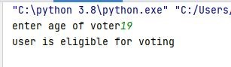Output:

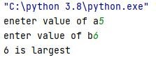

Q10)Write a programme in python to display whether the user is eligible to vote by taking age of the user. Ans)

age=int(input(**"enter age of voter"**)) if(age>=18): print(**"user is eligible for voting"**) else: print(**"user is not eligible"**)

Output:

Q11)Write a programme in python to display largest of three numbers. Ans)

a=int(input(**"enter value of a"**)) b=int(input(**"enter value of b"**)) c=int(input(**"enter value of c"**)) if a>=b and a>=c: print(**"a is largest"**)

elif b>=a and b>=c:

print(**"b is largest"**)

else:

print(**"c is largest"**)

Output:

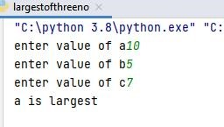

Exercise 12

Write a Python program to calculate number of days between two dates.

from datetime import date

d1 = date(2021, 10, 20) d2 = date(2022, 2, 20)

delta = d2 - d1

print(**'Difference is'**,delta,**'days'**) Output:



Exercise 13

Create a program that asks the user to enter their name and their age. Print out a message addressed to them that tells them the year that they will turn 100 years old.

name = input(**"Enter your name: "**) current_age = int(input(**"Enter your age: "**)) hundredth_year = 2023 + (100 - current_age) print(name, **"will become 100 years old in the year "**,hundredth_year)

Output:

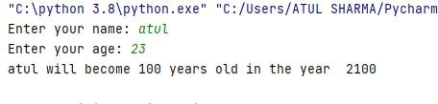

Exercise 14

Ask the user for a number. Depending on whether the number is even or odd, print out an appropriate message to the user.

num=int(input(**"enter a number"**)) if(num%2==0): print(**"the number is even"**) else:

print(**"the number is odd"**)

Output:

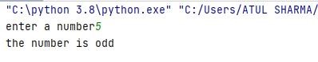

Exercise 15

Write a Python program which accepts a sequence of comma-separated numbers from user and generate a list and a tuple with those numbers.

values = input("Input some comma seprated numbers : ") list = values.split(",") tuple = tuple(list) print('List : ',list) print('Tuple : ',tuple)

Output:

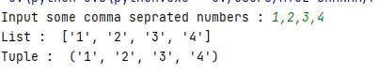

Exercise 16

Write a Python program to calculate the sum of three given numbers, if the values are equal then return thrice of their sum.

num1=int(input(**"enter value"**)) num2=int(input(**"enter value"**)) num3=int(input(**"enter value"**)) sum=num1+num2+num3 if(num1==num2 and num1==num3): print(**"the numbers are equal so the thrice of sum is"**,sum*3) else:

print(**"the numbers are not equal and sum**

**is"**,num1+num2+num3) Output:

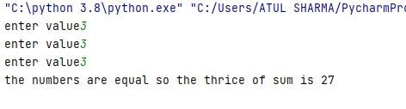

Exercise 17

Write a Python program to test whether a passed letter is a vowel or not.

def fun(str): if str in(**'a'**,**'e'**,**'i'**,**'o'**,**'u'**): print(**"vowel"**)

else:

print(**"not a vowel"**) fun(**"e"**) fun(**"g"**) Output:



Exercise 18

Take a list, say for example this one: a = [1, 1, 2, 3, 5, 8, 13, 21, 34, 55, 89] and write a program that prints out all the elements of the list that are less than 5.

1. Instead of printing the elements one by one, make a new list that has all the elements less than 5 from this list in it and print out this new list.
2. Ask the user for a number and return a list that contains only elements from the original list a that are smaller than that number given by the user.

A)

a=[1, 1, 2, 3, 5, 8, 13, 21, 34, 55, 89] b=[] for i in a:

if i<5:

b.append(i) print(b) Output:

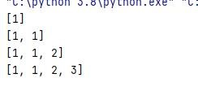

B)

a=[1, 1, 2, 3, 5, 8, 13, 21, 34, 55, 89] b=[]

d=int(input(**"enter a number"**)) for i in a:

if i<d:

b.append(i) print(b) Output:

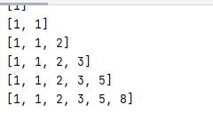

Exercise 19

Create a program that asks the user for a number and then prints out a list of all the divisors of that number.

choice=1 while choice == 1:

i=1

num=int(input(**"Enter Test Number: "**)) while i<(num/2+1):

if num%i==0: print(i)

i=i+1

try:

print(num)

choice=int(input(**"Try Again ?[1=Yes,0=No] Choice: "**))

except: print(**"Invalid Choice"**) choice=1

Output:

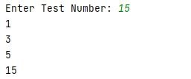

Exercise 20

Take two lists, say for example these two: a = [1, 1, 2, 3, 5, 8, 13, 21, 34, 55, 89] b =

[1, 2, 3, 4, 5, 6, 7, 8, 9, 10, 11, 12, 13] and write a program that returns a list that lists (without duplicates). Make sure your program works on two lists of different sizes and contains only the elements that are common between them.

a = [1, 1, 2, 3, 5, 8, 13, 21, 34, 55, 89] b = [1, 2, 3, 4, 5, 6, 7, 8, 9, 10, 11, 12, 13] both = []

if len(a) < len(b):

for i in a:

if i in b and i not in both:

both.append(i)

if len(a) > len(b):

for i in b:

if i in a and i not in both:

both.append(i)

print(both) Output:

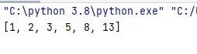

Exercise 21

Ask the user for a string and print out whether this string is a palindrome or not.

def isPalindrome(s):

return s == s[::-1]

s = input(**"enter any string"**) ans = isPalindrome(s)

if ans: print(**"Yes the string is palindrome "**) else:

print(**"No the string is not palindrome"**)

Output:

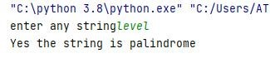

Exercise 22

Let’s say I give you a list saved in a variable: a = [1, 4, 9, 16, 25, 36, 49, 64, 81, 100]. Write one line of Python that takes this list a and makes a new list that has only the even elements of this list in it.

a = [1, 4, 9, 16, 25, 36, 49, 64, 81, 100] new_list = [] for i in a:

if i % 2 == 0:

new_list.append(i)

print(new_list)

Output:



Exercise 23

Generate a random number between 1 and 9 (including 1 and 9). Ask the user to guess the number, then tell them whether they guessed too low, too high, or exactly right.

import random

number = random.randrange(1, 10)

guess = 0 count = 0

while guess != number and guess != **"exit"**: guess = input(**"Please guess a number between 1 and 9. When you want to end the game print 'exit': "**)

if guess == **"exit"**:

print(**"Game Over"**) break

guess = int(guess) count += 1 if guess not in range(1, 10):

print(**"You have to guess a number between 1 and 9!"**)

elif guess < number: print(**"You've guessed too low!"**)

elif guess > number:

print(**"You've guessed too high!"**) else: print(**"Well done! You've got it in just"**,count ,**"tries"**)

Output:

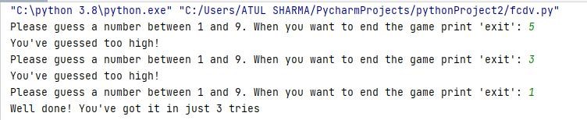

Exercise 24

Ask the user for a number and determine whether the number is prime or not.

num =int(input(**"enter a number"**)) if num > 1:

for i in range(2, int(num/2)+1):

if (num % i) == 0: print(num, **"is not a prime number"**) break

else:

print(num, **"is a prime number"**)

else:

print(num, **"is not a prime number"**)

Output:

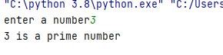

Exercise 25

Write a program (function!) that takes a list and returns a new list that contains all the elements of the first list minus all the duplicates.

def dedupe(x): y = [] for i in x:

if i not in y:

y.append(i)

return y

a = [1,2,3,4,3,2,1] b=dedupe(a) print(b) Output:



Exercise 26

Write a function that takes an ordered list of numbers (a list where the elements are in order from smallest to largest) and another number. The function decides whether or not the given number is inside the list and returns (then prints) an appropriate Boolean.

def find(ordered_list, element_to_find):

for element in ordered_list:

if element == element_to_find:

return True

return False

l = [2, 4, 6, 8, 10] print(find(l, 6)) Output:



Exercise 27

Implement a function that takes as input three variables, and returns the largest of the three.

def max(a,b,c):

if(a>b) and (a>c):

return a

elif(b>a) and (b>c):

return b else:

return c

a=int(input(**"enter a value"**)) b=int(input(**"enter b value"**)) c=int(input(**"enter c value"**)) largest=max(a,b,c) print(largest)

Output:

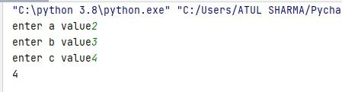

Exercise 28

Make a mini project.

Rock-Paper-Scissors game.Ask for player plays (using input), compare them, print out a message of congratulations to the winner, and ask if the players want to start a new game)

import random

while True:

print(**"Enter choice** \n **1 for Rock,** \n **2 for paper, and** \n **3 for**

**scissor** \n**"**) choice = int(input(**"User turn: "**))

while choice > 3 or choice < 1:

choice = int(input(**"enter valid input: "**))

if choice == 1: choice_name = **'Rock'**

elif choice == 2: choice_name = **'paper'** else:

choice_name = **'scissor'**

print(**"user choice is: "** + choice_name) print(**"**\n**Now its computer turn......."**) comp_choice = random.randint(1, 3)

while comp_choice == choice: comp_choice = random.randint(1, 3)

if comp_choice == 1: comp_choice_name = **'Rock'**

elif comp_choice == 2:

comp_choice_name = **'paper'** else:

comp_choice_name = **'scissor'**

print(**"Computer choice is: "** + comp_choice_name) print(choice_name + **" V/s "** + comp_choice_name)

if( choice == comp_choice): print(**"Draw=> "**, end=**""**) result = **"Draw"**

elif ((choice == 1 and comp_choice == 2) or

(choice == 2 and comp_choice == 1)):

print(**"paper wins => "**, end=**""**) result = **"paper"**

elif ((choice == 1 and comp_choice == 3) or

(choice == 3 and comp_choice == 1)):

print(**"Rock wins =>"**, end=**""**) result = **"Rock"** else:

print(**"scissor wins =>"**, end=**""**) result = **"scissor"**

if result == **"Draw"**: print(**"<== Its a tie ==>"**)

if result == choice_name:

print(**"<== User wins ==>"**) else:

print(**"<== Computer wins ==>"**)

print(**"Do you want to play again? (Y/N)"**) ans = input().lower

if ans == **'n'**: break **Output:**

