Module 2: Campus to Corporate

Task 1: Build your Resume
- Create a professional resume using a clean, structured format that highlights your skills, education, and achievements.
- Include the following sections: Personal Info, Education, Skills, Experience, Projects.

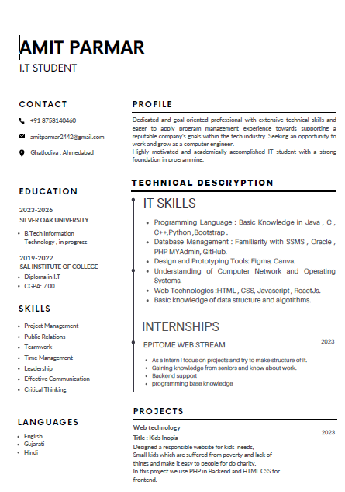

Task 2: LinkedIn Profile
- Create or update your LinkedIn profile to reflect your resume.
- Ensure your profile picture, headline, and summary are professional and complete all sections: LinkedIn Link:-
https://www.linkedin.com/in/amit-parmar-a42581201?utm_source=share&utm_campaign=share_via&utm_content=profile&utm_medium=android_app

