1. Certain data fields are required in every form: Initiator, Date Opened, Short Description, Due Date, Record Number, and Site/Location.
2. Division and Site/Location are the same.
3. Initiator and Originator are the same; Date Opened and Date of Initiation are the same.
4. A Short Description is required for Record Creation.
5. The fields Initiator, Date Opened, and Site/Location are auto-filled.
6. Date of Initiation is auto-filled and cannot be changed; this is the Document Creation Date.
7. The header of the document must include Site, Division/Project.
8. Audit Trail, Save, Next, Back, and Exit buttons should be available everywhere.
9. Every tab should have Save, Next, Back, and Exit buttons at the bottom, and the Activity Log (Signature) tab should have Back and Exit buttons.
10. Required data fields (*) and conditionally required data fields should be displayed when the condition is met.
11. The (*) symbol should also appear in the e-signature popup for the Username and Password.
12. The Audit Trail button and report are crucial. The Audit Trail should display every activity, including return activities and all data fields with timestamps.
13. When data fields are changed for the first time, 'change from' should always be 'Null.'

**Change type:**

* Create Record: Create
* First-time change: New
* Update Data field: Update

1. The first time a record is saved, 'Change from' should be 'Initiation,' not 'Initiator.'

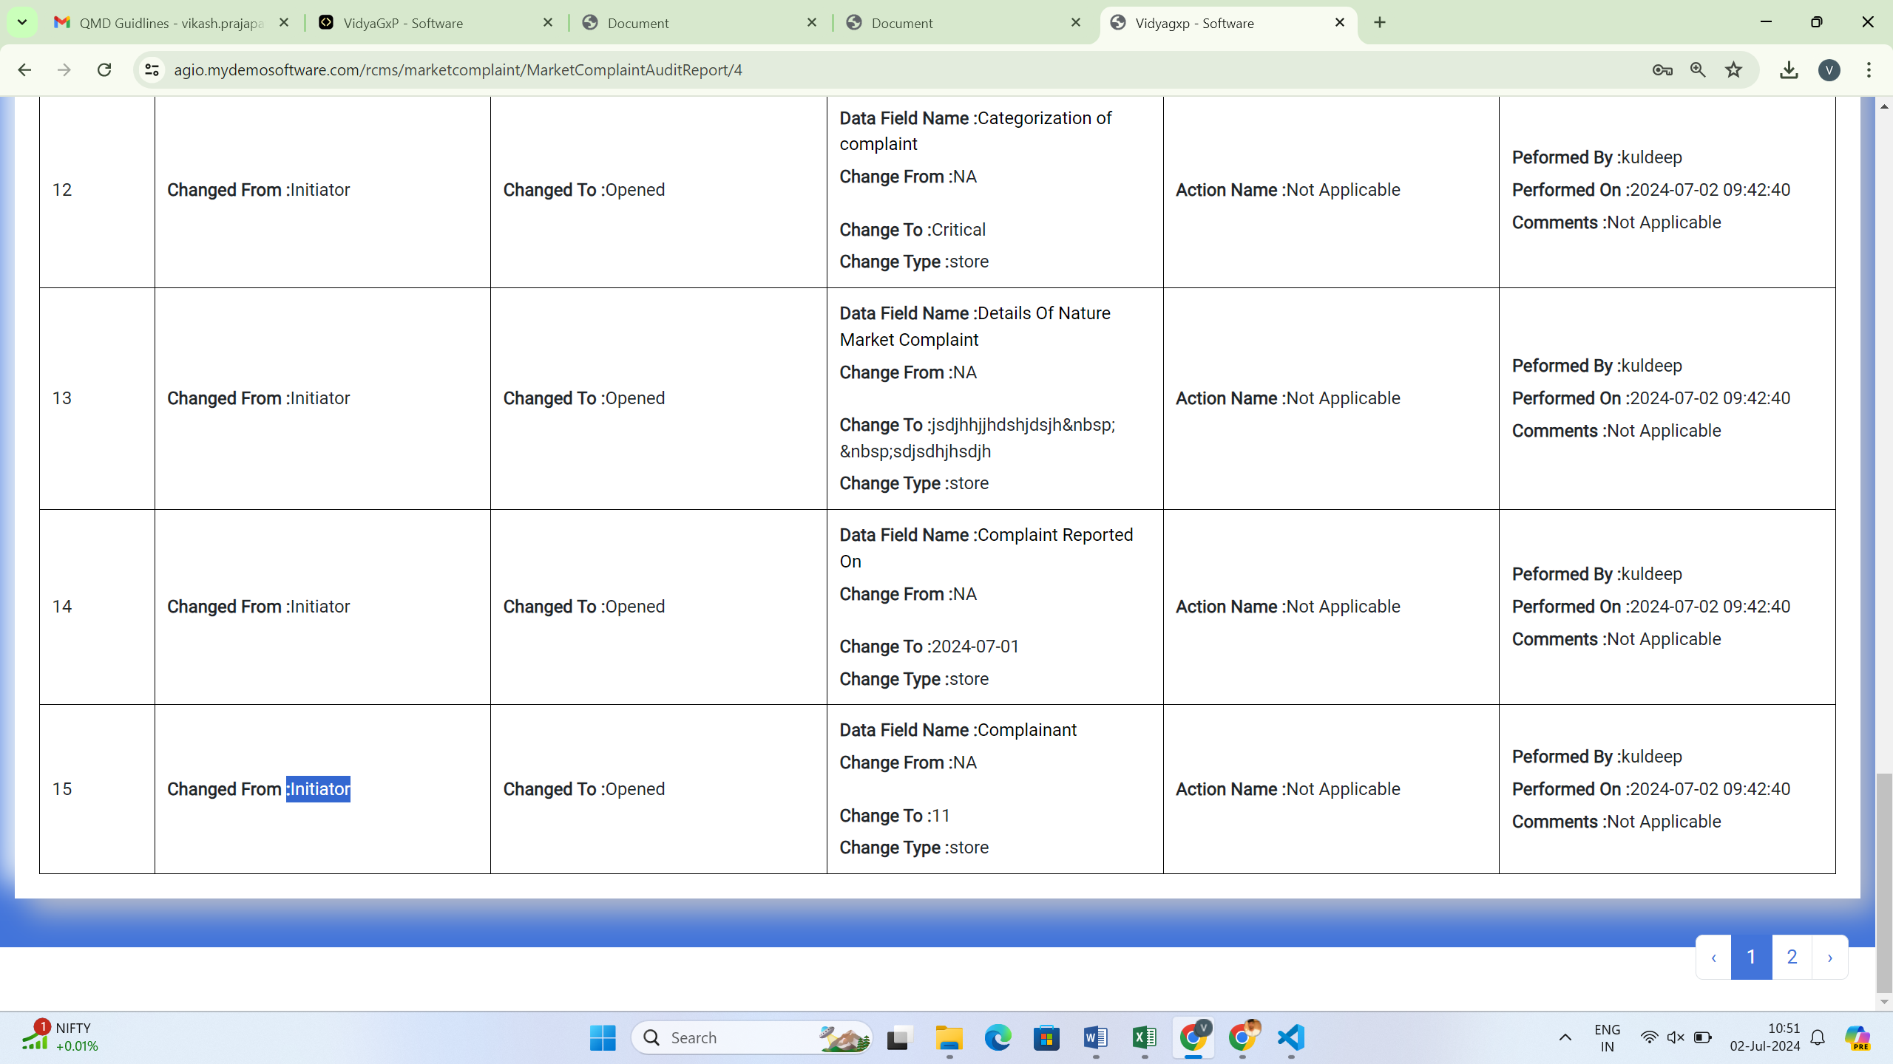

1. For subsequent saves, the current state should always be 'Change form,' and 'Change to' should be 'Not applicable.'
2. The department name should always be shown in full in reports and the Audit Trail.
3. The person's full name should always be shown in reports and the Audit Trail, not an ID.
4. The date format should always be DD/MM/YYYY or DD-MM-YYYY, not YYYY/MM/DD or YYYY-MM-DD.
5. The action name is the activity name in the Audit Trail.
6. Flex, Summer, and text area fields should always log data. String or text data fields should have a length of 255 characters.
7. The grid should always use remove and plus buttons. When clicking the save button, the remove button should not hide in the current state.
8. Ensure all field data are not lost from the first state to the last state.
9. In the closed-done, closed-cancelled, and closed states, all data fields should be locked, except for certain conditions.
10. Record Number and Division should be shown on the dashboard.



1. Text area fields should be shown as a single field per row in the report.
2. The grid and report should have small widths for Sr. No. and #Row.
3. Every page of the report and Audit Trail report should show the header and footer.
4. The report should show the same data as the config form.
5. The Audit Trail report should show the same data as the Audit Trail.