1. Load data and create Spark data frame

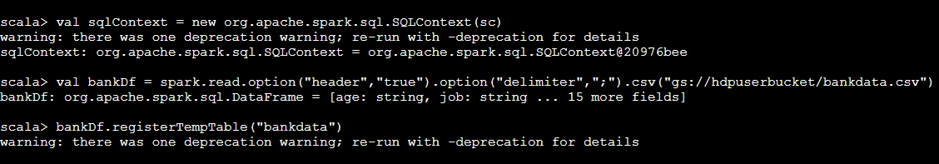

1. Give marketing success rate. (No. of people subscribed / total no. of entries)

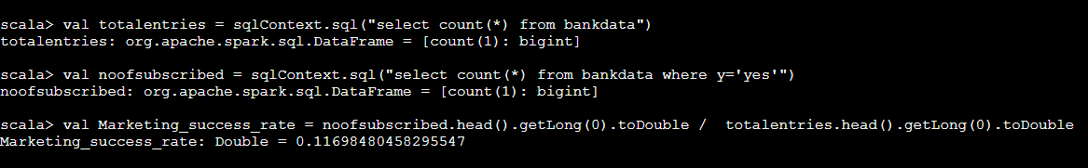

1. Maximum, Mean, and Minimum age of average targeted customer

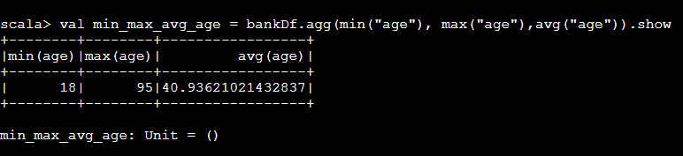

1. Check quality of customers by checking average balance, median balance of customers

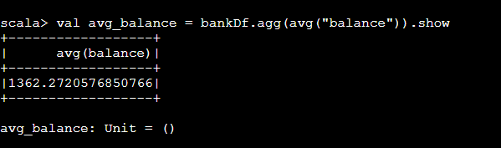

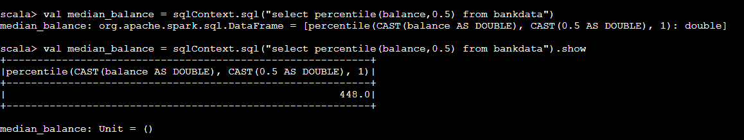

1. Check if age matters in marketing subscription for deposit

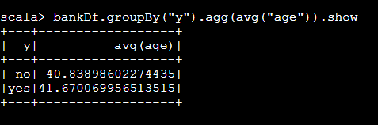

1. Check if marital status mattered for subscription to deposit.

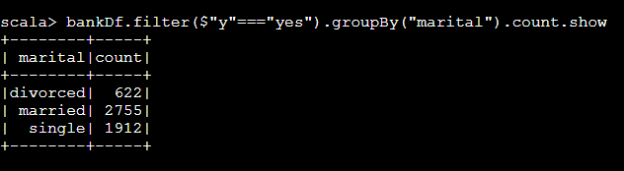

1. Check if age and marital status together mattered for subscription to deposit scheme

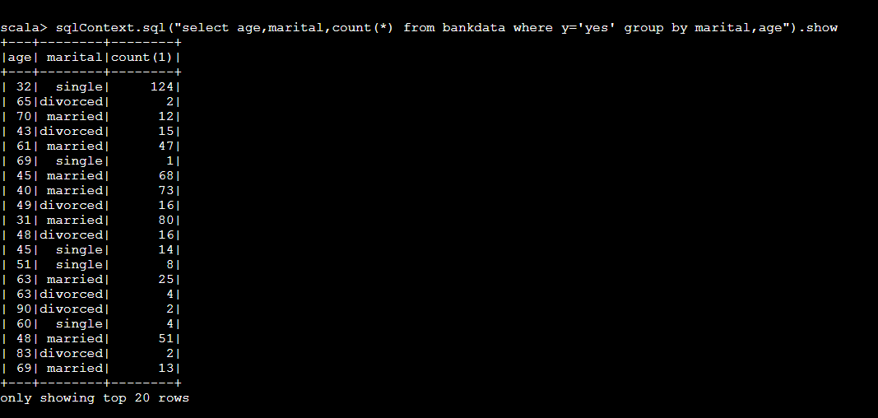

1. Do feature engineering for column—age and find right age effect on campaign

