**Recondition House Management System**

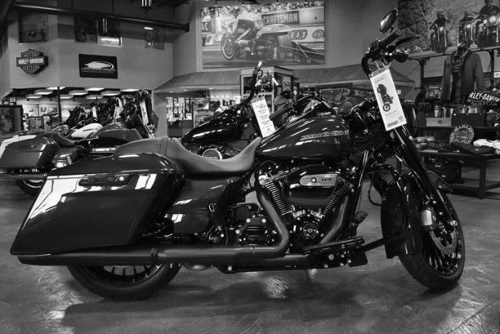

**Amit Pradhan**

**00172888**

**Computing Project**

**Level 5 Diploma in Computing**

**Email :** [amitpradhan195@gmail.com](mailto:amitpradhan195@gmail.com)

**Softwarica College of IT & E-Commerce**

***Kathmandu, Nepal***

01/27/2019

**Submitted to**: Kiran Rana

Table of Contents

Introduction: 3

Functional and Non-Functional: 3

Requirement Analysis: 4

USE CASE DIAGRAM 5

Initial Class Diagram 6

ER Diagram 7

Prototype: 8

UI Design: 12

Conclusion: 16

References 16

**List of Figures:**

Figure 1: Use Case Diagram 5

Figure 2: Initial Class Diagram 6

Figure 3: E-R Diagram 7

Figure 4: Login Page Prototype 8

Figure 5: Sign Up Page Prototype 8

Figure 6: Home Page Prototype 9

Figure 7: Gallery Page Prototype 9

Figure 8: Bookings Page Prototype 10

Figure 9: Categories Page Prototype 10

Figure 10: About Us Page Prototype 11

Figure 11: Admin Page Prototype 11

Figure 12: Home Page User Interface 12

Figure 13: Gallery Page User Interface 12

Figure 14: Bookings Page User Interface 13

Figure 15: Categories Page User Interface 13

Figure 16: About Us Page User Interface 14

Figure 17: Login User Interface 14

Figure 18: Sign Up User Interface 15

# Introduction:

In this document, I have analyzed the Functional and Non-Functional requirements, and filtered the requirements with MoSCoW Prioritization.

After completing the requirements analysis, I have started designing modeling such as Use Case Diagrams, Initial Class Diagrams, E-R Diagrams and Prototype. At last I have started designing UI design. In this phase, the tools that I have used are Star UML, Balsamiq and Mobirise for the outcome.

# Functional and Non-Functional:

Functional requirements are the requirements that specifies a particular behavior of function of the system when certain conditions are met .It defines what a system is supposed to do.

Non-Functional requirements are the requirements that specifies criteria that can be used to judge the operation of a system, rather than specific behaviors. It defines how a system is supposed to be. (Anon., n.d.)

In the below table, the functional and non-functional requirements are identified and then they are prioritized with MoSCoW prioritization.

Index used in the table below are:

**F**=Functional requirements

**NF**=Non-Functional requirements

**M**=Must Have

**S**=Should Have

**C**=Could Have

# Requirement Analysis:

|  |  |  |  |
| --- | --- | --- | --- |
| **S. No** | **Requirements** | **Functional or Non-Functional** | **MoSCoW** |
|  | User Login | **F** | **M** |
|  | Insert Item | **F** | **M** |
|  | Update Item | **F** | **S** |
|  | Delete Item | **F** | **S** |
|  | View Information | **F** | **M** |
|  | Book Item | **F** | **M** |
|  | Search Item | **F** | **S** |
|  | Purchase Item | **F** | **M** |
|  | Sell Item | **F** | **M** |
|  | Exchange Item | **F** | **M** |
|  | Registration | **F** | **M** |
|  | Home Page | **F** | **S** |
|  | Edit Profile | **F** | **S** |
|  | Gallery | **F** | **C** |
|  | User Review | **F** | **C** |
|  | Log Out | **F** | **M** |
|  | Generate Bill | **F** | **M** |
|  | Store Customer Information | **F** | **M** |
|  | Forgot Password | **F** | **C** |
|  | Slider | **F** | **C** |
|  | Contact Information | **F** | **S** |
|  | Visitor Counter | **F** | **C** |
|  | Store Bill | **F** | **M** |
|  | Manage Inventory | **F** | **M** |
|  | Authentication | **F** | **M** |
|  | Security | **NF** | **S** |
|  | Performance | **NF** | **S** |
|  | Availability | **NF** | **S** |
|  | Reliability | **NF** | **S** |
|  | Maintainability | **NF** | **S** |
|  | Usability | **NF** | **S** |
|  | Data Integrity | **NF** | **S** |
|  | Supportability | **NF** | **S** |

Table 1: Requirement Analysis Table

# USE CASE DIAGRAM

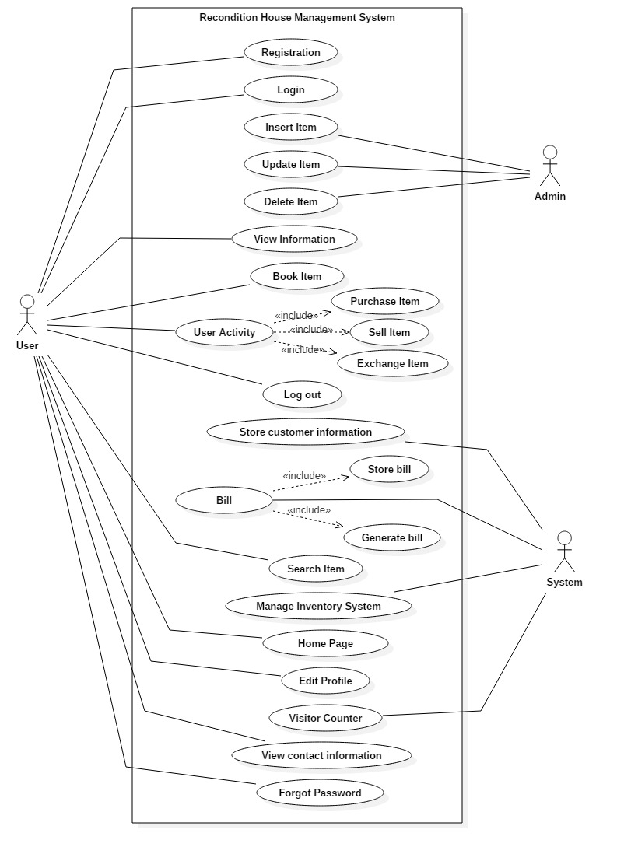

Figure 1: Use Case Diagram

# Initial Class Diagram

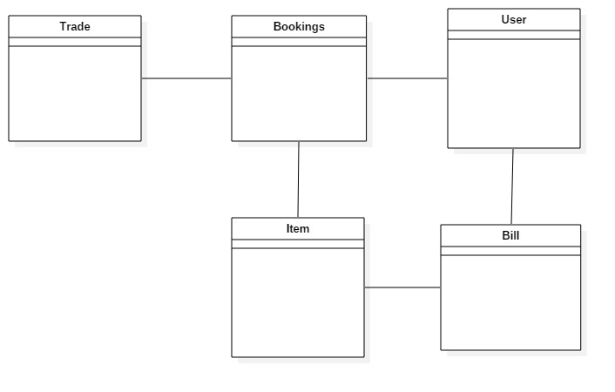

Figure 2: Initial Class Diagram

# ER Diagram

Figure 3: E-R Diagram

# Prototype:

1. **Login Page:**

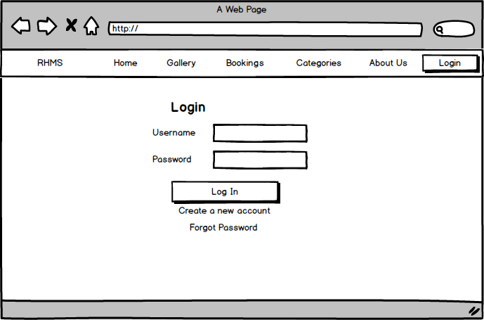

Figure 4: Login Page Prototype

1. **Sign Up Page:**

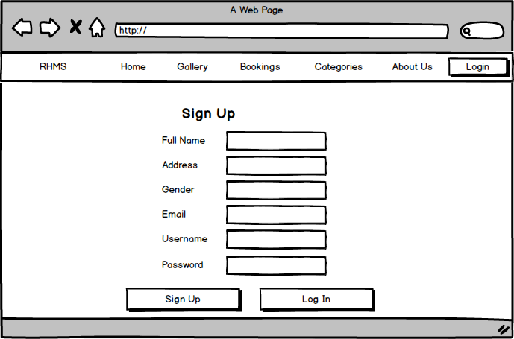

Figure 5: Sign Up Page Prototype

1. **Home Page:**

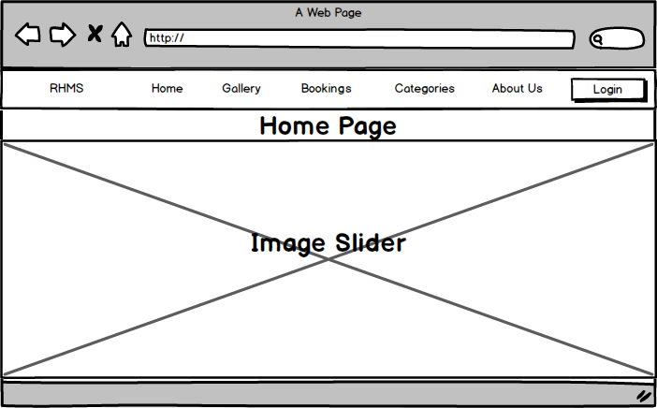

Figure 6: Home Page Prototype

1. **Gallery Page:**

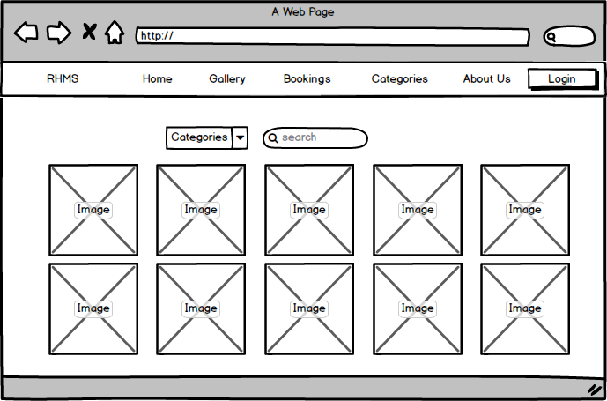

Figure 7: Gallery Page Prototype

1. **Bookings Page;**

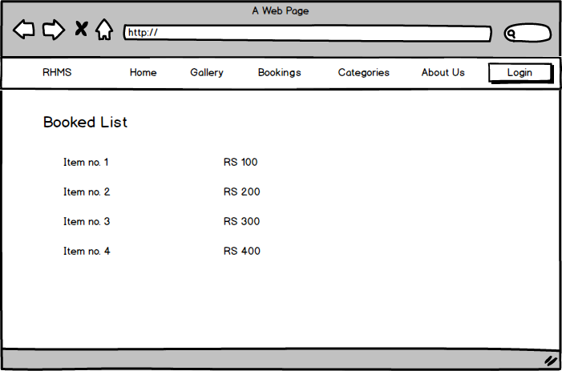

Figure 8: Bookings Page Prototype

1. **Categories Page:**

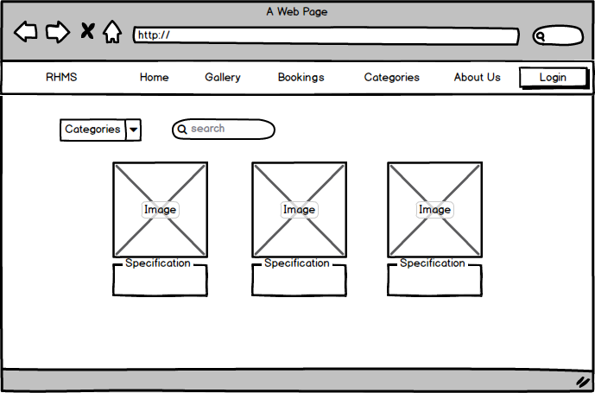

Figure 9: Categories Page Prototype

1. **About Us Page:**

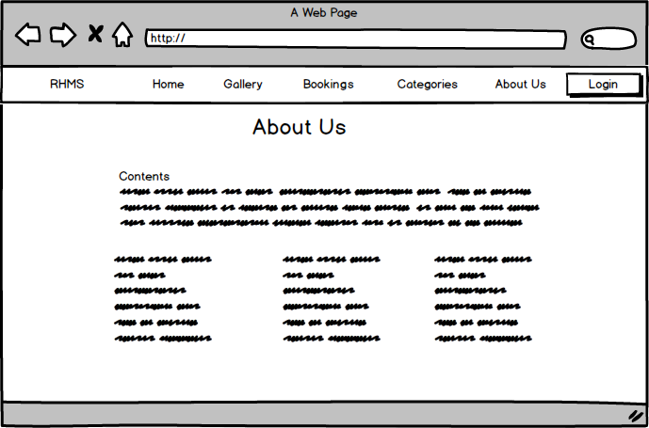

Figure 10: About Us Page Prototype

1. **Admin Page:**

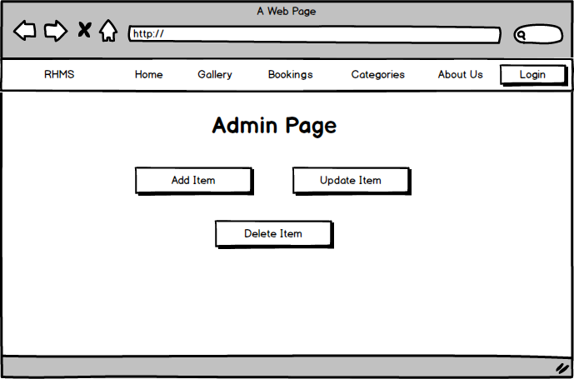

Figure 11: Admin Page Prototype

# UI Design:

1. **Home Page:**

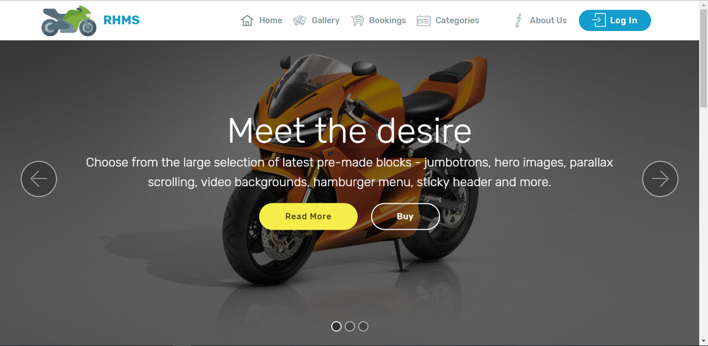

Figure 12: Home Page User Interface

1. **Gallery Page:**

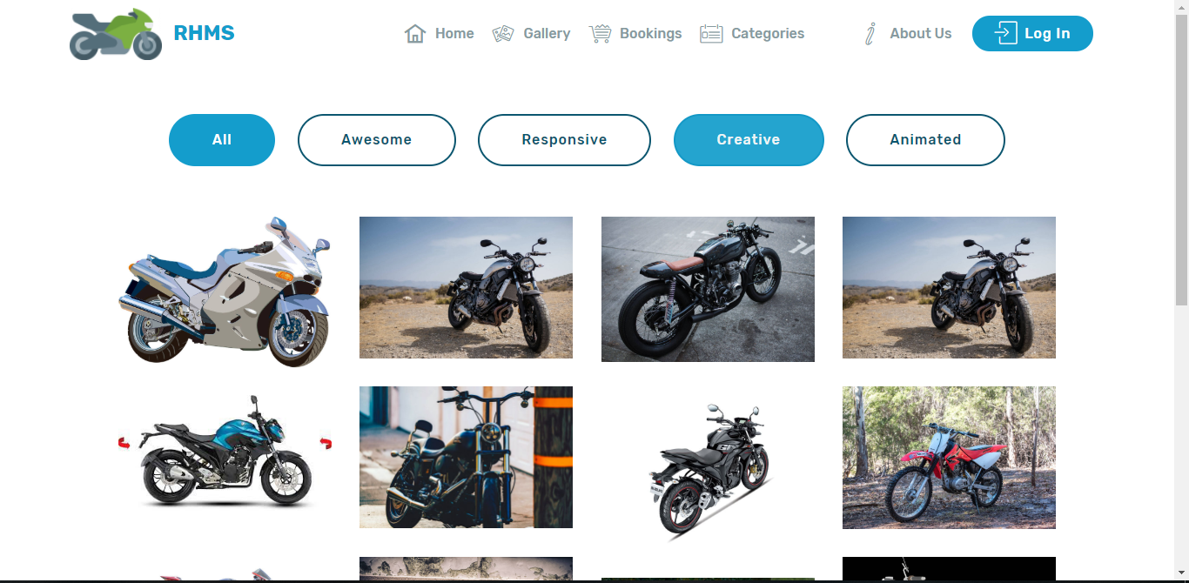

Figure 13: Gallery Page User Interface

1. **Bookings Page:**

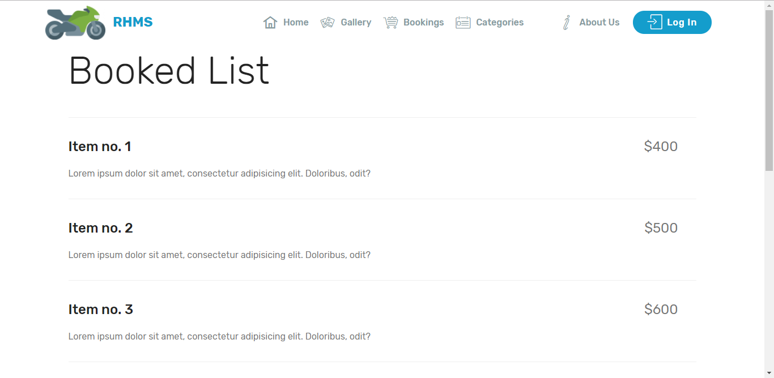

Figure 14: Bookings Page User Interface

1. **Categories Page:**

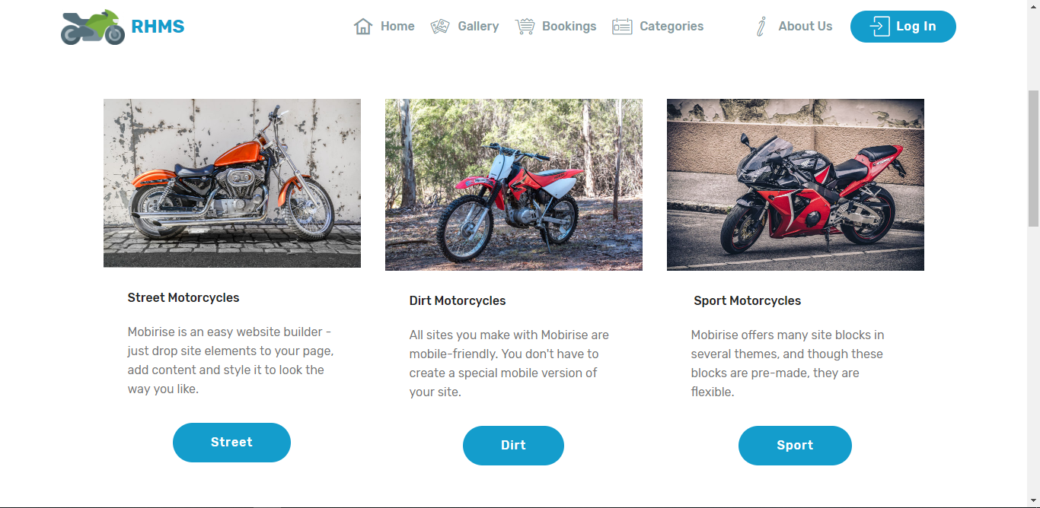

Figure 15: Categories Page User Interface

1. **About Us:**

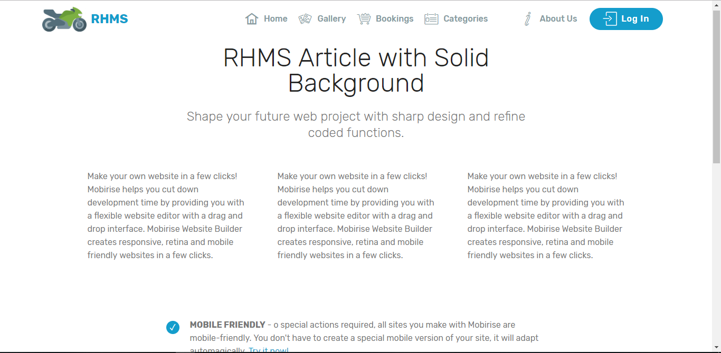

Figure 16: About Us Page User Interface

1. **Log In:**

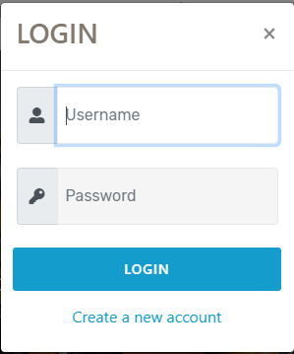

Figure 17: Login User Interface

1. **Sign Up:**

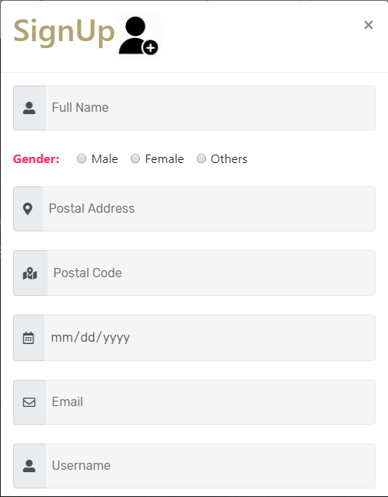

Figure 18: Sign Up User Interface

# Conclusion:

In this part, I have completed the analysis phase of developing software. In the completion of this phase, we have outcome the requirements, database model and user interface.

# References

Anon., n.d. *stack overflow.* [Online]   
Available at: https://stackoverflow.com/questions/16475979/what-is-the-difference-between-functional-and-non-functional-requirement