Project Proposal

On

**Recondition House Management System**



**Amit Pradhan**

**00172888**

**Computing Project**

**Level 5 Diploma in Computing**

**Email :** [amitpradhan195@gmail.com](mailto:amitpradhan195@gmail.com)

**Softwarica College of IT & E-Commerce**

***Kathmandu, Nepal***

01/04/2019

**Submitted to**: Kiran Rana

Table of Contents

List of figures: 3

1. Introduction 4

1.1 Project Introduction: 4

1.2 Justification for project 4

1.2.1 Background of the project: 4

1.2.2 Problem Statement: 4

1.3 Description of the project 5

1.3.1 Features 5

2. Project Scope 5

2.1 Scope and Limitation of project 5

2.2 Aims and Objectives 6

2.2.1 Aims 6

2.2.2 Objectives 6

3. Development Methodology 6

3.1 Methodology used 6

3.2 Design Pattern 8

3.3 System Architecture 8

4. Work Breakdown Structure (WBS) / Scheduling 9

4.1 Work Breakdown Structure (WBS): 9

4.2 Milestones 10

4.3 Description of Milestones: 11

4.4 Scheduling/Gantt Chart: 12

5. Risk Management: 14

6. Configuration Management: 15

7. Conclusion: 16

8. References: 17

# List of figures:

Figure 1 : Waterfall Model Approach 7

Figure 2: MVC pattern with Laravel framework 8

Figure 3: 3-tier Architecture 8

Figure 4 : Work Breakdown Structure 9

Figure 5: Milestones 10

Figure 6 : Time Schedule 12

Figure 7: Gantt chart 13

Figure 8: Risk likelihood values Dawson 2005 14

Figure 9: Risk consequence values Dawson 2005 14

Figure 10: Risk management table 14

Figure 11: Directory Folders 15

Figure 12: Directory Structure 15

# Introduction

## Project Introduction:

The project is about managing and recording the data of transaction process system in the organization. Though the name of the project is “Recondition House Management System”. But the name of the website will be AOS (Automobiles Online Store).

It is a web-based application designed for providing online services to the clients. The product will be capable of keeping all the records systematically and provides access to the records when needed.

## Justification for project

### Background of the project:

The product is designed to make the organization’s transaction process (business activity) easier, faster, and more efficient. This project will outcome the application that manages and provides a services of record keeping system about buyers, sellers, stocks, transactions etc. Online services is provided to increase the interaction between the clients. Bikes, Cars, Spare Parts, Accessories etc. are some of the items that will be included in the online products.

For the development of this software, I will be working on PHP (Hypertext Preprocessor) using Laravel framework, My SQL for managing the database and Sublime Text 3 (Editor) for developing the software.

### Problem Statement:

Clients will have direct interaction which keeps agents (brokers) away. Clients will have more options or favor according to their desire. Clients do not have to worry about prices (bargain) because all the prices will be reasonable and included as not negotiable. Solving all the problems matters in order to build trust with the clients.

The propose of choosing this project is the concept regarding this project is more clear to me because I had worked on the same project as desktop application on my previous years. Now I am developing it as web-based application.

Now let’s talk about income. First of all, we have to invest certain amount of money for developing this product and for digital marketing. After that, we can get profit from the product with various ways such as Advertisement, Promoting products as an affiliate, selling own product.

## Description of the project

### Features

Some main features of the software are:

* **User Login:**

It includes admin login and member login. Admin will have full permission on application whereas member will have limited permission.

* **Point of Buy, Sell and Exchange management :**

It processes payments, receipts and amount to be added. Records all the deals and ensures transactions completes correctly, adjusts inventory, prints receipts etc.

* **Inventory Control :**

Manage the inventory system automatically as per purchase, sale and Exchange.

* **Customer Management :**

Stores the customer information and data.

* **Security :**

Correct username and password is required for the transaction or data access. Also, optimize the security and validation of the number of purchase, sales and exchange.

* **Data Inquiry :**

Use less time for data access and easier to find information.

* **Booking system:**

Customer can book the items they want.

# Project Scope

## Scope and Limitation of project

Well now a days, online marketing is being more effective and efficient. Clients are more focused on this project. This product helps to increase the direct interaction between the clients. Clients can know the information online from wherever they want.

The features that the product will not contain is online payment system because we have cash on delivery system.

## Aims and Objectives

### Aims

The main aims of my project to automatize the inventory management system and to provide online services of buy, sell and exchange.

### Objectives

Some objectives of the project are listed below to achieve the desired goals or aim.

1. Proper analysis on the market situation
2. Providing online services to the clients
3. Creating attractive design (GUI)
4. Meeting the requirement
5. Designing secure Database
6. Performing proper Testing
7. Performing Maintenance

# Development Methodology

## Methodology used

For the development of this project, I have chosen Waterfall Model method. It is very simple to understand and use. In this model, each phase must be completed before the next phase can begin and there is no overlapping in the phases. **Hence, I chose this method because** Waterfall model works well where requirements are very well understood.(Waterfall Model, n.d.)

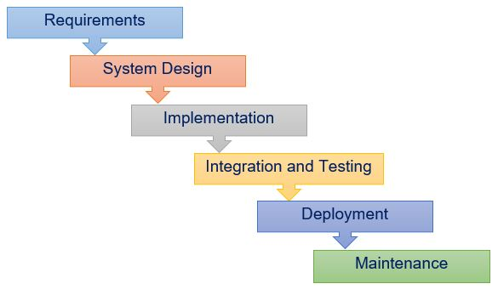

Figure 1 : Waterfall Model Approach

**Requirements:** All the possible requirements are analyzed and documented for the system to be developed for the software.

**System Design:** The system design is prepared or documented according to the specification of requirements analysis.

**Implementation:** Each unit is developed and tested for its functionality which is referred to as Unit Testing.

**Testing:** All the units developed in the implementation phase are integrated into a system after testing of each unit. The product is tested to find the bugs or issues and solves them.

**Deployment:** Once the functional and non-functional testing is done, the product is deployed in the customer environment or released into the market.

**Maintenance:** Modifications arises either due to change requests initiated by the customer, or defects uncovered during live use of the system.

## Design Pattern

In this project I will be working on MVC (Model-View-Controller) design pattern using PHP (Laravel) framework. Model to represent an objects, view to represent the visualization of the data that model contains and controller to control the data flow into model object and updates the view whenever data changes. The MVC pattern with Laravel framework functions as shown below (https://www.codecademy.com/articles/mvc, n.d.):

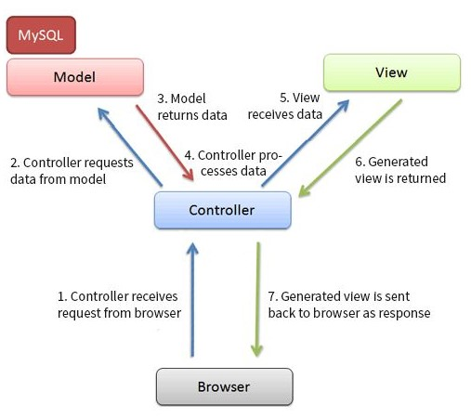

Figure 2: MVC pattern with Laravel framework

## System Architecture

I am going to use 3-tier architecture in this project. It separates the application into three major parts UI, Business Logic and Data Storage.

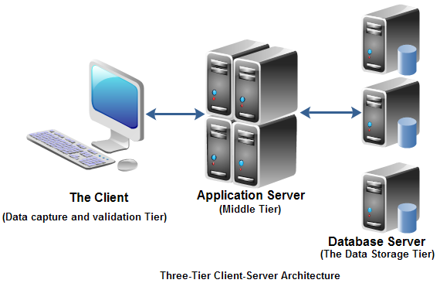

Figure 3: 3-tier Architecture

# Work Breakdown Structure (WBS) / Scheduling

Here, the project plan is described and shown in various ways. Microsoft word 2013, Project Libre 1.8 etc. are used for project plan.

## Work Breakdown Structure (WBS):

WBS is a hierarchical and incremental decomposition of the project into phases, deliverables and work packages. It is a tree structure, which shows a subdivision of effort required to achieve an objective (wikipedia, n.d.). A work breakdown structure helps to plan my work more efficiently.

Figure 4 : Work Breakdown Structure

## Milestones

|  |  |  |  |  |
| --- | --- | --- | --- | --- |
| **S. N** | **Task** | **Start Date** | **End Date** | **Days** |
| 1.  1.1  1.2  1.3  1.4 | **Project Management**  Risk Management  WBS  Configuration Management  Proposal Submission | 12/21/18  12/21/18  12/26/18  12/29/18  1/2/19 | 1/4/19  12/25/18  12/28/18  1/1/19  1/3/19 | **14**  5  3  4  2 |
| 2.  2.1  2.2  2.3  2.4 | **Analysis**  Requirement analysis  Use Case  Architecture  Analysis Specification | 1/4/19  1/4/19  1/12/19  1/15/19  1/20/19 | 1/28/19  1/11/19  1/14/19  1/19/19  1/28/19 | **25**  8  3  5  9 |
| 3.  3.1  3.2  3.3  3.4 | **Design**  Structural Model  Behavioral Model  UI Design  Database Design | 1/29/19  1/29/19  2/2/19  2/8/19  2/20/19 | 2/27/19  2/1/19  2/7/19  2/19/19  2/27/19 | **30**  4  6  12  8 |
| 4.  4.1  4.2 | **Implementation**  Building Database  Coding | 2/28/19  2/28/19  3/8/19 | 3/31/19  3/7/19  3/31/19 | **32**  8  24 |
| 5.  5.1  5.2  5.3  5.4 | **Testing**  Unit Testing  Integration Testing  Black box Testing  White box Testing | 4/1/19  4/1/19  4/3/19  4/5/19  4/8/19 | 4/12/19  4/2/19  4/4/19  4/7/19  4/12/19 | **12**  2  2  3  5 |
| 6.  6.1  6.2 | **Deployment**  User Training  Final Report | 4/13/19  4/13/19  4/19/19 | 4/22/19  4/18/19  4/22/19 | **10**  6  4 |
| **Total Days** | | |  | **123** |

Figure 5: Milestones

## Description of Milestones:

|  |  |
| --- | --- |
| **Activity** | **Estimate** |
| **Project Management**  Risk Management  WBS  Configuration Management  Proposal Submission | **14 days**  5 days  3 days  4 days  2 days |
| **Analysis**  Requirement  Use Case  Architectural (Initial Class Diagram)  Analysis Specification | **25 days**  8 days  3 days  5 days  9 days |
| **Design**  Structural model  Behavioral model  UI Design  Database Design | **30 days**  4 days  6 days  12 days  8 days |
| **Implementation**  Build Database  Coding | **32 days**  8 days  24 days |
| **Testing**  Unit Testing  Integration Testing  Black box Testing  White box Testing | **12 days**  2 days  2 days  3 days  5 days |
| **Deployment**  User Training  Final Report | **10 days**  6 days  4 days |
| **Total** | **123 days** |

Table 1: Time Estimation

## **Scheduling/Gantt Chart:**

The time schedule for my project is represented in a diagram of Gantt chart with milestones.

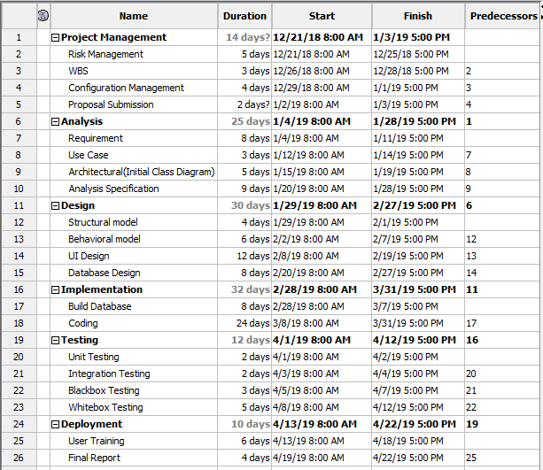

Figure 6 : Time Schedule

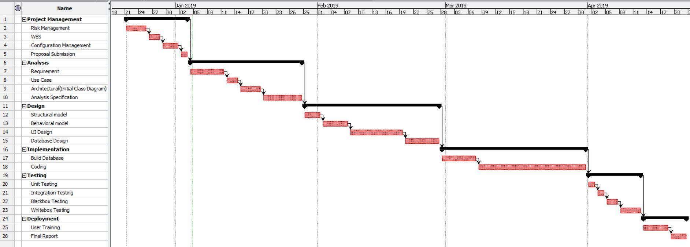

Figure 7: Gantt chart

# **Risk Management:**

Nothing is secure in the internet today. There are various types of threats or risks in using the internet. Some of the risks are identified that can be with my product are listed below using tabular form.

To estimate the impact of each identified risks we use:

***Impact = Likelihood × Consequence***

In this relation, the likelihood and consequence values are assigned based on the scale shown below:

|  |  |
| --- | --- |
| **Likelihood** | **Value** |
| Low | 1 |
| Medium | 2 |
| High | 3 |

Figure 8: Risk likelihood values Dawson 2005

|  |  |
| --- | --- |
| **Consequences** | **Value** |
| Very Low | 1 |
| Low | 2 |
| Medium | 3 |
| High | 4 |
| Very High | 5 |

Figure 9: Risk consequence values Dawson 2005

|  |  |  |  |  |  |
| --- | --- | --- | --- | --- | --- |
| **S. No** | **Risk** | **Likelihood** | **Consequences** | **Impact** | **Action** |
|  | Ransomware | 1 | 5 | 5 | Proper data Backup System. |
|  | Denial of service attack | 2 | 4 | 8 | Deployment of reputable antivirus and firewall |
|  | Server failure | 2 | 3 | 6 | Suitable environment |
|  | Phishing | 2 | 2 | 4 | Awareness and use of anti-phishing tools. |
|  | Insecure third party services | 3 | 3 | 9 | Use of cryptography. |
|  | Disk crash | 2 | 4 | 8 | Appropriate disk and proper backup. |
|  | Insufficient Features | 1 | 2 | 2 | Proper analysis is to be done. |

Figure 10: Risk management table

# **Configuration Management:**

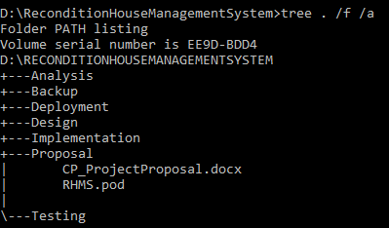The process of keeping and tracking the detail data, so the updates can flow with the existing project. Files and folder should be safely stored in a systematic order, so that it can be easily excessed whenever we need to. When configuration management is done, the consistency of the projects becomes better. The given figure shows the configuration management of my project:

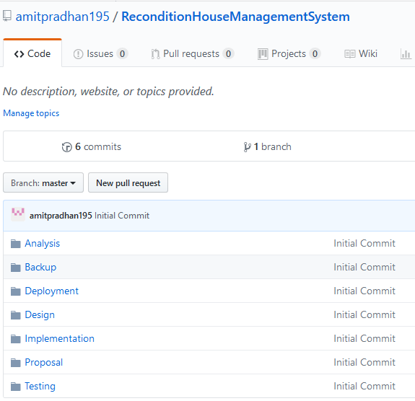Figure 12: Directory Structure

Figure 11: Directory Folders

# Conclusion:

The proposal defines all the requirements and plans about the project that provides an online services to allow book products, manage products stocks, and distribute relevant information about the products inventory.

The project aims to give better performance and security in record management system and provide access to the data or information when needed. Also reduces the time for the record operation and decreases the efficiency of loss.

# References:

* (n.d.). Retrieved from https://www.codecademy.com/articles/mvc.
* *Waterfall Model*. (n.d.). Retrieved from Toolsqa: http://toolsqa.com/software-testing/waterfall-model/
* *wikipedia*. (n.d.). Retrieved from https://en.wikipedia.org/wiki/Work_breakdown_structure.