1. **Introduction**

This project contains several parts:

1. Code. It contains the source code of the Engine/External Libraries/Tool sets/Game Project. It also contains the Property Sheets I used in the Project.
2. Assets. It contains the assets I used in the Game, includes Mesh/Texture/Shader/Effect/Material…  
   These assets are “raw” assets and should be processed by the
3. Scripts. It contains the information of the Assets we will build for the Game Project.   
   It also contains a script to build the assets.   
   In the future, the scene information scripts will also be added at here.
4. The files for Visual Studio 2015 and Git.
5. **How to Build the Project**

Like the figure above:

1. Please Build the “Game/BuildAssets” project.

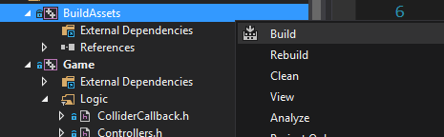

This step will generate the assets to the path: $ProjectDirt/temp/$Platform/$Configuration/game/

We will get the optimized assets we will use in the Game.

2. Change the setting of Debugging in the Game Project Property:

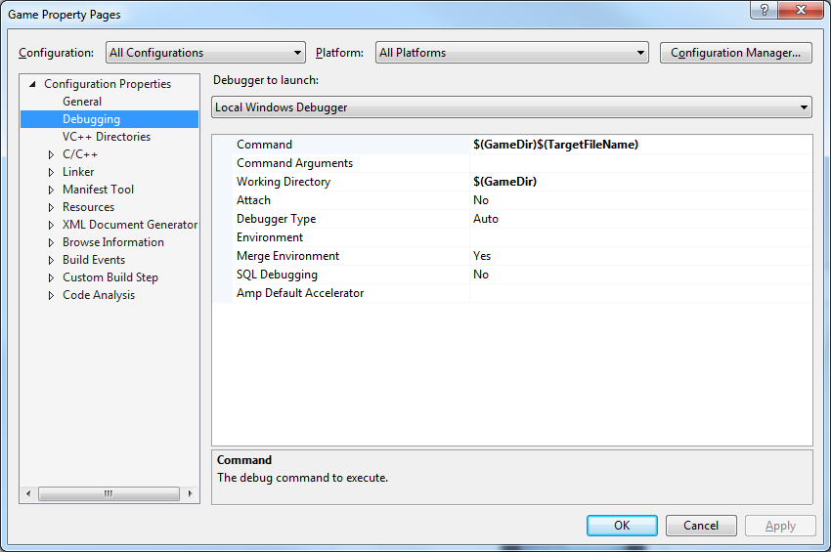

We need to tell the Visual Studio to use the target under the $ProjectDirt/temp/$Platform/$Configuration/game/, but the one under the $ProjectDirt/temp/$Platform/$Configuration/bin/.

Then, please build the “Game/Game” Project

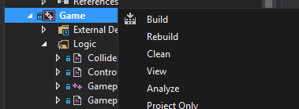

If everything is correct, when you run the Game project, you will see the correct result of game:

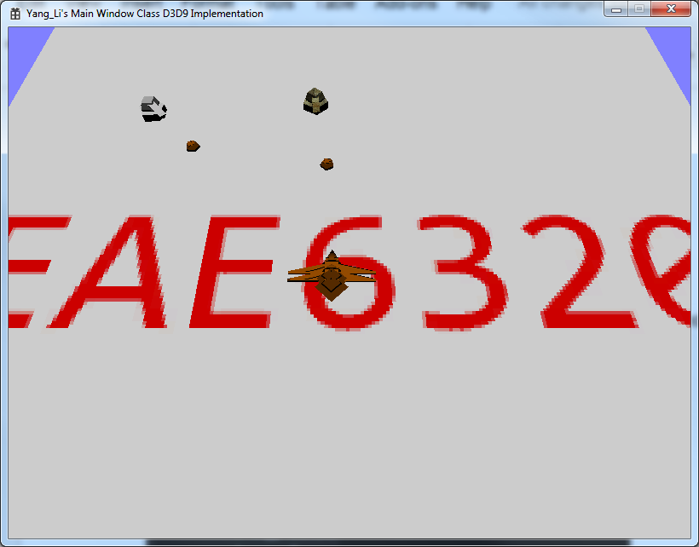

1. **More About the Project**

Please this [blog](https://sites.google.com/site/eae6320forleo/) for the detail of this project.

Thanks so much for your patience.

Leo