1. Top Menu need similar to https://yantratools.com/  
   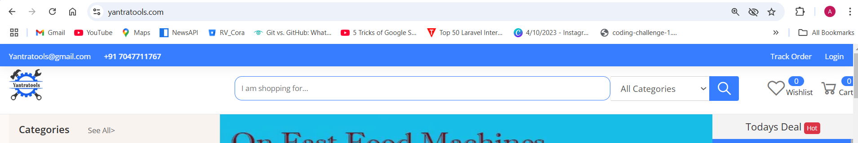
2. Scroll menu drop down sub sub category not showing properly
3. Side not fully fit in a screen scroller is there.
4. Product details page should quite similar to below screen. Content are same like yantratools  
   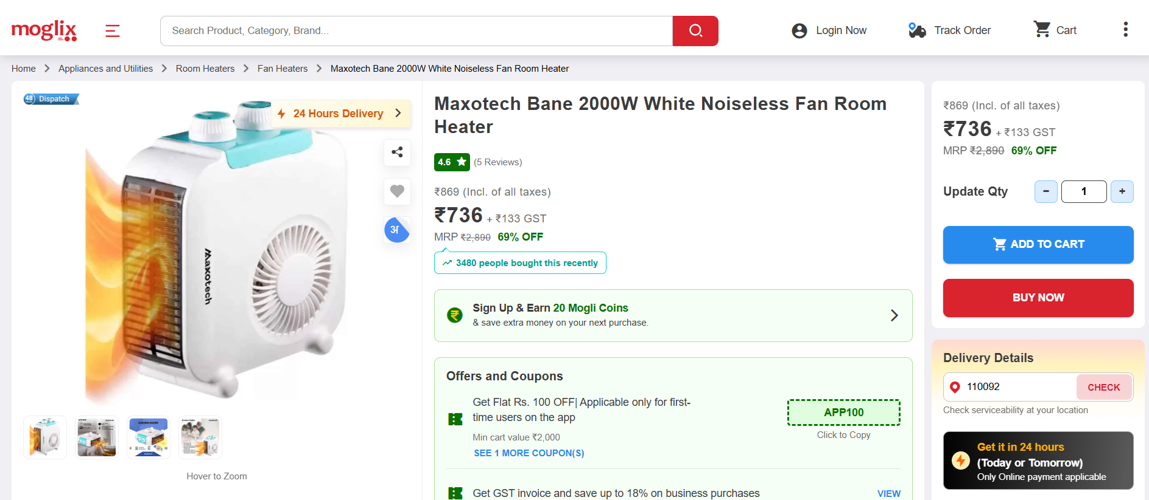
5. Bottom section is not a feature product it should similar products.
6. Review list then review form
7. Checkout page need + and – provision and form need to update  
   form fields are similar with below screen and payment options are similar with below option currently on COD other option will add later.  
   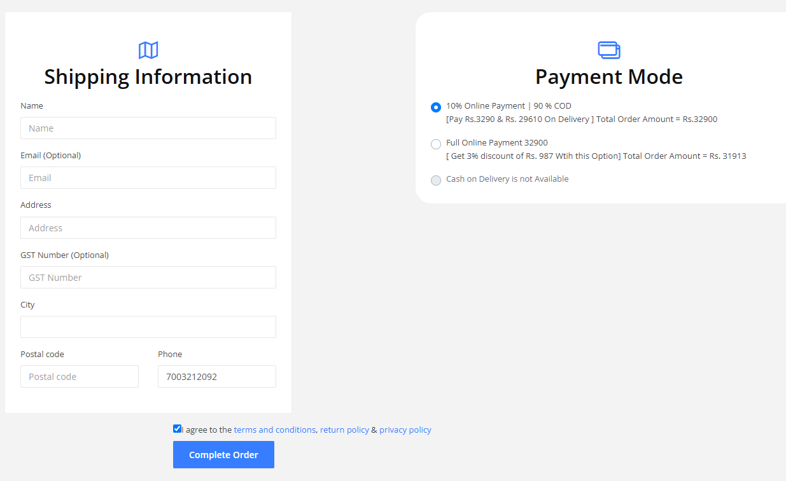
8. Thank you page
9. My account page (Dashboard, Orders, Wishlist, Profile)
10. Search Pages need to design fixing, Top scroll menu not showing properly

* Pagination not working (Need Infinite Scroll here)
* Other functionality like home page
* Left Searching and top searching should work properly