**1. Create news and store in data base.**

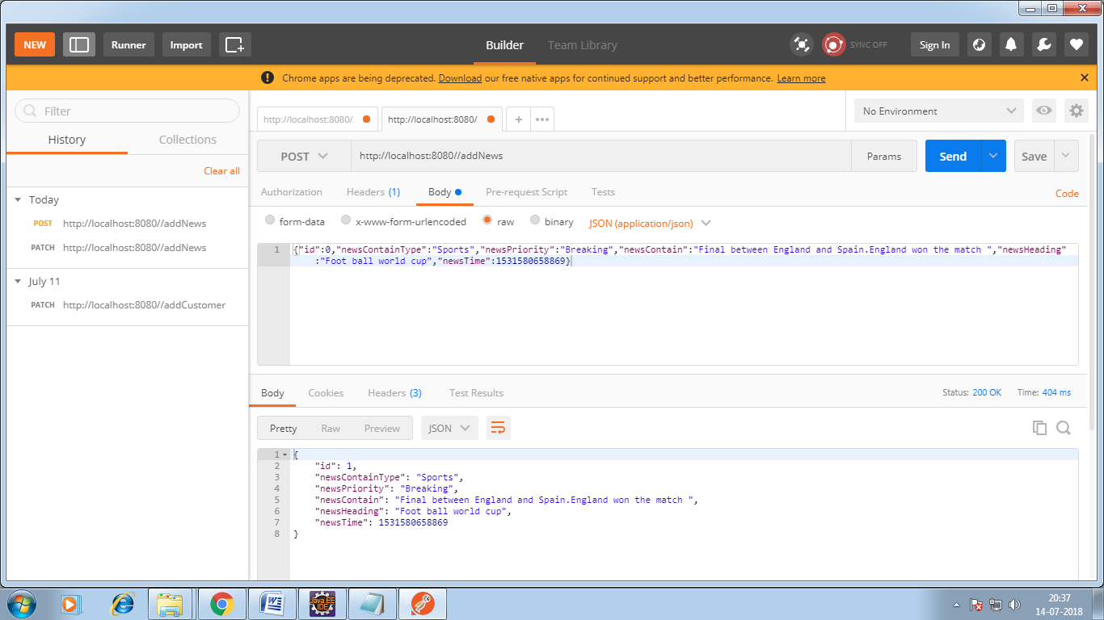

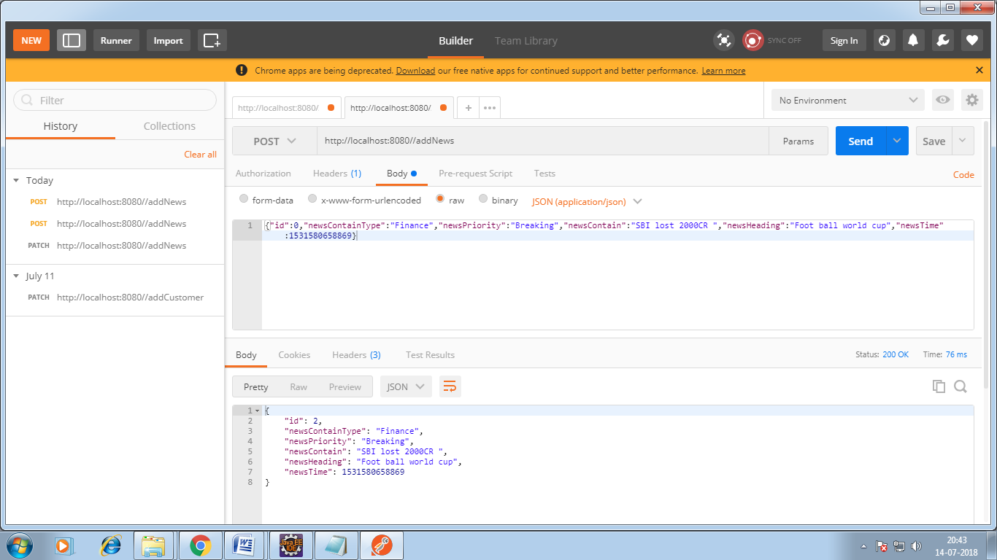

**2. Get all news to display on screen.**

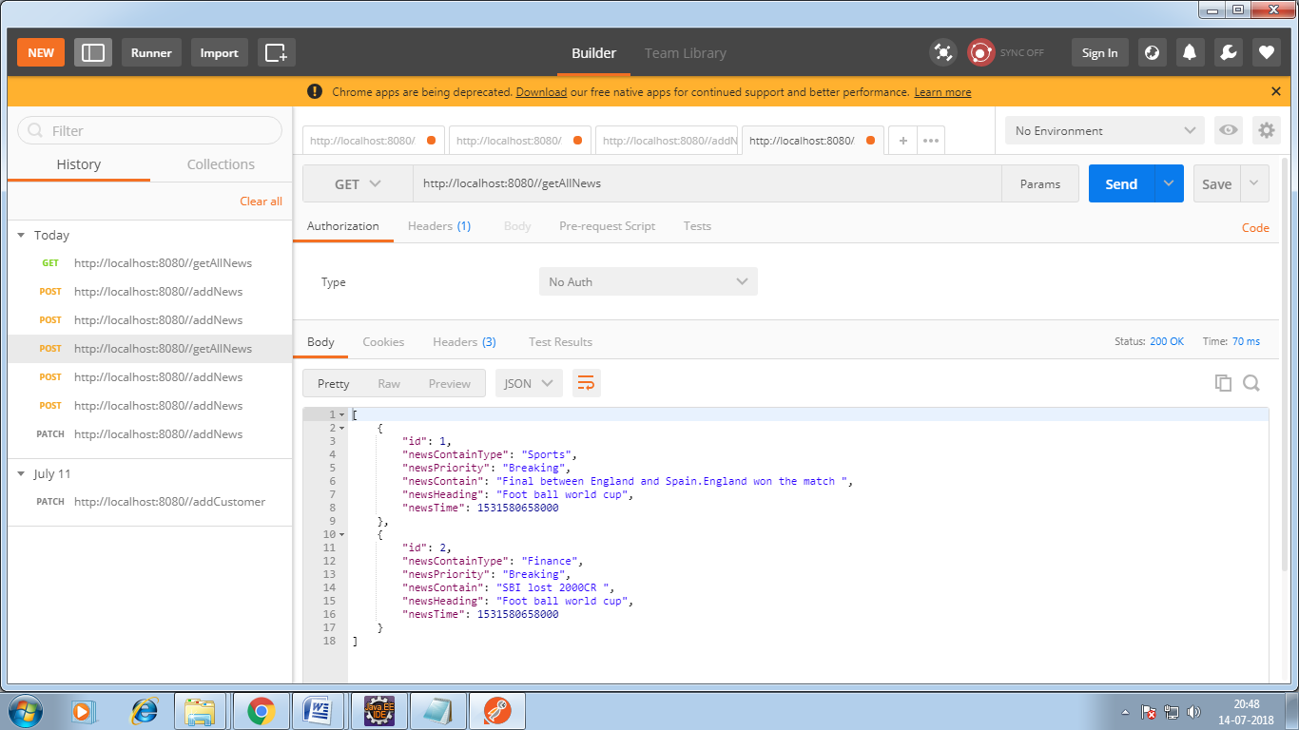

3. Implemented cash by using spring boot so No data base call every time. Spring cache implementation.

