WEB CRAWLER

Report submitted in partial fulfillment of the requirement for the degree of

B.Tech

in
Computer Science & Engineering


Under the supervision

of
Mr CM Sharma
Head of Dept.

by:-
Akshay Goel (016-CSE-A)
RachitAgrawal (005-CSE-A)
Rahul Nauni (013-CSE-A)
Sachit Verma (004-CSE-A) .

Department of Information Technology
Bhagwan Parshuram Institute of Technology
PSP-4, Sec-17, Rohini, Delhi-89
November 2016

DECLARATION

This is to certify that Report titled “What’s Nearby”, is submitted by us in partial fulfillment of the requirement for the award of degree B.Tech. in Computer Science & Engineering to BPIT, GGSIP University, Dwarka, Delhi. It comprises of our original work. The due acknowledgement has been made in the report for using others work.

Date: Akshay Goel-01620802713
Sachit Verma-00420802713
Rachit Agrawal-00520802713
Rahul Nauni-01320802713

Certificate by Supervisor

This is to certify that Report titled “What’s Nearby” is submitted by Akshay Goel, Sachit Verma, Rachit Agrawal, Rahul Nauni in partial fulfillment of the requirement for the award of degree B.Tech in Information Technology to BPIT, GGSIP University, Dwarka, Delhi. It is a record of the candidates own work carried out by them under my supervision. The matter embodied in this Report is original and has not been submitted for the award of any other degree.

Date: Supervisor

Certificate by HOD

This is to certify that Report titled “What’s Nearby” is submitted by, Akshay Goel, Sachit Verma, Rachit Agrawal, Rahul, Nauni under the guidance of Mr CM Sharma in partial fulfillment of the requirement for the award of degree B.Tech in Information Technology to BPIT, GGSIP University, Dwarka, Delhi. The matter embodied in this Report is original and has been dully approved for the submission.

Date: Dr. Deepali Virmani

ACKNOWLEDGEMENT

We have taken efforts in this project. However, it would not have been possible without the kind support and help of many individuals and organizations. We would like to extend our sincere thanks to all of them. We are highly indebted to our supervisor Mr. CM Sharma for his guidance and constant supervision as well as for providing necessary information regarding the project & also for their support in completing the project.
We would like to express our gratitude towards our parents for their kind co-operation and encouragement which helped us in completion of this project.
We would like to express our special gratitude and thanks to industry persons for giving us such attention and time.
Our thanks and appreciations also go to our colleague in developing the project and people who have willingly helped us out with their abilities
Akshay Goel
Sachit Verma
Rachit Agrawal
Rahul Nauni

LIST OF FIGURES

Fig No. Figure Name Page

1. Application xv

2. Screen Shot xxii

3. Screen Shot xxiii

4. Screen Shot xxiv

5. Screen Shot xxv

6. Location Use Case xxvii

7. weather Use Case xxviii

8. State Diag L

Content
PAGE NOS.

Abstract I

Chapter 1 : Introduction
Chapter 2 : Related Work
Chapter 3 : System Analysis and Design
3.1 : Software Requirement Specifications
3.2 : Use Case Diagrams
3.3 : Flow Chart/ Activity
Chapter 4 : Related code
Chapter 5 : Results
Chapter 6 : Future Work

REFERENCES

ABSTRACT

This Web Application allows web users to locate the places near the user using his GPS location or the user could enter the place manually all over the world.
This web application requires an Internet connection for using this application. Hence it comes in handy for searching nearby places and for traveling conveyance. This whole project has been designed using Google Api, Javascript, Html, Css.
This application demonstrates all the fundamental location map’s API capabilities such as finding shortest path, providing best service as per user satisfaction, showing accurate temperature which suggest user whether to visit the place.

.

i

Chapter 1

INTRODUCTION

1. INTRODUCTION

What’s Nearby is an android app that locates the nearby location of the user with weather update of that particular area. Integration of weather updates with nearby location make this app special for a user as one don’t switch to the other app in search of weather update where the user wants to go. Here present weather is simultaneously updated when the user search for the location with the help of GPS and Internet obvious.

1.1 WHAT IS ANDROID?

Android is a mobile operating system (OS) based on the Linux kernel and currently developed by Google. With a user interface based on direct manipulation, Android is designed primarily for touchscreen mobile devices such as smartphones and tablet computers, with specialized user interfaces for televisions (Android TV), cars (Android Auto), and wrist watches (Android Wear). The OS uses touch inputs that loosely correspond to real-world actions, like swiping, tapping, pinching, and reverse pinching to manipulate on-screen objects, and a virtual keyboard. Android's source code is released by Google under open source licenses, although most Android devices ultimately ship with a combination of open source and proprietary software, including proprietary software developed and licensed by Google. Initially developed by Android, Inc., which Google bought in 2005,Android was unveiled in 2007, along with the founding of the Open Handset Alliance – a consortium of hardware, software, and telecommunication companies devoted to advancing open standards for mobile devices.

1.2 ABOUT JAVA

Java is a general-purpose computer programming language that is concurrent, class-based, object-oriented, and specifically designed to have as few implementation dependencies as possible. It is intended to let application developers "write once, run anywhere” (WORA), meaning that compiled Java code can run on all platforms that support Java without the need for recompilation. Java applications are typically compiled to byte code that can run on any Java virtual machine (JVM) rticularly for client-server web applications, with a reported 9 million developers. Java was originally developed by James Gosling at Sun Microsystems (which has since been acquired by Oracle Corporation) and regardless of computer architecture.
As of 2015, Java is one of the most popular programming languages in use, pareleased in 1995 as a core component of Sun Microsystem platform.
2. ANDROID ARCHITECTURE
4.1 Application
4.2 Application Framework
4.3 Native Libraries (Runtime + DVM (Dalvik Virtual Machine))
4.4 Linux Kernel
2.1. Applications
You will find all the Android application at the top layer. You will write your application to be installed on this layer only. Examples of such applications are Contacts Book Browser, Games, etc.
2.2. Application Framework
The Application Framework layer provides many higher-level services to applications in the form of Java classes. Application developers are allowed to make use of these services in their applications.
The Android framework includes the following key services −
- Activity Manager − Controls all aspects of the application lifecycle and activity stack.
- Content Providers − Allows applications to publish and share data with other applications.
- Resource Manager − Provides access to non-code embedded resources such as strings, color settings and user interface layouts.
- Notifications Manager − Allows applications to display alerts and notifications to the user.
- View System − an extensible set of views used to create application user interfaces.

2.3. Libraries
On top of Linux kernel there is a set of libraries including open-source Web browser engine WebKit, well known library libc, SQLite database which is a useful repository for storage and sharing of application data, libraries to play and record audio and video, SSL libraries responsible for Internet security etc.
2.31 Android Libraries
This category encompasses those Java-based libraries that are specific to Android development. Examples of libraries in this category include the application framework libraries in addition to those that facilitate user interface building, graphics drawing and database access. A summary of some key core Android libraries available to the Android developer is as follows −
- Android.app − Provides access to the application model and is the cornerstone of all Android applications.
- android.content − Facilitates content access, publishing and messaging between applications and application components.
- android.database − Used to access data published by content providers and includes SQLite database management classes.
- android.opengl − A Java interface to the OpenGL ES 3D graphics rendering API.
- android.os − Provides applications with access to standard operating system services including messages, system services and inter-process communication.
- android.text − Used to render and manipulate text on a device display.
- android.view − The fundamental building blocks of application user interfaces.
- android.widget − A rich collection of pre-built user interface components such as buttons, labels, list views, layout managers, radio buttons etc.
- android.webkit − A set of classes intended to allow web-browsing capabilities to be built into applications.
Having covered the Java-based core libraries in the Android runtime, it is now time to turn our attention to the C/C++ based libraries contained in this layer of the Android software stack.

2.32. Android Runtime

This is the third section of the architecture and available on the second layer from the bottom. This section provides a key component called Dalvik Virtual Machine which is a kind of Java Virtual Machine specially designed and optimized for Android.
The Dalvik VM makes use of Linux core features like memory management and multi-threading, which is intrinsic in the Java language. The Dalvik VM enables every Android application to run in its own process, with its own instance of the Dalvik virtual machine.
The Android runtime also provides a set of core libraries which enable Android application developers to write Android applications using standard Java programming language.
2.4. Linux Kernel
At the bottom of the layers is Linux - Linux 3.6 with approximately 115 patches. This provides a level of abstraction between the device hardware and it contains all the essential hardware drivers like camera, keypad, display etc. Also, the kernel handles all the things that Linux is really good at such as networking and a vast array of device drivers, which take the pain out of interfacing to peripheral hardware.

.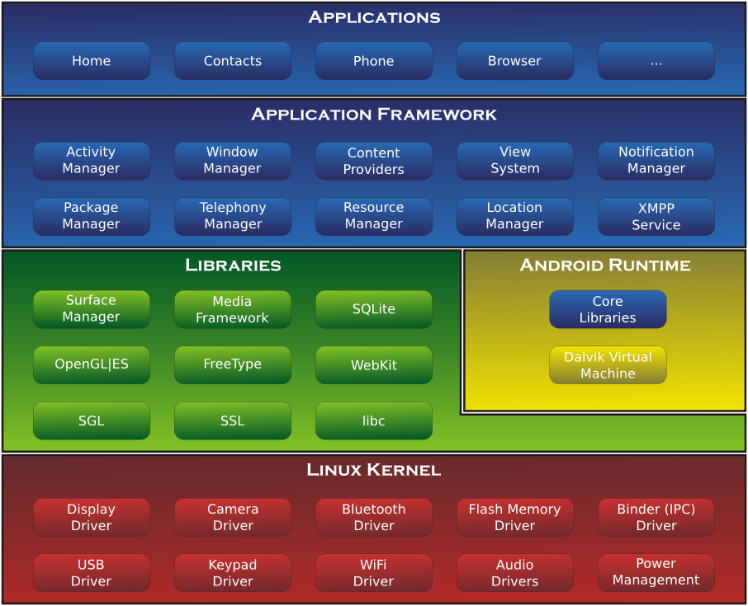

Fig: i

Chapter 2:

RELATED WORK

2. Process of How “What’s Nearby” Application Works :
- Initially the user could either enter the place of his choice in the search bar or he could let the app decide itself by switching on the GPS.
- When the user has finalized a particular place, the next screen that would pop up will contain categories like restaurants, malls, theatre, etc. and the user could choose any one of them.
- Then based on the category the app would list all the related places in the succeeding screen.
- The app would also show the weather forecast of the city.

2.1. Minimum requirements for developing an android application includes:
5.1 J2SE 5.0 or higher.
5.2 Integrated Development Environment (IDE).
5.3 Android Development Tools (ADT).
5.4 Software Development Kit (SDK).
2.1.1 J2SE 5.0
Codename Tiger. Originally numbered 1.5, which is still used as the internal java version number. The number was changed to "better reflect the level of maturity, stability, scalability and security of the J2SE.J2SE 5.0 entered its end-of-public-updates period on April 8, 2008; updates are no longer available to the public as of November 3, 2009. Updates were available to paid Oracle customers until May 2015.
Tiger added a number of significant new language features:
- Generics: Provides compile-time (static) type safety for collections and eliminates the need for most type casts(type conversion)
- Metadata: Also called annotations; allows language constructs such as classes and methods to be tagged with additional data, which can then be processed by metadata-aware utilities.
- Autoboxing/unboxing: Automatic conversions between primitive types (such as int) and primitive wrapper classes (such as Integer).
- Enumerations: The enum keyword creates a typesafe, ordered list of values (such as Day.MONDAY, Day.TUESDAY, etc.). Previously this could only be achieved by non-typesafe constant integers or manually constructed classes (typesafe enum pattern).
- Varargs: The last parameter of a method can now be declared using a type name followed by three dots (e.g. void drawtext(String... lines)). In the calling code any number of parameters of that type can be used and they are then placed in an array to be passed to the method, or alternatively the calling code can pass an array of that type.
- Enhanced for loop: The for loop syntax is extended with special syntax for iterating over each member of either an array or any iterable, such as the standard Collection classes.
- Improved semantics of execution for multithreaded Java programs. The new Java Memory Model addresses issues of complexity, effectiveness, and performance of previous specifications.
- Static imports
There were also the following improvements to the standard libraries:
- Automatic stub generation for RMI objects.
- Swing: New skinnable look and feel, called synth.
- The concurrency utilities in package java.util.concurrent.
- Scanner class for parsing data from various input streams and buffers.
2.2 Integrated Development Environment (IDE)
An integrated development environment (IDE) is a software application that provides comprehensive facilities to computer programmers for software development. An IDE normally consists of a source code editor, build automation tools and a debugger. Most modern IDEs have intelligent code completion..
Some IDEs contain a complier, interpreter, or both, such as NetBeans and Eclipse; others do not, such as SharpDevelop and Lazarus. Many modern IDEs also have a class browser, an object browser, and a class hierarchy diagram, for use in object-oriented software development.
Integrated development environments are designed to maximize programmer productivity by providing tight-knit components with similar user interfaces. IDEs present a single program in which all development is done. This program typically provides many features for authoring, modifying, compiling, deploying and debugging software.
2.3 Android Development Tools (ADT)
Android Developer Tools (ADT) is a plugin for Eclipse that provides a suite of tools that are integrated with the Eclipse IDE. It offers you access to many features that help you develop Android applications. ADT provides GUI access to many of the command line SDK tools as well as a UI design tool for rapid prototyping, designing, and building of your application's user interface. Some of the tools are:
- SDK manager - The Android SDK Manager separates the SDK tools, platforms, and other components into packages for easy access and management. You can also customize which sites the SDK Manager checks for new or updated SDK packages and add-on tools. For example, you can configure the SDK Manager to automatically check for updates and notify you when an installed SDK Tools package is updated. When you receive such a notification, you can then quickly decide whether to download the changes.
- AVD manager The AVD Manager provides a graphical user interface in which you can create and manage Android Virtual Devices (AVDs), which are required by the Android Emulator.
2.4 Software Development Kit (SDK)
A software development kit (SDK or "devkit") is typically a set of software development tools that allows the creation of applications for a certain software package, software framework, hardware platform, computer system, video game console, O/S, or similar development platform. To create applications you have to download this software development kit. For example if you want to create an Android app you require an SDK with java programming, for iOS apps you require an iOS SDK with swift language, and to develop MS Windows apps you require the .net language. There are also SDKs that are installed in apps to provide analytics and data about activity. Prominent examples include Google and Facebook.
It may be something as simple as the implementation of one or more APIs in the form of some libraries to interface to a particular programming languages or to include sophisticated hardware that can communicate with a particular embedded system. Common tools include debugging facilities and other utilities, often presented in an IDE.

Chapter 3 :
SYSTEM ANALYSIS AND DESIGN

3. OVERALL DESCRIPTION
Process of How “What’s Nearby” Application Works:

1) Initially the user could either enter the place of his choice in the search bar or he could let the app decide itself by switching on the GPS.

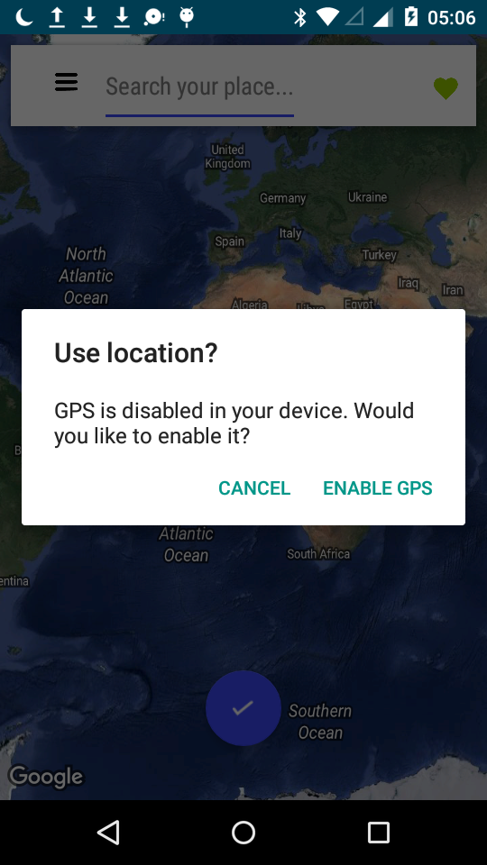

Fig. ii

2) Now the user enter the location where he wants to go.

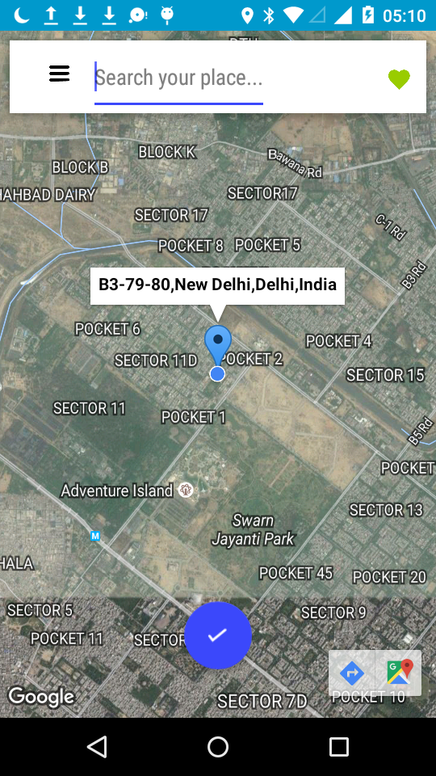
Fig: iii

3) Then based on the category the app would list all the related places in the succeeding screen.

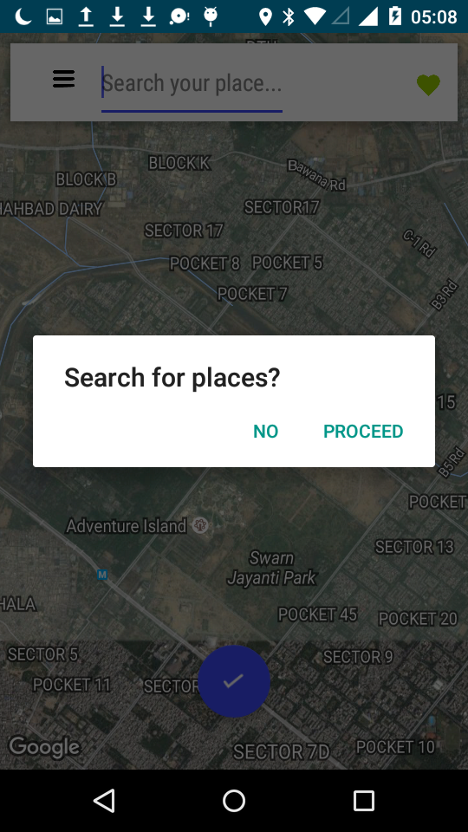
Fig: iv

4) The app would also show the weather forecast of the city.

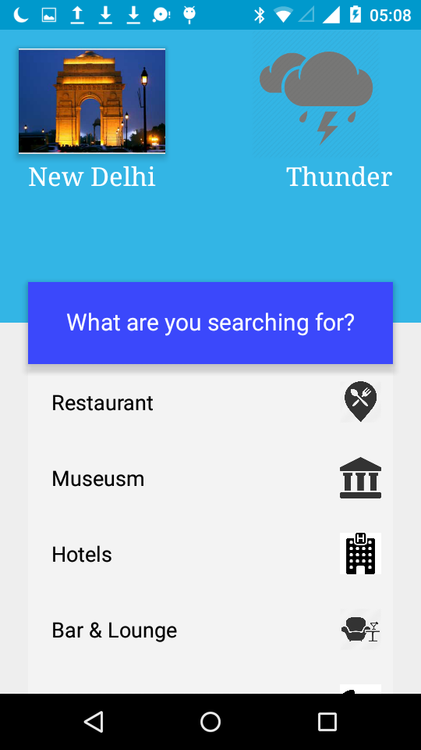

Fig: v

3.1) CONSTRAINTS AND DEPENDENCIES
- This application runs on android based O/S only.
- Minimum android version required is API level 21.

3.1.1 SPECIFIC REQUIREMENTS :

  - J2SE 5.0 or higher.
  - Integrated Development Environment (IDE)(Say Eclipse or Android Studio)
  - Android Development Tools (ADT).
  - Software Development Kit (SDK).
  - Minimum android version is 5.0 i.e. API level 21.

3.2)
Use-case Diagram
The use case diagram consists of the following criteria mentioned below:

• It should be the scenario that describes the interaction between a user and the system.

• It displays the relationship among actors and use cases.

There are two components in a use case diagram that helps understand the use case diagram. Those are,

• Actor
• Use-case

An actor in a use-case diagram represents a user using the system. On the other hand, a use-case represents the set of acts that a user might perform while using the system

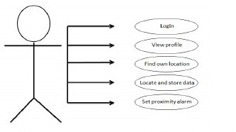

Fig: vi (Use Case of Location)
Fig : vii (Use Case of Weather)

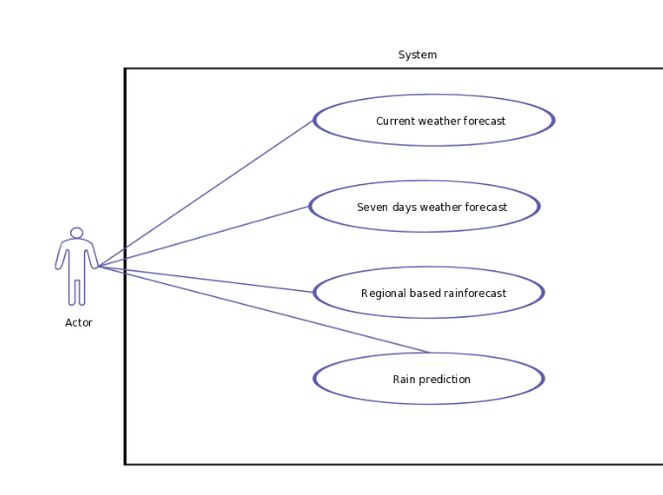

CHAPTER-4
RELATED CODE

Map Activity Code :

package com.example.scofield.nearby;

import android.*;
import android.Manifest;
import android.animation.Animator;
import android.content.Context;
import android.content.DialogInterface;
import android.content.Intent;
import android.content.pm.PackageManager;
import android.location.Geocoder;
import android.location.Location;
import android.location.LocationManager;
import android.net.ConnectivityManager;
import android.net.NetworkInfo;
import android.net.Uri;
import android.provider.Settings;
import android.support.annotation.NonNull;
import android.support.annotation.Nullable;
import android.support.design.widget.FloatingActionButton;
import android.support.v4.app.ActivityCompat;
import android.support.v4.app.FragmentActivity;
import android.os.Bundle;
import android.support.v7.app.AlertDialog;
import android.transition.Scene;
import android.transition.TransitionManager;
import android.util.Log;
import android.view.View;
import android.view.ViewAnimationUtils;
import android.view.ViewGroup;
import android.widget.EditText;
import android.widget.ImageView;
import android.widget.Toast;

import com.google.android.gms.appindexing.Action;
import com.google.android.gms.appindexing.AppIndex;
import com.google.android.gms.common.ConnectionResult;
import com.google.android.gms.common.api.GoogleApiClient;
import com.google.android.gms.common.api.PendingResult;
import com.google.android.gms.identity.intents.Address;
import com.google.android.gms.location.LocationListener;
import com.google.android.gms.location.LocationRequest;
import com.google.android.gms.location.LocationServices;
import com.google.android.gms.location.LocationSettingsRequest;
import com.google.android.gms.location.LocationSettingsResult;
import com.google.android.gms.location.internal.LocationRequestUpdateData;
import com.google.android.gms.maps.CameraUpdateFactory;
import com.google.android.gms.maps.GoogleMap;
import com.google.android.gms.maps.LocationSource;
import com.google.android.gms.maps.OnMapReadyCallback;
import com.google.android.gms.maps.SupportMapFragment;
import com.google.android.gms.maps.model.BitmapDescriptorFactory;
import com.google.android.gms.maps.model.CameraPosition;
import com.google.android.gms.maps.model.LatLng;
import com.google.android.gms.maps.model.Marker;
import com.google.android.gms.maps.model.MarkerOptions;

import java.io.IOException;
import java.util.List;
import java.util.Locale;

public class MapsActivity extends FragmentActivity implements OnMapReadyCallback, View.OnClickListener, GoogleApiClient.ConnectionCallbacks, GoogleApiClient.OnConnectionFailedListener, LocationListener {

private GoogleMap mMap;
EditText et;
ImageView iv;
int c = 0;
boolean isConnected;
GoogleApiClient googleAPIClient;
Location ls;
LocationRequest locationRequest;
LatLng latLng;
Marker marker;
FloatingActionButton fab;

private GoogleApiClient client;
/**
* ATTENTION: This was auto-generated to implement the App Indexing API.
* See https://g.co/AppIndexing/AndroidStudio for more information.
*/
private GoogleApiClient client2;

@Override
protected void onCreate(Bundle savedInstanceState) {
super.onCreate(savedInstanceState);
ConnectivityManager cm = (ConnectivityManager) this.getSystemService(Context.CONNECTIVITY_SERVICE);
NetworkInfo activeNetwork = cm.getActiveNetworkInfo();
isConnected = activeNetwork != null && activeNetwork.isConnectedOrConnecting();
/* if (isConnected == false) {
AlertDialog.Builder ab = new AlertDialog.Builder(this);
ab.setTitle("Connectivity Problem..");
ab.setMessage("The app requires internet connection!!");

ab.setPositiveButton("Ok", new DialogInterface.OnClickListener() {
@Override
public void onClick(DialogInterface dialogInterface, int i) {
finish();
}
});
ab.show();
}
else {

LocationManager locationManager = (LocationManager) getSystemService(LOCATION_SERVICE);

if (!locationManager.isProviderEnabled(LocationManager.GPS_PROVIDER)){
showGPSDisabledAlertToUser();
}

*/

setContentView(R.layout.activity_maps);

// Obtain the SupportMapFragment and get notified when the map is ready to be used.
SupportMapFragment mapFragment = (SupportMapFragment) getSupportFragmentManager()
.findFragmentById(R.id.map);
mapFragment.getMapAsync(this);

iv = (ImageView) findViewById(R.id.search_icon);
iv.setOnClickListener(this);
fab=(FloatingActionButton)findViewById(R.id.tickFab);
fab.setOnClickListener(this);

//}
// ATTENTION: This was auto-generated to implement the App Indexing API.
// See https://g.co/AppIndexing/AndroidStudio for more information.
client = new GoogleApiClient.Builder(this).addApi(AppIndex.API).build();
// ATTENTION: This was auto-generated to implement the App Indexing API.
// See https://g.co/AppIndexing/AndroidStudio for more information.
client2 = new GoogleApiClient.Builder(this).addApi(AppIndex.API).build();
}

private void showGPSDisabledAlertToUser(){
AlertDialog.Builder alertDialogBuilder = new AlertDialog.Builder(this);
alertDialogBuilder.setTitle("Use location?");
alertDialogBuilder.setMessage("GPS is disabled in your device. Would you like to enable it?")
.setCancelable(false)
.setPositiveButton("Enable GPS",
new DialogInterface.OnClickListener(){
public void onClick(DialogInterface dialog, int id){
Intent callGPSSettingIntent = new Intent(
android.provider.Settings.ACTION_LOCATION_SOURCE_SETTINGS);
startActivity(callGPSSettingIntent);
finish();
}
});
alertDialogBuilder.setNegativeButton("Cancel",
new DialogInterface.OnClickListener(){
public void onClick(DialogInterface dialog, int id){
finish();
}
});
AlertDialog alert = alertDialogBuilder.create();
alert.show();
}

/**
* Manipulates the map once available.
* This callback is triggered when the map is ready to be used.
* This is where we can add markers or lines, add listeners or move the camera. In this case,
* we just add a marker near Sydney, Australia.
* If Google Play services is not installed on the device, the user will be prompted to install
* it inside the SupportMapFragment. This method will only be triggered once the user has
* installed Google Play services and returned to the app.
*/
@Override
public void onMapReady(GoogleMap googleMap) {
mMap = googleMap;
mMap.setMapType(GoogleMap.MAP_TYPE_HYBRID);

if (ActivityCompat.checkSelfPermission(MapsActivity.this, Manifest.permission.ACCESS_FINE_LOCATION) != PackageManager.PERMISSION_GRANTED && ActivityCompat.checkSelfPermission(MapsActivity.this, Manifest.permission.ACCESS_COARSE_LOCATION) != PackageManager.PERMISSION_GRANTED) {
// TODO: Consider calling
// ActivityCompat#requestPermissions
// here to request the missing permissions, and then overriding
// public void onRequestPermissionsResult(int requestCode, String[] permissions,
// int[] grantResults)
// to handle the case where the user grants the permission. See the documentation
// for ActivityCompat#requestPermissions for more details.
return;
}

mMap.setMyLocationEnabled(true);
mMap.isIndoorEnabled();
buildGoogleApiClient();
googleAPIClient.connect();
}

protected synchronized void buildGoogleApiClient() {

googleAPIClient = new GoogleApiClient.Builder(this).
addConnectionCallbacks(this).
addOnConnectionFailedListener(this).
addApi(LocationServices.API).addApi(AppIndex.API).build();
}

@Override
public void onClick(View view) {
int finalRadius = (int) Math.hypot(view.getHeight() / 2, view.getWidth() / 2);
/* if(view.getId()==R.id.search_place){
Animator anim= ViewAnimationUtils.createCircularReveal(view,view.getWidth()/2,view.getHeight()/2,0,finalRadius);
anim.start();
}*/
if (view.getId() == R.id.search_icon) {
Animator anim = ViewAnimationUtils.createCircularReveal(view, view.getWidth() / 2, view.getHeight() / 2, 0, finalRadius);
anim.start();
if (c == 0) {
mMap.setMapType(GoogleMap.MAP_TYPE_TERRAIN);
c = 1;
} else if (c == 1) {
mMap.setMapType(GoogleMap.MAP_TYPE_NORMAL);
c = 2;
} else if (c == 2) {
mMap.setMapType(GoogleMap.MAP_TYPE_SATELLITE);
c = 3;
} else {
mMap.setMapType(GoogleMap.MAP_TYPE_HYBRID);
c = 0;
}
}
if(view.getId()==R.id.tickFab){
AlertDialog.Builder ab = new AlertDialog.Builder(this);
ab.setTitle("Search for places nearby?");
ab.setPositiveButton("Proceed", new DialogInterface.OnClickListener() {
@Override
public void onClick(DialogInterface dialogInterface, int i) {
Intent intent=new Intent(MapsActivity.this,NearbyPlaces.class);
startActivity(intent); }
});
ab.setNegativeButton("No", new DialogInterface.OnClickListener() {
@Override
public void onClick(DialogInterface dialogInterface, int i) {
dialogInterface.dismiss();
}
});
ab.show();

}
}

@Override
public void onConnected(@Nullable Bundle bundle) {
if (ActivityCompat.checkSelfPermission(this, Manifest.permission.ACCESS_FINE_LOCATION) != PackageManager.PERMISSION_GRANTED && ActivityCompat.checkSelfPermission(this, Manifest.permission.ACCESS_COARSE_LOCATION) != PackageManager.PERMISSION_GRANTED) {
// TODO: Consider calling
// ActivityCompat#requestPermissions
// here to request the missing permissions, and then overriding
// public void onRequestPermissionsResult(int requestCode, String[] permissions,
// int[] grantResults)
// to handle the case where the user grants the permission. See the documentation
// for ActivityCompat#requestPermissions for more details.
return;
}
//for getting the last location of the user
ls = LocationServices.FusedLocationApi.getLastLocation(googleAPIClient);
if (ls != null) {
//place marker at current place
latLng = new LatLng(ls.getLatitude(), ls.getLongitude());

String pos = latLng.toString();
MarkerOptions markerOptions = new MarkerOptions();
markerOptions.position(latLng);
markerOptions.title(pos);
markerOptions.icon(BitmapDescriptorFactory.defaultMarker(BitmapDescriptorFactory.HUE_BLUE));
marker = mMap.addMarker(markerOptions);

}

locationRequest = new LocationRequest();
locationRequest.setInterval(5000);//5 sec
locationRequest.setFastestInterval(3000);//3 sec
locationRequest.setPriority(LocationRequest.PRIORITY_BALANCED_POWER_ACCURACY);

LocationServices.FusedLocationApi.requestLocationUpdates(googleAPIClient, locationRequest, (LocationListener) this);
}

@Override
public void onConnectionSuspended(int i) {
Toast.makeText(this, "Connection Suspended", Toast.LENGTH_LONG).show();
}

@Override
public void onConnectionFailed(@NonNull ConnectionResult connectionResult) {

Toast.makeText(this, "Connection Failed", Toast.LENGTH_LONG).show();
}

@Override
public void onLocationChanged(Location location) {

Geocoder geocoder;
List<android.location.Address> addresses = null;
geocoder = new Geocoder(this, Locale.getDefault());

try {
addresses = geocoder.getFromLocation(ls.getLatitude(), ls.getLongitude(), 1); // Here 1 represent max location result to returned, by documents it recommended 1 to 5
} catch (IOException e) {
e.printStackTrace();
}

String address = addresses.get(0).getAddressLine(0); // If any additional address line present than only, check with max available address lines by getMaxAddressLineIndex()
String city = addresses.get(0).getLocality();
String state = addresses.get(0).getAdminArea();
String country = addresses.get(0).getCountryName();
//place marker at current position
//mGoogleMap.clear();
if (marker != null) {
marker.remove();
}
latLng = new LatLng(location.getLatitude(), location.getLongitude());
MarkerOptions markerOptions = new MarkerOptions();
markerOptions.position(latLng);

markerOptions.title(address + "," + city + "," + state + "," + country);
// markerOptions.title("Te Amo");
markerOptions.icon(BitmapDescriptorFactory.defaultMarker(BitmapDescriptorFactory.HUE_AZURE));
marker = mMap.addMarker(markerOptions);

//zoom to current position:
CameraPosition cameraPosition = new CameraPosition.Builder()
.target(latLng).zoom(14).build();

mMap.animateCamera(CameraUpdateFactory
.newCameraPosition(cameraPosition));

//If you only need one location, unregister the listener
LocationServices.FusedLocationApi.removeLocationUpdates(googleAPIClient, this);

}

}

XML
<?xml version="1.0"?>

-<RelativeLayout xmlns:android="http://schemas.android.com/apk/res/android" android:id="@+id/mapActivity" android:background="#d6d7d7" xmlns:tools="http://schemas.android.com/tools" xmlns:app="http://schemas.android.com/apk/res-auto" android:layout_width="match_parent" android:layout_height="match_parent">

<fragment android:id="@+id/map" xmlns:tools="http://schemas.android.com/tools" android:layout_width="match_parent" android:layout_height="match_parent" tools:layout="@layout/abc_action_bar_title_item" tools:context="com.example.scofield.nearby.MapsActivity" android:name="com.google.android.gms.maps.SupportMapFragment"/>

-<android.support.v7.widget.Toolbar android:id="@+id/view" android:background="#FFF" android:layout_width="match_parent" android:layout_height="60dp" android:elevation="8dp" android:layout_margin="8dp">

-<LinearLayout android:layout_width="wrap_content" android:layout_height="match_parent" android:orientation="horizontal">

<ImageView android:layout_width="50dp" android:layout_height="match_parent" android:src="@drawable/hamburg" android:padding="10dp"/>

<EditText android:id="@+id/search_place" android:layout_width="match_parent" android:layout_height="match_parent" android:layout_alignParentStart="true" android:fontFamily="sans-serif-condensed" android:hint="Search your place..." android:textColorHint="#333" android:maxWidth="170dp"/>

</LinearLayout>

-<RelativeLayout android:layout_width="match_parent" android:layout_height="match_parent" android:layout_marginLeft="100dp">

<ImageView android:id="@+id/search_icon" android:layout_width="wrap_content" android:layout_height="match_parent" android:src="@drawable/srch" android:padding="10dp" android:layout_alignParentEnd="true" android:layout_alignParentTop="true"/>

</RelativeLayout>

</android.support.v7.widget.Toolbar>

<android.support.design.widget.FloatingActionButton android:id="@+id/tickFab" android:layout_width="56dp" android:layout_height="56dp" android:elevation="16dp" android:src="@drawable/tick" android:layout_marginLeft="12dp" android:layout_marginBottom="40dp" android:layout_centerHorizontal="true" android:layout_alignParentBottom="true" android:layout_marginRight="12dp" app:pressedTranslationZ="24dp"> </android.support.design.widget.FloatingActionButton>

</RelativeLayout>

LINKING CODE:
<?xml version="1.0"?>
<android.support.design.widget.CoordinatorLayout tools:context="com.example.scofield.nearby.NearbyPlaces" android:fitsSystemWindows="true" android:layout_height="match_parent" android:layout_width="match_parent" xmlns:tools="http://schemas.android.com/tools" xmlns:app="http://schemas.android.com/apk/res-auto" xmlns:android="http://schemas.android.com/apk/res/android"><android.support.design.widget.AppBarLayout android:fitsSystemWindows="true" android:layout_height="300dp" android:layout_width="match_parent" android:theme="@style/ThemeOverlay.AppCompat.Dark.ActionBar" android:id="@+id/appBar"><android.support.design.widget.CollapsingToolbarLayout app:title="Places Nearby..." android:fitsSystemWindows="true" android:layout_height="match_parent" android:layout_width="match_parent" android:id="@+id/collapsingToolbar" app:collapsedTitleGravity="center_horizontal" app:expandedTitleGravity="bottom" app:expandedTitleMarginStart="16dp" app:contentScrim="?attr/colorPrimary" app:layout_scrollFlags="scroll|exitUntilCollapsed"><View android:layout_height="match_parent" android:layout_width="match_parent" android:background="@drawable/scrim" android:elevation="1dp"/><ImageView android:fitsSystemWindows="true" android:layout_height="match_parent" android:layout_width="match_parent" android:id="@+id/toolbarImage" app:layout_collapseMode="parallax" android:src="@drawable/back" android:scaleType="fitXY"/><FrameLayout android:layout_height="150dp" android:layout_width="175dp" android:id="@+id/cityPic" android:elevation="4dp"><TextView android:layout_height="wrap_content" android:layout_width="wrap_content" android:id="@+id/textView" android:layout_marginLeft="24dp" android:layout_gravity="left|bottom" android:fontFamily="serif" android:textColor="#fff" android:text="New Delhi" android:textAppearance="?android:attr/textAppearanceLarge"/><ImageView android:layout_height="90dp" android:layout_width="125dp" android:id="@+id/indiaGate" android:background="#fff" android:elevation="20dp" android:scaleType="centerCrop" android:layout_gravity="left|center_vertical" android:layout_margin="16dp"/><ImageButton android:layout_height="55dp" android:layout_width="55dp" android:id="@+id/arrow" android:background="#00000000" android:elevation="8dp" android:src="@drawable/arrow" android:layout_gravity="left|top"/></FrameLayout><android.support.v7.widget.Toolbar android:layout_height="?attr/actionBarSize" android:layout_width="match_parent" android:id="@+id/toolbar" android:elevation="8dp" app:layout_collapseMode="pin" app:popupTheme="@style/ThemeOverlay.AppCompat.Light"/></android.support.design.widget.CollapsingToolbarLayout></android.support.design.widget.AppBarLayout><android.support.v4.widget.NestedScrollView android:layout_height="match_parent" android:layout_width="match_parent" android:id="@+id/scrollview" android:background="#f5f5f5" app:layout_behavior="@string/appbar_scrolling_view_behavior" android:layout_marginTop="-5dp"><LinearLayout android:layout_height="match_parent" android:layout_width="match_parent" android:orientation="vertical"><FrameLayout android:layout_height="match_parent" android:layout_width="match_parent"><RelativeLayout android:layout_height="match_parent" android:layout_width="match_parent" android:id="@+id/relative2"> </RelativeLayout><RelativeLayout android:layout_height="match_parent" android:layout_width="match_parent"><TextView android:layout_height="match_parent" android:layout_width="150dp" android:id="@+id/textView2" android:textColor="#000" android:text="Restaurant" android:textSize="18sp" android:padding="20dp"/><ImageView android:layout_height="35dp" android:layout_width="35dp" android:id="@+id/imageView2" android:src="@drawable/rest" android:layout_margin="10dp" android:layout_alignParentEnd="true" android:layout_centerVertical="true"/></RelativeLayout></FrameLayout><FrameLayout android:layout_height="match_parent" android:layout_width="match_parent"><RelativeLayout android:layout_height="match_parent" android:layout_width="match_parent" android:id="@+id/relative3"> </RelativeLayout><RelativeLayout android:layout_height="match_parent" android:layout_width="match_parent"><TextView android:layout_height="match_parent" android:layout_width="150dp" android:id="@+id/textView3" android:textColor="#000" android:text="Museusm" android:textSize="18sp" android:padding="20dp"/><ImageView android:layout_height="35dp" android:layout_width="35dp" android:src="@drawable/museum" android:layout_margin="10dp" android:layout_alignParentEnd="true" android:layout_centerVertical="true"/></RelativeLayout></FrameLayout><FrameLayout android:layout_height="match_parent" android:layout_width="match_parent"><RelativeLayout android:layout_height="match_parent" android:layout_width="match_parent" android:id="@+id/relative4"> </RelativeLayout><RelativeLayout android:layout_height="match_parent" android:layout_width="match_parent"><TextView android:layout_height="match_parent" android:layout_width="150dp" android:id="@+id/textView4" android:textColor="#000" android:text="Hotels" android:textSize="18sp" android:padding="20dp"/><ImageView android:layout_height="35dp" android:layout_width="35dp" android:src="@drawable/hotel" android:layout_margin="10dp" android:layout_alignParentEnd="true" android:layout_centerVertical="true"/></RelativeLayout></FrameLayout><FrameLayout android:layout_height="match_parent" android:layout_width="match_parent"><RelativeLayout android:layout_height="match_parent" android:layout_width="match_parent" android:id="@+id/relative5"> </RelativeLayout><RelativeLayout android:layout_height="match_parent" android:layout_width="match_parent"><TextView android:layout_height="match_parent" android:layout_width="150dp" android:id="@+id/textView5" android:textColor="#000" android:text="Bar & Lounge" android:textSize="18sp" android:padding="20dp"/><ImageView android:layout_height="35dp" android:layout_width="35dp" android:src="@drawable/bar" android:layout_margin="10dp" android:layout_alignParentEnd="true" android:layout_centerVertical="true"/></RelativeLayout></FrameLayout><FrameLayout android:layout_height="match_parent" android:layout_width="match_parent"><RelativeLayout android:layout_height="match_parent" android:layout_width="match_parent" android:id="@+id/relative6"> </RelativeLayout><RelativeLayout android:layout_height="match_parent" android:layout_width="match_parent"><TextView android:layout_height="match_parent" android:layout_width="150dp" android:id="@+id/textView6" android:textColor="#000" android:text="Monuments" android:textSize="18sp" android:padding="20dp"/><ImageView android:layout_height="35dp" android:layout_width="35dp" android:src="@drawable/monument" android:layout_margin="10dp" android:layout_alignParentEnd="true" android:layout_centerVertical="true"/></RelativeLayout></FrameLayout><FrameLayout android:layout_height="match_parent" android:layout_width="match_parent"><RelativeLayout android:layout_height="match_parent" android:layout_width="match_parent" android:id="@+id/relative7"> </RelativeLayout><RelativeLayout android:layout_height="match_parent" android:layout_width="match_parent"><TextView android:layout_height="match_parent" android:layout_width="150dp" android:id="@+id/textView7" android:textColor="#000" android:text="Gardens" android:textSize="18sp" android:padding="20dp"/><ImageView android:layout_height="35dp" android:layout_width="35dp" android:src="@drawable/garden" android:layout_margin="10dp" android:layout_alignParentEnd="true" android:layout_centerVertical="true"/></RelativeLayout></FrameLayout><FrameLayout android:layout_height="match_parent" android:layout_width="match_parent"><RelativeLayout android:layout_height="match_parent" android:layout_width="match_parent"> </RelativeLayout><RelativeLayout android:layout_height="match_parent" android:layout_width="match_parent"><TextView android:layout_height="match_parent" android:layout_width="150dp" android:textColor="#000" android:text="Restaurant" android:textSize="18sp" android:padding="20dp"/><ImageView android:layout_height="35dp" android:layout_width="35dp" android:src="@drawable/rest" android:layout_margin="10dp" android:layout_alignParentEnd="true" android:layout_centerVertical="true"/></RelativeLayout></FrameLayout><FrameLayout android:layout_height="match_parent" android:layout_width="match_parent"><RelativeLayout android:layout_height="match_parent" android:layout_width="match_parent"> </RelativeLayout><RelativeLayout android:layout_height="match_parent" android:layout_width="match_parent"><TextView android:layout_height="match_parent" android:layout_width="150dp" android:textColor="#000" android:text="Restaurant" android:textSize="18sp" android:padding="20dp"/><ImageView android:layout_height="35dp" android:layout_width="35dp" android:src="@drawable/rest" android:layout_margin="10dp" android:layout_alignParentEnd="true" android:layout_centerVertical="true"/></RelativeLayout></FrameLayout><FrameLayout android:layout_height="match_parent" android:layout_width="match_parent"><RelativeLayout android:layout_height="match_parent" android:layout_width="match_parent"> </RelativeLayout><RelativeLayout android:layout_height="match_parent" android:layout_width="match_parent"><TextView android:layout_height="match_parent" android:layout_width="150dp" android:textColor="#000" android:text="Restaurant" android:textSize="18sp" android:padding="20dp"/><ImageView android:layout_height="35dp" android:layout_width="35dp" android:src="@drawable/rest" android:layout_margin="10dp" android:layout_alignParentEnd="true" android:layout_centerVertical="true"/></RelativeLayout></FrameLayout><FrameLayout android:layout_height="match_parent" android:layout_width="match_parent"><RelativeLayout android:layout_height="match_parent" android:layout_width="match_parent"> </RelativeLayout><RelativeLayout android:layout_height="match_parent" android:layout_width="match_parent"><TextView android:layout_height="match_parent" android:layout_width="150dp" android:textColor="#000" android:text="Restaurant" android:textSize="18sp" android:padding="20dp"/><ImageView android:layout_height="35dp" android:layout_width="35dp" android:src="@drawable/rest" android:layout_margin="10dp" android:layout_alignParentEnd="true" android:layout_centerVertical="true"/></RelativeLayout></FrameLayout></LinearLayout></android.support.v4.widget.NestedScrollView></android.support.design.widget.CoordinatorLayout>

Chapter 5 :
RESULTS

From a proper analysis of positive points and constraints of the system it is inferred that the system is working as per the objectives of the project. Installation is a hassle free-task. The user interface is user friendly and does not require specialized training or skills to operate.

Chapter 6:
FUTURE WORK

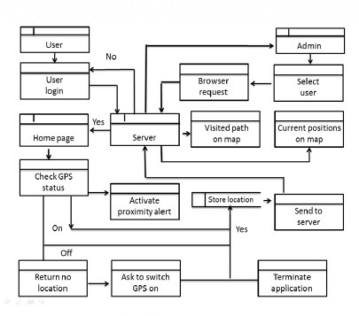
In future we are planning to integrate this app with the server so that for a particular user it will have memory as well as records of his traveling and user updates.
Following is the state of our future work:

Fig : viii

REFERENCES :
http://www8.garmin.com/aboutGPS/[2]

http://www.wild-heerbrugg.com/gps_timeline.htm[3]

http://inventors.about.com/od/gstartinventions/a/gps.htm[4]

http://spectrum.library.concordia.ca/[5]

http://www.collectionscanada.gc.ca/[6]

53

